### Issue 672: Quantifiers of P140, P141, P177

CEO gave an update on the issue, namely that the decision to change the property quantifiers of P140 & P141 from “many to many (0,n:0,n)” and P177 from “many to many, necessary (1,n:0,n)” to “many to one, necessary (1.1:0,n)” (which, in its turn, was motivated by the inability to discern which property type assignment (P177:E55) was connected to which instance of E13) has consequences for the quantifiers of the subproperties of P140/P141: they cannot be less restrictive than the ones used for P140-P141.

The SIG was presented with two alternatives concerning the relevant set of properties for the subclasses of E13 Attribute Assignment listed below: either change the cardinalities of their subproperties to “many to one, necessary (1,1:0,n)” or disengage them from P140 and P141 altogether.

* E14 Condition Assessment
  + P34 concerned (was assessed by): E18 Physical Thing (ISA P140)
  + P35 has identified (was identified by): E3 Condition State (ISA P141)
* E15 Identifier Assignment
  + P37 assigned (was assigned by): E42 Identifier (ISA P141)
  + P38 deassigned (was deassigned by): E42 Identifier (ISA P141)
* E16 Measurement
  + P39 measured (was measured by): E18 Physical Thing (ISA P140)
  + P40 observed dimension (was observed in): E54 Dimension (ISA P141)
* E17 Type Assignment
  + P41 classified (was classified by): E1 CRM Entity (ISA P140)
  + P42 assigned (was assigned by): E55 Type (IsA P141)

N.b. Changing the cardinalities does not entail having to redraft the scope notes, seeing as they explicitly mention connecting one instance of the E13 subclasses in their domain, to their range.

An implication of implementing the new cardinalities for the set of properties would be that (as far as the subclasses of E13 are concerned) each activity type will only be applied to/ affect exactly one thing. For instance, when documenting the measurement of the volume of an object, CIDOC CRM users would have to document measuring the height, the length, and the width of an object as distinct E16 Measurement events. Taking each of these measurements would become part of an overarching activity (i.e., “calculating the volume of object x”).

Also, seeing as the issue has implications for CRMsci (where the model for Observations is undergoing a major reorganization) and CRMarchaeo (properties dependent on subclasses of S4 Observation), there was the question of how to proceed –either resolve the issue for CRMbase and then have CRM extensions harmonize with base or wait for the new model for observations be accepted and harmonized with E13 Attribute Assignment before the relevant structures be updated in CRMbase.

* In terms of procedure, the SIG decided that CRMbase always takes precedence compared to CRM extensions –so they proceeded with examining the proposed changes.

**Discussion points**:

Some interesting points were raised that essentially lead the SIG to refrain from reaching a decision at this meeting. Specifically:

1. If E13 Attribute Assignment is only meant to be used for reification constructs, then its properties should only be used for this purpose –it doesn’t make sense that they have subproperties of themselves.
2. E14 Condition Assessment and E16 Measurement in particular are inherently different to E13 Attribute Assignment, insofar as they involve objectively true situations that are observed and documented, whereas E13 is purely declarational (i.e., E14 and E16 are uncovering facts about the world, whereas E13 is just stating them –thereby creating them).
3. The properties of E15 Identifier Assignment are not so different from one another (contrary to what is mentioned in the scope note).

The SIG decided to review the issue on the last day of the meeting.

### Issue 672: Quantifiers of P140, P141, P177 (continuation)

The SIG postponed reaching a decision on the original proposal on the grounds that

* if E13 Attribute Assignment is only to be used for reification constructs then it forms a very special case, and so do its properties. In that sense, they cannot have subproperties of their own, and
* P177 assigned property of type (is type of property assigned) is superfluous with respect to the subclasses of E13 Attribute Assignment.

Whether E13 Attribute Assignment should be disengaged from its current subclasses (E14 Condition Assessment, E15 Identifier Assignment, E16 Measurement, and E17 Type Classification) was discussed anew.

Evidence that we might not have to do that came from CRMaaa, where the constructs of ZE1 Institutional Fact resemble an E13 Attribute Assignment.

* It’s a temporal entity; but unlike E3 Condition State that exists independently of observation –only to become relevant once it’s been observed –ZE1 Institutional Fact only exists because society/ some group has collectively decided that it is the case.
* It connects two entities and ascribes a type of relation to them much like the E13 and P140, P141, P177 modeling construct in CRMbase. And it also allows to ascribe temporal and other information (actor, location, whatnots) to the institutional fact.

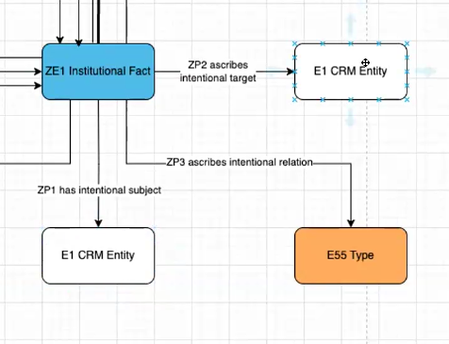

Still, the SIG could not reach a decision at that point. Whether P177 is used as in E13 (to reference the name of the property) or in a direct analogy to ZP3 ascribes intentional relation, its scope note will have to change. The same thing applies to the scope notes for E14, E15, E16, E17 and their properties, if they are disengaged from E13.

**How to proceed**:

**HW**: CEO, MD, WS to discuss this ahead of the next meeting. Come up with a concrete proposal by that time.