## Issue 663: Define Ixx Singleton Proposition Set

The SIG reviewed the model proposed by MD & PF (see figures below, as well as the class and properties definitions at the end of the document). What the proposed modelling construct aims to do is provide a CRM compatible method to implement reification and connect to E13 Attribute Assignment and properties.

**Discussion points**:

* For the modelling to work, the property quantifiers of P140, P141, and P177 need to be set to “many to one, necessary (1.1:0,n)”, but there seems to be no consensus on that (at least for the moment).   
  It is something that MD, CEO, WS, and PF will have to reconsider for issue 672.
* The proposed modeling construct provides a CRM compatible method to implement reification and connect to E13. It allows modelling one’s data as a knowledge graph (in the case that one is dealing with instances of I4 Proposition Set) or explicitly marking the truth value to statements connecting an instance of E13 Attribute Assignment to a I17 One Proposition Set. This cannot be done only relying on CRMbase –even after declaring E13 to be a subclass of I1 Argumentation –because P140/P141 implicitly take the content of the assignment to be true. The proposed modeling allows to document a knowledge revision process, during which the original E13 (represented through P140/P141/P177) will be augmented using the full path through J2 concluded that (was concluded by): I2 Belief. J4 that (is subject of): I4 Proposition Set. J5 holds to be: I6 Belief Value
* DH will be sharing relevant examples from archaeological excavation data with PF.

**Decisions**:

* The proposed definition for One-Proposition Set and its properties were accepted in principle.
* The properties were OK, but I17 One-Proposition Set needs some editing, in terms of making clear what its relation to reification is.   
  **HW**: GB will be contacting PF & MD to work on the scope note for I17 One-Proposition Set

### Diagrams

CRMinf Belief Adoption modelling construct

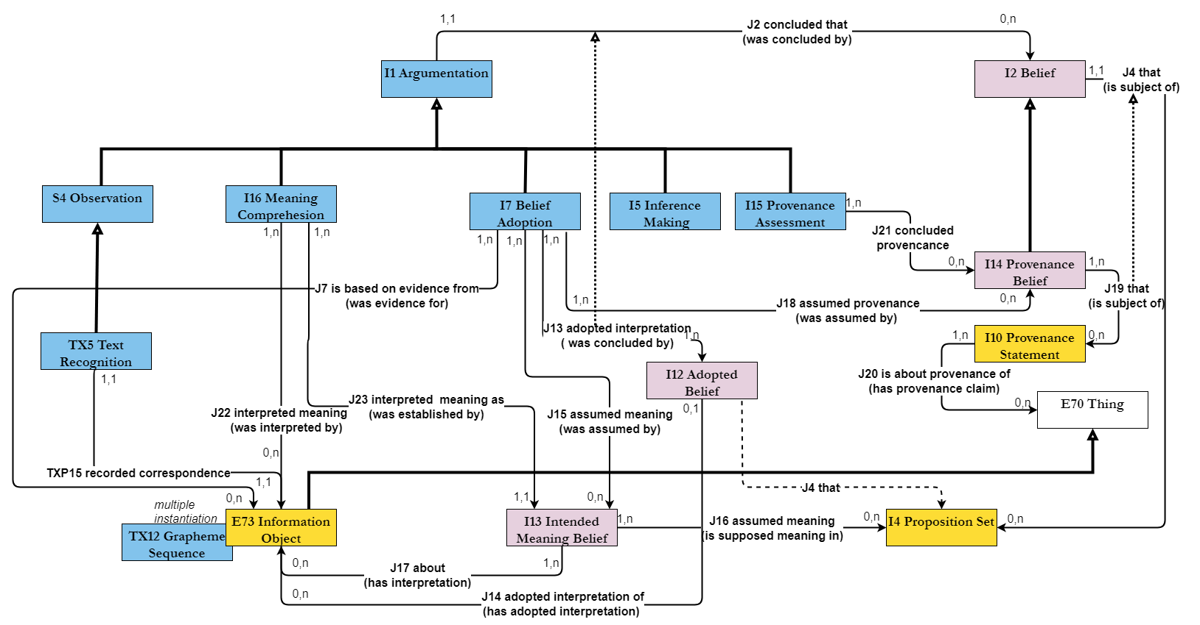

Proposition Sets and E13 Attribute Assignment

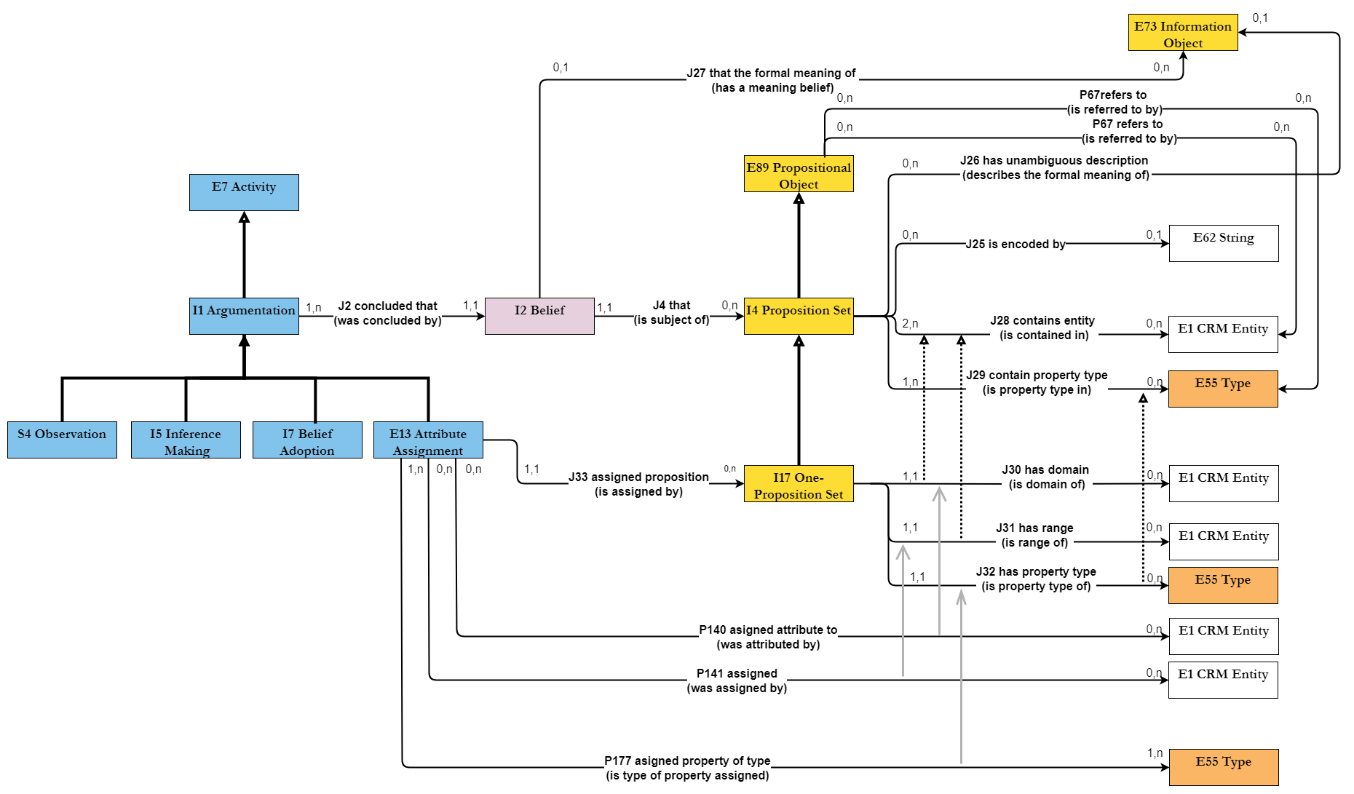

### Proposed properties

#### I17 One-Proposition Set

Subclass of:

I4 Proposition Set

Superclass of:

Scope note:

This class comprises proposition sets containing exactly one binary proposition which is or could, in principle be, encoded in a knowledge representation language. The identity of an instance of I17 One-Proposition Set is given by the total of its content, regardless equivalent encodings.

A property linking to an instance of I17 One-Proposition Set in a Knowledge Base may alternatively be implemented by a “reification” construct, and is regarded as logically equivalent in this model. Similarly, all triples of properties declared for one class to denote the domain, type and range of another property, such as the properties of E13 Attribute Assignment and its subclasses, can be interpreted as shortcuts to an instance of I17 One-Proposition Set and its properties *J30 has domain (is domain of), J31 has range (is range of), J32 has property type (is property type of)*, or as a “reification” implicit to the declaring class.

As such, the class I17 One-Proposition Set plays the role of an important *logical interface* between different ways to document a discourse about propositions within a Knowledge Base in different ways. It is particularly relevant for implementing effective queries. For documentation, the use of simpler shortcut properties will, typically, be the preferred approach.

Examples:

* The proposition set with content:

{The skeleton in La Tomba dell'Aryballos sospeso on the left bench (E20 Biological Object) *P2 has type* ‘male’ (E55 Type)} (I17) (Squires, 2013)

* The proposition set with content:

{The skeleton in La Tomba dell'Aryballos sospeso on the left bench (E20 Biological Object) *P2 has type* ‘female’ (E55 Type)} (I17) (Mandolesi, 2013)

* The proposition set with content:

{The burial arrangement in La Tomba dell'Aryballos sospeso on the left bench (E22 Human-Made Object) *is composed of* The spear found in La Tomba dell'Aryballos sospeso (E22 Human-Made Object)} (I17) (Mandolesi, 2013)

* The proposition set with content:

{The skeleton in La Tomba dell'Aryballos sospeso on the left bench (E20 Biological Object) *forms part of* The burial arrangement in La Tomba dell'Aryballos sospeso on the left bench (E22 Human-Made Object)} (I17) (Mandolesi, 2013)

[The skeleton found on the left bench of La Tomba dell'Aryballos sospeso, Doganaccia di Tarquinia, Tuscany, Italy, by Prof. Alessandro Mandolesi on the 21th of September 2013, was initially estimated by Prof. Mandolesi to be the remains of a male person, due to the lance found next to it, and published in the press as such. Soon after, osteological analysis carried out by the team revealed that it was of a female person, as published in the academic papers afterwards. This is a good example for a simple inference and scientific knowledge revision. We refer to this skeleton in these examples of propositions as “The skeleton on the left bench in La Tomba dell'Aryballos sospeso” and as “The burial arrangement on the left bench in La Tomba dell'Aryballos sospeso” respectively, meaning any unique identifier for the same real object.]

* The proposition set with content:

{The book MS Sinai Greek 418 (E22 Human-Made Object) *has binding structure* ‘unsupported’ (E55 Type) } (Honey & Pickwoad, 2010)

[‘has binding structure’ refers to a property, external to the CIDOC CRM, which connects a book (E22 Human-Made Object) to the type of its binding structure (E55 Type)]

In First Order Logic:

I17(x) ⇒ I4(x)

I17(x) ⇒ (∃uvw) [E1(u) ˄ J30(x,u) ˄ E1(v) ˄ J31(x,v) ˄ E55(w) ˄ J32(x,w)]

Properties:

J30 has domain (is domain of): E1 CRM Entity

J31 has range (is range of): E1 CRM Entity

J32 has property type (is property type of): E55 Type

#### J30 has domain (is domain of)

Domain:

I17 One-Proposition Set

Range:

E1 CRM Entity

Subproperty of:

I4 Proposition Set. J28 contains entity (is contained in): E1 CRM Entity

Superproperty of:

Quantification:

many to one, necessary (1,1:0,n)

Scope note:

This property associates an instance of I17 One-Proposition Set with an instance of E1 CRM Entity that must appear as the only domain instance of the proposition in the content of the former.

This property is part of the fully developed path from E13 Attribute Assignment through *J33 assigned proposition (is assigned by)*, I17 One-Proposition Set, *J30 has domain (is domain of)* E1 CRM Entity, which is shortcut by *P140 assigned attribute to (was attributed by)*.

Examples:

* The proposition set with content:

{The skeleton on the left bench in La Tomba dell'Aryballos sospeso (E20 Biological Object) *P2 has type* ‘male’ (E55 Type)} (I17) *has domain* The skeleton in La Tomba dell'Aryballos sospeso on the left bench (E20) (Squires 2013)

* The proposition set with content:

{The skeleton on the left bench in La Tomba dell'Aryballos sospeso (E20 Biological Object) *P2 has type* ‘female’ (E55 Type)} (I17) *has domain* The skeleton in La Tomba dell'Aryballos sospeso on the left bench (E20) (Mandolesi 2013)

* The proposition set with content:

{The burial arrangement on the left bench in La Tomba dell'Aryballos sospeso (E22 Human-Made Object) *is composed of* the spear found in La Tomba dell'Aryballos sospeso (E22 Human-Made Object)} (I17) *has domain* The burial arrangement in La Tomba dell'Aryballos sospeso on the left bench (E22) (Mandolesi 2013)

* The proposition set with content:

{The skeleton on the left bench in La Tomba dell'Aryballos sospeso (E20 Biological Object) *forms part of* The burial arrangement on the left bench in La Tomba dell'Aryballos sospeso (E22 Human-Made Object)} (I17) *has domain* The skeleton on the left bench in La Tomba dell'Aryballos sospeso (E20) (Mandolesi 2013)

* The proposition set with content:

{The book MS Sinai Greek 418 (E22 Human-Made Object) *has binding structure* ‘unsupported’ (E55 Type)} (I17) *has domain* The book MS Sinai Greek 418 (E22) (Honey & Pickwoad, 2010)

[See comments for examples of I17]

In First Order Logic:

J30(x,y) ⇒ I17(x)

J30(x,y) ⇒ E1(y)

J30(x,y) ⇒ J28(x,y)

J28(x,y) ) ˄ I17(x) ⇒ J30(x,y) OR J31(x,y)

#### J31 has range (is range of)

Domain:

I17 One-Proposition Set

Range:

E1 CRM Entity

Subproperty of:

I4 Proposition Set. J28 contains entity (is contained in): E1 CRM Entity

Superproperty of:

Quantification:

many to one, necessary (1,1:0,n)

Scope note:

This property associates an instance of I17 One-Proposition Set with an instance of E1 CRM Entity that must appear as the range of the proposition in the content of the former.

This property is part of the fully developed path from E13 Attribute Assignment through *J33 assigned proposition (is assigned by)*, I17 One-Proposition Set, *J31 has range (is range of)* E1 CRM Entity, which is shortcut by *P141 assigned (was assigned by)*.

Examples:

* The proposition set with content:

{The skeleton on the left bench in La Tomba dell'Aryballos sospeso (E20 Biological Object) *P2 has type* ‘male’ (E55 Type)} (I17) *has range* ‘male’ (E55) (Squires 2013)

* The proposition set with content:

{The burial arrangement on the left bench in La Tomba dell'Aryballos sospeso (E22 Human-Made Object) *is composed of* The spear found in La Tomba dell'Aryballos sospeso (E22 Human-Made Object)} (I17) *has range* The spear found in La Tomba dell'Aryballos sospeso (E22) (Mandolesi 2013)

* The proposition set with content:

{The skeleton on the left bench in La Tomba dell'Aryballos sospeso (E20 Biological Object) *forms part of* The burial arrangement on the left bench in La Tomba dell'Aryballos sospeso (E22 Human-Made Object)} (I17) *has range* The burial arrangement on the left bench in La Tomba dell'Aryballos sospeso (E22) (Mandolesi 2013)

* The proposition set with content:

{The book MS Sinai Greek 418 (E22 Human-Made Object) *has binding structure* ‘unsupported’ (E55 Type)} (I17) *has range* ‘unsupported’ (E55 Type) (Honey & Pickwoad, 2010)

[See comments for examples of I17]

In First Order Logic:

J31(x,y) ⇒ I17(x)

J31(x,y) ⇒ E1(y)

J31(x,y) ⇒ J28(x,y)

#### J32 has property type (is property type of)

Domain:

I17 One-Proposition Set

Range:

E55 Type

Subproperty of:

I4 Proposition Set. J29 contains property type (is property type in): E55 Type

Superproperty of:

Quantification:

many to one, necessary (1,1:0,n)

Scope note:

This property associates an instance of I17 One-Proposition Set with an instance of E55 Type that must appear as the only property type of the proposition in the content of the former.

This property is part of the fully developed path from E13 Attribute Assignment through *J33 assigned proposition (is assigned by)*, I17 One-Proposition Set, *J32 has property type (is property type of)* E1 CRM Entity, which is shortcut by *P177 assigned property of type (is type of property assigned).*

Examples:

* The proposition set with content:

{The skeleton on the left bench in La Tomba dell'Aryballos sospeso (E20 Biological Object) *P2 has type* ‘male’ (E55 Type)} (I17) *has property type* ‘P2 has type’ (E55). (Squires 2013)

* The proposition set with content:

{The skeleton on the left bench in La Tomba dell'Aryballos sospeso (E20 Biological Object) *P2 has type* ‘female’ (E55 Type)} (I17) *has property type* ‘P2 has type’ (E55). (Mandolesi 2013)

* The proposition set with content:

{The burial arrangement on the left bench in La Tomba dell'Aryballos sospeso (E22 Human-Made Object) *is composed of* The spear found in La Tomba dell'Aryballos sospeso (E22 Human-Made Object)} (I17) *has property type* ‘P46 is composed of’ (E55). (Mandolesi 2013)

* The proposition set with content:

{The skeleton on the left bench in La Tomba dell'Aryballos sospeso (E20 Biological Object) *forms part of* The burial arrangement on the left bench in La Tomba dell'Aryballos sospeso (E22 Human-Made Object)} (I17) *has property type* ‘P46i forms part of’ (E55). (Mandolesi 2013)

* The proposition set with content:

{The book MS Sinai Greek 418 (E22 Human-Made Object) *has binding structure* ‘unsupported’ (E55 Type)} (I17) *has property type* ‘has binding structure’ (E55). (Honey & Pickwoad, 2010)

[See comments for examples of I17]

In First Order Logic:

J32(x,y) ⇒ I17(x)

J32(x,y) ⇒ E55(y)

J32(x,y) ⇒ J29(x,y)

#### J33 assigned proposition (is assigned by)

Domain:

E13 Attribute Assignment

Range:

I17 One-Proposition Set

Superproperty of:

Subproperty of:

Quantification:

many to one, necessary (1,1:0,n)

Scope note:

This property associates an instance of E13 Attribute Assignment with an instance of I17 One-Proposition Set that describes the proposition made and believed to be true.

This property constitutes a formal logical alternative to specifying the proposition made by an instance of E13 Attribute Assignment via *P140 assigned attribute to (was attributed by),  P141 assigned (was assigned by)* and *P177 assigned property of type (is type of property assigned).* As such, it is of importance for querying knowledge bases compatible with either model.

This property forms part of the following three (3) fully developed paths from E13 Attribute Assignment through:

* *J33 assigned proposition (is assigned by)*, I17 One-Proposition Set, *J30 has domain (is domain of)* to E1 CRM Entity, which is shortcut by *P140 assigned attribute to (was attributed by)*.
* *J33 assigned proposition (is assigned by)*, I17 One-Proposition Set, *J31 has range (is range of)* to E1 CRM Entity, which is shortcut by *P141 assigned (was assigned by)*,
* *J33 assigned proposition (is assigned by)*, I17 One-Proposition Set, *J32 has property type (is property type of)* to E1 CRM Entity, which is shortcut by *P177 assigned property of type (is type of property assigned).*

This property is a shortcut for the path from E13 Attribute Assignment through *J2 concluded that (was concluded by)*, I2 Belief, *J4 that (is subject of)*, I4 Proposition Set, *J5 holds to be* to I6 Belief Value (= “True”).

Full path:

<???>

Examples:

* The gender classification of the skeleton on the left bench in La Tomba dell'Aryballos sospeso provided to the press by Prof. Alessandro Mandolesi on the 21th of September 2013 (E17, I5) *assigned proposition*

The proposition set with content:

{The skeleton on the left bench in La Tomba dell'Aryballos sospeso (E20 Biological Object) *P2 has type* ‘male’ (E55 Type)} (I17) (Squires 2013)

* The gender analysis of the skeleton on the left bench in La Tomba dell'Aryballos sospeso provided to the press by Prof. Alessandro Mandolesi on the 18th of October and academically published in 2013 (E17, S4) *assigned proposition*

The proposition set with content:

{The skeleton on the left bench in La Tomba dell'Aryballos sospeso (E20 Biological Object) *P2 has type* ‘female’ (E55 Type)} (I17) (Mandolesi 2013)

* The examination of MS Sinai Greek 418 by Nicholas Pickwoad in November 2003 (E13) *assigned proposition*

The proposition set with content:

{The book MS Sinai Greek 418 (E22 Human-Made Object) *has binding structure* ‘unsupported’ (E55 Type)} (I17) (Honey & Pickwoad, 2010)

[See comments for examples of I17]

In First Order Logic:

J33(x,y) ⇒ E13(x)

J33(x,y) ⇒ I17(y)

J33(x,y) ⇒ P140(x,u) ˄ J30(y,u) ˄ P141(x,v) ˄ J31(y,v) ˄ P177(w) ˄ J32(y,w)

J33(x,y) ⇒ (∃u) [I2(u) ˄ J2(x,u) ˄ J4(u,y) ˄ J5(u,’TRUE’)]  believed to be true!

E13(x) ⇒ (∃uvw) [E1(u) ˄ P140(x,u) ˄ E1(v) ˄ P141(x,v) ˄ E55(w) ˄ P177(x,w)]

J2(x,y) ˄ E13(x) ⇒ J33(x,y)

P140(x,y) ⇒ (∃u) [I17(u) ˄ J33(x,u) ˄ J30(u,y)]

P141(x,y) ⇒ (∃u) [I17(u) ˄ J33(x,u) ˄ J31(u,y)]

P177(x,y) ⇒ (∃u) [I17(u) ˄ J33(x,u) ˄ J32(u,y)]