Issue 701: Redo the diagram for E13 Attribute Assignment and its properties
MD presented the new diagram for E13 Attribute Assignment, to be included in the Functional Overview, as well as the Introduction of the CIDOC CRM (a subsection under Basic Concepts).
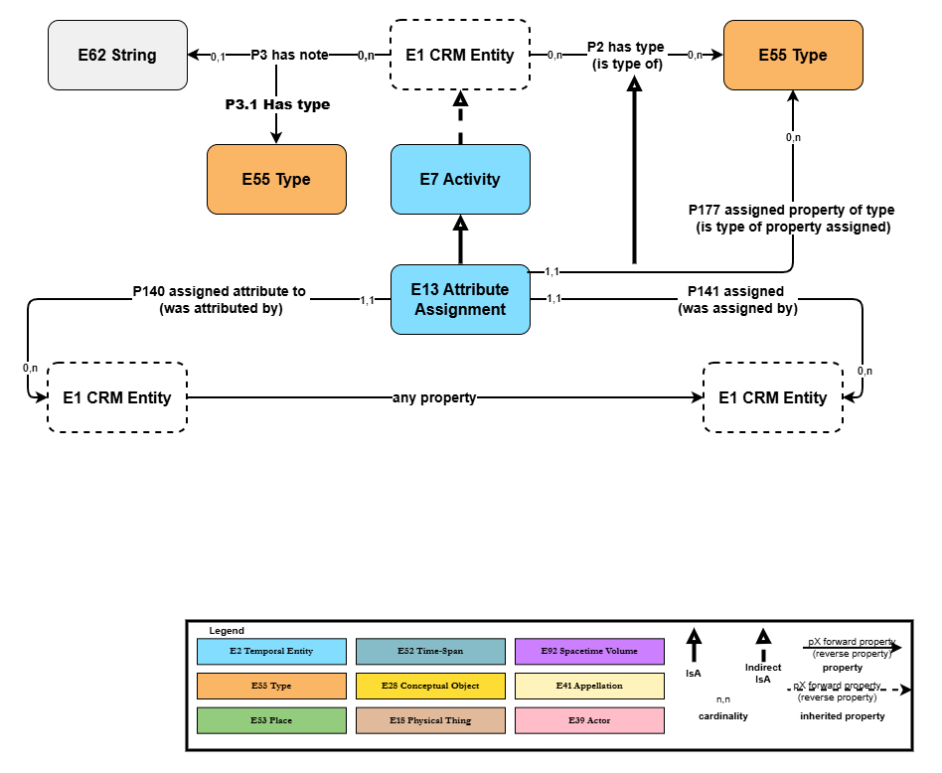
The diagram marks the shift to a more restrictive semantics of the properties of E13 Attribute Assignment, which resolves the previously existing ambiguity in the interpretation of P140, P141, P177 which permitted instantiating multiple attributes (values/dimensions/conditions/…) assigned to one object via one instance of E13. The resulting situation forms a major shift, around a core CIDOC CRM concept that affects a substantive part of the modelling (both in CIDOC CRM and its extensions).
Discussion points:
- The constructs around E13 form a core part of the model, one that should be properly explained. The diagram is a first step (so is the migration instruction at the end of the CIDOC CRM document), but for the purpose of teaching the model, some textual descriptions to accompany the diagram (in the spirit of issue 687) would prove to be very useful.
- The “any property” connecting two instances of E1 on the diagram should be able to be ascribed a type. There is currently no standard notation for this; it’s something to be reviewed for the next meeting.
  - On an unrelated topic, yet still on the topic of standardizing the notation used in diagrams: there is no uniform manner to represent shortcut properties until now. Enclosing them in boxes (like in Figure 2: Argumentation, Proposition Sets and E13 Attribute Assignment, in CRMinf v1.2.1, p.17) could serve like a blueprint.
- To be discussed in a new issue. GB or MD to start it.
Decision: Diagram approved.
Introduce the diagram in the functional overview, consider adding subclasses and subproperties, provide some textual description for it along the lines of 687. Ultimately add it to the CIDOC CRM Introduction section, under Basic Concepts.
HW: CEO to draft the text for the diagram.

