## Issue 614: Definition of I4 Proposition Set and what an instance of I2 Belief is about

The SIG reviewed the proposal by MD & PF to redefine I4 Proposition Set, i.e., introduce a set of related properties.

* Jxx1 is encoded by
* Jxx2 has unambiguous description (describes the formal meaning of)
* Jxx3 that the formal meaning of (has a meaning belief)
* Jxx4 contains entity (is contained in)
* Jxx5 contains property type (is property type in)

Plus, add a new example for I2 Belief

The diagrams illustrating the proposed changes be found below. The proposed definitions can be found at the end of this document.

**Discussion points**:

* Jxx has unambiguous representation: the label will have to change unless compelling evidence as to why it shouldn’t change are provided. It is not a question of it not reading nicely; rather, it is because it forms too strong a statement when in reality it is used to make claims about what goes on in people's heads. N.b.: The scope note does hypothesize an absolute lack of ambiguity independently of a context, but still the SIG was very vocal about wanting the label to change.
  + Proposed alternatives: has contextual description, has intended interpretation (something along these lines).
* Jxx that the formal meaning of (has a meaning belief): the “that” part on the label makes it hard to read and parse the property in the paths it appears. CRMinf is known to refer to beliefs in this fashion, “the instance of I2 Belief that … (rest of property name)”, but knowing that, does not make labels easier to read.
* Jxx contains entity (is contained in) AND Jxx contains property type (is property type in): the properties mix levels of representation. The instance of I4 Proposition Set, does not contain an instance of E1 CRM Entity;[1] rather it references it. Given that they are declared superproperties of P67 refers to, they are probably intended as a means to reference an entity or property (not to contain them).   
  The SIG has decided that the property scope notes in question need to undergo further editing.
  + If anything, a long path could form like I4 Proposition Set. P148 has component (is component of): E89 Propositional Object. P67 refers to (is referred to by): E1 CRM Entity
  + HW: MD & CEO to discuss it among themselves.

The SIG voted in favor of accepting the proposed changes in principle, with the caveat of MD, PF having to adjust the proposed definitions and labels as suggested and then put them to an evote; rather than wait for them to be approved at the next meeting.

**HW**: MD, PF, with the help of CEO.

**HW**: PF will be deploying some rdf data to demonstrate how these data points can be graphically represented using the CRMinf, plus how to query them.

### Diagrams

CRMinf Belief Adoption modelling construct

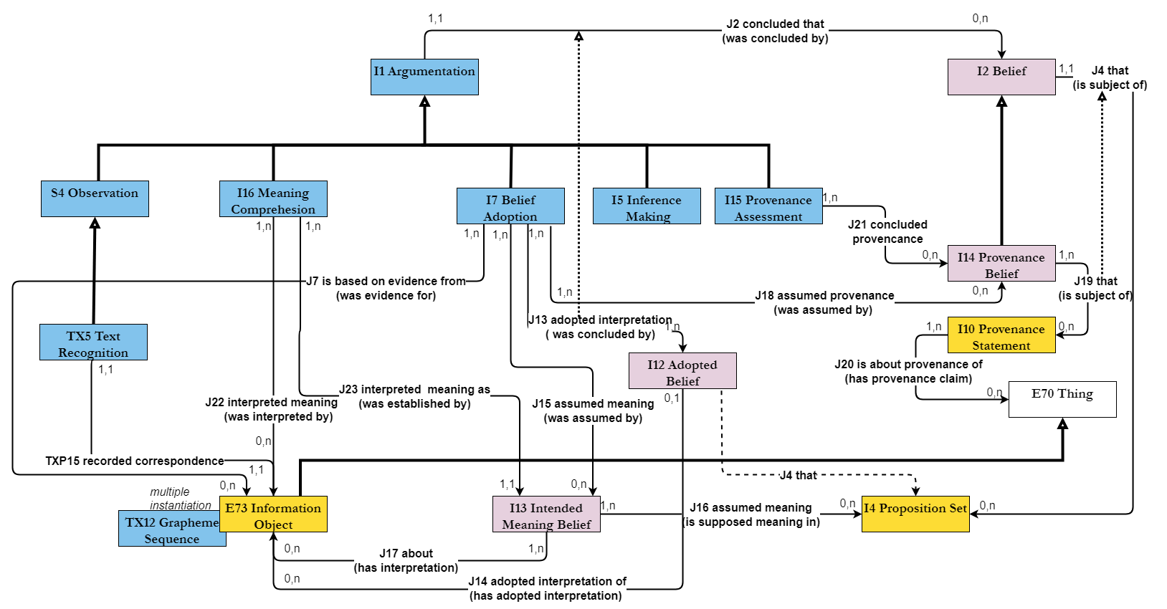

Proposition Sets and E13 Attribute Assignment

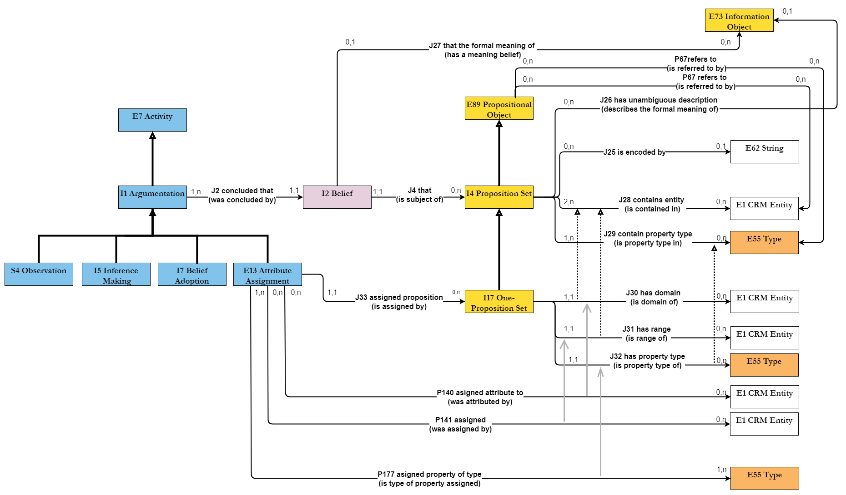

### Proposed scope notes

#### J25 is encoded by

Domain:

I4 Proposition Set

Range:

E62 String

Subproperty of:

<???>

Superproperty of:

<???>

Quantification:

one to many (0,n:0,1)

Scope note:

This property associates an instance of I4 Proposition Set with a “serialization” of its content in the format of a knowledge representation language. There may be more than one ontologically equivalent formal encodings of the same propositions.

In a Knowledge Base implementation, the content of an instance of I4 Proposition Set may be represented by the content of a Named Graph, but only if the propositions are encoded in the data model of the Knowledge Base and held to be true by the maintainers of a Knowledge Base because they become part of the stated knowledge. In this case, the platform-internal relation between the URI of the Named Graph and its content are regarded as equivalent to *J25 is encoded by*, and the property should formally not be instantiated.

<Fully developed path??>

Examples:

* {The skeleton on the left bench in La Tomba dell'Aryballos sospeso (E20 Biological Object) *P2 has type* ‘male’ (E55 Type)} (I17)

*is encoded by*

“<crm:E20_Biological_Object rdf:about=" https://cidoc-crm.org/crminf/examples/ Aryballos_Skeleton">

<rdfs:label xml:lang="en"> The skeleton on the left bench in La Tomba dell'Aryballos sospeso </rdfs:label>

<crm:P2_has_type>

<crm:E55_Type rdf:about="http://vocab.getty.edu/aat/300025928">

<rdfs:label xml:lang="en">men (male humans)</rdfs:label>

</crm:E55_Type>

</crm:P2_has_type>

</crm: E20_Biological_Object>” (E62). (Squires, 2013)

In First Order Logic:

J25(x,y) ⇒ I4(x)

J25(x,y) ⇒ E62(y)

#### J26 has unambiguous description (describes the formal meaning of)

Domain:

I4 Proposition Set

Range:

E73 Information Object

Subproperty of:

E1 CRM Entity. P129i is subject of (is about): E89 Propositional Object

Superproperty of:

Quantification:

one to many (0,n:0,1)

Scope note:

This property associates an instance of I4 Proposition Set with an instance of E73 Information Object that expresses the content of the former as propositions that are or could, in principle be, encoded in a knowledge representation language.

These propositions should be unambiguous at least within the context of provenance of the information object and the context of documenting them as the content of the instance of I4 Proposition Set. For a textual representation, rules of a normal scholarly consensus should be applied.

<Fully developed path??>

Examples:

* The proposition set with content:

{The skeleton on the left bench in La Tomba dell'Aryballos sospeso (E20 Biological Object) *P2 has type* ‘male’ (E55 Type)} (I17)

*has unambiguous description*

“The skeleton found on the left bench of La Tomba dell'Aryballos sospeso, Doganaccia di Tarquinia, Tuscany, Italy, by Prof. Alessandro Mandolesi on the 21th of September 2013 belongs to the remains of a male person” (E73). (Squires, 2013)

* The proposition set with content:   
  {Nero July 19, 64 AD (E93 Presence)

P164 is temporally specified by: July 19, 64 AD (E52 Timespan)

P195 was a presence of: Nero Claudius Caesar Drusus Germanicus (E21 Person)

P167 was within Rome in 64AD, Italy (E53 Place)

P10 falls within (contains): Nero Singing (E7 Activity)

P2 has type: Singing (E55 Type)

P14 carried out by: Nero Claudius Caesar Drusus Germanicus (E21)

P4 has timespan: July 19, 64 AD (E52 Timespan)

P7 took place at: Rome in 64AD, Italy (E53 Place)

P132 spatiotemporally overlaps with: The Great Fire of Rome (E5 Event)

P1 is identified by: incendium magnum Romae (E41 Appellation)

P4 has timespan: July 19-27, 64 AD (E52 Timespan)

P7 took place at: Rome in 64AD, Italy (E53 Place)

}

*has unambiguous description*

“Nero Claudius Caesar Drusus Germanicus was singing in Rome while it was burning from July 19 in 64 AD” (E73). (Bologna, 2021)

In First Order Logic:

J26(x,y) ⇒ I4(x)

J26(x,y) ⇒ E78(y)

J26(x,y) ⇒ P129(y,x)

#### J27 that the formal meaning of (has a meaning belief)

*comment by MD: The label “a formal meaning” is not adequate, because the link should only be used if the meaning is not ambiguous. Otherwise, J4 must be used!*

Domain:

I2 Belief

Range:

E73 Information Object

Subproperty of:

<??>

Superproperty of:

<??>

Quantification:

many to one (0,1:0,n)

Scope note:

This property associates an instance of I2 Belief with an instance of E73 Information Object that expresses the believed propositions in a form that are or could, in principle be, encoded in a knowledge representation language.

This property is a strong shortcut of the fully developed path from I2 Belief, *J4 that (is subject of)*, I4 Proposition Set, *J26 has unambiguous description (describes the formal meaning of)* to E73 Information Object. It is introduced into this model for the convenience of the user, when the implied instance of I4 Proposition Set appears not to be a separate object of discourse within this documentation context.

<Fully developed path??>

Examples:

* The belief of Prof. Alessandro Mandolesi in the gender of the skeleton on the left bench in La Tomba dell'Aryballos sospeso as provided to the press on the 21th of September 2013 (I2)

*that the formal meaning of*

“The skeleton found on the left bench of La Tomba dell'Aryballos sospeso, Doganaccia di Tarquinia, Tuscany, Italy, by Prof. Alessandro Mandolesi on the 21th of September 2013 belongs to the remains of a male person” (E73)

[“*holds to be* True (I6)”, see examples for J5].

(Squires, 2013)

In First Order Logic:

*comment by MD: J27 is a strong shortcut of J4 –J26*

J27(x,y) ⇒ I2(x)

J27(x,y) ⇒ E78(y)

J27(x,y) ⇔  (∃u) [I4(u) ˄ J4(x,u) ˄ J26(u,y)

#### J28 contains entity (is contained in)

*comment by PF: “element of one or more propositions”, refers to the domain or range class of an instance of a property in a proposition set, i.e., the subject or object of a statement in a triple.*

Domain:

I4 Proposition Set

Range:

E1 CRM Entity

Subproperty of:

E89 Propositional Object. P67 refers to (is referred to by): E1 CRM Entity

Superproperty of:

I10 Provenance Statement. J20 is about the provenance of (has provenance claim): E70 Thing

I17 One-Proposition Set. J30 has domain (is domain of): E1 CRM Entity

I17 One-Proposition Set. J31 has range (is range of): E1 CRM Entity

Quantification:

many to many, necessary (2,n:0,n)

Scope note:

This property associates an instance of I4 Proposition Set with an instance of E1 CRM Entity that appears as an element of one or more propositions in the content of the former.

This property serves on one side to relate an instance of I4 Proposition Set to other contexts of interest, in particular when its content is or cannot be represented as a Named Graph in the same knowledge base. On the other hand, it plays an important structural role in this model for expressing constraints to the content of an instance of I4 Proposition Set or one of its subclasses.

<Fully developed path??>

Examples:

* The proposition set with content:   
  {Nero in July 19, 64 AD (E93 Presence)

*P164 is temporally specified by*: July 19, 64 AD (E52 Timespan)

*P195 was a presence of*: Nero Claudius Caesar Drusus Germanicus (E21 Person)

*P167 was within* Antium in 64AD, Italy (E53 Place)

*P133 is spatiotemporally separated from*: The Great Fire of Rome (E5 Event)

*P1 is identified by*: incendium magnum Romae (E41 Appellation)

*P4 has timespan*: July 19-27, 64 AD (E52 Timespan)

*P7 took place at*: Rome in 64AD, Italy (E53 Place)

}

*contains entity* Antium in 64AD, Italy (E53 Place)

(Bologna 2021)

In First Order Logic:

J28(x,y) ⇒ I4(x)

J28(x,y) ⇒ E1(y)

J28(x,y) ⇒ P67(x,y)

#### J29 contains property type (is property type in)

Domain:

I4 Proposition Set

Range:

E55 Type

Subproperty of:

E89 Propositional Object. P67 refers to (is referred to by): E1 CRM Entity

Superproperty of:

I17 One-Proposition Set. J32 has property type (is property type of): E55 Type

Quantification:

many to many, necessary (1,n:0,n)

Scope note:

This property associates an instance of I4 Proposition Set with an instance of E55 Type that appears as property type in one or more propositions in the content of the former.

This property plays an important structural role in this model for expressing constraints to the content of an instance of I4 Proposition Set or one of its subclasses.

<Fully developed path??>

Examples:

* The proposition set with content:   
  {Nero in July 19, 64 AD (E93 Presence)

*P164 is temporally specified by*: July 19, 64 AD (E52 Timespan)

*P195 was a presence of*: Nero Claudius Caesar Drusus Germanicus (E21 Person)

*P167 was within* Antium in 64AD, Italy (E53 Place)

*P133 is spatiotemporally separated from*: The Great Fire of Rome (E5 Event)

*P1 is identified by*: incendium magnum Romae (E41 Appellation)

*P4 has timespan*: July 19-27, 64 AD (E52 Timespan)

*P7 took place at*: Rome in 64AD, Italy (E53 Place)

}

*contains property type* P195 was a presence of (E55 Type)

(Bologna, 2021)

In First Order Logic:

J29(x,y) ⇒ I4(x)

J29(x,y) ⇒ E55(y)

J29(x,y) ⇒ P67(x,y)

### New examples for I2 Belief

* One lance being in the burial arrangement on the left bench in La Tomba dell'Aryballos sospeso following Prof. Alessandro Mandolesi’s observation (I2) (Squires, 2013) (Mandolesi, 2013) [An observed fact, be it by many people, still constitutes a belief in the most general sense]
* The belief of Prof. Alessandro Mandolesi in the gender of the skeleton on the left bench in La Tomba dell'Aryballos sospeso as provided to the press on the 21th of September 2013 (I2) (Squires, 2013)

1. The scope note reads “the E1 CRM Entity that appears as an element of one or more propositions”.