How to implement CRM Time in RDF

Time span in CRM
The class E52 Time-Span in the CIDOC CRM represents an opinion about the “true” temporal extent an event, or better, an instance of E2 Temporal Entity, covers. The CRM further assumes that a precise temporal extent of an instance of E2 Temporal Entity neither can be observed nor actually exists. Rather, we can find inner or outer temporal bounds approximating more or less well the essentially fuzzy “true” temporal extent. Therefore Time-Spans have two properties, P81 and P82, in order to define temporal bounds. The property P81 is dedicated to modeling the Time-Span’s maximum known temporal extent i.e. (at least) ongoing_throughout. The property P82 is for modeling the minimum known outer bounds of events i.e. at_some_time_within. The two time intervals between P81 and P82 represent the uncertainty of the exact timing of an event. The following figure shows the above idea:

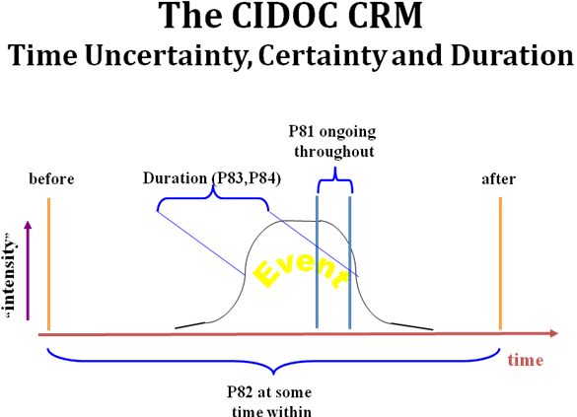Time in RDF
The CIDOC CRM models the actual temporal values as E61 Time Primitive, which is thought to be an exact temporal interval of arbitrary precision, since the CIDOC CRM does not make any commitment to a particular numerical or digital system. Rather, the CRM recommends to replace these classes by adequate approximations in the respective implementation environment. In an RDF schema there are no numerical values at all. Therefore the current RDF schema of the CIDOC CRM for the P81 and P82 properties defines that their values should be of type: http://www.w3.org/2000/01/rdf-schema#Literal., silently assuming that an exact temporal interval, (such as 333BC, a 1 year time-span), can be denoted by a literal.

This solution is adequate for data transport in RDF form, but not for querying an RDF Triple Store for time. It is common practice to extend the RDF literal in such systems by the primitive time datatype of XML schema: http://www.w3.org/2001/XMLSchema#dateTime. This type does not contradict the literal type as the date time is actually literal but in a more specific format. This encoding allows the interoperability between different Triple Store systems, but it does not allow for encoding an arbitrary exact time interval using one RDF property.

Alternative method
Alternatively we can define the end points of the CRM Time Primitives to which the above properties P81 and P82 point as separate properties, and define respective temporal constraints between them. For the P82 the 2 end points can be defined as “begin of the begin” and “end of the end”. For the P81 accordingly they can be defined as “end of the begin” and “begin of the end”.
These boundaries can be shown in the following figure:
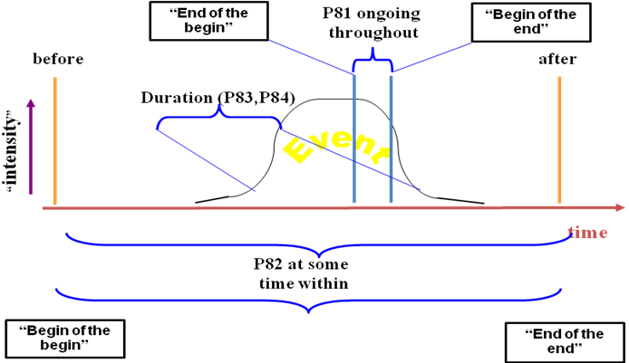

Constraints
Following the above definitions for the boundaries of the 2 properties, we can constraint these intervals in order to allow some relative chronological reasoning. The “begin of the begin” is the start of a larger period so it has to be the precedent of the other boundaries. After that we can define the “end of the begin”. Following the same logic, in the timeline the constraints can be the following:
“begin of the begin” ≤ “end of the end”
“begin of the begin” ≤ “end of the begin”
“begin of the begin”≤ “begin of the end”

“end of the begin” ≤ “end of the end”
“begin of the end” ≤”end of the end”

We observe that there needs not to be a defined constraint between the boundaries of P81. As a consequence the time interval of P81 can be negative. So that the “end of the begin” can be precedent of the “begin of the end”. This is allowed conventionally in cases in which the interval P81 is unknown, but the “true” begin and “true” end is still known to be contraint independently, as usual for larger archaeological or historical periods.

For implementation purposes we can then replace the above definitions and P82 and P81 by four formal properties:
- For the P82:
  - “begin of the begin” : “P82a”
  - “end of the end” : ”P82b”
- For the P81:
  - “end of the begin”: “P81a”
  - “begin of the end” : “P81b”

So, finally the constraints with the new naming of boundaries can be:
“P82a” ≤ “P82b”
“P82a” ≤ “P81a”
“P82a” ≤ “P81b”

“P81a” ≤ “P82b”
“P81b” ≤ “P82b”

