Issue 612-55th SIG; minutes
The SIG reviewed HW by AK & TV (diagrams and accompanying text for S23 Position Measurement and properties (Figure 9), plus an example instantiating them (Figure 10), to be displayed in the introduction of CRMinf).
The details can be found below:

Figure 9: Classes and properties for describing measuring the position of things

Diagram for S23 Position Measurement
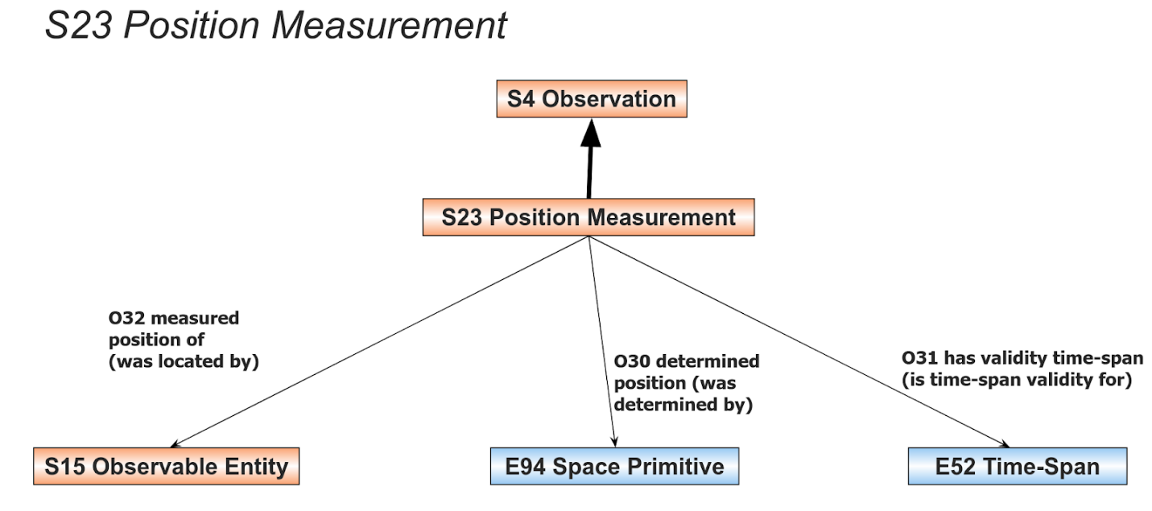
Figure 9: Classes and properties for describing measuring the positions of things

Accompanying text
Measuring positions
A specialisation of the class S4 Observation is the class S32 Position Measurement. It allows the modelling of the process of measuring the position of entities based on them being observed at a location in a given time-span. The properties connecting the observable entity with time and location are shown in Figure 9.

Figure 10: Example of position measurement of the Titanic after it hit an iceberg

Diagram for the example
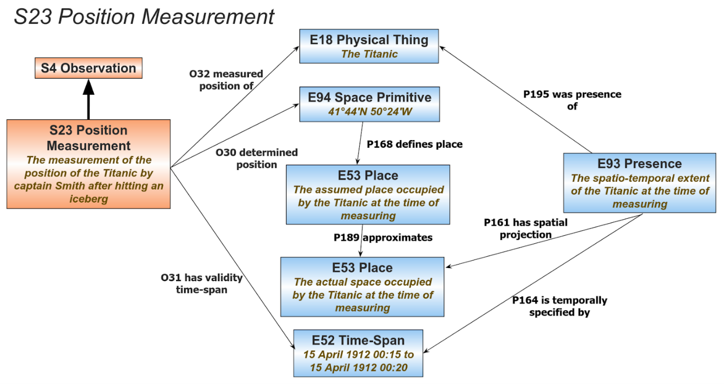
Figure 10: Example of position measurement of the Titanic after it hit an iceberg

Accompanying text
Figure 10 shows an example of measuring the position of the Titanic after it hit an iceberg. Before issuing a distress signal, Titanic’s captain Smith measured the position of the ship based on the distance travelled from the last known position, but this measurement was inaccurate. The Titanic is an instance of S15 Observable Entity and more specifically an instance of E18 Physical Thing and its spatio-temporal extent during measuring is an instance of E93 Presence. The spatial projection of this instance of E93 Presence is the actual place where the Titanic was after hitting the iceberg. Captain Smith’s measurement was inaccurate and the resulting latitude and longitude coordinates measured (instance of E94 Space Primitive) defined the assumed place of the ship and not the actual place. The assumed place is a separate instance of E53 Place which can only approximate the actual place. The two are connected with the property ‘P189 approximates’ which allows reasoning on different views of the location of things by comparing instances of E53 Place with their corresponding provenance.

Proposal:
Vote (separately for each diagram & short description pair) to be admitted in the introduction section of CRMsci.
- The SIG voted on admitting Figure 9 & accompanying short description in the introduction section of CRMinf.
Outcome of the vote.
In favor: 8 (6 in person, 2 online)
Against: None
(16 participants abstained)
- The SIG voted on admitting Figure 10 & accompanying short description in the introduction section of CRMinf.
Outcome of the vote.
In favor: 9 (6 in person, 3 online)
Against: None
(15 participants abstained)

Decision:
Introduce both Figure 9 & Figure 10 in the introduction section of CRMinf.
Issue closed

