Background

Need good real examples of transfer of custody

HW

Get examples from Getty Provenance Index of transfers of custody.

Outcome:

GB did this and proposes:

Proposal

Example 1

The transfer of custody of the work described s as “Von der Velden ein Ufer an der See” from Johann Matthäus von Merian to the Auction House Heldevier (Jacob) for the purpose of sale, ca. 1716

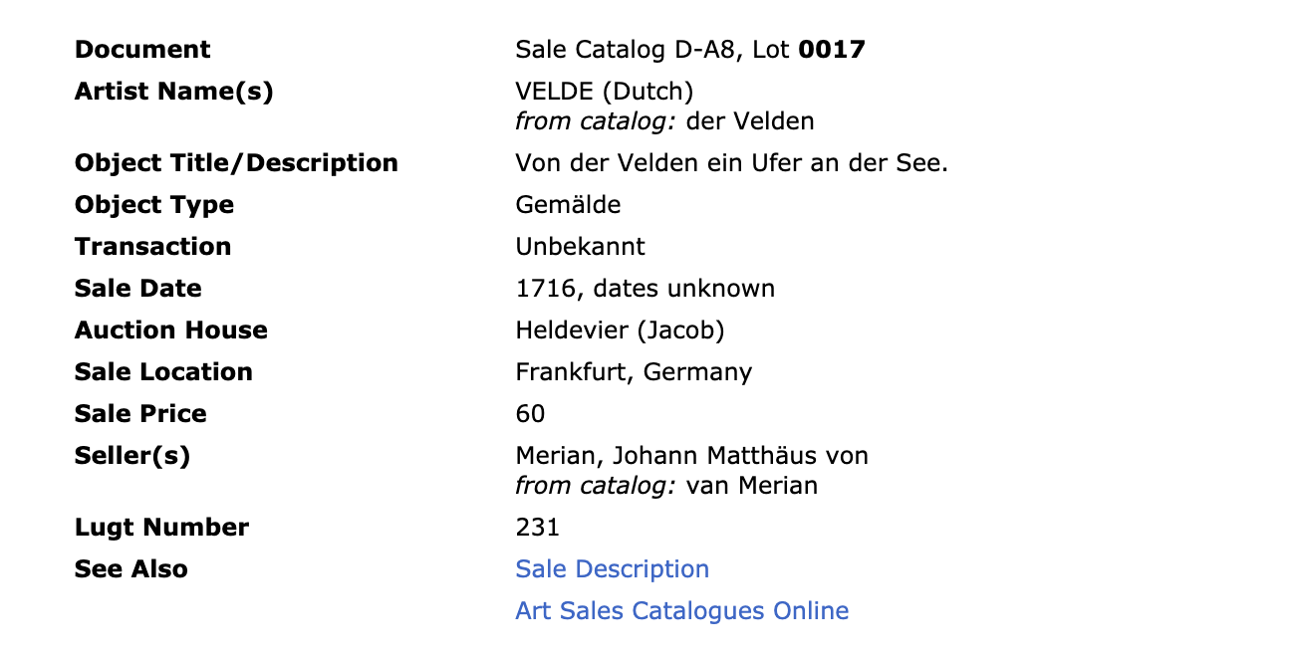

Document Sale Catalog D-A8, Lot 0017
Artist Name(s) VELDE (Dutch)
from catalog: der Velden
Object Title/Description Von der Velden ein Ufer an der See.
Object Type Gemälde
Transaction Unbekannt
Sale Date 1716, dates unknown
Auction House Heldevier (Jacob)
Sale Location Frankfurt, Germany
Sale Price 60
Seller(s) Merian, Johann Matthäus von
from catalog: van Merian
Lugt Number 231
See Also Sale Description
Art Sales Catalogues Online

Example 2

Document Knoedler Stock Book 8, Page 209, Row 54, Stock No. A2320
Artist Name(s) GAINSBOROUGH, THOMAS (British)
from stock book: T. Gainsborough
Object Title/Description Mrs Fitzherbert / J. Horace Harding Coll. Lot 60
Subject Portrait
Object Type Painting
Material/Dimensions 24 3/4 x 29 3/4
Transaction Sold
Entry Date 1941 Mar 1
Sale Date 1941 Mar 3
Purchase Price 11000 dollars
Sale Price 12100 dollars
Seller(s) Parke-Bernet Galleries (New York, NY, USA)
from catalog: Parke-Bernet Galleries
Buyer(s) Legion of Honor (no street address, San Francisco, CA, USA)
from catalog: California Palace of the Legion of Hono
Previous Owner(s) Harding, J. Horace [from stock book: J. Horace Harding]
Present Location San Francisco, CA, USA. California Palace of the Legion of Honor, 1941.19

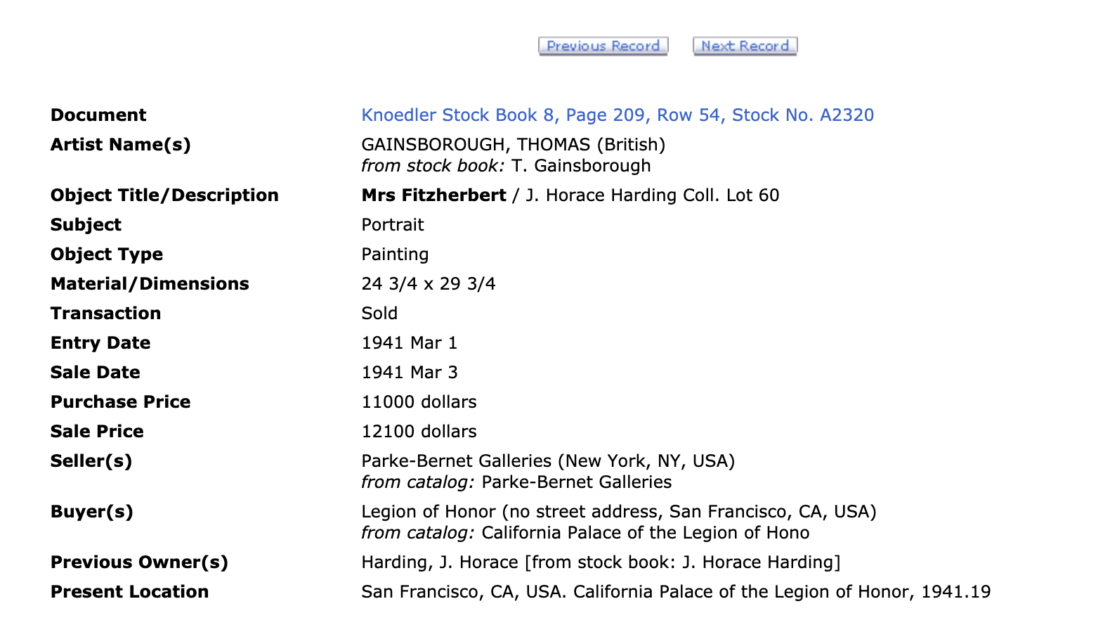

The transfer of custody of the painting Mrs. Fitzherbert to the art dealer Knoedler from Parke-Bernet Galleries (New York, NY, USA) ca. March 1941

