32nd joined meeting of the CIDOC CRM SIG and ISO/TC46/SC4/WG9 and the 25th FRBR - CIDOC CRM Harmonization meeting

Discussion about

CRM ISSUE 273
The sig distinguished two types of business transactions that may be needed to be modelled. These are
(a) Sales prices
(b) Generalizations
Sales prices are in the scope of spectrum. We decided that under the scope of CRM should be the economic evolution of cultural historical studies of economy and factors. The question is the sales prices as a more general question.
Then MD proposed to look at the ontology of Sumerian economic text corpus.
Finally we agreed to examine the business transactions under the aspect of cultural historical studies and as “social compensations activities / transactions”.
Firstly we will examine Spectrum and British museum data structure for financial data.
We detect notions of offer (plan), valuation (measurement), purchase price (Fact? Or Debt?), funding source.
It is a complex subject and we might have reciprocal transactions.
We discussed that the price is not a characteristic of the object e.g. Museum prices and Auctions prices. The type of this characteristic depends on planned transaction types.
Finally we agreed on the following dependency diagram of object.
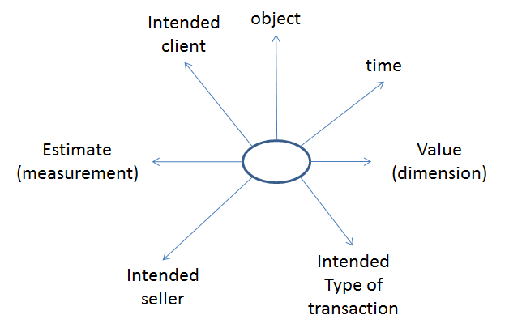

We need examples from Dominic.
Complexity: Do Museums make non-monetary compensation business?
Compensations for donations:
Spectrum, KEMU
Siegfried will give examples from his museum
BM
Finally we decide to make a proposal for business transactions and this will be added to the extension for Spectrum.
The question is the purchase price is fact or debt. Also it should be examined if every dimension is a result of measurement and what is the nature of the process that produces a dimension.
The purchase price that comes out of an agreement should we consider as a result of observation?
George, Steve, Dominic, Gordon should elaborate an answer in the view of the above.
Finally we decided to separate this issue into three different issues:
(a) a general model in cultural historical studies of economy and factors (to be elaborated by Nicolas Carboni, Terhi Nurmikko-Fuller, MD, Mathew Vincent)
(b) Financial transactions
(c) Coins and banknotes as artistic objects having industrial production.

