

Definition of the CRMdig v 5.0
Model for provenance metadata

Approved by the CIDOC CRM-SIG

Version 5.0

October 2025

Currently maintained by FORTH

Contributors: Martin Doerr, Athina Kritsotaki, Stephen Stead, Maria Theodoridou

CC BY-SA 4.0

This page is left blank on purpose
Table of Contents
Introduction 5
Scope 5
Status 5
Naming Conventions 5
CRMdig v 5.0 class hierarchy, aligned with portions from the CIDOC-CRM class hierarchy 6
List of external classes used in CRMdig v 5.0 7
CRMdig v 5.0 property hierarchy, aligned with portions from CIDOC-CRM property hierarchy 8
List of external properties used in CRMdig V 5.0 9
Graphical Overview 11
Class Hierarchy 11
Property Hierarchy 12
CRMdig v 5.0 Class Declarations 13
D1 Digital Object 14
D2 Digitization Process 14
D3 Formal Derivation 15
D7 Digital Machine Event 15
CRMdig v 5.0 Property Declarations 21
L1 digitized (was digitized by) 22
L2 used as source (was source for) 22
L10 had input (was input of) 23
L11 had output (was output of) 23
L12 happened on device (was device for) 24
L13 used parameters (parameters for) 24
L14 transferred (was transferred by) 25
L15 has sender (was sender for) 25
L16 has receiver (was receiver of) 26
L18 has modified (was modified by) 27
L19 stores (is stored on) 27
L20 has created (was created by) 28
L21 used as derivation source (was derivation source for) 28
L22 created derivative (was derivative created by) 29
L23 used software or firmware (was software or firmware used by) 29
L24 created logfile (was logfile created by) 30
L43 annotates (is annotated by) 30
L48 created annotation (was annotation created by) 31
L49 is primary area of (has primary area) 32
L50 is propagated area (has propagated area) 32
L54 is same as 33
L61 contains value set of (has value set representation) 33
Works Cited 35

Table of Tables

Table 1: Class Hierarchy 6
Table 2: List of external classes grouped by model and ordered by model (exception: CRMbase always goes first) and then by class identifier. 7
Table 3: Property Hierarchy 8
Table 4: List of external properties grouped by model and ordered by model (exception: CRMbase always goes first) and then by property identifier. 9

Table of Figures
Figure 1: CRMdig V 5.0 Class Hierarchy 11
Figure 2: CRMdig V 5.0 Property Hierarchy 12

Introduction

Scope
CRM Digital is an ontology and RDF Schema to encode metadata about the steps and methods of production ("provenance") of digitization products and synthetic digital representations such as 2D, 3D or even animated Models created by various technologies. Its distinct features compared to competitive models is the complete inclusion of the initial physical measurement processes and their parameters. It has been developed as compatible extension of CIDOC CRM, which allows for querying the most relevant facts and returning complete descriptions encoded in this model by generic ISO21127 terms without need to refer to its specific properties. In contrast, competitive models cannot be queried by a more general standard and are restricted to the computational provenance only. Data encoded in the major competitive models can be transformed without loss of meaning into a CRM-Digital-form.

Status
Stable version

Naming Conventions
All the classes declared were given both a name and an identifier constructed according to the conventions used in the CIDOC CRM model. For classes, the identifier consists of the letter D, followed by a number. Resulting properties were also given a name and an identifier, constructed according to the same conventions. The identifier consists of the letter L, followed by a number, which, in turn, is followed by the letter ‘i” every time the property is mentioned “backwards”, i.e., from target to domain. “D” and “L” do not have any other meaning. They correspond respectively to letters “E” and “P” in the CIDOC CRM naming conventions, where “E” originally meant “entity” (although the CIDOC CRM “entities” are now consistently called “classes”), and “P” means “property”.
Whenever CIDOC CRM classes are used in our model, they are named by the name they have in the CIDOC CRM itself.

CRMdig v 5.0 class hierarchy, aligned with portions from the CIDOC-CRM class hierarchy
This class hierarchy lists:
- all classes declared in CRMdig v 5.0
- all classes declared in CIDOC CRM version 7.1.3 or CRMsci version 3.1 that are declared as superclasses of classes declared in the CRMdig v 5.0,
- all classes declared in CIDOC CRM version 7.1.3 that are either domain or range for a property declared in the CRMdig v 5.0
Table 1: Class Hierarchy
E1 | CRM Entity
 | E7 | Activity
 |  | D7 | Digital Machine Event
 |  |  | D10 | Software Execution
 |  |  |  | D3 | Formal Derivation
 |  |  | D11 | Digital Measurement Event
 |  |  |  | D2 | Digitization Process
 | E65 | Creation
 |  | D7 | Digital Machine Event
 |  |  | D10 | Software Execution
 |  |  |  | D3 | Formal Derivation
 |  |  | D11 | Digital Measurement Event
 |  |  |  | D2 | Digitization Process
 |  | D30 | Annotation Event
 | I1 | Argumentation
 |  | S27 | Observation
 |  |  | S21 | Measurement
 |  |  |  | D11 | Digital Measurement Event
 |  |  |  |  | D2 | Digitization Process
 | E71 | Human-Made thing
 |  | E24 | Physical Human-Made Thing
 |  |  | E22 | Human-Made Object
 |  |  |  | D8 | Digital Device
 |  |  |  | D13 | Digital Information Carrier
 |  | E28 | Conceptual Thing
 |  |  | E89 | Propositional Object
 |  |  |  | D29 | Annotation Object
 |  |  | E73 | Information Object
 |  |  |  | D1 | Digital Object
 |  |  |  |  | D9 | Data Object
 |  |  |  |  | D14 | Software
 |  |  |  |  | D35 | Area
 |  |  |  | E31 | Document
 |  |  |  |  | D9 | Data Object

List of external classes used in CRMdig v 5.0
Table 2: List of external classes grouped by model and ordered by model (exception: CRMbase always goes first) and then by class identifier.
Class identifier | Class name | Model | Version
E1 | CRM Entity | CIDOC CRM | 7.1.3
E5 | Event | CIDOC CRM | 7.1.3
E7 | Activity | CIDOC CRM | 7.1.3
E11 | Modification | CIDOC CRM | 7.1.3
E18 | Physical Thing | CIDOC CRM | 7.1.3
E22 | Human-Made Object | CIDOC CRM | 7.1.3
E54 | Dimension | CIDOC CRM | 7.1.3
E65 | Creation | CIDOC CRM | 7.1.3
E73 | Information Object | CIDOC CRM | 7.1.3
E70 | Thing | CIDOC CRM | 7.1.3
E77 | Persistent Item | CIDOC CRM | 7.1.3
E89 | Propositional Object | CIDOC CRM | 7.1.3
E90 | Symbolic Object | CIDOC CRM | 7.1.3
S21 | Measurement | CRMsci | 3.1

CRMdig v 5.0 property hierarchy, aligned with portions from CIDOC-CRM property hierarchy
This property hierarchy lists:
- all properties declared in CRMdig v 5.0,
- all properties declared in CIDOC CRM version 7.1.3 or CRMsci version 3.1 that are declared as superproperties of properties declared in the CRMdig v 5.0
Table 3: Property Hierarchy
Property id | Property Name | Entity – Domain | Entity - Range
P12 | occurred in the presence of (was present at) | E5 Event | E77 Persistent Item
P16 | - used specific object (was used for) | E7 Activity | E70 Thing
L10 | - - had input (was input of) | D7 Digital Machine Event | D1 Digital Object
L2 | - - - used as source (was source for) | D10 Software Execution | D1 Digital Object
L21 | - - - - used as derivation source (was derivation source for) | D3 Formal Derivation | D1 Digital Object
L13 | - - - used parameters (parameters for) | D10 Software Execution | D1 Digital Object
L14 | - - - transferred (was transferred by) | D12 Data Transfer Event | D1 Digital Object
L23 | - - used software or firmware (was software or firmware used by) | D7 Digital Machine Event | D14 Software
P31 | - has modified (was modified by) | E11 Modification | E18 Physical Thing
L18 | - - has modified (was modified by) | D7 Digital Machine Event | D13 Digital Information Carrier
L12 | - happened on device (was device for) | D7 Digital Machine Event | D8 Digital Device
L15 | - - has sender (was sender for) | D12 Data Transfer Event | D8 Digital Device
L16 | - - has receiver (was receiver of) | D12 Data Transfer Event | D8 Digital Device
P94 | has created (was created by) | E65 Creation | E28 Conceptual Object
L11 | - had output (was output of) | D7 Digital Machine Event | D1 Digital Object
L20 | - - has created (was created by) | D11 Digital Measurement Event | D9 Data Object
L22 | - - created derivative (was derivative created by) | D3 Formal Derivation | D1 Digital Object
L24 | - - created logfile (was logfile created by) | D10 Software Execution | D1 Digital Object
L48 | - created annotation (was annotation created by) | D30 Annotation Event | D29 Annotation Object
O24 | measured (was measured by) | S21 Measurement | S18 Observable Entity
L1 | - digitized (was digitized by) | D2 Digitization Process | E18 Physical Thing
P106 | is composed of (forms part of) | E90 Symbolic Object | E90 Symbolic Object
L49 | - is primary area of (has primary area) | D35 Area | D1 Digital Object
L50 | - is propagated area (has propagated area) | D35 Area | D1 Digital Object
P128 | carries (is carried by) | E18 Physical Thing | E90 Symbolic Object
L19 | - stores (is stored on) | D13 Digital Information Carrier | D1 Digital Object
P129 | is about (is subject of) | E89 Propositional Object | E1 CRM Entity
L43 | - annotates (is annotated by) | D29 Annotation Object | E1 CRM Entity
L54 | is same as | E1 CRM Entity | E1 CRM Entity
L61 | contains value set (has value set representation) | D9 Data Object | E54 Dimension

List of external properties used in CRMdig V 5.0
Table 4: List of external properties grouped by model and ordered by model (exception: CRMbase always goes first) and then by property identifier.
Property identifier | Property name | Model | Version
P12 | occurred in the presence of (was present at) | CIDOC CRM | 7.1.3
P16 | used specific object (was used for) | CIDOC CRM | 7.1.3
P31 | has modified (was modified by) | CIDOC CRM | 7.1.3
P94 | has created (was created by) | CIDOC CRM | 7.1.3
P106 | is composed of (forms part of) | CIDOC CRM | 7.1.3
P128 | carries (is carried by) | CIDOC CRM | 7.1.3
P129 | is about (is subject of) | CIDOC CRM | 7.1.3
O24 | measured (was measured by) | CRMsci | 3.1

This page is left blank on purpose

Graphical Overview

Class Hierarchy
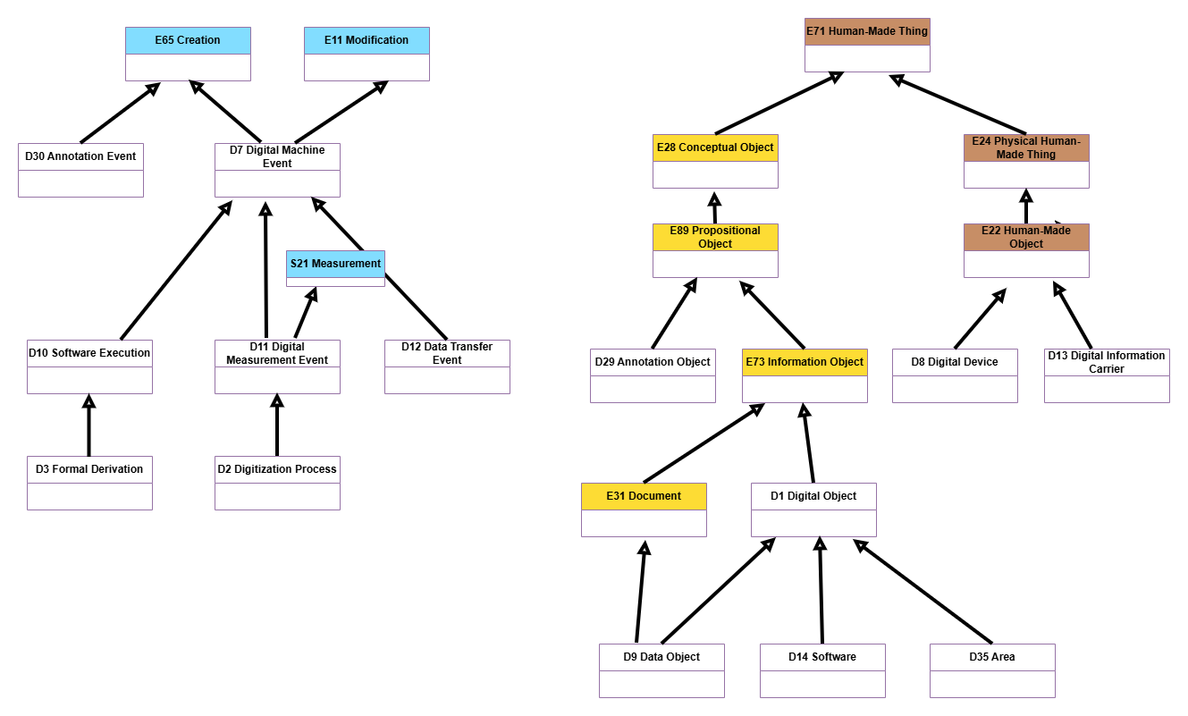
Figure 1: CRMdig V 5.0 Class Hierarchy

Property Hierarchy
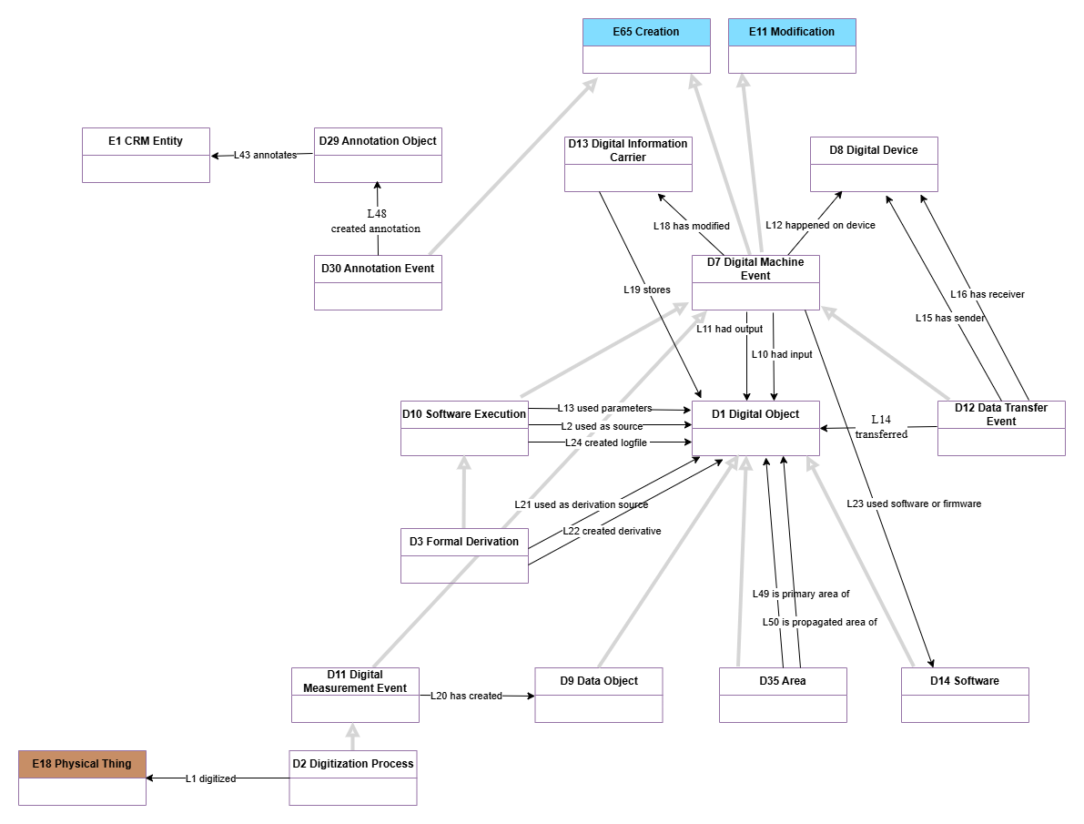
Figure 2: CRMdig V 5.0 Property Hierarchy

CRMdig v 5.0 Class Declarations
The classes are comprehensively declared in this section using the following format:

- Class names are presented as headings in bold face, preceded by the class’ unique identifier;
- The line “Subclass of:” declares the superclass of the class from which it inherits properties;
- The line “Superclass of:” is a cross-reference to the subclasses of this class;
- The line “Scope note:” contains the textual definition of the concept the class represents;
- The line “Examples:” contains a bulleted list of examples of instances of this class.
- The line “Properties:” declares the list of the class’s properties;
- Each property is represented by its unique identifier, its forward name and the range class that it links to, separated by colons;
- Inherited properties are not represented.

D1 Digital Object
Subclass of:
E73 Information Object
Superclass of:
D9 Data Object
D14 Software
D35 Area
Scope note:
This class comprises identifiable immaterial items that can be represented as sets of bit sequences, such as data sets, e-texts, images, audio or video items, software, etc., and are documented as single units. Any change in the bit sequence results in a new instance of D1 Digital Object.
Any aggregation of instances of D1 Digital Object into a whole treated as a single unit is also regarded as an instance of D1 Digital Object.
This means that for instance, the content of a DVD, an XML file on it, and an element of this file, are regarded as distinct instances of D1 Digital Object, mutually related by the P106 is composed of (forms part of) property. In the case of embedded metadata, the documentalist must take care to distinguish the identity of the object including the metadata from the identity of the included content described by the metadata.
A D1 Digital Object does not depend on a specific physical carrier, and it can exist on one or more carriers simultaneously.
Examples:

In First Order Logic:
D1(x) ⇒ E73(x)
Properties:

D2 Digitization Process
Subclass of:
D11 Digital Measurement Event
Superclass of:

Scope note:
This class comprises events that result in the creation of instances of D9 Data Object that represent the appearance (for instance, light reflection properties), form or recorded inner structure of an instance of E18 Physical Thing such as paper documents, statues, buildings, paintings, biological objects etc. Such methods are typically called “imaging techniques”.
A particular case is the analogue-to-digital conversion of audiovisual material.
This class represents the transition from a material item to an immaterial representation of a relevant spatial distribution of local physical properties on the material item (in the case of audio material item, also along the respective sound track)
Subsequent processing steps of the output of digitization processes that preserve or improve the relevant spatial correlations with the digitized object or a part of it are regarded as instances of D3 Formal Derivation.
Examples:
- A mummy CT, a statue scanned, a manuscript page…
In First Order Logic:
D2(x) ⇒ D11(x)
Properties:
L1 digitized (was digitized by): E18 Physical Thing

D3 Formal Derivation
Subclass of:
D10 Software Execution
Superclass of:

Scope note:
This class comprises events that result in the creation of a D1 Digital Object from another one following a deterministic algorithm, such that the resulting instance of digital object shares representative properties with the original object.
In other words, this class describes the transition from an immaterial object referred to by property L21 used as derivation source (was derivation source for) to another immaterial object referred to by property L22 created derivative (was derivative created by) preserving the representation of some things but in a different form. Characteristic examples are colour corrections, contrast changes and resizing of images.
Examples:
- …
In First Order Logic:
D3(x) ⇒ D10(x)
Properties:
L21 used as derivation source (was derivation source for): D1 Digital Object
L22 created derivative (was derivative created by): D1 Digital Object

D7 Digital Machine Event
Subclass of:
E11 Modification
E65 Creation
Superclass of:
D10 Software Execution
D11 Digital Measurement Event
D12 Data Transfer Event
Scope note:
This class comprises events that happen on physical digital devices following a human activity that intentionally caused its immediate or delayed initiation and results in the creation of a new instance of D1 Digital Object on behalf of the human actor.
The input of a D7 Digital Machine Event may be parameter settings and/or data to be processed. Some D7 Digital Machine Events may form part of a wider E65 Creation event. In this case, all machine output of the partial events is regarded as creation of the overall activity.
Examples:
- …
In First Order Logic:
D7(x) ⇒ D11(x)
Properties:
L10 had input (was input of): D1 Digital Object
L11 had output (was output of): D1 Digital Object
L12 happened on device (was device for): D8 Digital Device
L18 has modified (was modified by): D13 Digital Information Carrier
L23 used software or firmware (was software or firmware used by): D14 Software

D8 Digital Device
Subclass of:
E22 Human-Made Object
Superclass of:

Scope note:
This class comprises identifiable material items such as computers, scanners, cameras, etc. that have the capability to process or produce instances of D1 Digital Object.
Examples:
- …
In First Order Logic:
D8(x) ⇒ E22(x)
Properties:

D9 Data Object
Subclass of:
D1 Digital Object
E31 Document
Superclass of:

Scope note:
This class comprises instances of D1 Digital Object that are the result of measurements or other observations and / or their algorithmic evaluation in the form of structured data, such as encoded formal propositions, CSV files (“comma separated values”) or equivalent representations.
If an instance of D1 Digital Object contains the value set of an instance of E54 Dimension, such as the primary data from an instance of S21 Measurement, this association can be documented with the property L61 contains value set of (has value set representation).
Examples:
- …
In First Order Logic:
D8(x) ⇒ E22(x)
Properties:
L61 contains value set of (has value set representation): E54 Dimension

D10 Software Execution
Subclass of:
D7 Digital Machine Event
Superclass of:
D3 Formal Derivation
Scope note:
This class comprises events by which a digital device runs a software program or a series of computing operations on a digital object as a single task, which is completely determined by its digital input, the software and the generic properties of the device.
Examples:
- …
In First Order Logic:
D10(x) ⇒ D7(x)
Properties:
L2 used as source (was source for): D1 Digital Object
L13 used parameters (parameters for): D1 Digital Object
L24 created logfile (was logfile created by): D1 Digital Object

D11 Digital Measurement Event
Subclass of:
D7 Digital Machine Event
S21 Measurement
Superclass of:
D2 Digitization Process
Scope note:
This class comprises actions measuring physical properties using a digital device, that are determined by a systematic procedure and creates an instance of D9 Data Object, which is stored on an instance of D13 Digital Information Carrier.
In contrast to instances of D10 Software Execution, environmental factors have an intended influence on the outcome of an instance of D11 Digital Measurement Event.
Measurement devices may include running distinct software, such as the RAW to JPEG conversion in digital cameras, as an integral part of the overall process. If the respective software is configurable for the device, the event is regarded as an instance of both classes, D10 Software Execution and D11 Digital Measurement Event.
The actual physical properties measured should be documented using the property O39 observed dimension (was observed in): E54 Dimension. Note that the property L20 has created (was created by): D9 Data Object constitutes a shortcut of the full path from D11 Digital Measurement Event through O39 observed dimension (was observed in), E54 Dimension, L61 contains value set of (has value set representation), to D9 Data Object.
Examples:
- …
In First Order Logic:
D11(x) ⇒ D7(x)
D11(x) ⇒ S21(x)
Properties:
L20 has created (was created by): D9 Data Object

D12 Data Transfer Event
Subclass of:
D7 Digital Machine Event
Superclass of:

Scope note:
This class comprises events that transfer a digital object from one digital carrier to another. Normally, the digital object remains the same. If in general or by observation the transfer implies or has implied some data corruption, the change of the digital objects may be documented distinguishing input and output rather than instantiating the property L14 transferred (was transferred by).
Examples:
- …
In First Order Logic:
D12(x) ⇒ D7(x)
Properties:
L14 transferred (was transferred by): D1 Digital Object
L15 has sender (was sender for): D8 Digital Device
L16 has receiver (was sender for): D8 Digital Device

D13 Digital Information Carrier
Subclass of:
E22 Human-Made Object
Superclass of:

Scope note:
This class comprises all instances of E84 Information Carrier that are explicitly designed to be used as persistent digital physical carriers of instances of D1 Digital Object. An instance of D13 Digital Information Carrier may or may not contain information, e.g., an empty diskette.
Examples:
- …
In First Order Logic:
D13(x) ⇒ E22(x)
Properties:
L19 stores (is stored on): D1 Digital Object

D14 Software
Subclass of:
D1 Digital Object
Superclass of:

Scope note:
This class comprises software codes, computer programs, procedures and functions that are used to operate a system of digital objects.
Examples:
- …
In First Order Logic:
D14(x) ⇒ D1(x)
Properties:

D29 Annotation Object
Subclass of:
E89 Propositional Object
Superclass of:

Scope note:
This class comprises objects that make propositions about other artefacts.
Instances of this class are not the attributes themselves, by which things are annotated, but represent the connection between the concepts related in a proposition, and the activities of creation, modification and deletion.
This class is specialized by appropriate subclasses to express more specific relationships between annotated things, such as knowledge object, same as etc.
Examples:
- …
In First Order Logic:
D29(x) ⇒ E89(x)
Properties:
L43 annotates (is annotated by): E1 CRM Entity

D30 Annotation Event
Subclass of:
E65 Creation
Superclass of:

Scope note:
This class comprises activities of creating an annotation in the form of an instance of D29 Annotation Object. These activities typically constitute characteristic parts in scholarly and scientific workflows and processes, often in a dialogue or exchange of opinions between experts.
Examples:
- …
In First Order Logic:
D30(x) ⇒ E65(x)
Properties:
L48 created annotation (was annotation created by): D29 Annotation Object

D35 Area
Subclass of:
D1 Digital Object
Superclass of:

Scope note:
This class describes a part (of any shape or size) of interest in basically any media object stored in the Object Repository, i.e., a text, an image, a video or a 3D model. It points to content consisting of just a portion or area of a file. In some contexts, however, the area can also point to content represented by an integral (i.e., proper) file. It is equal to the METS AREA element.
Examples:
- …
In First Order Logic:
D35(x) ⇒ D1(x)
Properties:
L49 is primary area of (has primary area): D1 Digital Object
L50 is propagated area of (has propagated area): D1 Digital Object

CRMdig v 5.0 Property Declarations
The properties are comprehensively declared in this section using the following format:

- Property names are presented as headings in bold face, preceded by unique property identifiers;
- The line “Domain:” declares the class for which the property is defined;
- The line “Range:” declares the class to which the property points, or that provides the values for the property;
- The line “Superproperty of:” is a cross-reference to any subproperties the property may have;
- The line “Quantification:” declares the possible number of occurrences for domain and range class instances for the property. Possible values are: one to many, many to many, many to one. Quantifications are presented in UML format and in ER format (used by the CIDOC CRM);
- The line “Scope note:” contains the textual definition of the concept the property represents;
- The line “Examples:” contains a bulleted list of examples of instances of this property.

L1 digitized (was digitized by)
Domain:
D2 Digitization Process
Range:
E18 Physical Thing
Subproperty of:
S21 Measurement. O24 measured (was measured by): S15 Observable Entity
Superproperty of:

Quantification:

Scope note:
This property associates an instance of D2 Digitization Process with an instance of E18 Physical Thing which is a material thing.
Full path:

Examples:
- …
In First Order Logic:
L1(x,y) ⇒ D2(x)
L1(x,y) ⇒ E18(y)
L1(x,y) ⇒ O24(x,y)

L2 used as source (was source for)
Domain:
D10 Software Execution
Range:
D1 Digital Object
Subproperty of:
D7 Digital Machine Event: L10 had input (was input of): D1 Digital Object
Superproperty of:
D3 Formal Derivation. L21 used as derivation source (was derivation source for): D1 Digital Object
Quantification:

Scope note:
This property associates an instance of D10 Software Execution with an instance of D1 Digital Object which is used as a source, software essential for the performance.
Full path:

Examples:
- …
In First Order Logic:
L2(x,y) ⇒ D10(x)
L2(x,y) ⇒ D1(y)
L2(x,y) ⇒ L10(x,y)

L10 had input (was input of)
Domain:
D7 Digital Machine Event
Range:
D1 Digital Object
Subproperty of:
E7 Activity. P16 used specific object (was used for): E70 Thing
Superproperty of:
D10 Software Execution. L2 used as source (was source for): D1 Digital Object
D10 Software Execution. L13 used parameters (parameters for): D1 Digital Object
D12 Data Transfer Event. L14 transferred (was transferred by): D1 Digital Object
Quantification:

Scope note:
This property associates an instance of D7 Digital Machine Event with an instance of D1 Digital Object which is the input used to specify the machine action.
Full path:

Examples:
- …
In First Order Logic:
L10(x,y) ⇒ D7(x)
L10(x,y) ⇒ D1(y)
L10(x,y) ⇒ P16(x,y)

L11 had output (was output of)
Domain:
D7 Digital Machine Event
Range:
D1 Digital Object
Subproperty of:
E65 Creation. P94 has created (was created by): E28 Conceptual Object
Superproperty of:
D11 Digital Measurement Event. L20 has created (was created by): D9 Data Object
D3 Formal Derivation. L22 created derivative (was derivative created by): D9 Data Object
D10 Software Execution. L24 created logfile (was logfile created by): D1 Digital Object
Quantification:

Scope note:
This property associates an instance of D7 Digital Machine Event with an instance of D1 Digital Object which is the output of the activity.
Full path:

Examples:
- …
In First Order Logic:
L11(x,y) ⇒ D7(x)
L11(x,y) ⇒ D1(y)
L11(x,y) ⇒ P94(x,y)

L12 happened on device (was device for)
Domain:
D7 Digital Machine Event
Range:
D8 Digital Device
Subproperty of:
E5 Event. P12 occurred in the presence of (was present at): E77 Persistent Item
Superproperty of:
D12 Data Transfer Event. L15 has sender (was sender for): D8 Digital Device
D12 Data Transfer Event. L16 has receiver (was receiver of): D8 Digital Device
Quantification:

Scope note:
This property associates an instance of D7 Digital Machine Event with an object, the D8 Digital Device, which happened with, e.g. a capturing event that happened on/with a digital camera, etc.
Full path:

Examples:
- …
In First Order Logic:
L12(x,y) ⇒ D7(x)
L12(x,y) ⇒ D8(y)
L12(x,y) ⇒ P12(x,y)

L13 used parameters (parameters for)
Domain:
D10 Software Execution
Range:
D1 Digital Object
Subproperty of:
D7 Digital Machine Event. L10 had input (was input of): D1 Digital Object
Superproperty of:

Quantification:

Scope note:
This property associates an instance of D10 Software Execution with an instance of D1 Digital Object used as a parameter during the process.
Full path:

Examples:
- …
In First Order Logic:
L13(x,y) ⇒ D10(x)
L13(x,y) ⇒ D1(y)
L13(x,y) ⇒ L10(x,y)

L14 transferred (was transferred by)
Domain:
D12 Data Transfer Event
Range:
D1 Digital Object
Subproperty of:
D7 Digital Machine Event. L10 had input (was input of): D1 Digital Object
Superproperty of:

Quantification:

Scope note:
This property identifies an instance of D1 Digital Object transferred by a D12 Data Transfer Event.
Full path:

Examples:
- …
In First Order Logic:
L14(x,y) ⇒ D12(x)
L14(x,y) ⇒ D1(y)
L14(x,y) ⇒ L10(x,y)

L15 has sender (was sender for)
Domain:
D12 Data Transfer Event
Range:
D8 Digital Device
Subproperty of:
D7 Digital Machine Event. L12 happened on device (was device for): D8 Digital Device
Superproperty of:

Quantification:

Scope note:
This property identifies an instance of D8 Digital Device used as a medium on which data are transferred through a D12 Data Transfer Event.
Full path:

Examples:
- …
In First Order Logic:
L15(x,y) ⇒ D12(x)
L15(x,y) ⇒ D8(y)
L15(x,y) ⇒ L12(x,y)

L16 has receiver (was receiver of)
Domain:
D12 Data Transfer Event
Range:
D8 Digital Device
Subproperty of:
D7 Digital Machine Event. L12 happened on device (was device for): D8 Digital Device
Superproperty of:

Quantification:

Scope note:
This property identifies an instance of D8 Digital Device used as a medium to receive data through a D12 Data Transfer Event.
Full path:

Examples:
- …
In First Order Logic:
L16(x,y) ⇒ D12(x)
L16(x,y) ⇒ D8(y)
L16(x,y) ⇒ L12(x,y)

L18 has modified (was modified by)
Domain:
D7 Digital Machine Event
Range:
D13 Digital Information Carrier
Subproperty of:
E11 Modification. P31 has modified (was modified by): E18 Physical Thing
Superproperty of:

Quantification:

Scope note:
This property identifies a D13 Digital Information Carrier modified in a D7 Digital Machine Event for storing its results.
Full path:

Examples:
- …
In First Order Logic:
L18(x,y) ⇒ D7(x)
L18(x,y) ⇒ D13(y)
L18(x,y) ⇒ P31(x,y)

L19 stores (is stored on)
Domain:
D13 Digital Information Carrier
Range:
D1 Digital Object
Subproperty of:
E18 Physical Thing. P128 carries (is carried by): E90 Symbolic Object
Superproperty of:

Quantification:

Scope note:
This property associates an instance of a D13 Digital Information Carrier with the instance of Digital Object that is stored on it.
Full path:

Examples:
- …
In First Order Logic:
L19(x,y) ⇒ D13(x)
L19(x,y) ⇒ D1(y)
L19(x,y) ⇒ P128(x,y)

L20 has created (was created by)
Domain:
D11 Digital Measurement Event
Range:
D9 Data Object
Subproperty of:
D7 Digital Machine Event. L11 had output (was output of): D1 Digital Object
Superproperty of:

Quantification:

Scope note:
This property associates an instance of D11 Digital Measurement Event with an instance of D9 Data Object that was created for storing the results, i.e., observed values, of the measurement.
Full path:

Examples:
- …
In First Order Logic:
L20(x,y) ⇒ D11(x)
L20(x,y) ⇒ D9(y)
L20(x,y) ⇒ L11(x,y)

L21 used as derivation source (was derivation source for)
Domain:
D3 Formal Derivation
Range:
D1 Digital Object
Subproperty of:
D10 Software Execution. L2 used as source (was source for): D1 Digital Object
Superproperty of:

Quantification:

Scope note:
This property associates an instance of a D3 Formal Derivation with the instance of D1 Digital Object that is used as a derivation source.
Full path:

Examples:
- …
In First Order Logic:
L21(x,y) ⇒ D3(x)
L21(x,y) ⇒ D1(y)
L21(x,y) ⇒ L2(x,y)

L22 created derivative (was derivative created by)
Domain:
D3 Formal Derivation
Range:
D1 Digital Object
Subproperty of:
D7 Digital Machine Event. L11 had output (was output of): D1 Digital Object
Superproperty of:

Quantification:

Scope note:
This property associates an instance of a D3 Formal Derivation with the instance of D1 Digital Object that is used to create a version of.
Full path:

Examples:
- …
In First Order Logic:
L22(x,y) ⇒ D3(x)
L22(x,y) ⇒ D1(y)
L22(x,y) ⇒ L11(x,y)

L23 used software or firmware (was software or firmware used by)
Domain:
D7 Digital Machine Event
Range:
D14 Software
Subproperty of:
E7 Activity. P16 used specific object (was used for): E70 Thing
Superproperty of:

Quantification:

Scope note:
This property associates an instance of D7 Digital Machine Event with the instance of D14 Software that it used.
Full path:

Examples:
- …
In First Order Logic:
L23(x,y) ⇒ D7(x)
L23(x,y) ⇒ D14(y)
L23(x,y) ⇒ P16(x,y)

L24 created logfile (was logfile created by)
Domain:
D10 Software Execution
Range:
D1 Digital Object
Subproperty of:
D7 Digital Machine Event. L11 had output (was output of): D1 Digital Object
Superproperty of:

Quantification:

Scope note:
This property identifies the logfile that was created by an instance of D10 Software Execution in order to record all the activities in the system.
Full path:

Examples:
- …
In First Order Logic:
L24(x,y) ⇒ D10(x)
L24(x,y) ⇒ D1(y)
L24(x,y) ⇒ L11(x,y)

L43 annotates (is annotated by)
Domain:
D29 Annotation Object
Range:
E1 CRM Entity
Subproperty of:
E89 Propositional Object. P129 is about (is subject of): E1 CRM Entity
Superproperty of:

Quantification:

Scope note:
This property associates an instance of D29 Annotation Object with a relevant instance of E1 CRM Entity explicitly referred to in the annotation object.
Full path:

Examples:
- …
In First Order Logic:
L43(x,y) ⇒ D29(x)
L43(x,y) ⇒ E1(y)

L48 created annotation (was annotation created by)
Domain:
D30 Annotation Event
Range:
D29 Annotation Object
Subproperty of:
E65 Creation. P94 has created (was created by): E28 Conceptual Object
Superproperty of:

Quantification:

Scope note:
This property identifies the D29 Annotation Object (associations) that came into existence as a result of a D30 Annotation Event.
Full path:

Examples:
- …
In First Order Logic:
L48(x,y) ⇒ D30(x)
L48(x,y) ⇒ D29(y)
L48(x,y) ⇒ P94(x,y)

L49 is primary area of (has primary area)
Domain:
D35 Area
Range:
D1 Digital Object
Subproperty of:
E90 Symbolic Object. P106 is composed of (forms part of): E90 Symbolic Object
Superproperty of:

Quantification:

Scope note:
This property describes the association between an instance of a particular D35 Area declared in an original instance of D1 Digital Object.
Full path:

Examples:
- …
In First Order Logic:
L49(x,y) ⇒ D35(x)
L49(x,y) ⇒ D1(y)
L49(x,y) ⇒ P106(x,y)

L50 is propagated area (has propagated area)
Domain:
D35 Area
Range:
D1 Digital Object
Subproperty of:
E90 Symbolic Object. P106 is composed of (forms part of): E90 Symbolic Object
Superproperty of:

Quantification:

Scope note:
This property describes the association between an instance of D35 Area and the instance of D1 Digital Object to which it is propagated.
Full path:

Examples:
- …
In First Order Logic:
L49(x,y) ⇒ D35(x)
L49(x,y) ⇒ D1(y)
L49(x,y) ⇒ P106(x,y)

L54 is same as
Domain:
E1 CRM Entity
Range:
E1 CRM Entity
Subproperty of:

Superproperty of:

Quantification:

Scope note:
This property describes a non-unique identification applied to E1 CRM Entity.
Full path:

Examples:
- …
In First Order Logic:
L54(x,y) ⇒ E1(x)
L54(x,y) ⇒ E1(y)

L61 contains value set of (has value set representation)
Domain:
D9 Data Object
Range:
E54 Dimension
Subproperty of:

Superproperty of:

Quantification:

Scope note:
This property associates an instance of D9 Data Object with an instance of E54 Dimension, in the case that the former contains the set of values of the respective dimension in a digital format.
Full path:

Examples:
- …
In First Order Logic:
L61(x,y) ⇒ D9(x)
L61(x,y) ⇒ E54(y)

Works Cited

