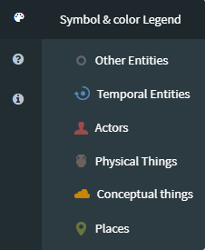

Entity | Element Color | Type Color | Icon
Temporal Entities | #5286b5 | #cce1ea
Actors | #9b4c4c | #e0d3d5
Physical Things | #6b625e | #cec6c0
Conceptual Things | #aa9126 | #efe8bb
Places | #6a753d | #d5e0c6
Other Entities | #cdd1d3 | #656666

RDF Visualizer Example
