596: Supplementary Documentation

Background
Link to issue description.
It’s a new issue the goal of which is to group and present additional documentation on the CIDOC CRM in a way that it is easily accessible.
A number of documents (outputs of resolved/ongoing issues) were identified as falling into this category. For the moment, said documents can be found embedded in issue threads, but they need to be accessed from a central point on the site.

Current state:
Documents (with reference to issue):
- Template for family models doc. (issue 384)
- Example templates doc. (Issue 493)
- Scope-Note Writing Examples doc. (issue 494)
- Translation order proposal doc. (issue 528)
- Best Practices Guide doc. (issue 528)
- Governance Guideline (once it’s ready, now it’s at a very early stage) doc. (issue 528)
- The small edits checklist for CRM and family models (submission form and response sheet)
- An overview of .1 properties per CIDOC CRM version (here) (Issue 571)
- An overview of the properties of the CIDOC CRM the domain and range of which are the same class (doc). (Issue 517)
- information on institutions/projects that use the CIDOC CRM (spreadsheet) (Issue 512)
- information on institutions/people (& contact points) involved in the translation initiative (PM to provide the relevant info) (Issue 528).
- Data Examples (representation of CIDOC CRM instances in RDF) (Issue 471)

Proposal:
The documents fall into five separate types:
- documents relevant for all models, irrespective of their version (1-6),
- documents relevant for one particular version of CRMbase & family models that influence subsequent releases thereof (7),
- documents relevant only for a specific version of CRMbase (8,9),
- documents conveying information on implementations of the CRMbase & family models in projects etc. (10, 11).
- data examples (12)

For type (a): documents relevant for all models, irrespective of their version (1-6)
- Resources\ “Guidelines and Templates” or “Craft Materials” \ “Templates” ^{[1]}
- Template for family models doc.
- Example templates doc
- Scope-Note Writing Examples doc.
^{[1]} “Guidelines and Templates” or “Craft Materials” \ “Templates”: corresponds to new sections on the site, under Resources. The labels are up for debate.
- Resources\“Guidelines and Templates” or “Craft Materials”\“Assisting Translations” ^{[2]}
  - Translation order proposal doc.
  - Best Practices Guide doc.
  - Governance Guideline doc.
^{[2]} “Guidelines and Templates” or “Craft Materials” \ “Assisting Translations”: corresponds to new sections on the site, under Resources. The labels are up for debate.

For type (b): Small Edits checklist
- Home\ “Editorial Issues” or “Editorial Suggestions” ^{[3]}
  - submission form
  - response sheet that the form feeds into
    - Nb.1: the spreadsheet must to be set to “view only”,
    - Nb.2: the names and emails of respondents must not be visible
    - The status of each proposal for editing must also be visible (Resolved, Rejected)

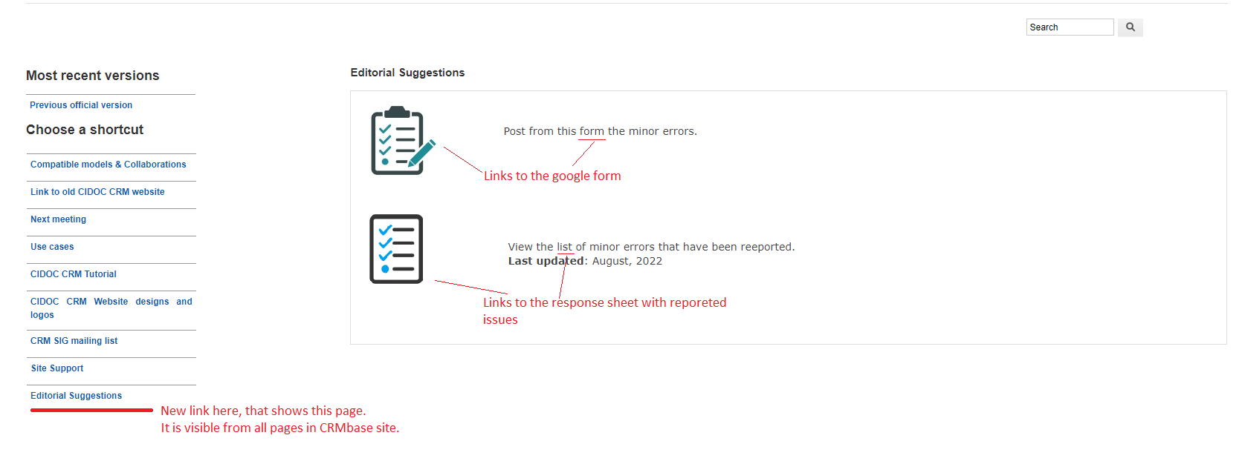
Figure: Mockup for page “Editorial Suggestions”, including links for form submission and list of reported issues.
^{[3]} “Editorial Issues” or “Editorial Suggestions” : corresponds to a new section on the site, under Home. The labels are up for debate.

For type (c): documents relevant only for a specific version of CRMbase
- Resources\Version x.y.z\ Classes & Properties Declarations (stands for supplementary material, i.e., anything that is not the specification document)
  - overview of .1 properties per CIDOC CRM version (here)
  - overview of the properties of the CIDOC CRM the domain and range of which are the same class (doc)
ETz will be extracting both lists for each new version.

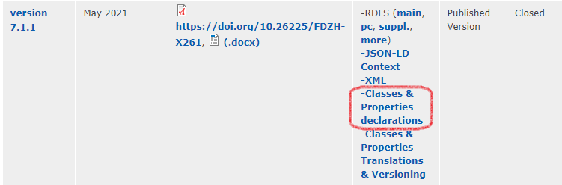
Figure: where the two lists will appear under (v7.1.1 used to indicate position)

For type (d): documents conveying community information
CRM Community Activity Documentation (doc) now sits under The Model\ Use Cases (link), as decided at the 48th SIG meeting. [Issue 512]
It is not compatible with what the Use Cases stand for. It groups information on institutions and projects working using the CRM or have done development work for the CRM. It is not done justice there and the useful information it contains is lost (if one doesn’t know where to look).
Proposal: add a separate link under Community, labeled “Activity Documentation”, and add the spreadsheet there.
Create a Google Form out of the column names and circulate it on a yearly basis (SIG list and other networks) and post updated versions of the response sheet on the site.

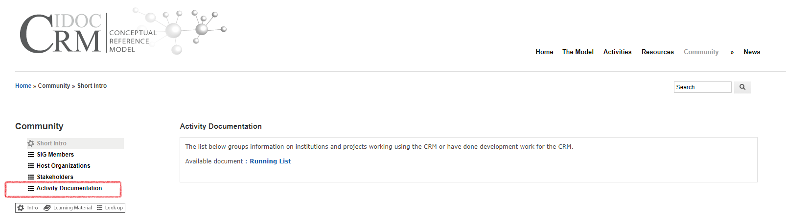
Figure: Activity documentation spreadsheet on the website (mockup)

For type (e): representation of CIDOC CRM instances in RDF
New link “Data Examples” under Resources (Resources\Data Examples) where to add:
- the RDF examples for the Winkelmann graphs (HW by NC for Issue 471), and the graphs used in CRMbase v.7.1.2 as well
- A comprehensive data example for the CRM from the museum Benaki with rich comments about form and contents. [(from the Old site)
Links to Use & Learn \ Methodology (see Issue 601) will also be provided.

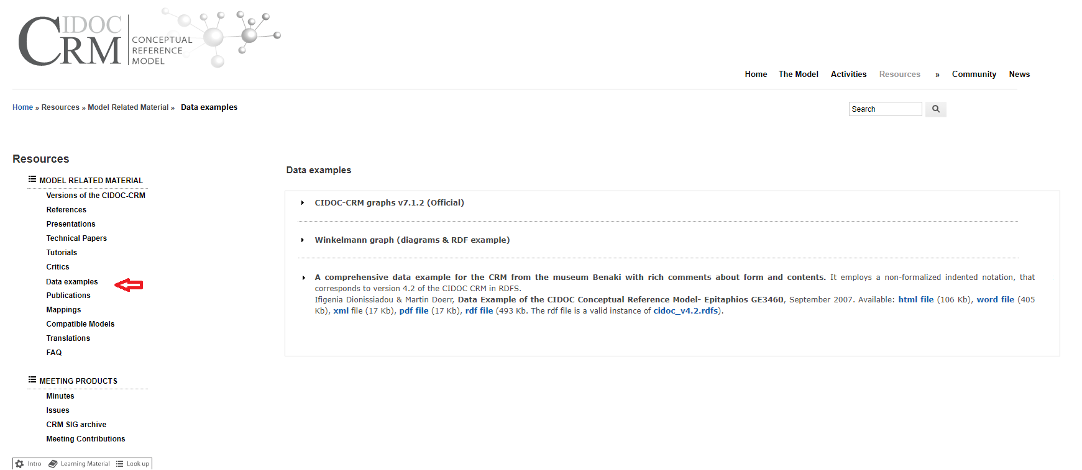
Figure: new link “Data examples” under “Resources”

