Issue 326: Resolving inconsistences between E2, E4, E52 and E92 / Issue 438: proposal to replace E18 isa E92 and E4 isa E92 with properties
CEO walked everyone through the presentation (see below) on alternatives to relations among high-level classes of the CRM to E92 STV. The difficulties of users of CRM to deal with the applicability of E92 STV to the domain of physical things as well as the domain of temporal entities and the resulting mistakes (f.i. positing more than one STVs per object, each corresponding to a separate phase in its evolution/existence), suggested that a revision of the definition of E92 Spacetime Volume is in order.
Specifically, people seemed to have trouble understanding that an instance of E92 Spacetime Volume that is also an instance of E4 Period is never an instance of E18 Physical Thing (and vice versa).
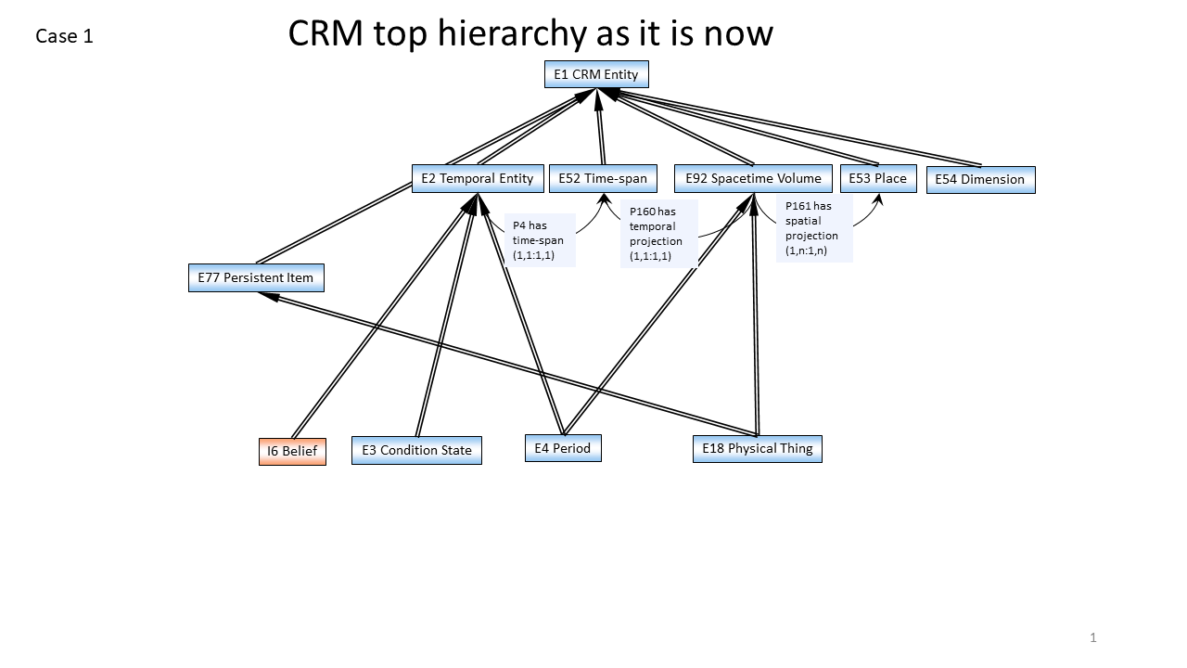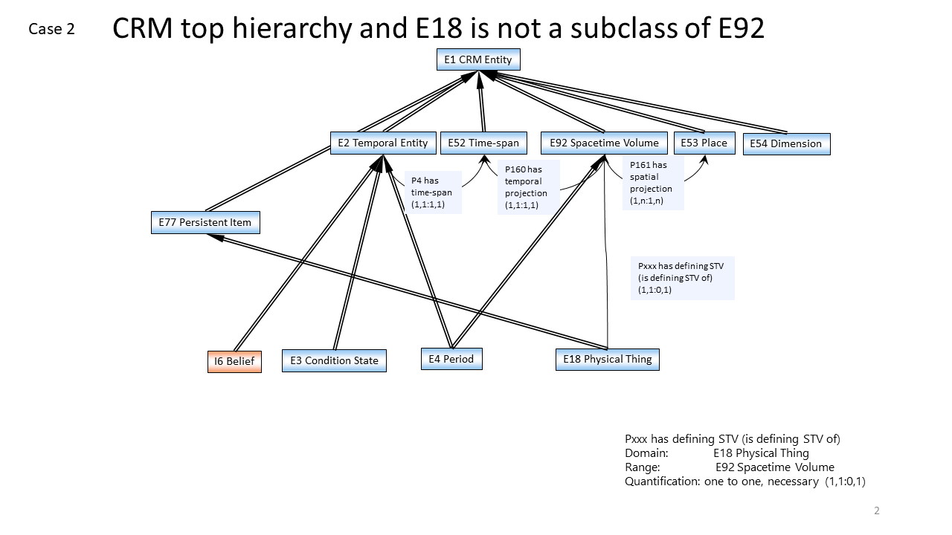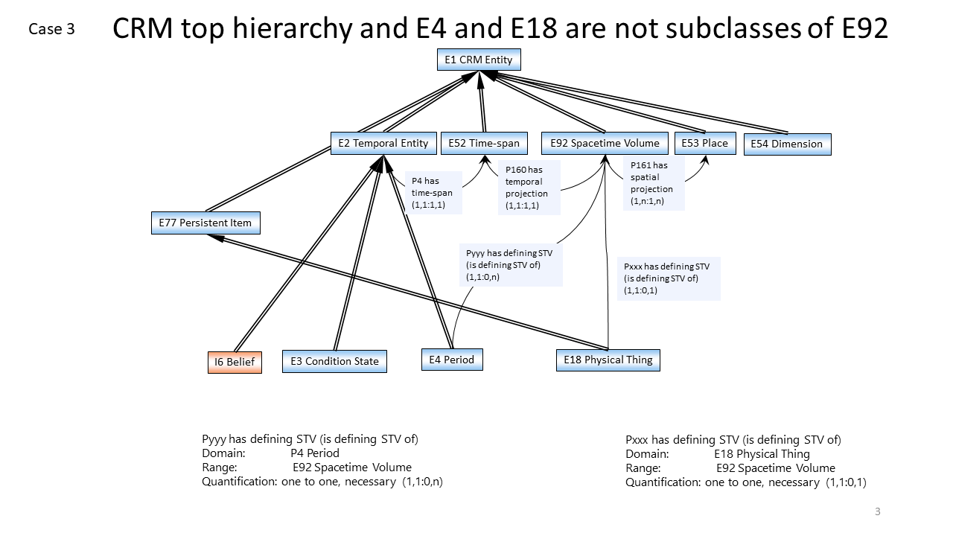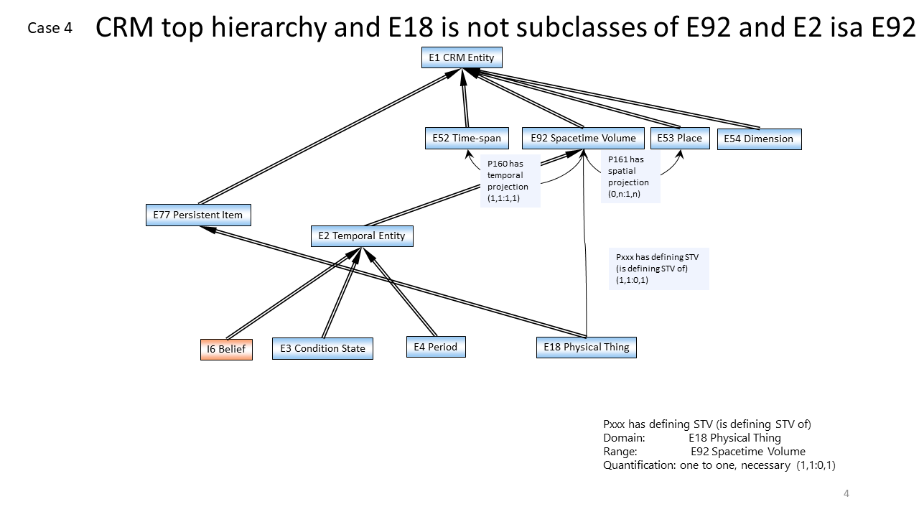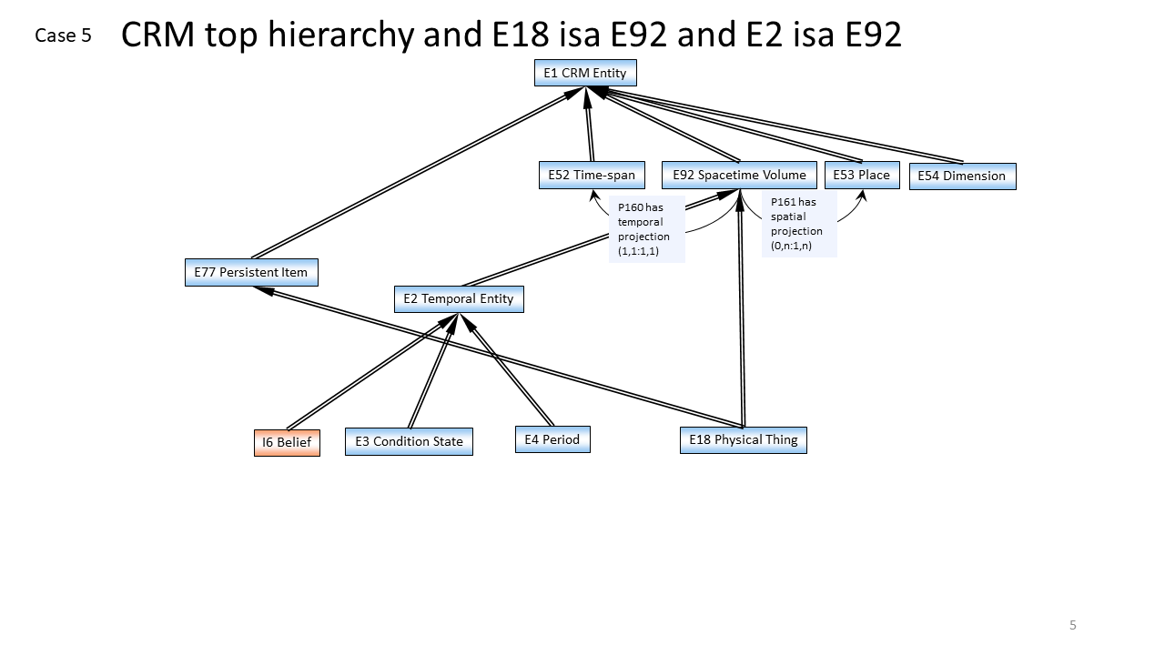

DECISION: Keeping E18 disjoint from E92 is in line with the kind of assertions that can be made for an instance of E18 and an instance of E92 in practice –and also solves the problem of creating unintended models, f.i. when people are tempted to assign temporality to instances of E18.
From this point of view, Cases 2, 3, 4 (but not Case 5) in CEO’s slides can be considered in as preferred alternatives to the current state of affairs regarding the definition of STV in the CRM.
Turning to case 3 (E4 Period isA E2 Temporal Entity; E2 Temporal Entity and E92 STV are disjoint):
Background: Properties linking Periods/Events (isA E92) to their temporal and spatial projections can give the impression that two or more events that happened (approximately) over the same place and at (approximately) the same time actually share a Spacetime Volume. Making E4 Period NOT isA E92 Spacetime Volume serves the purpose of keeping STVs of different events apart.
However, this ‘shared’ STV is false impression; P161 and P160 link the E92 STV that is an event to the approximations of the space and time over which it unfolded. It is these approximations that can be shared (i.e. can almost completely overlap with one another), not the STV as such.
DECISION: Hence, the sig decided that declaring E4 NOT isA E92 (Case 3 in CEO’s slides) is unwarranted.

Turning to case 4 (E2 isA E92 STV):
Even though periods are construed as extending over space, this does not necessarily hold for all instances of E2 Temporal Entity (Beliefs do not have a spatial extent for instance).
DECISION: Hence declaring that E2 isA E92 (Case 4 in CEO’s slides) is also unwarranted.

Case 2: E4 isA E92; E18 NOT isA E92
DECISION: The crm-sig accepted to keep the E4 isA E92, replace the E18 isA E92 with a property and explore the resulting consequences for the model by this change. The relations declared in the Case 2, will appear in the next CRM official version (v.7.0).
According to CEO’s slides, there is need to:
- check the scope-notes of classes and properties mentioning E92 and E18 for inconsistencies with the new structure.
- change the definition for E18 Physical Thing (take out paragraph about multiple inheritance)
- declare a property linking an instance of E18 to its E92:
  - in CEO’s slides:
Pxx has defining STV (is defining STV of) [D: E18, R: E92]
- change the superclass definition for:
  - P46 is composed of (forms part of) [D:E18, R:E18]; it can no longer be a subproperty of P132
    - this also affects its subproperty P56 bears feature (is found on) [D:E19, R:E26]
  - P156 occupies (is occupied by) [D:E18, R:E53]; it can no longer be a subproperty of P161
- declare a property linking instances of E18 to E93 Presence [Pxxx has presence (was presence of) D: E18, R: E93]
- change the diagrams in the introductory section
Comments on CEO’s slides:
- Comments on CEO’s slides Pxx has defining STV (is defining STV of) [D: E18, R: E92]: probably a misnomer –it is not the physical object that gets its identity from the E92 Spacetime Volume; rather the opposite. So property should be labelled: Pxx defines STV (is STV defined by) [D: E18, R: E92]
- P160 has temporal projection [D: E92, R: E52] is identical with P4, if its domain is set to E4 or a subclass thereof.
The issue 326 closed
HW: CEO is to edit the slides accordingly (labels on properties) and send them to Chrysoula (see more in the appendix).
HW: CEO & MD are to go through the revisions proposed by CEO (affected classes and properties, diagrams in the introduction etc.).

Appendix issue 326/438 CE presentations
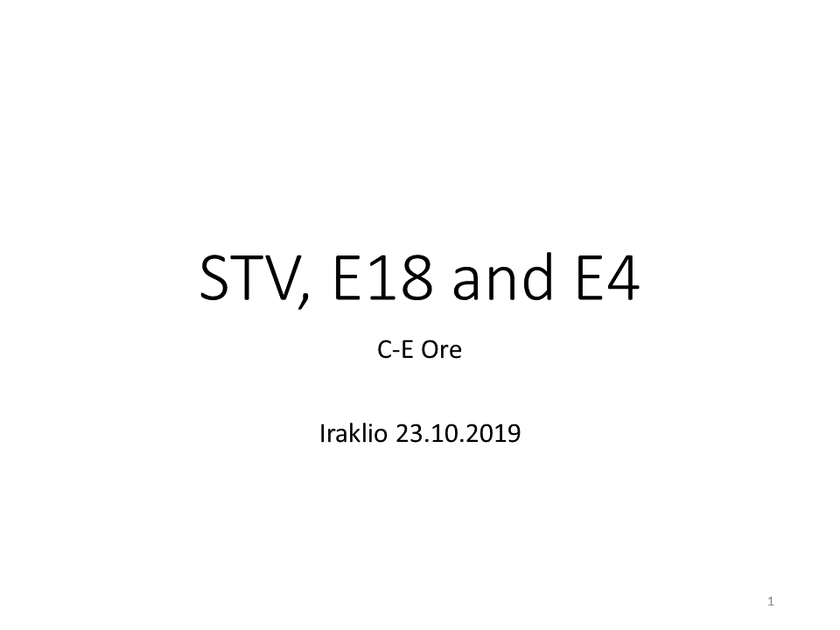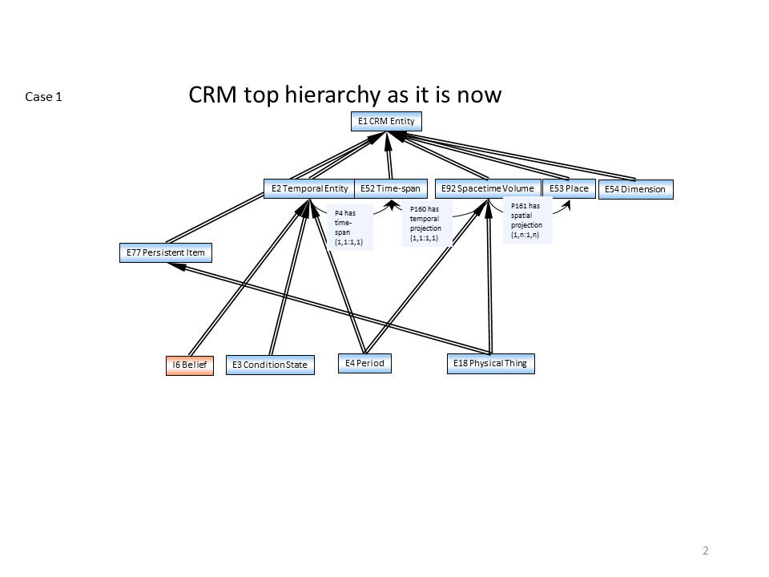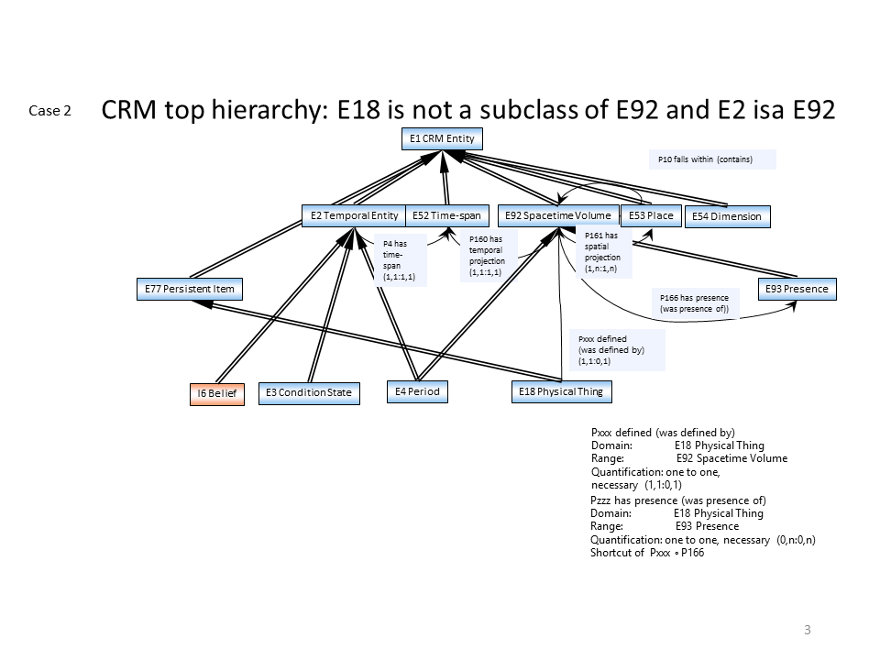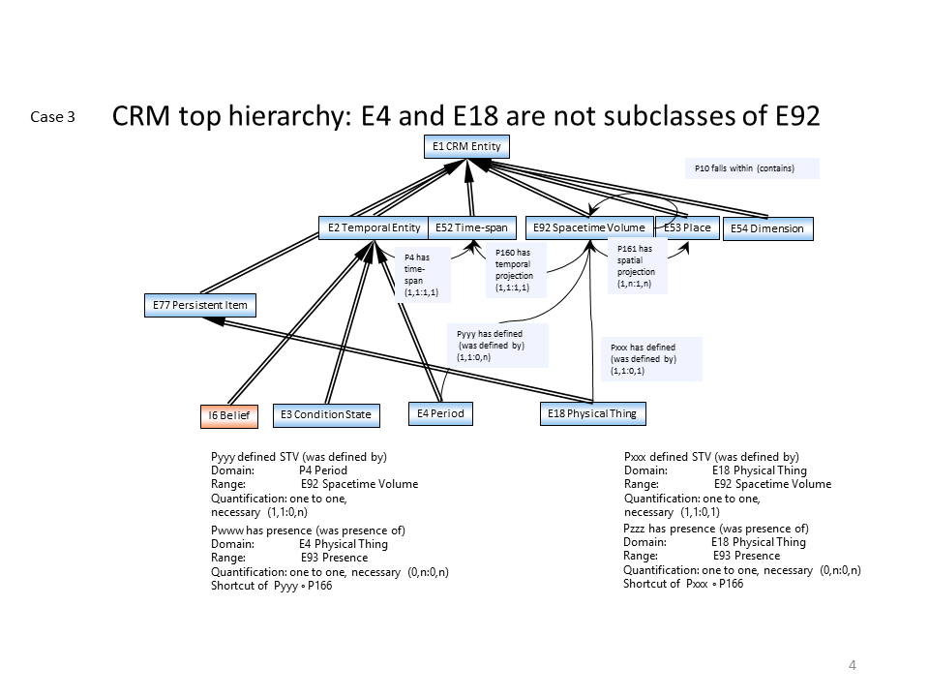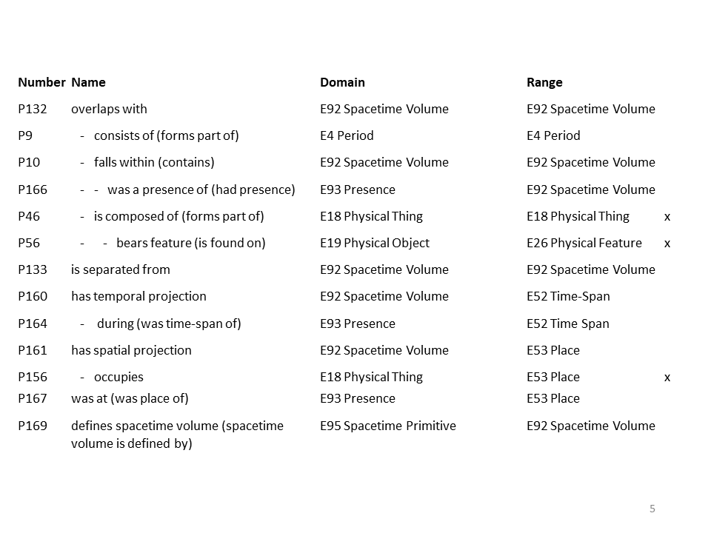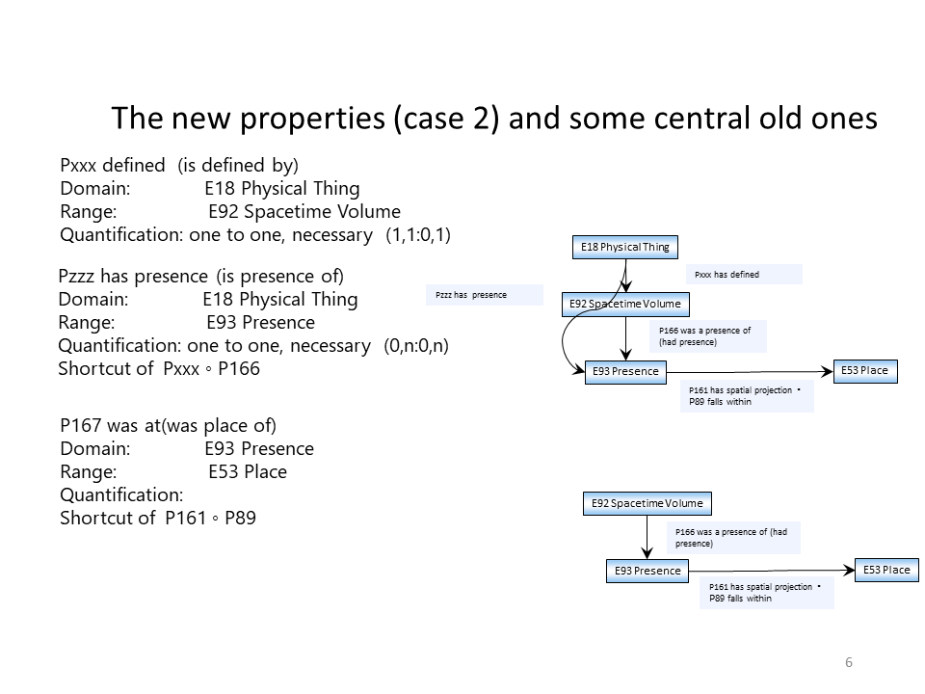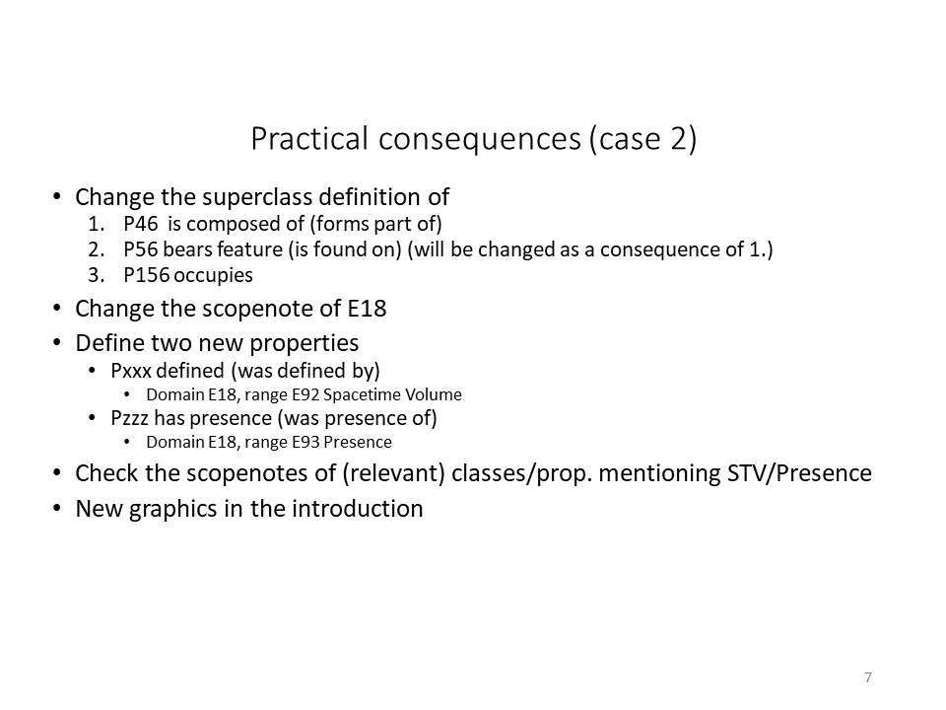

«[…] As the actual extent of an instance of E4 Period in spacetime we regard the trajectories of the participating physical things during their participation in an instance of E4 Period. […]”

