27th CIDOC SIG meeting and the 20th FRBR-CIDOC CRM Harmonization meeting
19 November – 22 November, 2012
Cultural Heritage Agency of Netherlands
(Rijksdienst voor het Cultureel Erfgoed: RCE)
Smallepad 5, Amersfoort, Netherlands

Participants:
1st Day: Chryssoula Bekiari (ICS-FORTH, GR), Patrick Le Boeuf (National Library of France, FR), Martin Doerr (ICS-FORTH, GR), Steve Stead, Mika Nyman, Christian Emil Ore, Tanja Merčun(University of Lubljiana, SI), Maja Žumer (National and University Library, SI), Thomas Wikman, (Delving B.V.),
2nd Day :Chryssoula Bekiari (ICS-FORTH, GR), Patrick Le Boeuf (National Library of France, FR), Martin Doerr (ICS-FORTH, GR), Steve Stead, Mika Nyman, Christian Emil Ore, Tanja Merčun(University of Lubljiana, SI), Maja Žumer (National and University Library, SI), Thomas Wikman, (Delving B.V.), Justyna Walkowska (Poznan Supercomputing and Networking center, PL), Dominic Oldman (British Museum, UK)
3rd Day: Chryssoula Bekiari (ICS-FORTH, GR), Patrick Le Boeuf (National Library of France, FR), Martin Doerr (ICS-FORTH, GR), Steve Stead, Mika Nyman (University of Jyväskylä,FI), Christian Emil Ore, Tanja Merčun(University of Lubljiana, SI), Maja Žumer (National and University Library, SI), Thomas Wikman, (Delving B.V.), Justyna Walkowska (Poznan Supercomputing and Networking center, PL), Dominic Oldman (British Museum, UK), Gerald de Jong (Delving, NL), Peter Andrew (DIGISAM, SE),
Achille Felicetti (PIN PRATO, IT), Sanja Halling (DIGISAM, SE), Rolf Källman (DIGISAM, SE), Cris Kremers (Erfgoed Brabant, NL), Geert Bukkems (Klok & Peel Museum, NL), Stefan Gradmann (HUMBOLDT University Berlin, De), Christian Stein(HUMBOLDT University Berlin, De), Hans Schraven, Gerald Hiebel (UIBK, AT), Oyvid Eide, Günther Görz (FAU, DE), Christina Vona (UCL, UK), Jonathan Whitson Cloud (British Museum, UK), Paola Ronzino (PIN Cyprus, CY)
4th Day: Chryssoula Bekiari (ICS-FORTH, GR), Patrick Le Boeuf (National Library of France, FR), Martin Doerr (ICS-FORTH, GR), Steve Stead, Mika Nyman (University of Jyväskylä,FI), Christian Emil Ore, Tanja Merčun(University of Lubljiana, SI), Maja Žumer (National and University Library, SI), Thomas Wikman, (Delving B.V.), Justyna Walkowska (Poznan Supercomputing and Networking center, PL), Dominic Oldman (British Museum, UK), Gerald de Jong (Delving, NL), Peder Andrew (DIGISAM, SE),
Achille Felicetti (PIN PRATO, IT), Sanja Halling (DIGISAM, SE), Rolf Källman (DIGISAM, SE), Cris Kremers (Erfgoed Brabant, NL), Geert Bukkens (Klok & Peel Museum, NL), Stefan Gradmann (HUMBOLDT University Berlin, De), Christian Stein(HUMBOLDT University Berlin, De), Hans Schraven, Gerald Hiebel (UIBK, AT), Oyvid Eide, Günther Görz (FAU, DE), Christina Vona (UCL, UK), Jonathan Whitson Cloud (British Museum, UK), Paola Ronzino (PIN Cyprus, CY), Pekka Hentonen

Monday 19/11/2012
The SIG started with reviewing the draft text of the FRBR ver. 2.0.
- The name of Pat Riva is added to the editor’s list
- The contributors list is re arranged
- We make changes in 1.1 purposes
- The Introduction will be revised by Maja
- We changed the text in 1.1.10
- We revised the F12 and we decided to add an example to show how talking about a person creates variants about concepts and not individual
- Then we revised the 1.2.2 paragraph, F18 and F35. In F35 we add a note in order to check if something is needed to be changed.
- Mika will give an issue about electronic publishing and F3 Manifestation Product Type
- We changed the scope note of F24
- We discussed about what a scope next will contain and we decided that in a scope note it should be described the following:
- Substance
- Identity condition
- Unity criteria
- Existence conditions
- Discussing about F35, we decided that it should be in CRM in P142 a library example
- We decided to make some structures with graphical overview about some logical units in 2.1 (Patrick will do them)
- Maja will ask about the acceptance of FRBRoo, before the next meeting to have a final form of FRBR 2.0
- We revised the examples in F50
- F51 we changed the scope note and a new example is added
- In F52 we discussed about how we identify an event. We decided to introduce a viaf identifier to the examples
- We revised (i) the scope note and the examples of R8, (ii) section 2.4, (iii) the scope note of R32, R36
- Patrick will make an example for F35
- Maja will add an example in R37
- In R38 we changed the superclass
- An example is needed for F50, we checked the examples.

Tuesday 20/11/2012
- We revised the texts in 1.1, 1.1.2, 1.3, 1.2.2
- The example of Maxwell equations in F50 should be added to E28 Conceptual Object
- Revising the examples in R32 we decided to represent the Name Use Statement by a line that contains the identifier and the ellipsis to represent the Nomen Use statement
- We revised again the 1.1.2, R38 examples, R40,R54, R59 (we need some real life examples)
- Discussing about R60 it is proposed a proposal to be made by Martin about how to describe categorical statements and to introduce in the mapping comments for all categorical statements
- Then we revised the scope notes and examples of R62, R63

Wednesday 21/11/2012
Morning session:
CRM-SIG started the discussion mapping tools. The target of this discussion was about the need of a common reference model. This reference model will include a process model and schema matching.
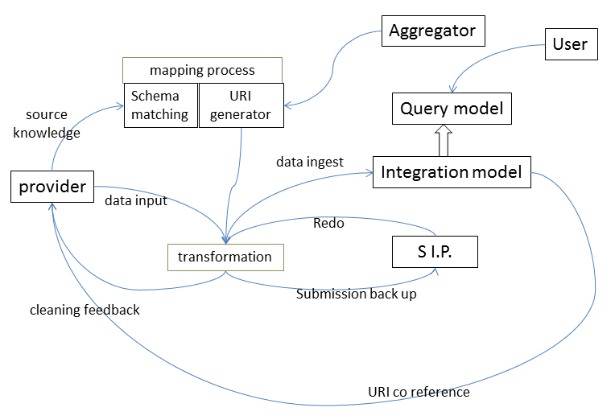

The CRM-SIG decided to create a list of existing tools and a text about the current situation. The list will be created in the site of CIDOC-CRM and Martin will write this text which should be circulated between the attendances of this meeting.
Then Gerald de Jong, Achilles Felliceti from PIN PRATO, Justyna Walkowska , Gunther Georz(wissky project), Douglas Tudhope, and Martin Doer, Eide Eyvind about coreference resolution, made presentations about mapping tools they have elaborated.
The SIG decided that
- the “mapping reference model” should include part of co-referencing, geo referencing and Digital provenance models.
- For those that they are interested to participate in this list to declare their expression of interest along with their available existing resources. Interest for participation in this list expressed so far the following
- Stefan Gradmann, who will represent the DM2E project , Europeana 2.0. and will ask NET7 if they are interested in participating
- Gerald de Jong, who will represent Delving, contributing its SIP Creator
- Christian Emil Ore representing the Uni Oslo
- Achille Fellicetti representing PIN Prato and possibly ARIADNE project
- Justyna Walkowska will ask the Poznan Supercomputing and Networking Center, if they are interested in participating.
- Dominic Oldman, representing British Museum and the ResearchSpace project
- Steve stead representing Paveprime Ltd.
- ICS- FORTH.
- Gerald de Jong will set up a google group.
- To perform a skype meeting every two months and to circulate issues by email
- Initial input to specific modules of common reference mapping model will be:
  - Audience (British Museum)
  - target architecture vision as needed to justify processes (British Museum, Rolf Kallman, Martin Doerr, Christian Ore Emil, Konstantin Baierer), this group will take input from DM2E first
  - process model (DM2E del. as input)
  - component definition (Justyna, tbc)
  - interface formats
  - mapping definition format
  - mapping memory site (Steve Stead)
  - component exchange / coordinated development
Afternoon session:
About English labels in Rdfs form of CRM, we decided that we use English language for the name of the entities and properties and labels ( eg. E55_Type, “Type” ). Also we will denote the backward link only by using the letter r “i” instead of “F/B”.
We discussed the CIDOC – CRM issues
195: Christian Emil Ore will elaborate this issue and will make a proposal to the next CRM-SIG or will send his proposal for vote electronically.
195: It remains pending
199: The scope note needs more elaboration
202: it is pending
204: The issue is done
205: It remains open. Eide, Mika, Gerald Hiebel will prepare a proposal for the next meeting
207: The proposal is accepted, the issue was closed.
208: The issue is closed. The definition of the property, the scope notes and the example are accepted as they are.
209: The issue is closed Dominic Oldman will give an example.
210: the issue is accepted since it is a library practice to register such official transformation.
211: It accepted and closed
212 :Steve Stead will prepare an official answer
213: The proposal was not accepted, the issue is closed
214: The name of the property was changed to “P69 has association with (is associated with)”. Martin Doerr will elaborate the scope note and Patrick Le Boeuf will write an example
215: Patrick will elaborate the scope note. It remains open
216: The SIG decided that the scope note of E7 Activity covers the notion of continuity. Two examples are added to denote the continuity
217: There was a mistake, no issue
218: A text about multiple instantiation is needed
219: P88 deleted, we should check CRM for inverse superproperty relationships. (Christian Emil Ore and Martin Doerr)
Decisions:
- If somebody wants an issue to be discussed in the CRM-SIG meeting, he/she should submit the issues, two weeks before the meeting.
- About the mapping tools, we have to make a special page on the website of CIDOC-CRM presenting the Reference Model on mapping tools presented in the morning session.
- In the site of CIDOC CRM to have a FAQ, instead of the wiki Forum.

Thursday 22/11/2012
- Presentation by Pekka Hattonen.
- They have built their own model partly is based on FRBR. Pekka Hattonen remarked that they have built their own model partially related to FRBR, but the compatibility with CIDOC is not clear. Also, he remarked that ICA has developed its own model. In the following we discussed what they intend to do in collaboration with FRBR, CRM group.
- Martin proposed that the FRBR-CRM group can assist them in methodological issues. The work of CRM SIG address the following :
  - political / functional scope of work
  - clarification of epistemological role of CRM
    - rules, ontology
    - CRM methodology
    - CRM issues
- Then we agreed on the following statements:
- The methodology helps to locate the focus
- Formal ontologies addresses the common world
- We are looking for the elements that are connected and could be part of a story
- It is a method to crystalize the things out
- We try to integrade historical event regardless how they are classified and regardless of their syntactically representation
- Methodology is a key element. It is a knowledge engineering method and it is neutral to each fileld.
- Methodological questions can ask for certain evidence material
- Then Martin presented the practical tips of theory of identity. Then we concluded to the following:
“The principle of abstraction, we produce here is not the principle of disciplinary focus, degree of relevance. It is the existed materials and documents”
- Finally the CRM-FRBR group decided
  - to provide examples of the meeting of Helsinki and
  - to formulate up to the next meeting what are the principle of abstraction?
  - That it is needed a document because of people different perception
- All the participants of the meeting agreed that
  - CRM is a product of KE method
  - KE method is discipline neutral which produces “primary theories” for specific functional discource in human scale, to find what happened to the past. It doesn’t apply to future events
  - Very close to archival world is the provenance documentation.
  - The provenance of information has a historical aspect but it focus to the monitoring from the very beginning
- Then we discussed what will be the focus of collaboration with archives for information integration. We decided that a first formulation should be expressed from the archival world and then to continue. Martin Doerr, Christian Emil Ore, Thomas Wikman, Pekka Hentonen, Feber from digisam will cooperate in order, to bring into life common concepts.
- Then the CRM-FRBR group commented and mapped to CIDOC the presented by Hentonnen archival model.
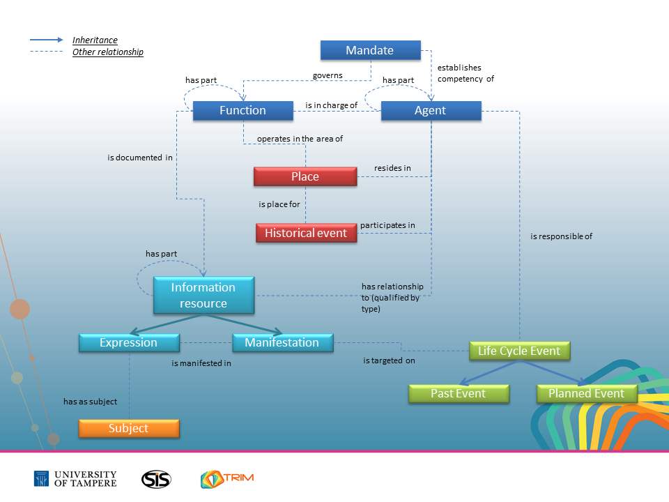
  - Agent = E39 Actor: The word Agent confuses the machines. It is not the appropriate word because is being used widely for many different meanings even for chemical reactors. The proposal is to check the ISO 23081, record management process. We can compare the definition of agent there.
  - Mandate = E29 Design or Procedure
  - Function= It might be categorical, ISAD(F) + read records
  - Historical event =
    - Is place for P7 took place
    - Participants = P11
    - Residence = P74, = P76
  - Is responsible for : stands for what mandate for event type, models the world of patterns of our plan
  - Is regarded of= was present at
  - Is target on = P12
- Then the group proposed the following aspects of a potential approach of developing a model for archives
  - Community function
    - Give advice on modeling constructs to groups … having a learing on
  - Technical function
    - Info integration
    - Cross institutional
    - Cross – disciplinary
    - Trans – disciplinary
    - Via common facts (primary theory)
  - Utility function
    - Categorical
      - Archives may have “museum objects”
      - Museums may have “archives”
      - Answering historical research question
      - Particular : an approach
- Then we discussed about the next meeting
  - We could envisage a scientific observation model
  - Cooperate with coreference working group. It is proposed a letter to be written for cooperation on modeling with this group.
  - We decided the dates for the next two meeting in 2013
    - the first meeting to take place in Stockholm, 4-7 of June with the following agenda
    - One day coreference modeling
    - One day CRM issues
    - One day FRBR issues
    - One day archives
    - The second to take place in Crete (optional Paris) 21st -24th of October.

