31st joined meeting of the CIDOC CRM SIG, ISO/TC46/SC4/WG9 and the 24th FRBR - CIDOC CRM Harmonization meeting
29 September-2 October, 2014
FORTH -ICS
Heraklion, Crete

Trond Aalberg (BIBSYS, NO), Anthi Agoropoyloy (ICS-FORTH, GR), Chryssoula Bekiari (ICS-FORTH, GR), Patrick Le Boeuf (National Library of France,FR), Maria Daskalaki (ICS-FORTH, GR), Martin Doerr (ICS-FORTH, GR), Øyvind Eide (Universität Passau, DE), Akille Felicett (PIN Prato, IT), Mark Fichtner (German Library), Gerald Hiebel (ICS-FORTH, GR), Gerald de Jong (Delving, NL), Siegfried Krause (GNM, DE), Richard Light (UK), Carlo Meghini (CNR,IT), Dominic Oldman (British Museum, UK), Christian Emil Ore (Unviversity of Olso, Norway), Manolis Peronakis (IONION University/NDC GR)), Aline Le Provost (ABES , FR), Pat Riva (Bibliothèque at Archives nationales du Québec, CA ), Paola Ronzino (PIN Prato, IT), Michalis Sfakakis (IONION University/NDC GR), Richard Smiraglia (University of Wisconsin Milwaukee, USA), Steve Stead (Paveprime, UK), Maria Theodoridou (ICS-FORTH, GR) Maja Žumer (National and University Library, SI)

Monday 29/9/2014
Christian Emil started with update of CRM-SIG about the meeting in CIDOC 2014.
He said about the tutorials that have been presented at CIDOC 2014 conference in Dresden at Sunday 7/9. These are the CIDOC CRM by Christian Emil, The CRMsci model and the CRM Archeo by Chryssoula Bekiari, Synergy model by Dominic Oldman, Also a CRM-Sig meeting have been taking place on Monday 8/9/2014.
The current situation of CRM family models presented at the CIDOC Board meeting are:
1 ) FRBRoo 2.0, endorsed by FRBR Review Group and the CRM-SIG
2) PRESSoo endorsed by FRBR Review Group and the CRM-SIG
3) CRMarcheo ongoing work: (compatible extension of CRM)
4) CRMsci ongoing work: (compatible extension of CRM)
5) Strategy for data provision, ongoing work: endorsed by CRM-SIG as in the scope of the objectives of CRM-SIG.
Christian-Emil informed the CIDOC Board
- that the FRBR Review Group recently endorsed (1) and (2) models as valid ontologies for semantics relations in descriptions provided by libraries.
- The European Research Infrastructure Project ARIADNE for archaeology has proposed a draft extension of CIDOC CRM for complete representation or archaeological excavation records: CRMarcheo (Shortly presented in the conference). This model was briefly presented in connection with the presentation of the observation model and is under review by the CIDOC Archaeological working group and CRM-SIG, being harmonized with CRMSci.
- CRM-SIG approved that the development of CRMSci and its exsention CRMarcheo into CRM compatible ontologies is in its scope. The harmonization of the two models will be a part of the development of version 6 of CIDOC CRM CRM-SIG. The goal is that CRMSci and CRMarcheo will become a model recommended by CIDOC.
- CRM-SIG approved that the development of SYNERGY is in its scope. A reference model like SYNERGY is a prerequisite for effective use of the CIDOC-CRM. The goal is that SYNERGY will become a reference model recommended by CIDOC

Then we started the FRBR issues:

R14 incorporates.
There was a problem with superproperty E89 Propositional Object. P148 has component (is component of): E89 Propositional Object. We commented that both superproperties are problematic and we decided that “ Incorporation” means piece of information having different provenance and it should be either a CIDOC CRM property or to redefine the P106. We will accept that R14 is a subproperty of P106 only. Finally we decided to add to the CIDOC CRM a new property, P165, with E73 Information Object as its domain. For this new property it is needed to be modified the scope note and examples for R14/P165 (by PLB)

R57 is based on (is basis for)
We updated the scope note and the examples and we added a shortcut

R65 recorded aspects of (had aspects recorded through)
We updated the short cuts by substituting the superclass (E2 Temporal Entity) with the specialized class (E3 Condition State) and the scope note.

R60 used to use language (was language used by)
We discussed about the subproperty and we changed to ‘short cut of’ and we decided that it is needed to be related with collective activities. Since the Pursuit in FRBRoo is a collective activity. Then we brought up examples of collective activities such as ‘the production of coins’ which consists of a series of production events.
The discussion about collective activities was postponed. We decided to cut off the improvements and to finalize the current version, since the approval by IFLA does not depend on this issue.

R61 occurred in kind of context
We interpreted this context as the pursuit. The name use activity is part of pursuit, one actor may have more than pursuit, and so we need to make the scope note more specific. This is not a subproperty of anything in CRM. So we need only a shortcut.

R62 was used for membership in
We added a shortcut and we deleted the first example.

Highlights in “3.5. FRAD to FRBROO Mappings”
We reviewed the remaining highlights in pages 130 (section 4.3 / 4.4 ), 132 (section 4.7 ), 133 (section 5.4.1, 2, 3, 4/5.4.1,3,4/5.4.3), 134 (section 5.5), 135 (section 5.3.7). The section 5.5 elaborated more by PAT and discussed next day in the morning

Approval by IFLA
The FRBR-CRM sig decided the version 2.1of FRBRoo to be submitted for approval by IFLA.

FRBRoo-Core
The FRBR-CRM sig discussed about the formulation of FRBRoo Core and decided that the FRBR CORE should include formulation of direct relationships between propositional object-performance and performance plan. Patrick should elaborate this proposal.

FRBRoo Primer
The FRBR-CRM sig discussed about the usefulness of the creation of the FRBR primer . The target audience of such document will be the designers and implementers of library systems. Dominic Oldman will prepare a draft document for the FRBR primer.

FRBRoo tutorial
Anthi Agoropouloy presented the progress made on the FRBRoo tutorial . The FRBR-CRM sig decided that this a different issue from FRBRoo Primer. The tutorial should inform the target audience about the details. Maja, Pat, Aline and Christian – Emil will review and help Anthi in preparing the examples and texts for the tutorial. Maja and Pat will give in a month a document about the bibliographic universe. Also Trond and Maja will send to Anthi the EDM-FRBR example. Steve proposed an extra subject related to the implementation. Also it is mentioned that we need text about ER models.

Collective activity from archives
Then we reviewed the last minutes from Hague meeting about the collective activity.
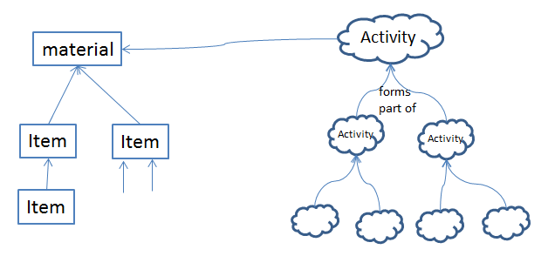
In order to facilitate the full understanding of Unit Date in archival practice it is felt that we should examine the idea of collective activities.
Initially 3 distinct ideas for possible Class definitions emerged:-
1. A supra-activity that gathers together a number of activities that have a unity of purpose, i.e. making objects of a particular type, minting coins, the performances of a run of a theatre production
2. The collecting of the results of a series of activities where the unity criteria is determined by the performer of the activities
3. The collecting of the results of a series of activities where the unity criteria is determined by the collector of the results of the activities
The approach will be to consider proto-typical use cases for each and look for multiple examples to check that these potential classes form an adequate coverage of the cases discovered. This should then allow the production of scope notes that capture the nature of these and any other classes that are identified as necessary.
The FRBR- CRM-SIG decided to that the domain – range should pertain to the collection time??
Christian – Emil and Stephen Stead will try to find examples or categories for this collective activity.

Next meeting
Dominic Oldman will send a pointer to Oxford group

Lists merging
The FRBR-CRM and the CIDOC – CRM sigs decided to merge the lmailing lists crm-sig@ics.forth.gr and frb-crm@ics.forth.gr

CRM issue 261
The CRM-sig discussed about asking for didactic material and how to find a mechanism to release materials easily and then to improve those.
Dominic Oldman presented the “CRM primer” for approval . The crm-sig endorsed it as a didactic material. Future improvements may follow.
Christian Emil and Dominic will collaborate in further versions to CIDOC Primer. Martin will send it to FRBRoo list. Dominic will submit the version1.2.

Twitter account
Dominic will set up a twitter account on behalf of crm-sig.

ISSUE 199
The scope note of P152 has been updated. Christian Emil, Eyvind, Steve Stead will map ULAN association roles and present to next crm-sig. Then we see the mismatches. Christian Emil will give an example by tomorrow.
Then we discussed how to deal with roles:
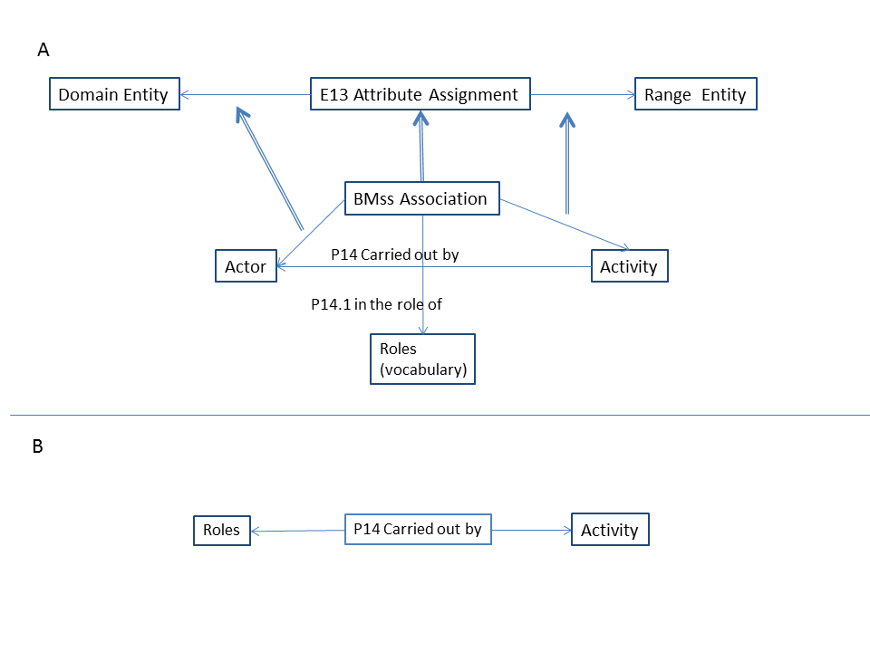
Figure 1
By using reification we must (a) control vocabularies (b) make mapping to CRM properties (c) in the case we have to model properties of properties we may reify the property as a class and then the property of property as a regular property (Figure 1.B)

ISSUE 227
Discussing this issue we decided to introduce a property P165 incorporates (is incorporated in) in the CRM with domain the E73 Information Object. The scope note and the examples of this new property is based on the R14. The scope note also of E73 should be modified. PLB will make the appropriate changes to it.

ISSUE 230
MD presented the new text for the scope note for E91 which includes references to the use of URI. Øyvind Eide will refine it.

ISSUE 234
Discussing this issue, we decided,
(a) to put a new issue if the E92 and E93 should be merged
(b) examples added in P157, also the name has been changed
(c) the scope note of P158, P159 and E4 has been changed
(d) then the sig assigned to Øyvind Eide to refine E4 and check the cardinalities of P4. In the case that we accept in the scope note P158 that “… Therefore it cannot be verified, if two different instances of E4 Period occupy exactly the same space time volume. We therefore determine that a spacetime volume may only be occupied by one instance of E4 Period.”
Then the quantification is (1,n:0,1).

Tuesday 30/9/2014

Mappings FRBRoo to FRAD and FRSAD
We started with the section 5.5 with mappings of FRAD and FRSAD. The changes have been added to the document.

Inheritance in F15 Complex Work -> R10 has member -> F1 Work
Then we discussed about inheritance and the scope notes for the chain F15 Complex Work -> R10 has member -> F1 Work. Trond suggested that this is a specialization of E89->P148->E89, but he noted that this is not correct.
The scope note of P148 is rather specifically defined as a structural part-of relationships. When this is inherited in R10 it implicitly includes both alternatives and component relationships (as described in the F15 scope notes). This imho means that a statement made by the use of F15->R10->F1 is not necessarily valid/meaningful if "cast" to the super type-based expression E89->P148->E89. Trond made suggestions for changing the scope notes. The group discussed them but finally the FRBR-CRM sig decided that the issue is more complex. The group left the F1, F15 as they were, since the problem is to distinguish between component, members and other alternatives of work in particular with respect to serial works as well as complex work.
Finally we made minor revisions to the scope note of F1 and F14, F15.

Synergy Model
Then we started the synergy reference model. The following presentations took place
- Component demonstration 3M (Theodoridou),
- Narthex, Source Analyzer(Gerald de Jong)
- SYNERGY – overview (Martin Doerr)
- X3ML and RML by Carlo Alloca
We continued with discussions
(a) on how to don’t create blank nodes (URI),
(b) how to introduce in X3ML if /then functions, regular expressions- if we want to decompose values we need regular expressions – hidden schema in the fields when we have regular expressions.
(c) Martin proposed that all the intellectual information to be complete and transparent.
We continued with presentation by Martin Doerr ‘The SYNERGY Reference Model of Data Provision and Aggregation’. There were comments that maybe the small museums decide to be represented by an agent.
Martin proposed in the scenarios of collaborations that we have to describe to include a role of the user that provides feedback. Also we discussed that the aggregator can play a broker role and in the next version the kind of interaction should be analyzed.
Then discussing about process hierarchy, the co reference resolution came into light. Konstantina proposed to be included in the ingest process. Steve commented that the
The coreference is part of metadata validator and proposed that we need to know how the metadata is transformed.
Discussing if we should include the co reference resolution in this model or if we leave it out, we decided that we may refer to those but we will not analyze any further, just only for the first version.
Then discussing about update processing, Dominic said that a messager is needed for each module of this process. Konstantina will look for interface requirements for work flow managers.
Then we discussed about minimal requirements of 3M editor – how to visualize source and target schema and interaction functionality about 3M editor – it is needed to be defined a complete set of functions.
Achilles will contribute with software w components fitting to reference model.
Dominic will make a page what it is needed and will send an invitation to volunteers – to inform open community about our intentions. Steve, Christian Emil, Achille will take part in the editing of the documents.
Then we continue with Europeana Task Force. The subject would be data provisions and aggregation. We could probably succeed to invite DPLA. It could be a CIDOC document, we could make a recommendation to the community. It will be two or three meetings to Europeana. Martin, Dominic, Achille, Thomas will discuss with Antoine

Wednesday 1/10/2014

Formalization of CRM
We started with Martin to justify why we didn’t find a common language with Erlagen team about owl implementation. This may be happen because there is no formalization of the CRM.
Then Carlo Meghini presented some formalization about disjointedness, short cut semantics, metaproperties, etc. We conclude that
(a) the semantics of CRM follow the open world assumption,
(b) the E1 is a subclass of owl:thing since we have numbers and strings that are not part of E1 CRM Entity. We have to have a list of primitive types and to provide mapping to the primitives that owl provides. We have to check in the scope notes which classes are subject to implementation.
(c) there are no data type that covers mathematical real numbers.
(d) we need to have something for integration. We need to have a list of primitive types and provide mapping to the primitives that owl provides.
(f) The ISO standard does not define the implementation. We posted an issue that for each primitive types we should make a logical model and we should revise the scope note of E59. In order to satisfy interoperability, we need to have a common format. How we can transform without loss of meaning. The question was “can we create an owl equivalent to CRM or not?” We need to formulate the data types. We decided to revise the primitive values (CEO, MD, Mark Fichner, PLB).
(g) We need to decide which are object properties and which are data properties. URI can be appellations in the sense of CRM. Not all the names are strings. A text is needed about what we can implement in owl. A revision of appellations by librarians is needed. Data property is not symmetric.
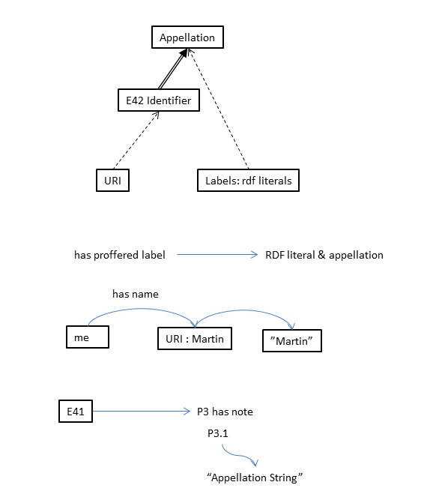
(i) If a shortcut results from a deduction, it is problematic. It is needed to be defined under what conditions the shortcuts of CRM are strong. Mark Fichner will help Carlo in the next steps. A proposal is to do not write statements in owl that contradict alternatives
(j) Then Carlo Meghini presented "Ontologies and Knowledge bases" . We decided that all statements have a provenance of knowledge since the systems are made for scientific knowledge.

ISSUE 234
Then we continue with this issue in order to resolve the quantification of P4. For having an activity with two parts, we shall have examples as shown in the next figure.
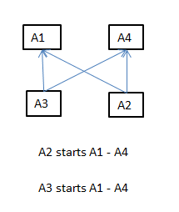

Steve said as an example the coronation of a king, and the death of a king.
Finally we decided to made no changes to quantification of P4. Martin, Steve and Gerald will re write the scope note of P4 and P158 taking into account the equality of time spans and space time volume about causally related events.

ISSUE 235
Resolving this issue, the sig accepted Martin’s Homework; the scope note of P9 has been rephrased in order to include space–time, and to be consistent with phenomenal space /time. Also we add the superproperty. The issue remains open.

ISSUE 236
In the frame of this issue the CRM-SIG decided that:
(a) a documentation about CRM family models is needed. This is should be in a central place in the website. Barry and Mark Fichner will work on this.
(b) the SIG should invite for integrated extensions. Steve will write the process which should be uploaded to the cidoc - crm site. This document should include (a) invitation for extensions (b) what is the procedure (c) what is the current situation.

ISSUE 238
The scope note of P89 has been changed. The issue remains open.

ISSUE 245
Resolving this issue we decided
(a) P81a, P81b, P82a, P82b should be added to the rdf implementation of CRM with the sense that where a range of dates is provided the “a” in the P81a and P82a will represent the upper bound of a time-span, while the “b” in P81b and P82b will represent the lower bound.
(b) CRM needs no other modelling of states. In CRMSci, there will be a refined model of states.
The issue is closed.

ISSUE 246
Resolving this issue, we changed the second example. The issue is closed.

ISSUE 247
Resolving this issue the sig decided that no action required. Coincidental aggregations of things can be modelled by enumeration with respect to environment or context, and need not be assigned to an individual persistent identity as a whole. The issue is closed.

ISSUE 252
Resolving this issue, the sig decided that named graphs should be regarded valid cases of E73 Information Object. Concept will be dealt with in CRMInf. An example about AAT as LoD has been added to E73. Martin Doerr with George Flouris will check the consistence of it with FOL.

ISSUE 253
Resolving this issue, the crm - sig changed the scope note of E70 Thing to the following:
"This general class comprises discrete, identifiable, instances of E77 Persistent Item that are documented as single units, that either consist of matter or depend on being carried by matter and are characterized by relative stability.
They may be intellectual products or physical things. They may for instance have a solid physical form, an electronic encoding, or they may be a logical concept or structure."
The issue is closed.

ISSUE 255
Reviewing this issue decided that FAQ on shape and color required.

ISSUE 256
The sig decided that we should Collect examples of vocabularies and consolidate and map them to CRM. CEO will send examples.

ISSUE 219
Continuing review of the issue 219, we changed the subproperty of P130 to the inverse.

ISSUE 249
Resolving this issue the sig decided that this is a viewer problem. No action from SIG required. The issue is closed.

ISSUE 259
The sig resolving this issue revised the scope notes P128, E84, domain of P128 updated. The issue is closed.

Thursday 2/10/2014

ISSUE 240
Resolving this issue, the sig decided to define a property P166 of E90 that allows to specify which interpretation of the symbols in an E90 provide identity to the content represented by some carrier or content encoding, not only an E62, such as “latin alphabet and punctuation symbols” “words of the English language”. Also it is needed to be defined a Symbolset and to expand scope note of E90 to define “content representation” , a sort of “representative Item”.
Christian Emil will elaborate the E90 and P166.

Procedure for endorsement standards / support for work of CRM SIG
At this point we had short discussion about a procedure for endorsement of standards / support for work of CRM SIG .
Christian Emil Ore points out that
- the FRBRoo ver. 2.0 and PRESSoo do require formal endorsement. They are the responsibility of the International Working Group on FRBR/CIDOC CRM Harmonization, which is composed of members of the IFLA FRBR Review Group and the ICOM-CIDOC CRM-SIG. The FRBR Review Group recently endorsed both models as valid ontologies for semantics relations in descriptions provided by libraries, while the CRM-SIG endorsed the two models in April 2014 as compatible extensions of CIDOC-CRM.
- The CRMsci, CRM archeo and SYNERGY model are “work in progress”, so formal endorsement is not needed at this stage (though the groups working on the harmonization may need a letter of support from the CIDOC Board )
The above situation raises the need for a clear operating procedure that will allow CIDOC to endorse normative documents developed by its working groups. At present, a decision by the AGM (Annual Group Meeting) is the only formal mechanism though which CIDOC as a whole can make an endorsement. The board feels that it would not be appropriate to vote at the Dresden AGM on these questions. A decision taken in this way would be ill-informed and would lack credibility. Thus taking into account that :
- IFLA is developing its own procedure for the formal endorsement of IFLA standards.
- Günther Görz has suggested that any procedure put in place needs to be light-weight and relatively swift. He recommends the model used for W3C recommendations which has the advantage of making key documents available for use very quickly.
- Susanne Nickel has proposed an outline procedure for accepting normative documents
Combining the advantages of these approaches results in the following procedure:

Step 1: A CIDOC working group develops as normative document which it considers to be worthy of publication. The document is released by the WG, under its own authority, as a “Working Group draft recommendation”.
Step 2: At some point it becomes clear to the WG that the draft recommendation is relatively mature, stable and is being used. The WG makes the case to the CIDOC board that the document should be submitted for acceptance as a CIDOC recommendation. If the board agrees, the document becomes a “CIDOC draft recommendation”.
Step 3: The CIDOC board organizes a ballot of the CIDOC membership. This ballot period lasts several months. During the ballot period, CIDOC members are invited to vote on whether the draft document should be recognized as a CIDOC recommendation and to submit comments.
Step 4: At the end of the ballot, the CIDOC board decides on whether or not to accept the document (on the basis of stability, maturity and acceptance by the community). The document then becomes a “CIDOC recommendation”.
Step four is the final step. The board agrees that CIDOC will issue “Recommendations” rather than “Standards”. Submission to ISO is the preferred mechanism for the preparation and adoptions of standards.
The CIDOC board accepts this outline procedure while noting that it requires further elaboration.
Expressed in terms of this foregoing, we are now at Step 2 with respect the CRM SIG request. The CRM SIG has effectively released FRBRoo 2.0 and PRESSoo as WG draft recommendations and is now requesting formal endorsement so that they become CIDOC recommendations.
The board agrees to this request. FRBRoo 2.0 and PRESSoo thus have the status of CIDOC draft recommendations. This decision initiates the process for these two models to become CIDOC Recommendations. The board will submit the two draft documents for ballot by the CIDOC membership.

About modularity of CRM- family models
We discussed about the modularity of crm family models. We argued that we have two models the original and the projectional model. We discussed about formulation of modularity of the extensions, and how to encode and define consistency that an extension may introduce a new class between two classes of another module, Carlo Meghini and Martin Doer will work on this subject.
A new issue is “how do we talk about the crm and its extensions and what we regard them as ontology and how to distinguish them, part of ontologies or different ontologies. Maria Daskalaki will elaborate this issue.

CRMinf
Then Steve Stead presented the CRMinf. During this presentation we discussed the following items.
- Belief adoption (I7) is a scientific citation, Carlo Meghini will send a paper about this
- Belief (I2); the logic of initiation and ending of a belief should be in the introduction. It should be part of the practical or theoretical scope.
- The proof function is implicitly
- Martin and Maria Daskalaki will write something about empirical science in order to be included in the introduction
- We accepted that collecting all the knowledge is a manual task and human perception is not the same with the machine
- Discussing about I5, We decided to add something about knowledge dependency by MD and Steve
- Discussing about I6, we argued about the appropriate super class of I6, should be the E59 Primitive or something else? This is under consideration.
- Discussing about I7, we wondered about if trust is a parameter of belief adoption? We decided to think about this and to investigate if a more relax notion should be developed.
- In J6 we accepted that a property is needed showing the source of the belief adoption. Steve will elaborate it.

Administrational issues
The CRM-SIG appointed two deputy chairs of CRM-SIG Christian-Emil Ore and Dominic Oldman.
The next meeting after Oxford will be in Nuremberg, May from 18 to 21st 2015.

About the owl version of Erlagen CRM
This version now is in hands of Germaniche National Museum (WISSKI project). They will expand the old owl version with a new version. For official recommendation of crm-sig approval, a list of features that are different is needed for open discussion about any ontological implications may exist.

CRMarcheo
- Martin made a short presentation . Achille and Paola will improve the scope notes.
- The status of the document is a draft under revision by Gerald Hiebel .
- Gerald will communicate with EH-CRM Keith May. We need a statement
- Carlo and Gerald will work together on how to represent AP14
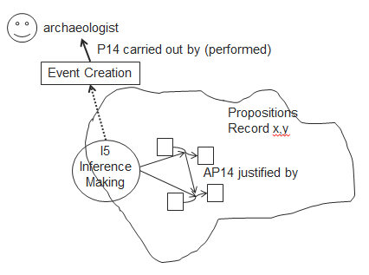

- To add an explanation of the example and in the scope note about not connected stratigraphic units (Achille and Paola )

