29th CIDOC SIG and the 22nd FRBR-CIDOC CRM Harmonization meeting
21 – 25 October, 2013
FORTH, Heraklion, Crete

Participants:
Trond Aalberg (BIBSYS, Norway), Carlo Alloca (ICS-FORTH, GR), Chryssoula Bekiari (ICS-FORTH, GR), Patrick Le Boeuf (National Library of France,FR), Martin Doerr (ICS-FORTH, GR), Øyvind Eide (Universität Passau, DE), Achille Felicetti (PIN PRATO, IT), Gerald Hiebel (ICS-FORTH, GR), Gerald de Jong (Delving, NL), Athina Kritsotaki (ICS-FORTH, GR),Richard Light(UK), Ambjorn Lindahl (National Archives of Sweden, SE), Ambjörn (Naeve, KTH,SE), Nikos Minadakis (ICS-FORTH, GR), Mika Nyman (Synapse Computing, FI), Dominic Oldman (British Museum, UK), Christian Emil Ore (Unviversity of Olso), Manolis Papadakis (ICS-FORTH, GR), Aline Le Provost (ABES , FR), Pat Riva (Bibliothèque at Archives nationales du Québec, CA ), Michalis Sfakakis (IONION University, GR), Ourania Smyrnaki (ICS-FORTH, GR), Steve Stead (Paveprime, UK),Maria Theodoridou (ICS-FORTH, GR), Thomas Wikman, (Delving B.V, National Archives, SE), Maja Žumer (National and University Library, SI),

Monday 21/10/2013
The meeting has been started by discussing FRBR issues.
FRBR ISSUE 10: We started discussing about the physicality of the F5 Item. We discuss if there is a unit boundary and we agreed that each item belongs to one publication expression and electronic publishing means no item. Under this view item has to go out from figure 5.
Also we made clear that URLs identify a file in a machine. Finally we decided
- to make a note in F32 Carrier Production Event (SS’ HW) scope note that this kind of event may produce either an item or a publication in electronic media
- to add a new class F53 Material Copy(MD’s HW) of a file, taking into account the following
- To address the use of URL’s
- The physical file is an area on the disc and the disc can be seen physically
- To consider the copy of a file on the disc as an entity
- The publication expression remains identical even though the item is not identical
- The scope note of F5 should remain unchanged.
FRBR ISSUE 12 : We discussed about different notions of work. We made it clear that the work conception is not necessarily the birth of the very first idea for a work, but can take place at a somewhat later stage (scope note to be modified – PLB’s HW). We decided to add other examples for F27 work Conception (PLB’s HW). Then we saw that a link is needed between F28 Expression creation and F27 Work Conception (PLB’s HW: to add a statement in scope note for F28 in order to make it explicit that instances of F28 can be typified, e.g., F28 P2 has type E55 Type {major contribution}). Finally we decided to make a subtyping of R3 in order to introduce a vocabulary of types of contribution and to make a statement in the introduction about the concept of “a representative type of a contribution”
FRBR ISSUE 14 : We discussed about how to consider the relationship between a performance and the performed theatre play. Finally we concluded that a theater play is not a real plan, otherwise it would be impossible to distinguish between a (literary) Work realized in the theatrical text regarded as an instance of F25 Performance Plan, and an F20 Performance Work genuinely realized (R12) in an instance of F25. We decided to reformulate the proposal in issue 12 and to add a new subproperty of P16 for making the relationship between performance and theatre play more explicit.
FRBR ISSUE 15 : We decided to change the range of R14 from F2 Expression to E90 Symbolic Object for covering the case of instances of F24 Publication Expression which incorporate the signs (whether intended and meaningful or accidental and meaningless) produced in the course of the reproduction of a physical thing. (Scope note to be rephrased accordingly – PLB’s HW)
FRBR ISSUE 17 : Pat will correct the examples.
FRBR ISSUE 18: PLB’s proposal to typify the R64 property is rejected. Instead, we decided to add to the scope note a statement in order to specify that any instance of F52 Name Use Activity can be associated with an instance of E55 Type (through P2), e.g. “use of a pseudonym,” “use of husband’s last name (for am arried woman)”, etc. (PLB’s HW).
Superproperty of R57: MD will refine a shortcut “F38 Character.P94B was created by (has created):E65 Creation.P17 was motivated by (motivated): E39 Actor” with restriction to specialization
Discussion about FRBR tutorial: Then Korina Doerr presented the FRBRoo tutorial. Recommendations by the FRBR-CRM SIG are the following:
- View for information science students
- Separate translation files
- All the content should be renewed
- Web application
- Two kind of promotions (1) for managers (2) for those that do the actual work (Maja will help on this)
- Two kind of levels (1) Overview and (2) detailed
- Multimedia interaction (Dominic Oldman will help in the design)
- Examples should be provided (Trond will help on this)
- Also help will be provided by Øyvind, CEO and Steve Stead with students
- FORTH will make a mailing list to send it to the whole group.
- Pieces of text will include comments on individual basis
PRESSoo : Patrick Le Boeuf presented PRESSoo. Comments or recommendations are:
Some events have starting events (Z6-Z7), we should introduce a new property in CRM.
The properties Z6-Z7 would be more specific such as earliest known, starting event
A subclass of publication work specific to monographs is to be introduced in PRESSoo.
Discussing about continuation, we decided to make an issue for CRM for restricting transformation to physical things.
We decided that we approve this extension as compatible with both FRBRoo and CIDOC CRM, and that the authors of PRESSoo only have to fix a limited number of issues for it to be approved during the next meeting.

Tuesday 22/10/2013
UNIMARC and FRBRoo mapping.
We started with Aline Le Provost’s presentation. She presented how ABES (the French Bibliographic Agency for Academic and Research Libraries) map UNIMARC records to FRBRoo. She said that they need shortcuts and they need to create extensions since typing of properties is not possible in RDF. Also she proposed to combine FRBRoo with vocabularies (SKOS, DUBLIN CORE).
Photographs: Then we discussed about photographs. Several opinions discussed such as:
- The creation of photograph is a recording (by PLB)
- Is it reasonable to distinguish photos that represent an object or represent a scene from an activity? (by MD)
- The museums also treat photographs as objects. Also there are documentary art forms.
- Under the sense of semiotics photograph is the recording of light reflection in time (Øyvind). Then Martin said that the total of the scene still is reflected by a distribution of light. Also there are formal transformations which preserve the subject and basic features.
- The distinction is not that we did something someday but the processing of bits of an image is a subject of correlation between the physical objects (the reality) and the image.
In the discussion about the difference between digital and analog photographs, several opinions are presented such as:
- The analog keeps the initial recording while the digital is not preserved. (Øyvind)
- In digital provenances we can register the process. Then we have no distortion, since the process is recordable and the recovering is possible. (MD)
Then we made the note that since photographs can no longer be used for legal issues, the authenticity notion is no longer relevant. We agreed that the use of photos is mainly for documentary purposes as they record states of affairs. Photographs that are not created for documentary purposes are art objects, they are the result of creation events. Finally we decided the following actions:
- To modify F26 Recording to include photographs (Øyvind, PLB)
- To modify the scope note of F29 Recording Event, and to add a shortcut that describes the recording of an object (Øyvind, PLB)
- To draft a statement as to how FRBRoo models photographs and animated images (Øyvind, PLB).
Linked Data Patterns
Then Richard Light presented the work of the CIDOC Documentation Standards Working Group (CDSWG), and more particularly of the Group about Linked Data Patterns using CRM, including proposals how to encode time in RDF. The following comments were made:
- CRM-SIG has discussed and published similar guidelines on the same subject on the CRM-SIG Website (http://www.cidoc-crm.org/official_release_cidoc.html).
- The Properties P81a, P81b, P82a, P82b mentioned in the presentation are not in the official version of CRM but to Erlangen version of CRM.
- The encoding proposed by the CDSWG has semantic and computational consequences the CDSWG had not analyzed in depth.
- Dominic Oldman stressed the wish of CRM users to talk to one committee as a single point of reference for CRM semantics.
- The CIDOC Board has decided in Helsinki in 2012 that CIDOC Working Groups should not engage in alternative work on the same subject.
- Martin Doerr mentioned that CRM-SIG deals with the issue how to represent particular information, but not with what information should be presented. That leaves space for collaboration with other working groups on something like “application profiles”, i.e. recommendations as to which information should be provided in particular contexts. It would be very valuable to have such guidelines for publishing Linked Open Data.
- It was discussed that CRM-SIG appreciates any help and collaboration, but any issue overlapping with the work of CRM-SIG , such as issues of encoding, should be harmonized with CRM-SIG before being published.
- Then a proposal led by Vladimir Alexiev from Ontotext was discussed that he and others form a team to promote the standardization of an OWL version of CIDOC CRM based on the work from the University of Erlangen.
- CRM-SIG decided that the principles discussed with the CDSWG also apply to this proposal. Any decision on encoding which has a bearing on semantics, such as additional constraints, but also which is the authoritative standard version, must be approved in a transparent way by the user community by a protocol which allows for tracing the authority to the CIDOC General Assembly. In turn, ISO recognizes CIDOC-ICOM as the authority to talk for the user community behind ISO21127. CRM-SIG has maintained this transparency by publishing all issues and outstanding decisions in a way approved by the CIDOC Board and General Assembly, reporting to the General Assembly on its activities and asking for approval by the General Assembly. Any request for change in the delegation of authority is a matter for the CIDOC Board, rather than for CRM-SIG to decide.
- CRM-SIG acknowledges the fact that the labor for maintaining the standard is continuously increasing and appreciates all help in this matter. Physical meetings impose some limitations. Therefore the mechanism of e-mail communication and decision taking could be more widely used to manage the necessary coordination between groups working on related issues or directly contributing to CRM-SIG. It can be used to resolve obvious issues more quickly and to engage a much larger group of people actively. So all teams interested in contributing to CRM-SIG topics or topics related to it are invited to subscribe to CRM-SIG and harmonize their work with us.
- Therefore CRM-SIG made it clear that anybody can call for an e-mail vote and a decision will be taken within two weeks via e-mail. Also the CRM-SIG is open to non CIDOC members. Anybody who would like to propose something should send to CRM-SIG mailing list the inquiries or proposals, the SIG will discuss openly and take decisions. May be the SIG decides an adaptation or alteration of a request for decision if needed. Although this procedure is already described on the CIDOC-CRM site, the CRM-SIG decides to re-write a statement for this procedure and to put it in a visible place in the current CIDOC-CRM for the newcomers. The text is attached to the minutes of this meeting entitled “rules of communication”.
The CRM-SIG proposed to add Richard Light and Jonathan Whitson-Cloud to the crm-sig mailing list. The FRBR-CRM SIG proposed to add Øyvind Eide to the FRBRoo mailing list.

Spatio temporal issues
Martin presented the overview of the proposed Spatiotemporal model.
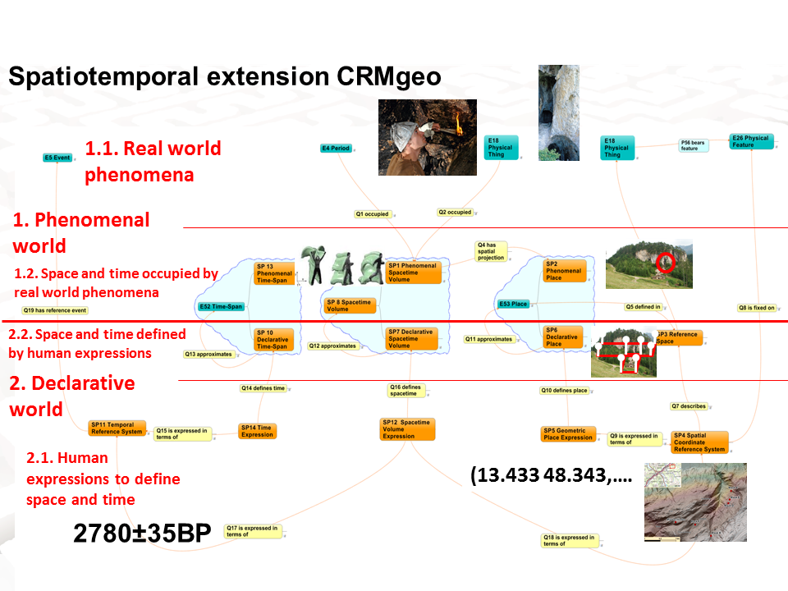

Then we discussed the proposed classes and properties of CIDOC-CRM issue 234.
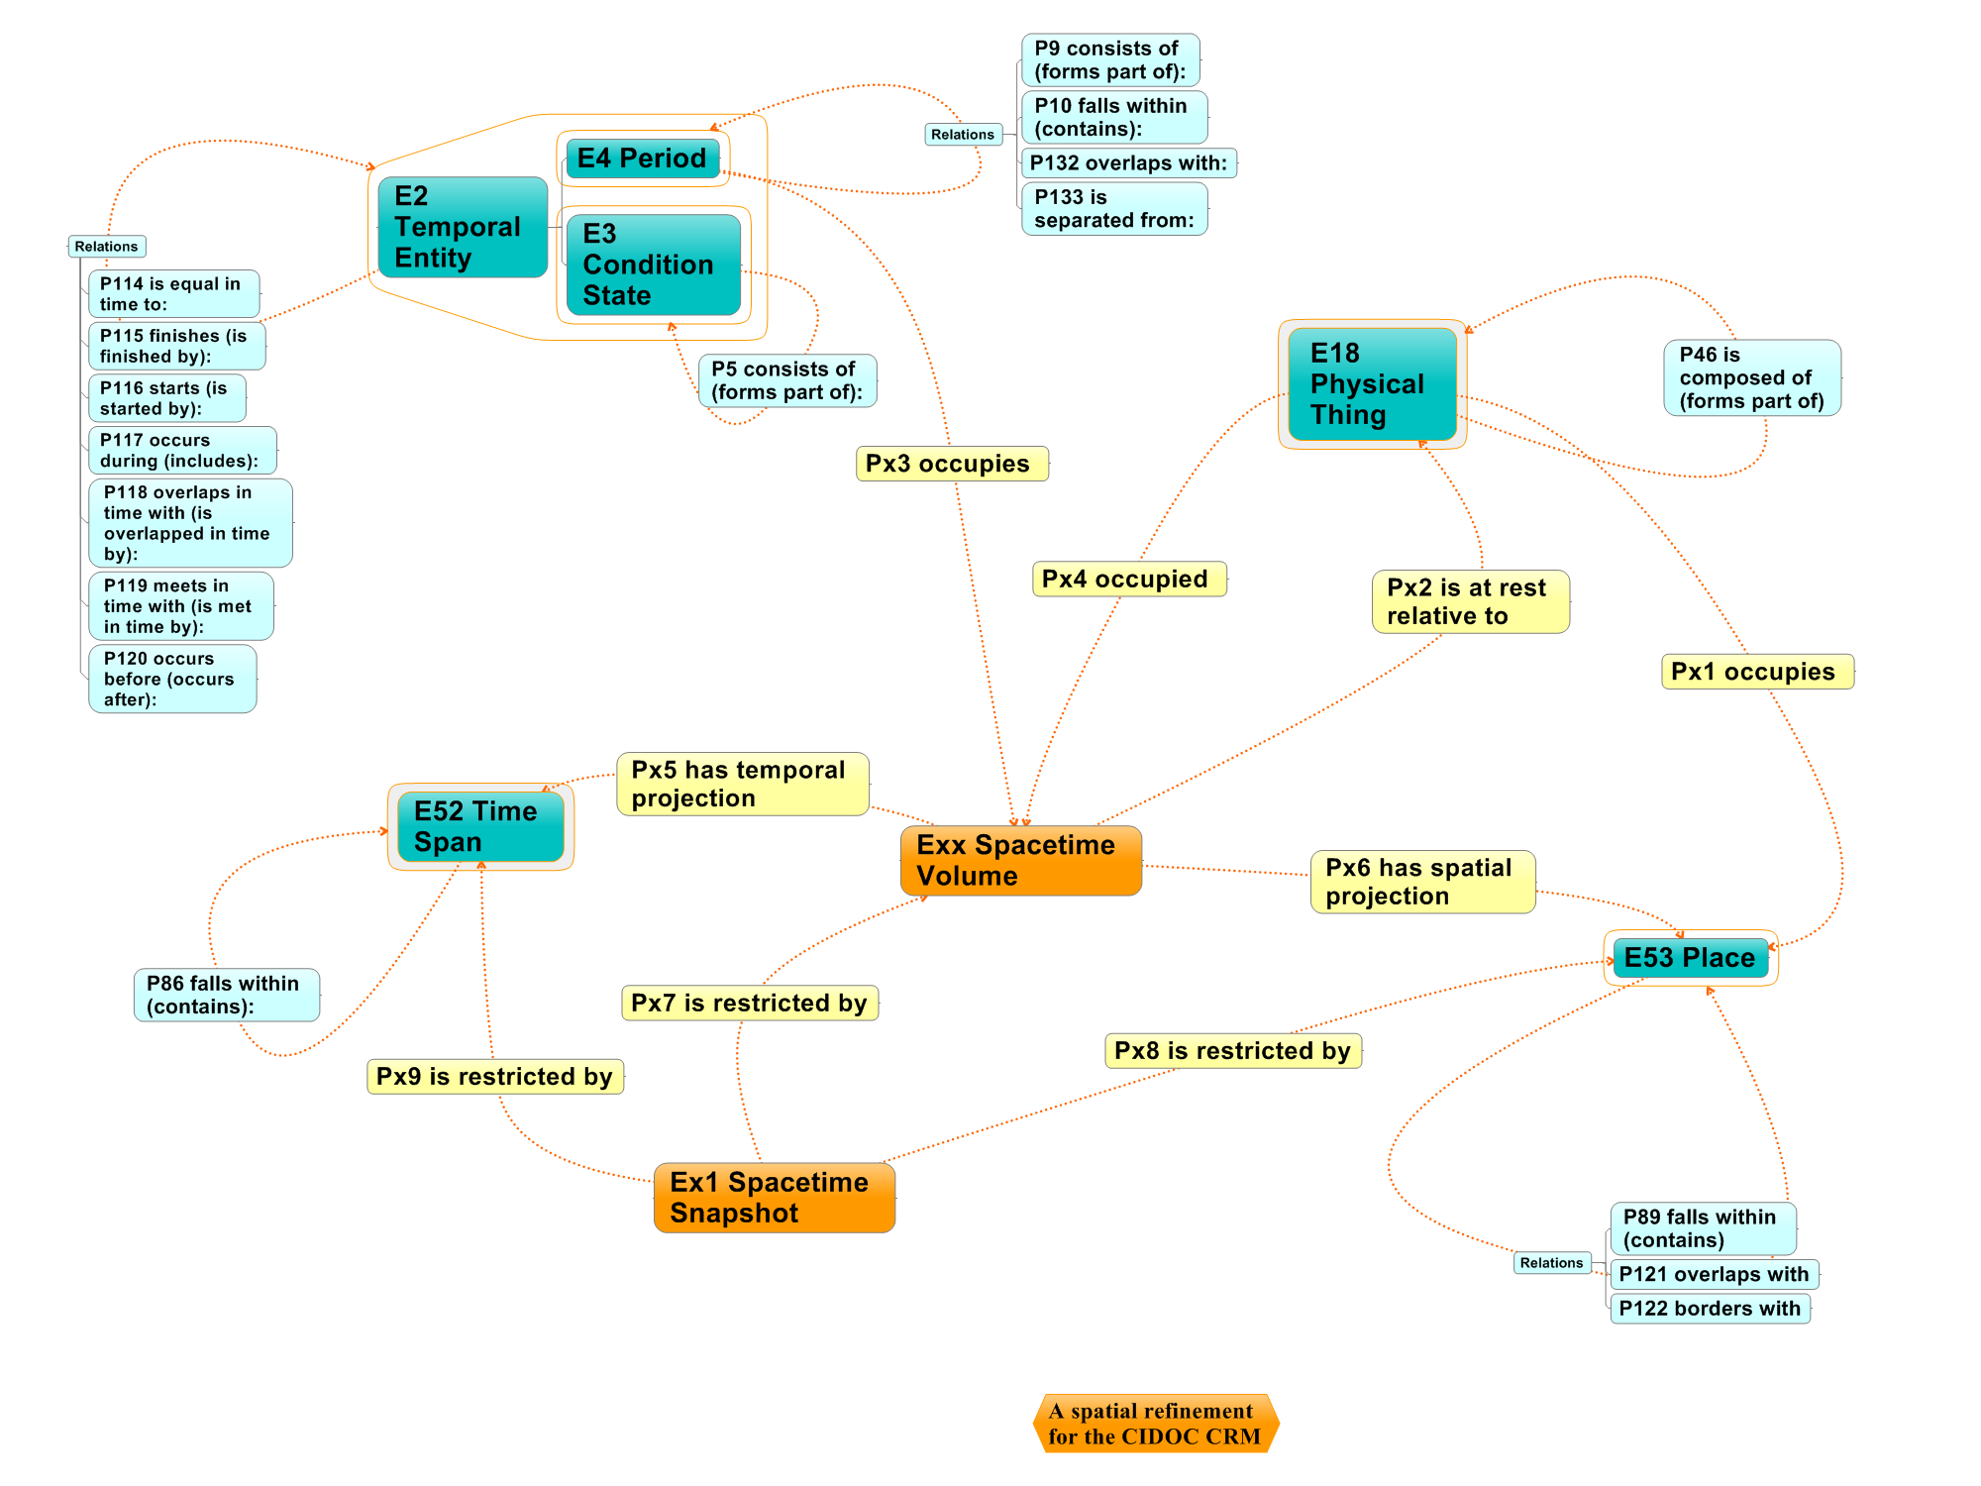

Some remarks and questions were discussed. Highlights of this discussion are
- The continuum is well defined, but the snapshots are problematic.
- A question was what sort of gaps we accept and what the consequences are.
- Other posed questions are “do we have to construct the intersections of instances or what we know from history? Are the intersections finite? Do we have to model all this complexity?”
- If we construct the space time volume we need the space time snapshot.
- Finally we decided that Dominic, Christian, Steve, Øyvind will review the proposed scope notes for the next meeting.
FRBR CORE. Martin presented the Final Report on EDM – FRBRoo Application Profile Task Force. Martin focused on how easily Europeana extracted data from FRBRized records and the mapping was fast and automatic. The FRBR-CRM SIG agreed that it is a good starting point for FRBR CORE. Also the examples are very informative for tutorial purposes.
Then the SIG noted that this report is a political compromise between FRBRoo and Europeana and discussed how to take advantage of this. The SIG decided
- To reuse this material in the framework of the FRBRoo tutorial
- To determine what we have to demonstrate by enchasing this as it is.
- To show that the data in the Libraries is complex and cannot be exploited unless a sophisticated model is used
- To make an rdf recommendation to present what we recommend as a harmonization group. We must be sure that the simplifications are valid.
- The FRBR-CRM SIG has to review page 10 of this report.
- We would make each point as an issue. Should these things be an integral part of FRBRoo or should they be used to define a core model? If we agree we need to check if this is sound and what will be the representative examples. Then in order to validate that rule we need a definition of the context, specifically we decided that we need the following:
  - Research questions on clustering
  - Research questions on aggregating results
  - Research questions to find related resources
  - Are these representative enough, do we need others?
- Then we agreed that the context is depending on what data we have and what kind of use we will make.
- FRBRized data can be extracted from catalogues that are not “natively” FRBRized. FRBR is the formalization of what should be in catalogues, independently from the technique that was used to produce them.
- Finally we decided to regard this document as an exercise, to see what it is about. Dominic, Trond, Aline, Patrick will contribute and give some paragraphs. We need a homogeneous graphical representation. Context, purpose and a set of properties can serve as a subset of FRBR core. For doing this we need to take some concepts of FRBRoo and CRM and add some rules to imply FRBR and CRM properties. Then we have to prove the coverage. For the coverage we need a proposal by Maja, or Maja will describe as a procedure and the result will be a journal paper. It will be a document that we should approve as a group.
Issue 10: Then we discussed again about the proposed class material copy. We decided to check the restrictions of it and to think about the identification of a material copy. Should it be restricted to something produced through a production carrier event? Finally we decided this issue will remain open until the next meeting which will be held in National Archives in The Hague on March 31st.
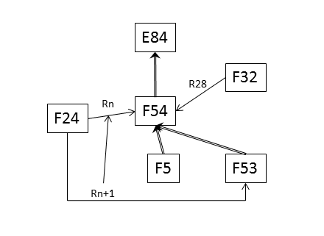

Wednesday 23/10/2013
SPARQL endpoints, mapping technology, querying.
We started with the presentation of Dominic Oldman, about what they have done in British Museum. He spoke about the SPARQL endpoint with CRM data. He asked for any suggestions on www.oldman.blog.uk.
Then Martin presented a proposal for querying semantic networks. Martin said that we may present something like this for CRM querying.
The SIG discussed about mapping technology. Ourania presented the mapping memory. We decided that we need to make a distinct terminology mapping and co reference particulars since terminology is part of scheme information. It is missing the mapping resolving terminology(source and target terminology). Sometimes both are needed.
The mapping doesn’t depend on the particulars while terminology depends on particulars.
We should make a distinction between aggregator storage and ingestion storage.
Then Martin presented the process model that he has sent to the CRM-LAB.
Then Ourania presented her thesis. Then we discussed how to proceed? Dominic will give comments on user process. Achille will send us a note about data contribution.
Then we discussed about CRM-LAB. The updated text is attached to the minutes of this meeting.
New site for CIDOC-CRM
Then we continued with the presentation of new CIDOC-CRM site. Some remarks are:
To be appropriate for (1) content and research director of collections (2) teachers, teaching material, (3) people without knowledge of conceptual models (4) digital humanities groups (5) intellectual use.
- To have an advertising part
- In main page case studies should be appeared as a term
- News sheet in main page,
- Home page should be in main page and show everything below
- To support FAQ (why people should keep looking in CIDOC-CRM, criticism about KB
- Reverse numbering in versions.
- Delving presented a proposal also.
Finally, Korina will send the new content for proposal. Gerald, CEO, Dominic, Steve, PLB will send their comments by December.
ISSUE 229: Observation model
Martin presented the observation model as it has been designed in Ariadne project. The CRM – SIG commented that it is complementary to the CIDOC-CRM and it is complementary to archaeological group model. Both groups should review it from their perspective. It will be on CRM-site on an internal link for reviewing.
ISSUE 195. Discussing this issue we noted the following:
- The continuation of activities is similar to publishing a serial that presents itself as the continuation of another one, such as modeled in PRESSoo.
- You cannot continue an activity that will take place in the future. The end of the range should therefore take place after the beginning of the domain
At the light of the above statements we decided that no Allen operator fits.
Finally we decided that
- Continuation happens at some point
- The current definition of “continuous” is ambiguous
- We propose to add a statement in the scope note for the P134 property, in order to make it clear that if activity B is a continuation of activity A, then the beginning of activity A must necessarily take place before the end of activity B.
The new proposal for P134 should satisfies the following:
Let As, Ae denotes the beginning and end of activity A respectively, and Bs and Be denotes the denotes the beginning and end of activity B respectively. Then we decided that
B continues A means B is influenced by A then As must be before Be.
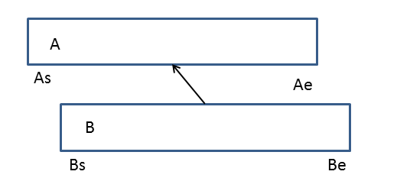
P9 and P10 should be rephrased and should include space–time, to be checked if this is consistent with phenomenal space /time
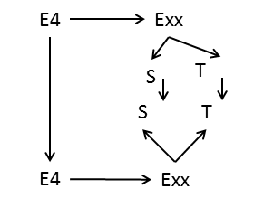
ISSUE 202
The text about multiple instantiation proposed by Martin was reviewed by CRM-SIG and accepted.
ISSUE 203
We discussed this issue along with issue 205 and 227. The CRM-SIG decided that the 203 will remain open until a real example is formulated (see also next 205, 227).
ISSUE 205
We change the scope note proposed by Øyvind. One example has been added and a second example will be formulated by MD from 3D Coform
ISSUE 214
Harmonize scope note of “shows feature of” with P69. The scope note is accepted; the examples need to be particular (CEO will look for examples)
ISSUE 230: co reference statement
We discussed about positive and negative links. In an open world system the negative links will be made implicitly while in closed world the negative is implied. Also we decided to make a citation to the scope note of co reference statement. MD will write a statement about co reference.
ISSUE 232: The CRM-SIG modified the scope note of P32. The changed scope note accepted by the CRM-SIG..
ISSUE 199:Biological parenthood
We should find examples and re –write the scope note (CEO).
CRM CORE: Then we discussed about defining an RDF file for CRM CORE in the light of new extensions presented in the figure 4.
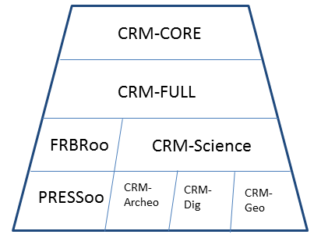
The CRM-SIG decided (1) to produce a subset for things, texts, images, persons, Martin Doerr will describe this thing and he will send it for comments (2) to make explicit some simplification rules (3) to simplify isA hierarchy without losing semantics (4) to start to make the profile and to put as issue in the WEB.
Amendments: The CRM-SIG decided to put in the issues list the amendments to ISO version. Patrick will give the amendments.

