The 35nd joined meeting of the CIDOC CRM SIG and ISO/TC46/SC4/WG9 and the 28th FRBR - CIDOC CRM Harmonization meeting
24-26 February 2016
PIN s.c.r.l.
Prato – Florence- Italy
Valentina Bartalesi (CNR-ISTI, IT), Chryssoula Bekiari (ICS-FORTH, GR), George Bruseker (ICS-FORTH, GR), Pierre Choffé (BnF, FR), Eleni Christaki (University of Athens, GR), Maria Daskalaki (ICS-FORTH, GR), Martin Doerr (ICS-FORTH, GR), Øyvind Eide (Universität Passau, DE), Mark Fichtner, (GNM, DE), Achille Felicetti (PIN Prato, IT), Stefane Gehrke(Equipex Biblissima, FR), Gerald Hiebel (university of Innsbruck, AT), Martijn Van Leusen (University of Groningen, NL), Matteo Lorenzini (Austrian Academy of Science, AT), Cinzia Luddi (VAST-LAB, PIN) , Carlo Meghini (CNR-ISTI, IT), Dominic Oldman (British Museum, UK), Christian Emil Ore (Unviversity of Olso, NO), Paola Ronzino (PIN Prato, IT), Richard Smiraglia (University of Wisconsin, USA), Stephen Stead (Paveprime Ltd, UK),Thanasis Velios (University of the Arts, UK), Schmidle Wolfgang (DAI,DE),

Monday, 24th of February

Issue 195
The sig reviewed the text by Manos Papadakis about the temporal relations and decided the following:
(a) the proposed temporal primitives: P173 starts before the end of (ends after the start of), P174 starts before (starts after the start of), P175 starts within (includes the start of), P176 ends before (starts after the end of), P177 ends within (includes the end of), P178 ends after or with (ends before or at the end of) should be introduced in CIDOC CRM
(b) To keep both Allen and the proposed ones ( to add a comment in the scope note of each of the Allen operators). Allen relations should be described as sub properties of these properties. Also we should think about deprecation of the Allen operators in the future or to examine the use of them as shortcuts
(c) To add another paragraph in introduction about temporal relations (as compact as possible and including the schematic representations/graphs) which gives the order of these new temporal properties and how they relate.
(d) to add /maintain graphs representing the properties in the main document, The fuzzy boxes should visually better represent the ‘fuzzy’ zones.
(e) to consider that there will an extremely large number of temporal properties and to attempt to answer how a user can ergonomically find the property that applies. Do we need an index of temporal properties?
(f) to introduce the logical conditions in the description of each new relation like (ends within (Aend < Bend & Aend > Bstart))
(g) review all labels to include the appropriate prepositions such as with or at as appropriate to make them more readily understandable.
(h) Help on review of document: Steven, CEO, Oyvind, Wolfgang. When the review is completed Steven will attempt an introduction for overall document.
(i) before more action, there is a need for editorial revision and to present the document again at the next meeting.

ISSUE 270
The crm-sig accepted the outcome of the vote by email and changed the name and the scope note of the class E78. Thus the label of the E78 Collection has officially been changed to E78 Curated Holding. The changes have been incorporated in CIDOC CRM version 6.2.2

ISSUE 234 Spatiotemporal Entities
The crm-sig discussed the issue 234 and decided the following:
a) that P132 is a super property of P9 and P10
b) to accept the proposed first proposed example for P132 by GB, and that the second should be revised.
c) that the proposed by GB example of P133 is needed to be revised.
d) To delete all the inverse part of the label in all path descriptions in the CRM text

ISSUE 235
The crm-sig, in resolving the issues 234 & 275, reviewed issue 235. The sub/sup property of the definition of P10 was completed and the scope note was updated. The changes have been incorporated into CIDOC CRM 6.2.2
The issue is closed

ISSUE 275 Space Primitives
The crm-sig changed the scope note of E94 Space Primitive, P168 place is defined by (defines place). Also new classes and properties have been introduced, these are E95 Spacetime Primitive, P169 defines spacetime volume (spacetime volume is defined by), P171 at some place within , P172 contains
These changes have been incorporated into the CIDOC CRM version 6.2.2
Also, it was pointed out that the scope note of E61 Time Primitive needs revision. To it should be added the following paragraph,
“Note that it is possible for a time-span to be defined by phenomena causal to it or other forms of identification rather than by an instance of E61 Time Primitive. In this case, this property must not be used for approximating the respective instance of E52 Time span with an instance of E61 Time Primitive.”
It was decided that a construct for a declarative time span which is the result of a time primitive needs be added.

P81 and P82 that point to E61 time primitives are references to declarative E52 time spans which approximate an E52 time Span.

CEO – will modify E61 scope note.

ISSUE 285
The crm-sig made editorial changes to the property P115 finishes (is finished by). The changes are incorporated to the CIDOC CRM version 6.2.2. The issue is closed. Also it was decided that Editorial work on all other properties should be undertaken by FORTH alongside the review of the fuzzy operator properties.

Tuesday, 25th of February

Presentations
- Holism, ontology and intensionality: new challenges : Maria Daskalaki, Martin Doerr
- Building an Argumentation Platform for 3D Reconstruction using CIDOC-CRM and Drupal : A. Guillem & G. Bruseker
- How It’s Made: Franco Niccolucci
- Are You Sure? : Franco Niccolucci
- Navigating the Semantic Model: a CIDOC CRM Browser Cinzia Luddi, Achille Felicetti
- Scripta Manent: a CIDOC CRM Semiotic Reading of Ancient Texts Achille Felicetti, Francesca Murano
- Conservation documentation: Thanasis Velios
- Doremus model: Pierre Choffe
- A CRM-based Ontology for Narratives: Carlo Meghini, Valentina Bartalesi
- CIDOC-CRM game: George Bruseker
- Towards a CRM for archaeological field walking surveys : Martijn van Leusen
- Modelling between digital and humanities: presenting a new research project: Øyvind Eide

Wednesday, 26th of February

Planned Activities
Pierre Choffe and Martin started a discussion about planned activities. The patterns of planned activities i.e. performances, productions etc. were discussed and the following figures designed:
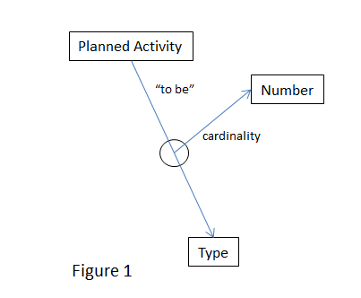

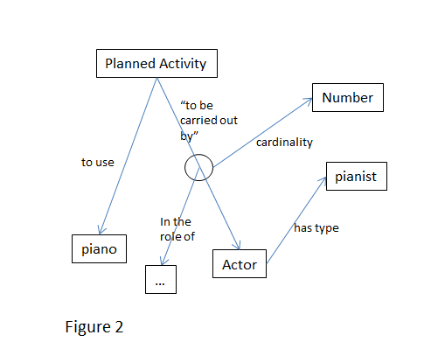

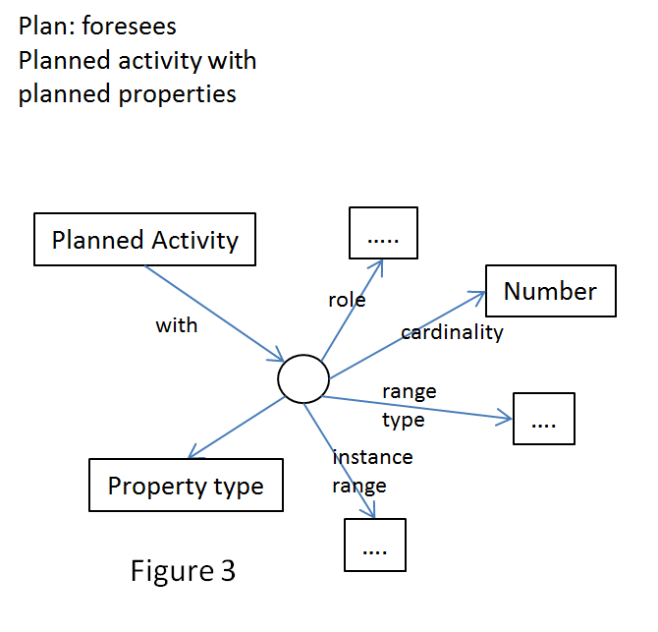

Steve, Oyvind, Christian Emil and George will formulate a proposal about planned activities

ISSUE 273
The sig reviewed the scope notes for: E96 Purchase, E97 Monetary Amount, E98 Currency. The scope notes of these new classes have been incorporated into the CIDOC CRM version 6.2.2 (These should be reviewed and completed by Steve)
The discussion about whether Monetary Amount is quantity or measure was postponed for future meetings.

Didactic Material
Discussing the method for producing didactic material, Dominic Oldman presented an introduction to the question, first dealing with the nature of the audience for this material. He divided the audiences as follows:

1. Producers of digital data who don’t understand /see the value of structured data (they are text oriented)
2. Producers of digital data who don’t see the importance of digital integration
3. People who produce and understand the importance of digital publishing but don’t understand quality, they see it as complexity and they are bound to legacy systems

A discussion followed on from the introduction by D. Oldman that led the sig to decide that in order to prepare suitable didactic material, the following areas would need to be clarified to fully understand user needs and the appropriate material/approach to meet this demand:
- Target area / Community
- Format
- Teacher Skills
- Context of teaching
- Business need

The discussion about communities led to distinguishing the following typical communities:
- Curators (they need specific project)
- Programmers Librarians
- Researchers
- IT
- Archivists
- Management
- Students by discipline

The style of teaching was also discussed i.e. broad teaching or one to one
Finally, it was concluded that the training material should take into account
- The business needs
- Teaching goals (what people should understand in order to accept CRM for their needs)
- Skills (to work on their own)

The issue was left open for further discussion at the next meeting of the sig.

ISSUE 281
The crm-sig resolving the issue 281 proposed and decided the following:
- About the symmetric properties P130 shows features of (features are also found on), P139 has alternative form, and P69 has association with (is associated with) , it accepted the proposal by CEO to remove the symmetry axiom form the FOL paragraph of the properties and adjust the scope notes.
- CEO has commented that it seems to be closest to the intention of scope notes and best from a mathematical/FOL point of view. The way it stands now is close to what we criticise in DC. We cannot know the meaning without checking the value. The first order parts are not definitions of the properties; they state the strongest possible conditions that are true for all instances (or some if we use existential quantifiers).
- Also it is decided that for all properties that have same domain and range, and are not transitive, this should be stated explicitly.
- The crm-sig revised the scope note of P130. The revised text is incorporated in the version 6.2.2 of the CIDOC CRM. Also it was assigned to CEO to write a definition for the term “directed” to go into terminology, taking into account the Carlo’ s statement.
- In order to avoid confusions in the discussion about transitivity, the scope notes of P165 incorporates (is incorporated in) and P150 defines typical parts of (defines typical wholes for) were revised appropriately. The changes are incorporated in CIDOC CRM 6.2.2
- The sig reviewed the text provided by CEO about transitivity and accepted it to be added into the terminology section with the following additions:
  - To put property numbers when reference is made to categories of properties i.e properties referred to time/space/transitive
  - To put class numbers when reference is made to them,. i.e In the examples referred to classes
- It is assigned to Christian Emil to write definitions for “symmetry” to go into terminology. The point mathematically should be non-symmetry
- The symmetry statement in FOL needs to be updated
- Symmetric properties are P69, P130, 139. The scope notes of P69 and P139 should be rewritten, by Martin, taking into account the statement of directedness.
- In the previous meeting has been accepted that in the official release we will keep things backwards compatible. (Compatible at least in instance level). Mark should distribute to crm-sig the respective owl versions with compatible statements. (It is still open)

Erlangen OWL Version
- About Erlagen version of OWL CRM it is decided the following headers to be added:

Official CIDOC CRM/Erlangen CRM OWL Header
Version DDMMYYYY of the Erlangen CRM
- Implements CIDOC CRM Version 5.0.5
- uses OWL Version 1.0 DL

Things you should know about before use
- the CIDOC Conceptual Reference Model (CIDOC CRM, http://www.cidoc-crm.org/)
- the Web Ontology Language (OWL, http://www.w3.org/standards/techs/owl)
- the primer for the Web Ontology Language (https://www.w3.org/TR/owl-primer/)
- the Erlangen CRM (ECRM, http://erlangen-crm.org/)

This Version of the Erlangen CRM
- is the recommended OWL implementation of the CRM approved by the of the CIDOC CRM Special Interest Group (SIG)
- contains all classes, properties, scope notes and examples of the CIDOC CRM
- contains class and property hierarchy as well as statements for transitive and inverse/symmetric properties
- does not contain any further restrictions or quantifications

In case this is not the version you were looking for, consider using
- the standard Erlangen CRM (http://erlangen-crm.org/current-version)
- the RDF version as provided by the CRM SIG (http://cidoc-crm.org/official_release_cidoc.html)
- the standard document of the CIDOC CRM (http://cidoc-crm.org/official_release_cidoc.html)

Standard Erlangen CRM OWL Header
Version 150929 of the Erlangen CRM
- Implements CIDOC CRM Version 6.2
- uses OWL Version 1.0 DL

Things you should know about before use
- the CIDOC Conceptual Reference Model (CIDOC CRM, http://www.cidoc-crm.org/)
- the Web Ontology Language (OWL, http://www.w3.org/standards/techs/owl)
- the primer for the Web Ontology Language (https://www.w3.org/TR/owl-primer/)
- the Erlangen CRM (ECRM, http://erlangen-crm.org/)

This version of the Erlangen CRM
- is NOT the recommended OWL version of the CIDOC CRM Special Interest Group (SIG). See http://erlangen-crm.org/current-version for the recommended OWL version.
- contains all classes, properties, scope notes and examples of the according CIDOC CRM version.
- contains class and property hierarchy as well as statements for transitive and inverse/symmetric properties
- contains existential and quantitive property restrictions derived from the CRM scope notes and quantifications
- supports automatic deduction systems to find logical contradictions
- may be used by people knowing restrictions as well as their benefits and drawbacks or for those who are convinced the ECRM developers know what they are doing

In case this is not the version you were looking for, consider using
- the SIG-recommended Erlangen CRM ‘without restrictions’ (http://cidoc-crm.org/something)
- the RDF version as provided by the CRM SIG (http://cidoc-crm.org/official_release_cidoc.html)
- the standard document of the CIDOC CRM (http://cidoc-crm.org/official_release_cidoc.html)

Also it is decided to add a suitable creative common licence considering that the ISO version has copyright and the (2) companies can use an internal version of CRM modified and this DOES NOT imply that their products etc. have to be open source.

ISSUE 274
The crm sig discussing the proposal made by Thanassis Velios (see http://new.cidoc-crm.org/Issue/archetypical-sounds ) about this issue proposed that a team should be organized to find if there are any examples from ethnology or sonic archives. An outline of the definition of this class is drawn but it is decided to postpone the incorporation of this class in the CRM until there is evidence and if the evidence conforms to the proposed definition. Also we should examine if such a concept imply traditional melodies and if there is any community of use.

Decisions
Decision: in all path descriptions we delete the inverse part of the label.(from issue 234)

NEXT meeting
Looking for suitable dates, the crm-sig decided by vote the next meeting to be in Heraklio, in August 2016.

