The 33nd joined meeting of the CIDOC CRM SIG and ISO/TC46/SC4/WG9 and the 26th FRBR - CIDOC CRM Harmonization meeting
Germanisches Nationalmuseum
Kartäusergasse , 90402 Nürnberg

Chryssoula Bekiari (ICS-FORTH, GR), Elke Bauer (Herder Institute, DE), Patrick Le Boeuf (National Library of France,FR), George Bruseker (ICS-FORTH, GR), Pierre Choffé (BnF, FR), Maria Daskalaki (ICS-FORTH, GR), Martin Doerr (ICS-FORTH, GR), Øyvind Eide (Universität Passau, DE), Ute Engel(GNM, DE), Mark Fichtner, (GNM, DE), Achille Felicetti (PIN Prato, IT), Stefanie Gehrke (Biblissima, FR), Günther Görz (FAU-DE), Peggy Grosse (GNM, DE), Said Habib (GNM, DE), Georhe Hohmann (Deutsches Museum, DE), Siegfried Krause (GNM, DE), Dorian Merz (FAU-DE), Dominic Oldman (British Museum, UK), Christian Emil Ore (Unviversity of Olso, NO), Anna Pawlik (GNM, DE),Maria Anna Pfeifer (ZFMK, DE), Kerstin Reinfandt (GNM,DE), Mathias Rösch (Erlagen university, DE), Martin Scholz (FAU,DE), Steve Stead (Paveprime, UK), Thanasis Velios (University of the Arts, UK), Thomas Urban ( Herder Institute, DE), Wolfgang Schmidle (DAI, DE)

Tuesday 19/5/2015

In the beginning Martin Doerr talked about current activities of CIDOC CRM SIG. Siegfried Krause gave a short overview of the Wisski project. Then the following presentation took place.
Presentation by Anna Pawlik about „Totenschilde“ and the role of WissKI within the project
Presentation by Mathias Rösch (FAU Erlangen) about the research collections of the University and the use of WissKI
Presentation by Maria Anna Pfeifer (ZFMK) ( about reason on type- structure databases about features have been lived).
Presentation by Engel (Bavarian Academy of Research and Sciences), about the project of Baroque Ceiling Paintings (discussion about identification. Two cases are discussed - one to add an artificial number and another to add the dimension coming out of a measurement event)
Presentation by Piotr Kuroczyński( Herder-Institut) about Virtual reconstruction of Baroque palaces in the former East Prussia using WissKI
Presentation by Patrick Le Boeuf on the HADOC programme and model
Presentation by Stefanie Gehrke on the Biblissima project
Presentation by Pierre Choffé on the DoReMus project. (It was mainly a discussion about the need for target schema visualizer. It was proposed the use of excel. Also we discussed about visualization of complex processes and how to model the accidental or incidental role using a certain instrument to a particular performance. Then we discussed the need for modelling equivalence patterns and how to produce principles that the presenter to verify the extension he proposed. )
Presentation by Maria Daskalaki (FORTH) about challenges of formal ontologies as a subject of philosophical studies or so

Wednesday 20/5/2015

Teaching material
We started with comments on Pierre Choffé presentation
Modeling pattern is not a question of schema knowledge, is depending of the data
“Person”: What information the string convey
“Authority”: in computer science, they discuss ontological patterns. We should collect instances of patterns to understand what these are. (Dominic said that we should add these to website). Every different mapping of British Museum is a different approach.
Then Dominic showed the graphs from British museum.
What are the parameters?
- Characteristic fields in museum records
- We talk about patterns of both sides
- It is a typical compensation
- It is mixed the conceptual and physical subject
So it comes up to characteristic ontological distinction to the source.

Martin said that we have to do the following
- How to organize such patterns
- How to index the dependencies
- Could the information categories of CRM map to these patterns?

Different types of acquisition
“pattern based mapping”
Patterns of fields in the source database (CIDOC categories, Spectrum museum process)
- Ontological disambiguation
- Corresponding CRM pattern(+ context) by object – actor thing

What are the basic problems?
(1) what construct to map to
=> is there another construct that identifies alternative ?
=> typical conclusions “do not use for”
=> more examples do not use
(2) what is the right index (or access point ) starting point?
(3) What is the adequate unit ? (views and descriptive parameters)

There are many tasks / Practical steps
We have many issues, some documents with completely different structure
(ILT material)
(A) tutorials can be improved (in which units we use)
Steve showed his structure about his tutorial, How they create new schema based on CRM
Old tutorial: functional units of CIDOC categories
Finish: process of enriching existing db, mapping CRM compatible
We should criticize the functional units
(B) We need to create document
- Pattern oriented view of mapping process (Dominic, George and Steve)
(C) Functional definition of “pattern” and its descriptive parameters. What is the intellectual material?
(D) Empirical study of patterns: collection of patterns variation, relation, dependency, Wisski, KtP, Spectrum, graphical representation of CRM.
What we had a classification to Dominic document, link to CIDOC dictionary, dictionary of terms (Øyvind, Mark)
Then we went back to the problem which source field is the best candidate representation of the CRM property between Entity A B?
We need views and descriptive parameters like subject headings, all the complexity comes from the fields.
When you see the pattern you understood the pattern, how to recognize the pattern in your source? Study on source patterns (knowledge representation)
It appears that something like <source>, <pattern or functional unit> which corresponds to the CIDOC categories, or like characteristic fields of Spectrum, and we have also general fields, how to describe persons etc..

Pattern oriented view: The mapping process

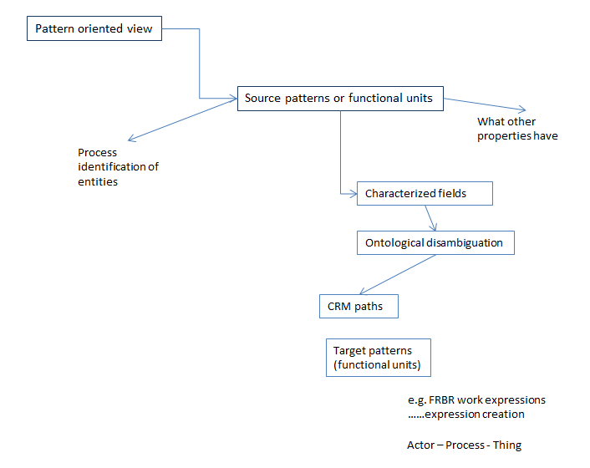

It should be a cookbook. Eg. If you find a date you might have an event, then go back to the source, to find the rest parts of the events.
We can make a process model, to produce a resource to identify the specific documents we need fitting in this scenario
- Identify the objects
- Identify the actor roles
- What are processes you do
It is needed to define the products and then to distribute work.

IT Design
(E) An information system, hypertext document, user annotation mechanism: the actual guidelines that would give advice to the user for each step. We need teaching and self – supervised
(F) Guidelines which are process driven pattern oriented
(G) Principals of KR based information modeling. All the introductory step, multiple instantiations etc. (Steve)
Principles and practicalities, domain adequate material
Trainers, experts, consultants
(H) We need theoretical courses in ontology engineering, training
Philosophical theory support, empirical ontology engineering questions of reality and knowledge in cultural, historical studies and descriptive sciences, how reality influences our knowledge (George, Øyvind,MaD, MD)

We inform that everybody who has funding source to inform the group to send the certain requirements that they have to their sources. (How to inform each other)

Issue Erlagen owl/ CRM

If we want to transport data to RDF in a completely neutral way we should map to RDF literal. In rdfs all data types are a kind of literals, we should introduce xsd data types.
The issue of equivalent to be discussed, to be introduced examples in rdfs version.
URI: Erlagen should communicate with FORTH how to find the other versions of Erlagen CRM/OWL.
We accepted the constraints. It is decided to exist an official owl version of CRM. Only the owl official version will have two name spaces, CIDOC CRM and Erlagen owl.
FORTH will produce the RDFSand ERLAGEN will produce the OWL. Both of them will be accessible through the CIDOC CRM site.
We do not create a new version if we have something that affect the instances. The mechanism and the policy should be the same. (Richard Light)
We should make a decision about the name spaces and to harmonize them in the next CRM meeting.
In the CRM name space will be without restrictions. (Dominic should verify the truth). Erlagen will present to the next meeting the properties that Erlagen have implemented as symmetric, in order to be approved by CRM-SIG. The procedure is to be approved the transitivity and equivalence.
Manos Papadakis should check the transitivity for all Allen operators. Christian Emil will review all CIDOC CRM transitive properties.

Discussion about FOL representation of shortcuts
Formalization of shortcuts: two action points (1) to control all the quantifications and (2) all subproperties.

P2 :
Events allow a more detailed path from E1 CRM Entity through P41 classified (was classified), E17 Type Assignment, P42 assigned (was assigned by) to E55 Type for assigning types to objects compared to the shortcut offered by P2 has type (is type of).
There exists at least one event of type E17 such that…This may be part of the epistemological layer.
May cause infinite recursion!
Knowledge creation events cannot be inferred within the same named graph.
This is a weak shortcut.
Action: We have to distinguish knowledge. Øyvind will make a statement about knowledge creation process and shortcuts. If one who maintains the knowledge base takes a stamp of the observer. Knowledge creation events cannot be inferred by rule. (if you are the God, you don’t describe yourself in the graph you may describe other gods). George and Øyvind will work in this.

P43 :
It is a weak shortcut, dimension could be computed
P44:
This shortcut concerns the epistemological layer

P48:
This is a property of type “current”. The long path cannot infer its validity at the time of recording. This is not a shortcut. There is a cardinality conflict!:
It is decided that Martin and CEO will check the FOL for shortcut Logic

P49:
This shortcut supposes the existence of at least one representative part standing physically for the whole. Discuss knowledge revision process if a piece taken to be the representative of the whole must be regarded piece of another. Things kept may have parts in other hands.
A comment should be stated. Steve, MD, Athinak should think together

P50:
“current” cannot be inferred, it is not a weak shortcut

P51:
It is a weak shortcut, it does not pertain to all parts.

P52:
“current” cannot be inferred, it is not a weak shortcut. We drew the following figure in the board
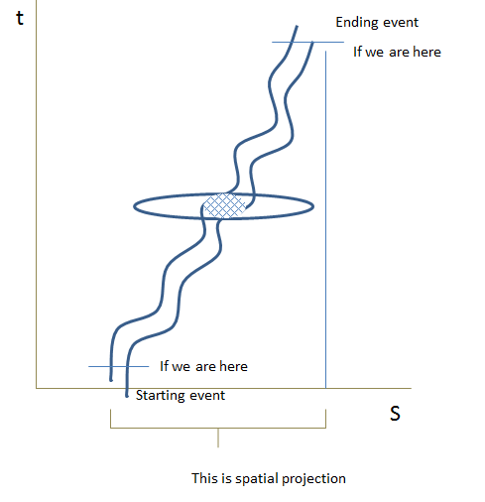

Action : to be discussed in the sense of causality. It is complicated because of E53 Place.
P53:
The inverse is weak because create the shortcut from the link and not from the whole path. It should be discussed.
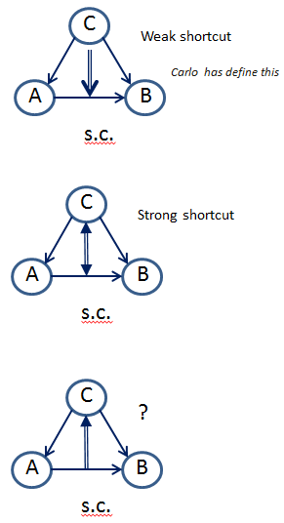

Thursday 21/5/2015

Discussion about formalization of shortcuts (cont.).

P55:
It is a weak shortcut, alternatives are ambiguous

P56:
It is a strong shortcut

P59:
It is a weak shortcut, alternatives are ambiguous

P62:
to be elaborated by Steve

P105:

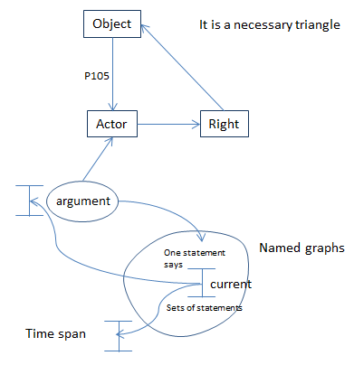

There is a problem with the “current” when data is aggregated. There is no problem with local data. Maybe an addition is needed to CRMinf to propose how a property is current.
Wolfgang Schmidle and Pierre Choffe, will send what they have understood.
CRM does not restrict any CRM user to CRM concepts since it models only concepts that can be shared for querying across the resources.

P107:
It is a weak shortcut. The sig reviewed the scope note of E66 Formation and it is noted that this doesn’t mean that the members of the group are being enumerated. It is highlighted a part of the scope note, in order to be discussed later. The question to Carlo is how to formulate that an inverse exist in strong shortcuts?
Then a golden rule is formulated :
“CRM concepts and isA hierarchy must be adequate to the states of knowing but not to give a complete account of causality”
We discuss the purpose of introducing the strong shortcuts. There is an aspect of utility denoting the strong shortcuts. We should find those expansions of paths that they are regarded useful for querying. Then the sig made changes to the scope note of E85 Joining.

P152:
It is a weak shortcut. Alternatives are ambiguous. The question is what are the states of not knowing? We have to revise what is the utility of making a strong shortcut inference explicit (question to Carlo)

P130:
MD will change the scope note to reflect the inference

P109:
The scope note is changed. “Being a shortcut is not inherited to subproperties”
The sig decided that in the introduction to CRM it should be stated that someone before read and use CRM, should read certain documents. It should be written an introduction for RDF and OWL representation of CRM. (Mark Fichtner will prepare such documents)

ISSUE 234

P8:
It is a weak short-cut. Reviewing the short-cut in P8, the sig made changes in the scope note
General comment:
The sig decided that in a class definition should be clarified the following:
Substance, Identity, Conditions of instances, Unity (SUICU) (Does this substance belongs to it.), Existence (when does it come into existence/ends, can we say if exists or not sometimes), Potentiality of behavior.
Martin will write two pages guideline about the content of scope note as SUICU

Comments for CRMarcheo
Achille presented the new version of CRMarcheo. Comments are:
- A unified view should be added in the text.
- It should be clear what CRMarcheo does not enforce.
- EH-CRM is more specific while CRMarcheo is more general.
- Achille should send communicate with Keith for mapping CRMarcheo and EH – CRM. Also Achille should check with Gerald the coverage with archaeological records and CIDOC CRM, the classes that are instantiated.
- The scope note of A3 should be revised. MD should find a good reference for CRM archeo
- The crm-sig decided that that PIN Prato will be responsible for the CRMarcheo from now on.
Martin asked Mark Fichner to do the mappings (like FRBRoo and FRBRer) for their extensions.

Space time Volume
We started the discussion about space-time issue 234
We revised the scope notes of E4,E18,
Golden warning: If we have a class with many properties then it seems that something is missing

P7
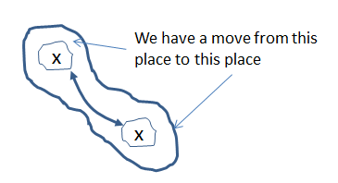

P156

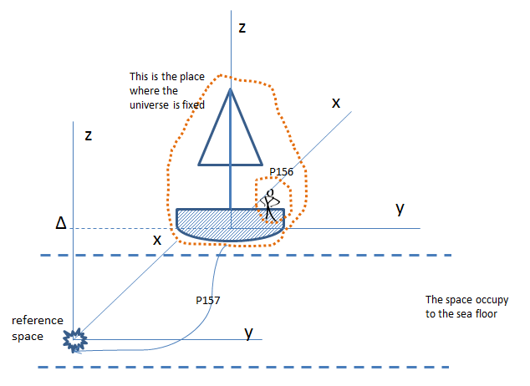

An animation is needed for P156

Friday 22/5/2015
We started with the questions of Choffe
1st question: How we make use of P80-P81, P82.
The sig decided to put the tutorial of Steve in the comprehensive introduction.
Q: when we have to document on the 22nd of May at 8:30?
A: It does not mean that starts exactly
Q: How to translate the date of the database
A: always you can express in time interval e. time span, sometime within, time primitives (we replace P82, P81 by two properties in rdf we use xsd: datetime
PLB commented that the examples of time primitive are not informative; it is needed to explain the philosophical argumentation that requires this modeling.
A paper is needed how to deal with the time.
2nd question: How to deal with the sequence in information objects. Eg. Performance order (this is the first movement -> the second movement etc. in the performance the order of concerts, symphony), reading order, adjacency, how information is displayed (PLB: see ontology of BnF), perspective models, forthcoming events, planned events (advertisements, brochures, websites)

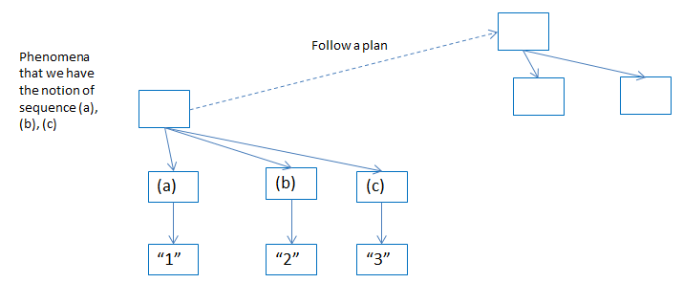

The sig decided that there is no model to describe how the future has past, no way to decide if the planned event had happened or not, the projected future and the past are separated.
When something started you cannot foresee how it continues.
A future event consists of desirable constraints, space, time, kind of, actions, interactions. In a real event we have fitting constraints, additional properties.
The deviation of a plan is quite important in political history. We distinguish four time spans
a. a plan execution time
b. a plan actual creation time
c. a plan will time
d. a plan creation time

In law proposal, it is stated the execution time.
It is an expression of interest about modelling of plan events. Relevant work have be done in KB lab project , in legal models in Capar Project, tambo models of Jane Hunter.
Thanassis Velios, Arianna Ciula, Øyvind, Piotr Kuroczyński, are interested in modelling planned events. Planned events concern (a) the conception of future, (b) architectural plans (c) performance plans, (d) political decisions. In the next meeting, a slot should be given to discusss about categorical patterns.

P62, P8
The sig revised the scope note of P62, P8. It was a continuation of the discussion about shortcuts.

Issue 235
The properties P9 and P10 have been reviewed by crm-sig.
Martin and Gerald Hiebel should give an example with Roman empire from until and geo coordinates (GH)

Issue 234, 263 continued
P26, P27 have been updated. Carlo should review the FOL representations
P46, P160, P161 have been updated. Examples are missing for P160, P161. Øyvind will provide them.
Then we discussed about E93 presence of
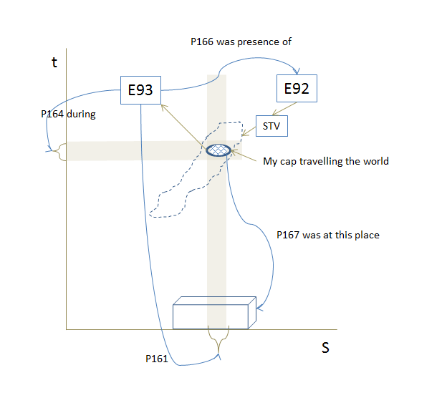

Issue 275
Then we discussed the issue 275. A new class for space – primitive has been added and new property about the place defined by a space primitive.

