Definition of the CRMarchaeo
An Extension of CRMbase to support the archaeological excavation process

Approved by CIDOC CRM - SIG

Editorial Status: Stable

Version 2.1.1
April 2024

Contributors: Eleni Christaki, Martin Doerr, Achille Felicetti, Sorin Hermon, Gerald Hiebel, Athina Kritsotaki, Anja Masur, Keith May, Christian-Emil Ore, Paola Ronzino, Wolfgang Schmidle, Maria Theodoridou, Despoina Tsiafaki, and others.

Index
Introduction 4
Scope 4
Status 4
Naming Conventions 4
Allen Operators 5
Class and Property hierarchies 6
CRMarchaeo class hierarchy, aligned with portions from the CRMsci and the CRMbase class hierarchies 7
List of external classes used in CRMarcheo 9
CRMarchaeo property hierarchy, aligned with portions from the CRMsci and the CRMbase property hierarchies 10
List of external properties used in CRMarchaeo 12
Graphical overview 13
Class and property usage examples 16
CRMarchaeo Class Declarations 22
A1 Excavation Processing Unit 23
A2 Stratigraphic Volume Unit 24
A3 Stratigraphic Interface 24
A4 Stratigraphic Genesis 25
A5 Stratigraphic Modification 25
A6 Group Declaration Event 26
A7 Embedding 26
A8 Stratigraphic Unit 27
A9 Archaeological Excavation 27
A10 Excavation Interface 28
CRMarchaeo Property Declarations 29
AP1 produced (was produced by) 30
AP2 discarded (was discarded by) 30
AP3 investigated (was investigated by) 30
AP4 produced surface (was surface produced by) 31
AP5 removed part or all of (was partially or totally removed by) 31
AP6 intended to approximate (was approximated by) 32
AP7 produced (was produced by) 33
AP8 disturbed (was disturbed by) 33
AP9 took matter from (provided matter to) 34
AP10 destroyed (was destroyed by) 34
AP11 has physical relation to (is physical relation from) 35
AP12 confines (is confined by) 36
AP13 has stratigraphic relation to (is stratigraphic relation of) 36
AP13.2 justified by (is justification of) 37
AP15 is or contains remains of (is or has remains contained in) 37
AP16 assigned attribute to (was attributed by) 38
AP17 is found by (found) 38
AP18 is embedding of (is embedded) 39
AP19 is embedding in (contains embedding) 39
AP21 contains (is contained in) 40
AP22 is equal in time to 40
AP23 finishes (is finished by) 41
AP24 starts (is started by) 42
AP25 occurs during (includes) 42
AP26 overlaps in time with (is overlapped in time by) 43
AP27 meets in time with (is met in time by) 43
AP28 occurs before (occurs after) 44
AP29 appears in (has appearing type) 45
AP30 restricted to (restricts appearance of) 45
AP31 typical for (has typical type) 46
AP32 discarded into (was discarded by) 47
Bibliography 48

Introduction

Scope

This document presents CRMarchaeo, an extension of CRMbase created to support the archaeological excavation process and all the various entities and activities related to it. The model has been created starting from standards and models already in use by national and international cultural heritage institutions and has evolved through deep analysis of existing metadata from real archaeological documentation. It has been enriched by continuous collaboration with various communities of archaeologists from different countries and schools. Furthermore, it takes advantage of the concepts provided by CRMsci, from which it inherits and extends most of the geological and stratigraphic principles that govern archaeological stratigraphy.
CRMarchaeo intends to provide all necessary tools to manage and integrate existing documentation in order to formalise knowledge extracted from observations and interpretations made by archaeologists, recorded in various ways and adopting different standards. In this sense, its purpose is to facilitate the semantic encoding, exchange, interoperability and access of existing archaeological documentation.
CRMarchaeo takes inspiration from the basic idea on which archaeology is based according to Harris [Harris 1989], that the features of an archaeological site are to be found in the stratified context, which is investigated by an archaeological excavation. It takes into account the physical arrangement of archaeological stratification and the events that led to the formation of a particular stratigraphic situation. The model comprises entities and properties for describing stratigraphic genesis and modifications and the natural phenomena or human intervention that led to their creation, the nature and shape of existing stratifications and surfaces, and the analysis of the human remains, or artefacts found within the strata. This will enable archaeologists to determine the relative chronological order in which stratification was formed. The interpretation of the chronological sequences, also based on the space-time analysis of a specific site, provides all the elements needed for the reconstruction of the identity, life, beliefs, behaviour and activities of a given group of people in the past in that specific place.
Furthermore, the model provides the ability to document the various aspects of an archaeological excavation process, including the technical details concerning different methods of excavation, the reasons for their application and the observations made by archaeologists during their activities in the field in a transparent way. This approach allows the creation of objective documentation that guarantees the scientific validity of the results, making them revisable following further investigations and reusable in different research contexts, in order to answer further (and potentially different) research questions.
One of the most important goals of the model is to overcome the differences resulting from the application of different excavation techniques and procedures, e.g. from different traditions and schools of archaeology, revealing the common ways of thinking that characterise the stratigraphic excavation. This will serve to provide a unified view that can express the common concepts without imposing any specific recording or investigation technique on stratigraphic activity and will also provide a sound basis for the integration of various methods.
From a technical point of view, the model provides conceptual descriptions of classes and properties in an encoding-agnostic formalism, inherited from CRMbase, allowing implementation of its concepts and relationships by the use of various languages and formal encodings (such as RDF and OWL), thereby providing maximum flexibility for operations of mapping and conversion and giving IT experts the freedom to implement it in the way they prefer.

Status

CRMarchaeo is the result of collaboration between many cultural heritage institutions and the unifying efforts of numerous European projects, including ARIADNE. The first need that the model attempts to meet is to create a common ground for the integration of archaeological records on every level, from raw excavation data to official documentation produced according to national and institutional standards. This document describes a community model, which has been approved by CRM SIG to be formally and methodologically compatible with CRMbase. However, in a broader sense, it is always open to any possible integration and addition that may become necessary as a result of its practical use on real archaeological problems on a large scale. The model is intended to be maintained and promoted as an international standard.

Naming Conventions

All the declared classes were given both a name and an identifier constructed according to the conventions used in the CRMbase model. For classes, that identifier consists of the letter A followed by a number. Resulting properties were also given a name and an identifier, constructed according to the same conventions. That identifier consists of the letters AP, followed by a number, which in turn is followed by the letter “i” every time the property is mentioned “backwards”, i.e., from target to domain (inverse link). “A” and “AP” do not have any other meaning. They correspond respectively to letters “E” and “P” in the CRMbase naming conventions, where “E” originally meant “entity” (although the CRMbase “entities” are now consistently called “classes”), and “P” means “property”. Whenever CRMbase classes are used in our model, they are named by the name they have in the original CRMbase. CRMsci classes and properties are referred with their respective names, classes denoted by S and properties by O.

Allen Operators
In CRMbase, the seven properties originally representing the Allen Operators (Allen, 1983), which, in their turn, represent all possible topological relations between time intervals, have been replaced with eight new temporal operators (P173–P176 and P182–P185) that, in distinction to the Allen operators, aim to represent the natural fuzziness of real-world temporal extents. The Allen operator modelling artificially assumes that temporal extents have hard and exact beginning and end boundaries. That is to say, it assumes that different temporal intervals match exactly at end points or not at all. The Allen operators are useful and, in some fields, widely adopted for modelling of temporal relations. For example, within archaeological documentation, Allen Operators still have a great deal of utility and are broadly used, because they often fit to relationships in the traditional conceptions of cultural periods. Other cases in cultural heritage documentation call out the fact that the boundaries of temporal extents often do slightly overlap and therefore require representation in this regard. Further, formulating constraints of temporal relations via Allen Operators, as they can be derived from historical facts, often require logical “or” combinations, which are hard to be implemented effectively in common knowledge representation frameworks.

The eight new temporal operators in CRMbase allow for the representation of such ‘fuzzy’ temporal boundary interrelations and for formulating all Allen Operators using logical “and” combinations. Precise boundaries appear as limit values of fuzzy boundaries. Therefore, formulating the Allen Operators with the new temporal operators constitute a ‘fuzzy-value’ generalisation of the Allen Operators. Users of CRMbase or extensions who wish to continue using the Allen operators may refer to the CRM extension CRMarchaeo where this modelling is preserved and can still be applied with a new set of properties (AP22–AP28).

The relation between the new CRM temporal operators (P173–P176 and P182–P185) and the old properties representing Allen operators (P114–P120) is not that of a one-to-one correspondence. Each of the original properties implies one or more of the new properties, and thus make them subproperties of the implied new ones. For example, AP28 [was P120] occurs before (occurs after) is a subproperty of the new property P183 ends before the start of (starts after the end of). In the case of the three Allen operators “starts”, “finishes” and “equal to”, the two related temporal entities respectively share a temporal start point, end point or both. Sharing a start point can be expressed by the use of the property P175 starts before or with the start of and its inverse P175i starts after or with the start of and correspondingly when representing the fact of sharing a temporal end point P184i ends before or with the end of and P184i ends with or after the end of. Thus, for example, AP22 is equal in time to has P175, P175i, P184, P184i as superproperties.

The full mapping of the original CRMbase properties (P114-P120) representing the Allen Operators to the new "fuzzy" properties is described in appendix “Deprecated classes and properties” of CRMbase version 7.1.2 which describes the deprecated classes and properties from the previous official version and how to transition from the old representation to the new one. The “is a” relationships between the original properties representing the Allen Operators and the new "fuzzy" properties in CRMbase are fully declared in the CRMarchaeo property scope notes to further aid interoperability.

The concept of fuzzy temporal borders is explained in the introduction to CRMbase (available in CRM 7.1.2), section Introduction to the basic concepts, subsection Temporal Relation Primitives based on fuzzy boundaries.

Class and Property hierarchies
The CRMbase model declares no “attributes” at all (except implicitly in its “scope notes” for classes), but regards any information element as a “property” (or “relationship”) between two classes. For CRMarchaeo, the semantics are therefore rendered as properties, according to the same principles as the CRMbase model.
Although they do not provide comprehensive definitions, compact mono hierarchical presentations of the class and property IsA hierarchies have been found to significantly aid in the comprehension and navigation of the model, and are therefore provided below.
The class hierarchy presented below has the following format:
• Each line begins with a unique class identifier, consisting of a number preceded by the appropriate letter “E” (CRMbase), “A” (CRMarchaeo), “S” (CRMsci)
• A series of hyphens (“-”) follows the unique class identifier, indicating the hierarchical position of the class in the IsA hierarchy.
• The English name of the class appears to the right of the hyphens.
• The index is ordered by hierarchical level, in a “depth first” manner, from the smaller to the larger sub hierarchies.
• Classes that appear in more than one position in the class hierarchy as a result of multiple inheritance are shown in an italic typeface.

CRMarchaeo class hierarchy, aligned with portions from the CRMsci and the CRMbase class hierarchies

This class hierarchy lists:
- all classes declared in CRMarchaeo,
- all classes declared in CRMsci version 2.0 and CRMbase version 7.1.2 that are declared as superclasses of classes declared in the CRMarchaeo,
- all classes declared in CRMsci version 2.0 or CRMbase version 7.1.2 that are either domain or range for a property declared in the CRMarchaeo,
- all classes declared in CRMsci version 2.0 and CRMbase version 7.1.2 that are either domain or range for a property declared in CRMsci version 2.0 or CRMbase version 7.1.2 that is declared as a superproperty of a property declared in the CRMarchaeo,
- all classes declared in CRMsci version 2.0 and CRMbase version 7.1.2 that are either domain or range for a property that is part of a complete path of which a property declared in CRMarchaeo is declared to be a shortcut.
Table 1: Class Hierarchy
E1 CRM Entity
E2 - Temporal Entity
E4 - - Period
E5 - - - Event
E7 - - - - Activity
S1 - - - - - Matter Removal
A1 - - - - - - Excavation Processing Unit
E13 - - - - - Attribute Assignment
A6 - - - - - - Group Declaration Event
S4 - - - - - - Observation
A1 - - - - - - - Excavation Processing Unit
A9 - - - - - - - Archaeological Observation
S19 - - - - - - - Encounter Event
S18 - - - - Alteration
A5 - - - - - Stratigraphic Modification
A4 - - - - - - Stratigraphic Genesis
S17 - - - - - Physical Genesis
A4 - - - - - - Stratigraphic Genesis
E63 - - - - Beginning of Existence
S17 - - - - - Physical Genesis
A4 - - - - - - Stratigraphic Genesis
E12 - - - - - Production
A1 - - - - - - Excavation Processing Unit
E11 - - - - Modification
E12 - - - - - Production
A1 - - - - - - Excavation Processing Unit
E64 - - - - End of Existence
A1 - - - - - Excavation Processing Unit
E92 - Spacetime volume
E4 - - Period
E5 - - - Event
E7 - - - - Activity
S1 - - - - - Matter Removal
A1 - - - - - - Excavation Processing Unit
E13 - - - - - Attribute Assignment
A6 - - - - - - Group Declaration Event
S4 - - - - - - Observation
A1 - - - - - - - Excavation Processing Unit
A9 - - - - - - - Archaeological Observation
S19 - - - - - - - Encounter Event
S18 - - - - Alteration
A5 - - - - - Stratigraphic Modification
A4 - - - - - - Stratigraphic Genesis
S17 - - - - - Physical Genesis
A4 - - - - - - Stratigraphic Genesis
E63 - - - - Beginning of Existence
S17 - - - - - Physical Genesis
A4 - - - - - - Stratigraphic Genesis
E12 - - - - - Production
A1 - - - - - - Excavation Processing Unit
E11 - - - - Modification
E12 - - - - - Production
A1 - - - - - - Excavation Processing Unit
E64 - - - - End of Existence
A1 - - - - - Excavation Processing Unit
E77 - Persistent Item
E70 - - Thing
S10 - - - Material Substantial
S11 - - - - Amount of Matter
E18 - - - - Physical Thing
E26 - - - - - Physical Feature
E27 - - - - - - Site
E25 - - - - - - Human-Made Feature
A10 - - - - - - - Excavation Interface
E24 - - - - - Physical Human-Made Thing
E25 - - - - - - Human-Made Feature
A10 - - - - - - - Excavation Interface
S20 - - - - - - Rigid Physical Feature
E27 - - - - - - - Site
A10 - - - - - - - Excavation Interface
A8 - - - - - - - Stratigraphic Unit
A7 - - - - - - - - Embedding
A2 - - - - - - - - Stratigraphic Volume Unit
A3 - - - - - - - - Stratigraphic Interface
S22 - - - - - - - Segment of Matter
S15 - Observable Entity
E5 - - Event
E7 - - - Activity
S1 - - - - Matter Removal
A1 - - - - - Excavation Processing Unit
E13 - - - - Attribute Assignment
A6 - - - - Group Declaration Event
S4 - - - - - Observation
A1 - - - - - - Excavation Processing Unit
A9 - - - - - - Archaeological Observation
S19 - - - - - - Encounter Event
S18 - - - Alteration
A5 - - - - Stratigraphic Modification
A4 - - - - - Stratigraphic Genesis
S17 - - - - Physical Genesis
A4 - - - - - Stratigraphic Genesis
E63 - - - Beginning of Existence
S17 - - - - Physical Genesis
A4 - - - - - Stratigraphic Genesis
E12 - - - - Production
A1 - - - - - Excavation Processing Unit
E11 - - - Modification
E12 - - - - Production
A1 - - - - - Excavation Processing Unit
E64 - - - End of Existence
A1 - - - - Excavation Processing Unit
S10 - - Material Substantial
S11 - - - Amount of Matter
E18 - - - Physical Thing
E26 - - - - Physical Feature
E25 - - - - - Human-Made Feature
A10 - - - - - - Excavation Interface
E24 - - - - Physical Human-Made Thing
E25 - - - - - Human-Made Feature
A10 - - - - - - Excavation Interface
S20 - - - - - Rigid Physical Feature
A10 - - - - - - Excavation Interface
A8 - - - - - - Stratigraphic Unit
A7 - - - - - - - Embedding
A2 - - - - - - - Stratigraphic Volume Unit
A3 - - - - - - - Stratigraphic Interface
S22 - - - - - - Segment of Matter
E53 - Place
S20 - - Rigid Physical Feature
E27 - - - Site
A10 - - - Excavation Interface
A8 - - - Stratigraphic Unit
A7 - - - - Embedding
A2 - - - - Stratigraphic Volume Unit
A3 - - - - Stratigraphic Interface
S22 - - - Segment of Matter

List of external classes used in CRMarcheo
Table 2: List of external classes grouped by model and ordered by model and then by class identifier.
Class ID | Class name | Model | Version
E2 | Temporal Entity | CRMbase | 7.1.2
E4 | Period | CRMbase | 7.1.2
E5 | Event | CRMbase | 7.1.2
E7 | Activity | CRMbase | 7.1.2
E11 | Modification | CRMbase | 7.1.2
E12 | Production | CRMbase | 7.1.2
E13 | Attribute Assignment | CRMbase | 7.1.2
E18 | Physical Thing | CRMbase | 7.1.2
E26 | Physical Feature | CRMbase | 7.1.2
E27 | Site | CRMbase | 7.1.2
E53 | Place | CRMbase | 7.1.2
E55 | Type | CRMbase | 7.1.2
E64 | End of Existence | CRMbase | 7.1.2
S1 | Matter Removal | CRMsci | 2.0
S4 | Observation | CRMsci | 2.0
S10 | Material Substantial | CRMsci | 2.0
S11 | Amount of Matter | CRMsci | 2.0
S15 | Observable Entity | CRMsci | 2.0
S17 | Physical Genesis | CRMsci | 2.0
S18 | Alteration | CRMsci | 2.0
S19 | Encounter Event | CRMsci | 2.0
S20 | Rigid Physical Feature | CRMsci | 2.0
S22 | Segment of Matter | CRMsci | 2.0

CRMarchaeo property hierarchy, aligned with portions from the CRMsci and the CRMbase property hierarchies

This property hierarchy lists:
- all properties declared in CRMarchaeo,
- all properties declared in CRMsci version 2.0 and CRMbase version 7.1.2 that are declared as superproperties of properties declared in CRMarchaeo,
- all properties declared in CRMsci version 2.0 and CRMbase version 7.1.2 that are part of a complete path of which a property declared in CRMarchaeo, is declared to be a shortcut.
Table 3: Property Hierarchy
O2 | removed (was removed by) | S1 Matter Removal | S11 Amount of Matter
AP1 | - produced (was produced by) | A1 Excavation Processing Unit | S11 Amount of Matter
AP2 | - discarded (was discarded by) | A1 Excavation Processing Unit | S11 Amount of Matter
P12 | occurred in the presence of (was present at) | E5 Event | E77 Persistent Item
P31 | - has modified (was modified by) | E11 Modification | E18 Physical Thing
P108 | - - has produced (was produced by) | E12 Production | E24 Physical Human-Made Thing
AP4 | - - - produced surface (was surface produced by) | A1 Excavation Processing Unit | A10 Excavation Interface
P31 | - brought into existence (was brought into existence by): | E63 Beginning of Existence | E77 Persistent Item
P108 | - - has produced (was produced by) | E12 Production | E24 Physical Human-Made Thing
AP4 | - - - produced surface (was surface produced by) | A1 Excavation Processing Unit | A10 Excavation Interface
P93 | - took out of existence (was taken out of existence by) | E64 End of Existence | E77 Persistent Item
AP10 | - - destroyed (was destroyed by) | A1 Excavation Processing Unit | S22 Segment of Matter
O1 | diminished (was diminished by) | S1 Matter Removal | S10 Material Substantial
AP5 | - removed part or all of (was partially or totally removed by) | A1 Excavation Processing Unit | A8 Stratigraphic Unit
O18 | altered (was altered by) | S18 Alteration | E18 Physical Thing
O17 | - generated (was generated by) | S17 Physical Genesis | E18 Physical Thing
AP7 | - - produced (was produced by) | A4 Stratigraphic Genesis | A8 Stratigraphic Unit
AP8 | - disturbed (was disturbed by) | A5 Stratigraphic Modification | A8 Stratigraphic Unit
AP9 | - took matter from (provided matter to) | A4 Stratigraphic Genesis | S10 Material Substantial
AP11 | has physical relation (is physical relation of) | A8 Stratigraphic Unit | A8 Stratigraphic Unit
AP11.1 | has type | AP11 has physical relation (is physical relation of) | E55 Type
O7 | confined (was confined by) | S20 Rigid Physical Feature | S10 Material Substantial
AP12 | - confines (is confined by) | A3 Stratigraphic Interface | A2 Stratigraphic Volume Unit
AP13 | has stratigraphic relation (is stratigraphic relation of) | A5 Stratigraphic Modification | A5 Stratigraphic Modification
AP13.2 | justified by (is justification of) | AP13.1 has stratigraphic relation | AP11.1 has physical relation
AP15 | is or contains remains of (is or has remains contained in) | A8 Stratigraphic Unit | S10 Material Substantial
P140 | assigned attribute to (was attributed by) | E13 Attribute assignment | E1 CRM Entity
AP16 | - assigned attribute to (was attributed by) | A6 Group Declaration Event | E18 Physical Thing
O8 | - observed (was observed by) | S4 Observation | S15 Observable Entity
AP3 | - - investigated (was investigated by) | A9 Archaeological Excavation | E27 Site
AP6 | - - intended to approximate (was approximate) | A1 Excavation Processing Unit | A3 Stratigraphic Interface
AP18 | - - is embedding of (is embedded) | A7 Embedding | E18 Physical Thing
AP19 | is embedding in (contains embedding) | A7 Embedding | A2 Stratigraphic Volume Unit
AP21 | contains (is contained in) | A2 Stratigraphic Volume Unit | E18 Physical Thing
P173 | starts before or with the end of (ends after or with the start of) | E2 Temporal Entity | E2 Temporal Entity
AP27i | - is met in time by (meets in time with) | E2 Temporal Entity | E2 Temporal Entity
P174 | - starts before the end of (ends after the start of) | E2 Temporal Entity | E2 Temporal Entity
AP26i | - - - is overlapped in  time by (overlaps in time with) | E2 Temporal Entity | E2 Temporal Entity
P184 | - - ends before or with the end of (ends with or after the end of) | E2 Temporal Entity | E2 Temporal Entity
AP22 | - - - is equal in time to | E2 Temporal Entity | E2 Temporal Entity
AP23 | - - - - finishes (is finished by) | E2 Temporal Entity | E2 Temporal Entity
AP23i | - - - - is finished by (finishes) | E2 Temporal Entity | E2 Temporal Entity
P185 | - - - ends before the end of (ends after the end of) | E2 Temporal Entity | E2 Temporal Entity
AP24 | - - - - starts (is started by) | E2 Temporal Entity | E2 Temporal Entity
AP25 | - - - - occurs during (includes) | E2 Temporal Entity | E2 Temporal Entity
AP26 | - - - - overlaps in time with (is overlapped  in time by) | E2 Temporal Entity | E2 Temporal Entity
P182 | - - - - ends before or with the start of (starts after or with the end of) | E2 Temporal Entity | E2 Temporal Entity
AP27 | - - - - meets in time with (is met in time by) | E2 Temporal Entity | E2 Temporal Entity
P175 | - - starts before or with the start of (starts after or with the start of) | E2 Temporal Entity | E2 Temporal Entity
AP22 | - - - is equal in time to | E2 Temporal Entity | E2 Temporal Entity
AP24 | - - - starts (is started by) | E2 Temporal Entity | E2 Temporal Entity
AP24i | - - - is start by (starts) | E2 Temporal Entity | E2 Temporal Entity
P176 | - - - starts before the start of (starts after the start of) | E2 Temporal Entity | E2 Temporal Entity
AP23 | - - - - finishes (is finished by) | E2 Temporal Entity | E2 Temporal Entity
AP25i | - - - - includes (occurs during) | E2 Temporal Entity | E2 Temporal Entity
AP26 | - - - - overlaps in time with (is overlapped  in time by) | E2 Temporal Entity | E2 Temporal Entity
P182 | - - - - ends before or with the start of (starts after or with the end of) | E2 Temporal Entity | E2 Temporal Entity
P183 | - - - - - ends before the start of (starts after the end of) | E2 Temporal Entity | E2 Temporal Entity
AP28 | - - - - - - occurs before (occurs after) | E2 Temporal Entity | E2 Temporal Entity
AP29 | appears in (has appearing type) | E55 Type | E4 Period
AP30 | - restricted to (restricts appearance of) | E55 Type | E4 Period
AP31 | - typical for (has typical type) | E55 Type | E4 Period
AP32 | discarded into (was discarded by) | A1 Excavation Processing Unit | S11 Amount of Matter

List of external properties used in CRMarchaeo
Table 4: List of external properties grouped by model and ordered by model and then by property identifier.
Property identifier | Property name | Model | Version
P9 | consists of | CRMbase | 7.1.2
P108 | has produced (was produced by) | CRMbase | 7.1.2
P93 | took out of existence (was taken out of existence by) | CRMbase | 7.1.2
P173 | starts before or with the end of (ends after or with the start of) | CRMbase | 7.1.2
P182 | ends before or with the start of (starts after or with the end of) | CRMbase | 7.1.2
P183 | ends before the start of (starts after the end of) | CRMbase | 7.1.2
P184 | ends before or with the end of (ends with or after the end of) | CRMbase | 7.1.2
P185 | ends before the end of (ends after the end of) | CRMbase | 7.1.2
O1 | diminished (was diminished by) | CRMsci | 2.0
O7 | confined | CRMsci | 2.0
O8 | observed (was observed by) | CRMsci | 2.0
O17 | generated (was generated by) | CRMsci | 2.0
O18 | altered (was altered by) | CRMsci | 2.0
O19 | has found object | CRMsci | 2.0

Graphical overview

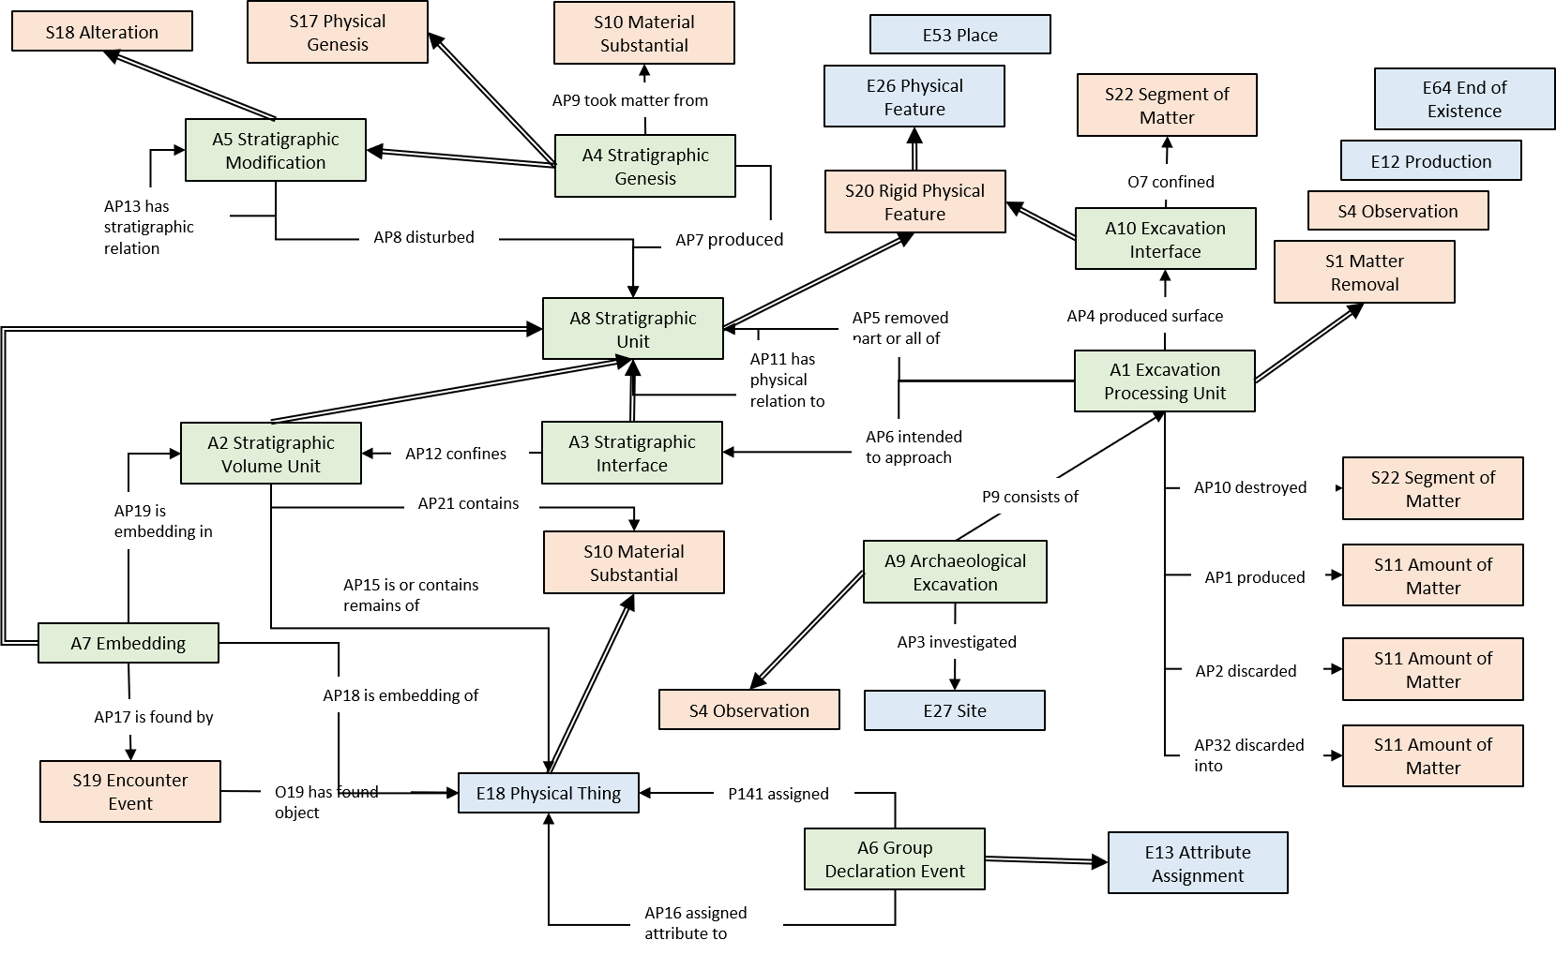

Figure 1a: CRMarchaeo classes and properties with relations to CRMbase and CRMsci classes

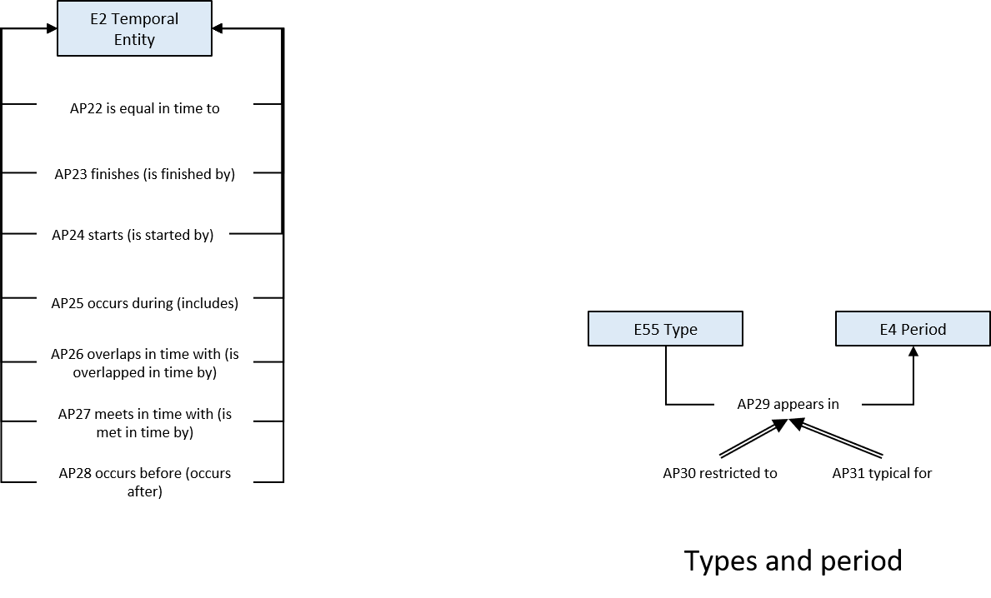

Figure 1b: CRMarchaeo properties with relations to CRMbase classes

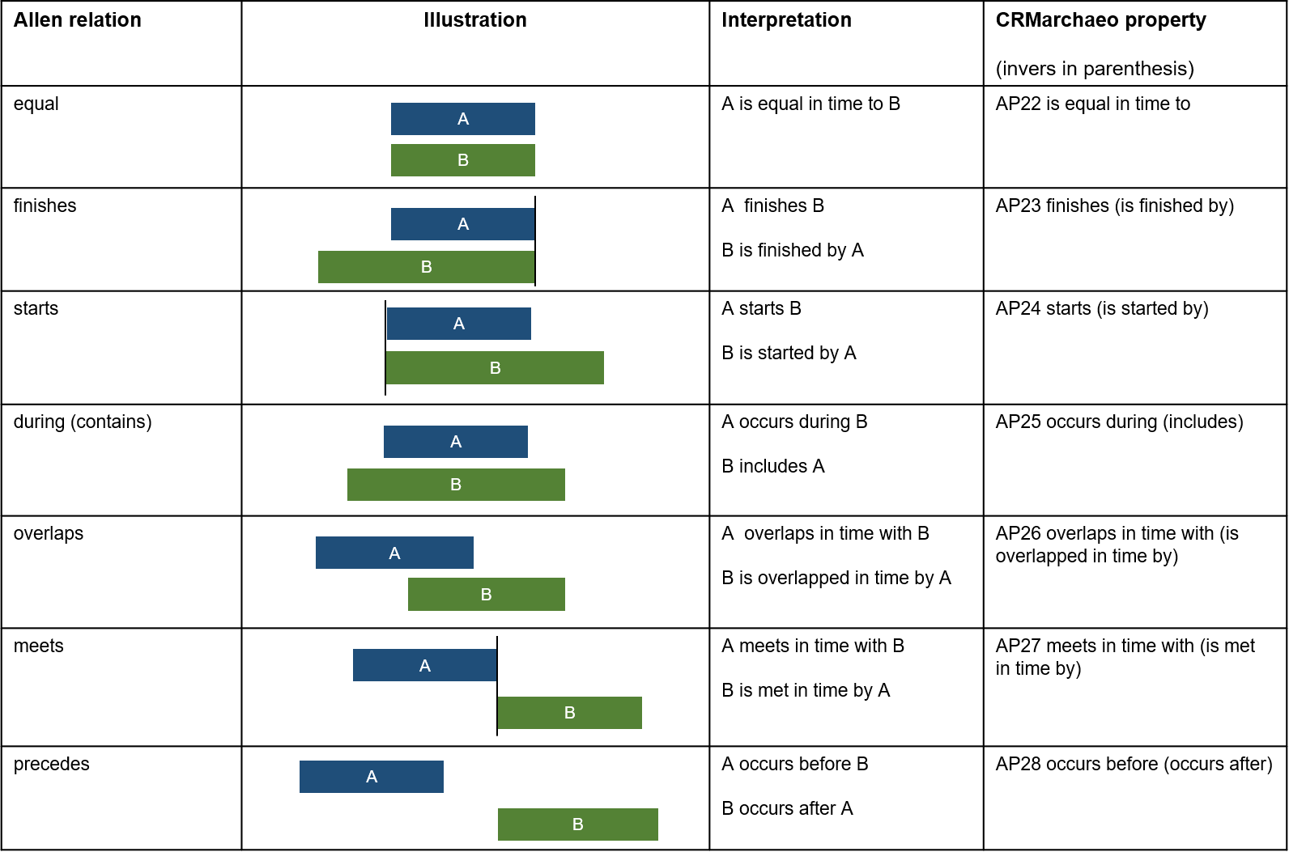

Figure 1c: The original Allen operators (Allen,1983) and the corresponding CRMarchaeo properties

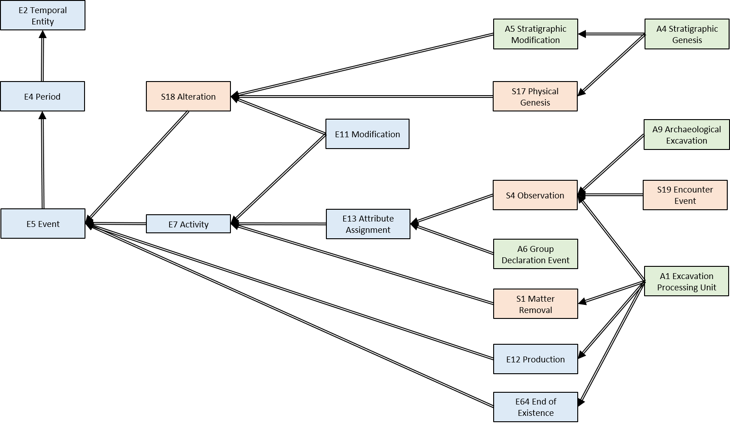

Figure 2: CRMarchaeo, temporal entities

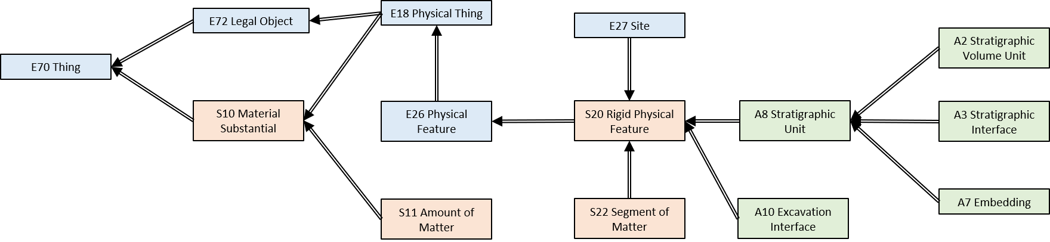

Figure 3: Things in CRMarchaeo

Class and property usage examples

The following examples are taken from the English Heritage Recording Manual (Harris, 1989) and try to illustrate the use of classes and properties of CRMarchaeo to represent the entities and relations of documentation praxis in relation to the Harris Matrix.
The stratigraphic sequence explains how the site was formed. For this example, we’ll work backwards and explain how the site was formed to make determining the stratigraphic sequence easier. Focussing near the top of Figure 4, the post-hole [3] was dug and the post inserted, the hole was packed (18). Eventually the post rotted away, leaving a post-pipe [19], into which later material accumulated (2) –see Figure 4a below.

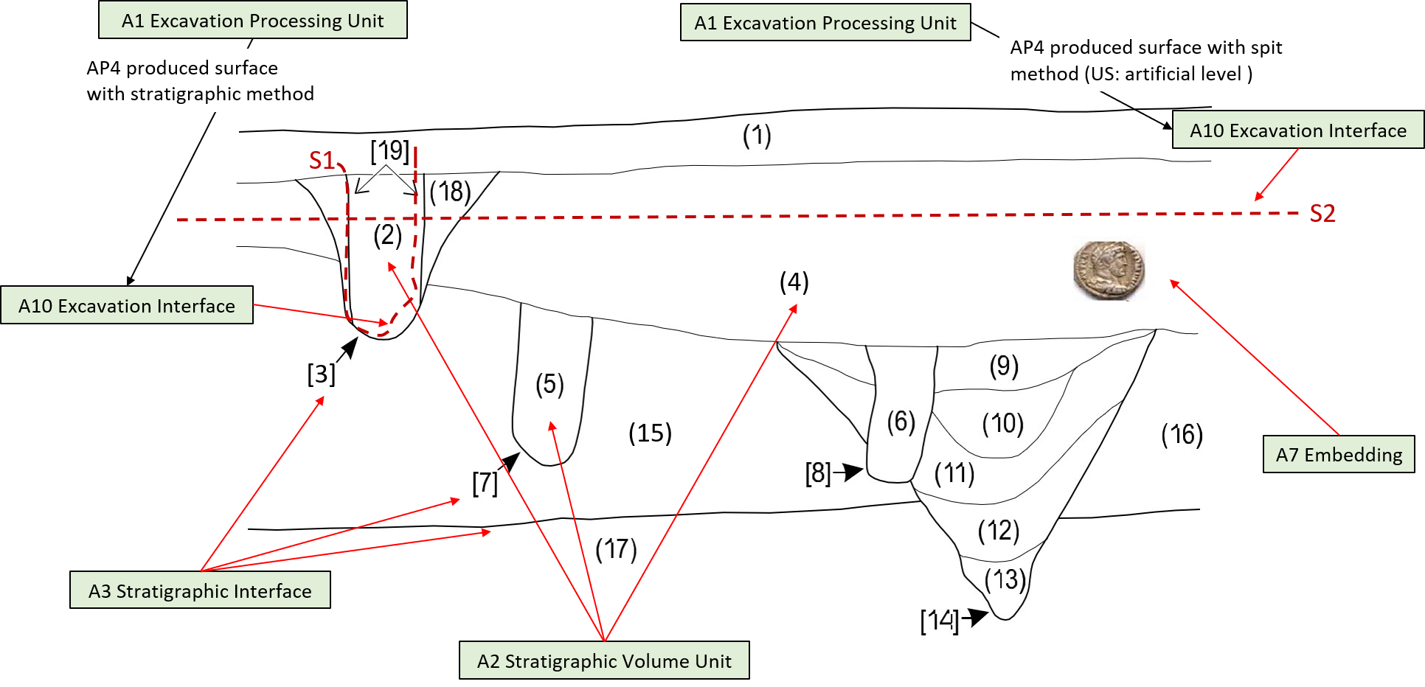

Figure 4a: Section drawing with A3 Stratigraphic Interfaces in square brackets [], A2 Stratigraphic Volume Unit in round brackets (), the surfaces S1 and S2 created through A1 Excavation Processing Units using different methodologies and an A7 Embedding of a coin.

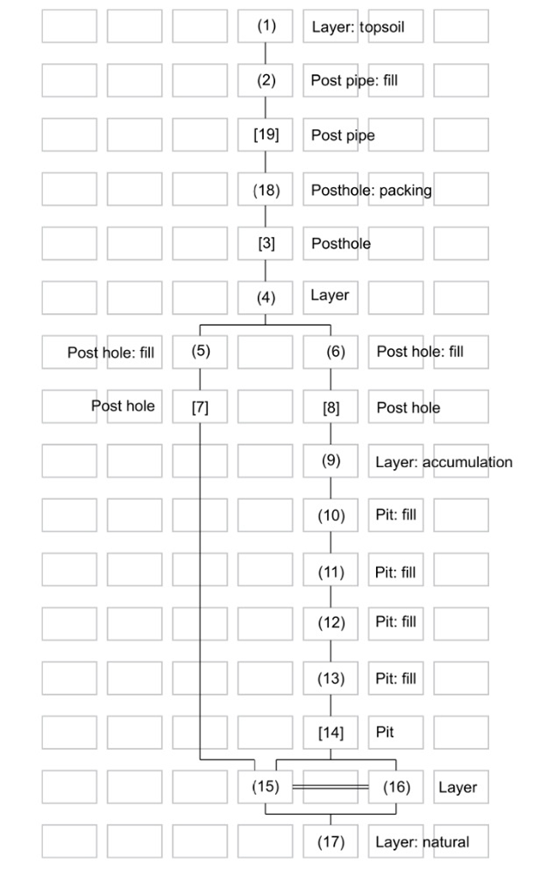

Figure 4b: A Harris Matrix showing a chronological interpretation for the section drawing in figure 4a. (Historic England Excavation Recording Manual, 2018)

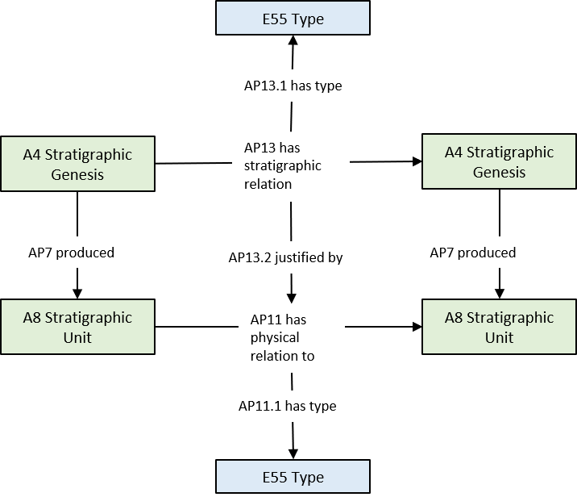

Figure 5: CRMarchaeo conceptualisation to represent stratigraphic relationships contained in Harris Matrix, being justified by physical relationships.

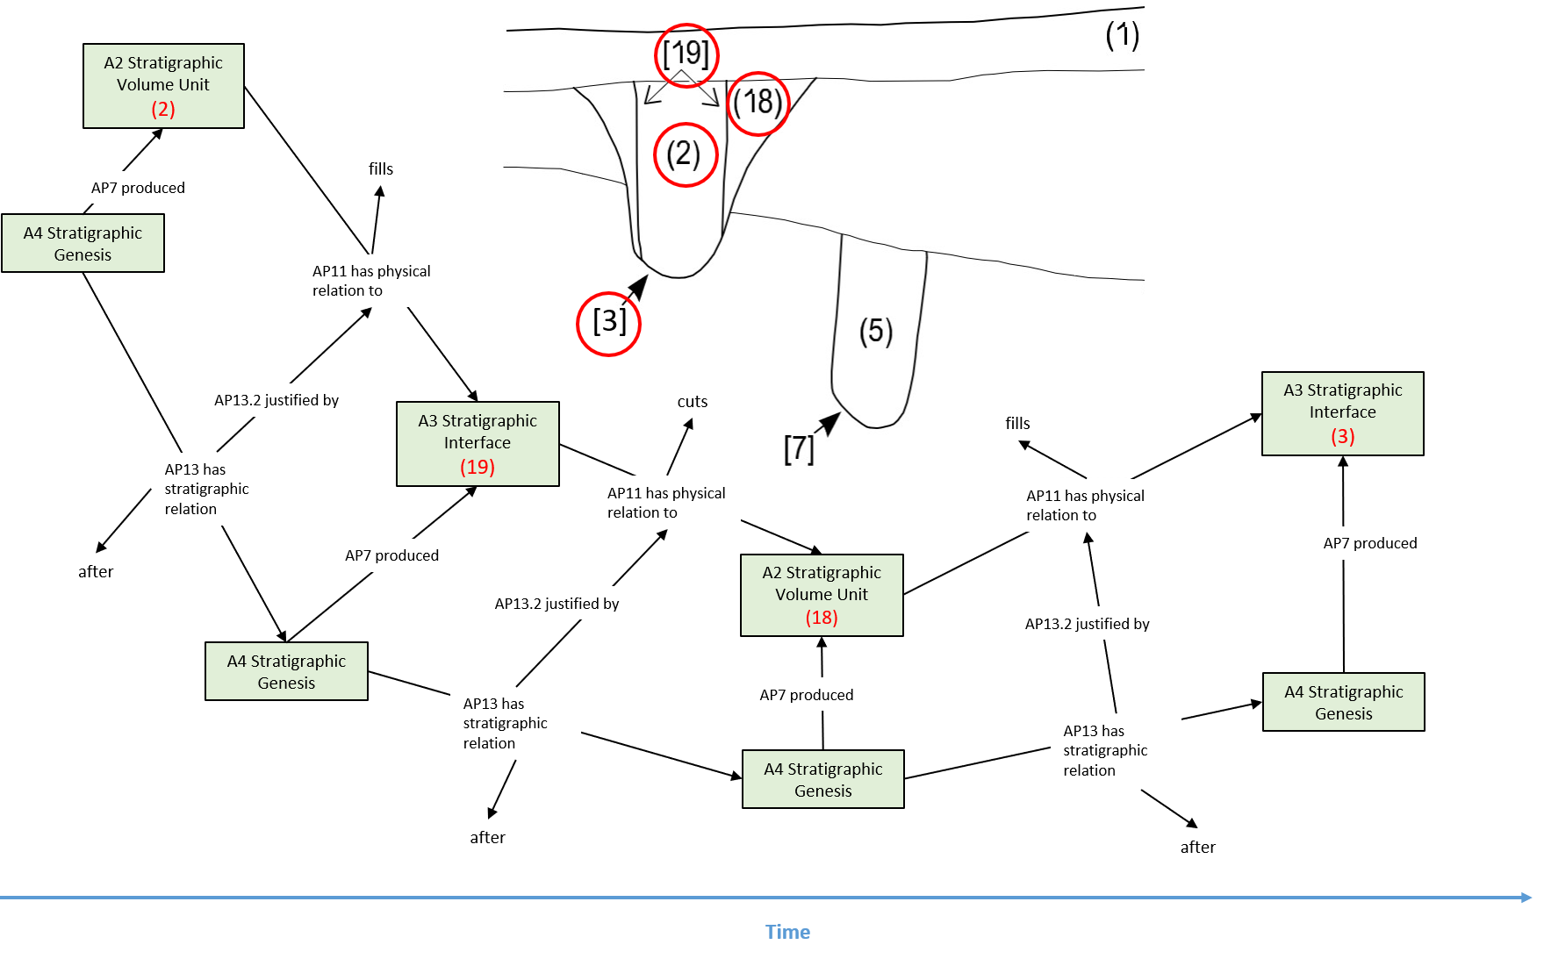

Figure 6: CRMarchaeo representation of a part (post-hole [3]) of the Harris Matrix for the section drawing (Figure 4a, and 4b)

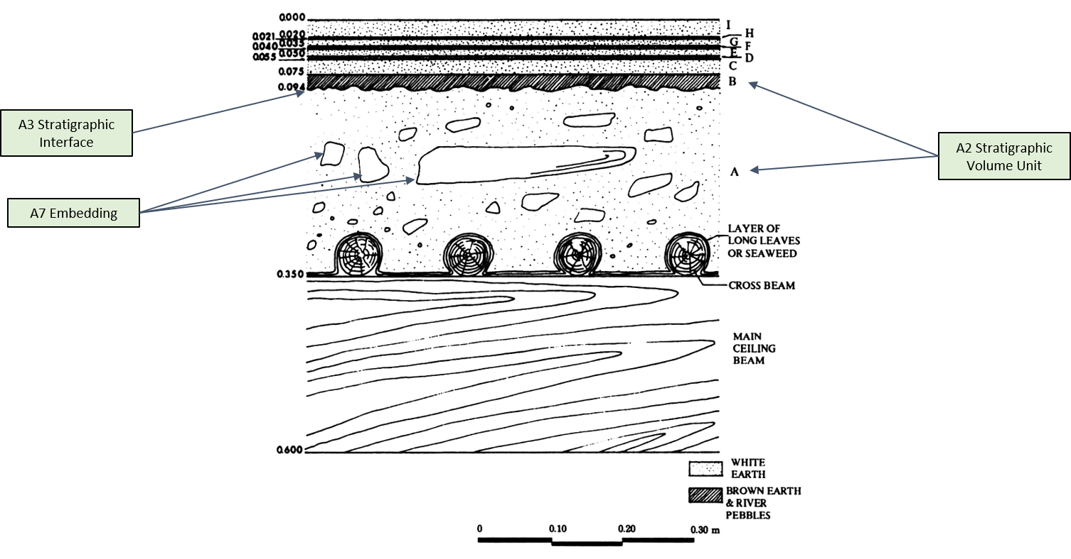

Figure 7: CRMarchaeo example of A2, A3 and A7 classes (Shaw, 1977; illustration 1), (Michailidou, 2001; figure 24)

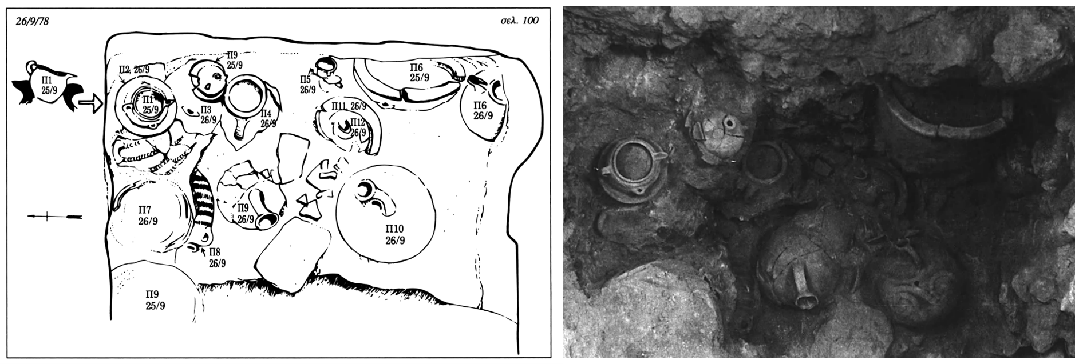

Figure 8: CRMarchaeo example where to use the class A7 Embedding (Michailidou, 2001; figures 55, 59). Western House, Room 6. Encounter of large pottery vessels embedded in the deposits of the room, during its excavation

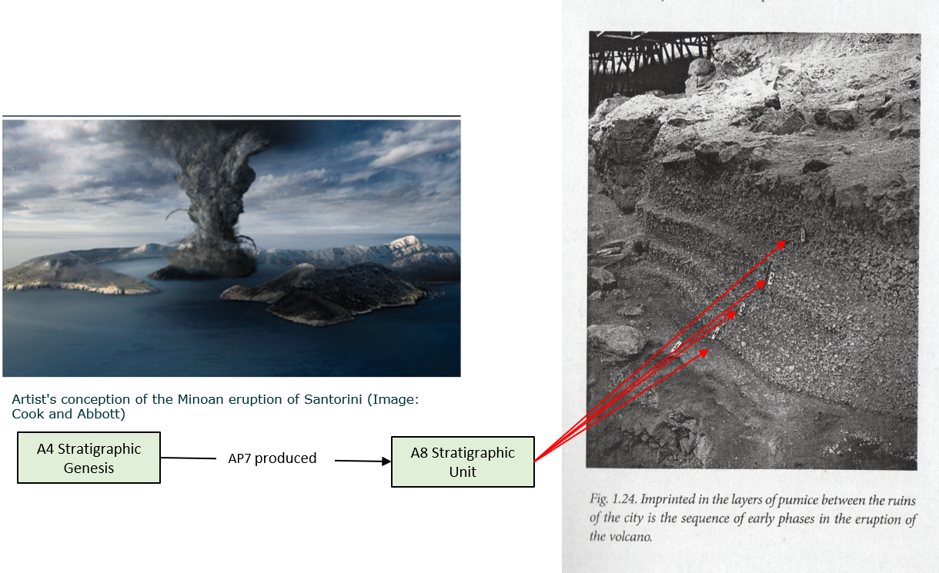

Figure 9: CRMarchaeo example of A4 and A8 classes (Doumas, 2015; figure 1.24)

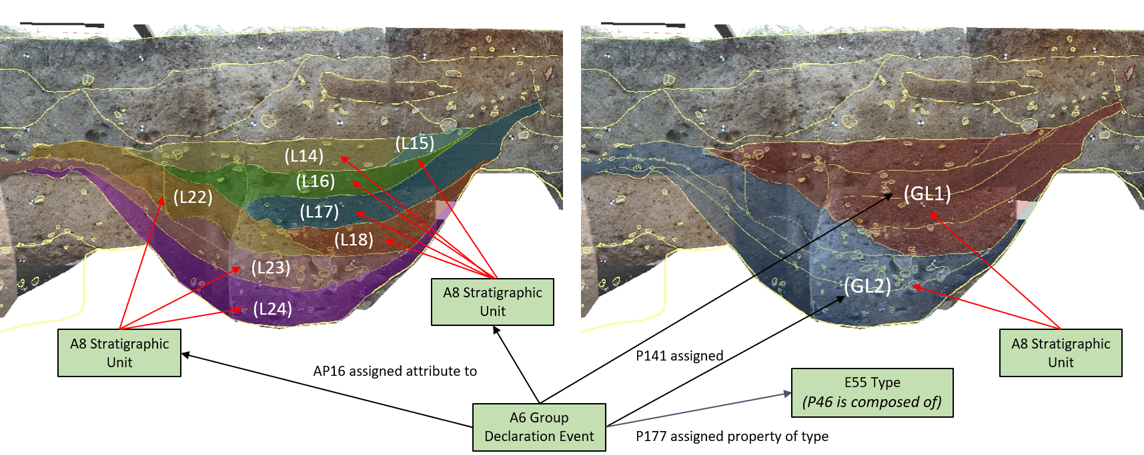

Figure 10: CRMarchaeo example of stratigraphic grouping process using the A6 class. Individual stratigraphic layers (A8) forming the fill of a neolithic ditch (Trenches 6 and 21 at the archaeological site of Paliambela Kolindros) are grouped into larger stratigraphic entities or fill episodes (A8).

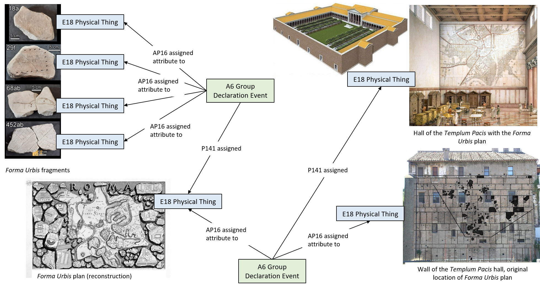

Figure 11: This figure shows the use of the A6 Group Declaration class and the related properties (AP16, P141) to document the reconstruction process of the original shape and location of the Forma Urbis Romae (https://formaurbis.stanford.edu/docs/FURmap.html) starting from the marble fragments of it found by scholars since the 16th century in different parts of the city. The figure shows how the AP16 property is used to assign the various fragments found by scholars (E18) to a single group of objects (A6) which in the past made up the original Forma Urbis (P141 –> E18). The same mechanism can be used to assign (AP16) the ancient Forma Urbis (E18) and the wall that originally housed it (E18) to the group (A6) of objects that in the past constituted the single structure of the Templum Pacis ancient building (E18).

CRMarchaeo Class Declarations

The classes are comprehensively declared in this section using the following format:

- Class names are presented as headings in bold face, preceded by the class’s unique identifier;
- The line “Subclass of:” declares the superclass of the class from which it inherits properties;
- The line “Superclass of:” is a cross-reference to the subclasses of this class;
- The line “Scope note:” contains the textual definition of the concept the class represents;
- The line “Examples:” contains a bulleted list of examples of instances of this class.
- The line “In first-order logic:” expresses the formal constraints of the class in terms of logical axioms in a First-Order Logic notation.
- The line “Properties:” declares the list of the class’s properties;
- Each property is represented by its unique identifier, its forward name and the range class that it links to, separated by colons;
- Inherited properties are not represented;
- Properties of properties, if they exist, are provided indented and in parentheses beneath their respective domain property.

A1 Excavation Processing Unit
Subclass of:
S1 Matter Removal
S4 Observation
E12 Production
E64 End of Existence
Scope Note:
This class comprises activities of excavating in the sense of archaeology, which are documented as a coherent set of actions of progressively recording and removing matter from a pre-specified location under specific rules. Typically, an instance of A1 Excavation Processing Unit would be terminated if significant discontinuities of substance or finds come to light, or if the activity is interrupted due to external factors, such as end of a working day. In other cases, the termination would be based on predefined physical specifications, such as the boundaries of a maximal volume of matter to be excavated in one unit of excavation.
Depending on the methodology, an instance of A1 Excavation Processing Unit may intend to remove matter only within the boundaries of a particular stratigraphic unit, or it may follow a pre-declared spatial extent such as a trench. It may only uncover, clean or expose a structure or parts of it.
The process of excavation results in the production of a set of recorded (documentation) data that should be sufficient to provide researchers enough information regarding the consistency and spatial distribution of the excavated Segment of Matter and things and features embedded in it. Some parts or all of the removed physical material (instances of S11 Amount of Matter) may be dispersed, whereas others may be kept in custody in the form of finds or samples, while others (such as parts of walls) may be left at the place of their discovery. The data produced by an instance of A1 Excavation Processing Unit should pertain to the material state of matter at excavation time only and should be clearly distinguished from subsequent interpretation about the causes for this state of matter.
The current class A1 Excavation Processing Unit is somewhat overloaded and may be split into two subclasses, one for the intellectual process and one for the physical process. This is left for a future refinement of the model.
Examples:
- The activity taking place on 21.9.2007 between 12:00 and 13:00 that excavated the Stratigraphic Volume Unit “(2)” of Figure 4 and created the surface “S1”
- The activity that excavated the first 20 cm of a spit excavation on 21.7.2007 created the surface “S2” in Figure 4.
In First Order Logic:
A1(x) ⇒ S1(x)
A1(x) ⇒ S4(x)
A1(x) ⇒ E12(x)
A1(x) ⇒ E64(x)
Properties:
AP1 produced (was produced by): S11 Amount of Matter
AP2 discarded (was discarded by): S11 Amount of Matter
AP4 produced surface (was surface produced by): A10 Excavation Interface
AP5 removed part or all of (was partially or totally removed by): A8 Stratigraphic Unit
AP6 intended to approximate (was approximated by): A3 Stratigraphic Interface
AP10 destroyed (was destroyed by): S22 Segment of Matter
AP32 discarded into (was discarded by): S11 Amount of Matter

A2 Stratigraphic Volume Unit
Subclass of:
A8 Stratigraphic Unit
Scope Note:
This class comprises instances of A8 Stratigraphic Unit which are connected portions of terrain or other solid structures on, in, or under the surface of earth or seafloor exhibiting some homogeneity of structure or substance and which are completely bounded by surfaces or discontinuities in substance or structure with respect to other portions of the terrain or surfaces of objects or finds.
Normally at least one of the surfaces, i.e. instances of A3 Stratigraphic Interface (such as the lower one), from the genesis event of the A2 Stratigraphic Volume Unit will remain during its existence.
An instance of A2 Stratigraphic Volume Unit may contain physical objects.
Examples:
- the stratigraphic deposit unit number “(2)” of Figure 6 representing the filling of post hole “[3]”
- thick layer “A”, consisting of grey soil and small tuff stones
[One of the principal successive layers making up a collapsed part of the roof of the West House, which was found in a horizontal position on the first floor during the excavation of Room 3 –see Figure 7] (Michailidou, 2021)
- thinner layer “B”, consisting of brownish red soil and marine pebbles
[One of the principal successive layers making up a collapsed part of the roof of the West House, which was found in a horizontal position on the first floor during the excavation of Room 3 –see Figure 7] (Michailidou, 2021)
In First Order Logic:
A8(x) ⇒ A2(x)
Properties:
AP21 contains (is contained in): E18 Physical Thing

A3 Stratigraphic Interface
Subclass of:
A8 Stratigraphic Unit
Scope Note:
This class comprises instances of A8 Stratigraphic Unit, which are coherent parts of a boundary surface that appear as the result of a stratigraphic genesis event or process. The interface marks the limit of the geometric extent of the effect of a genesis or modification event, and indicates in particular where the effect of this event ended. Each event of creation or destruction of a deposition layer implies the creation of new interfaces. Thus, there are two main types of interfaces: those that are surfaces of strata (that can be directly related to the corresponding stratum via the AP12 confines property), and those that are only surfaces, formed by the removal or destruction of existing stratifications.
Examples:
- the Stratigraphic Interface number “[19]” confining the Stratigraphic Volume Unit number “(2)” in Figure 6
- the stratigraphic interface separating layers “A” and “B”, in Figure 7 (Michailidou, 2021)
In First Order Logic:
A3(x) ⇒ A8(x)
Properties:
AP12 confines (is confined by): A2 Stratigraphic Volume Unit

A4 Stratigraphic Genesis
Subclass of:
S17 Physical Genesis
A5 Stratigraphic Modification
Scope Note:
This class comprises activities or processes that have produced homogeneous, distinguishable units of stratification that are in a relatively stable form from the time of their genesis until they are observed. Such processes may be the aggregation of cycles of erosion/destruction, deposit/accumulation, or transformation/modification occurring on a particular site throughout a particular period of time. These processes are usually not only due to natural forces (i.e., climate, the impact of flora and fauna, other natural events), but also to human activities, in particular excavation and construction. An event of stratification genesis typically produces two main forms of stratification units, both a deposit and an interface.
Examples:
- the production of the stratigraphic interface “[3]” by the cut in the pre-existing strata of the posthole –see Figure 6
- the production of the stratigraphic unit volume “(18)” via the filling of the posthole with detritus or some other matter –see Figure 6
- the creation of the one-meter-thick level of pumice caused by the Minoan eruption of Thera and consisting of five distinct layers, which covers the ruins at the excavation Akrotiri, Thera –see Figure 9 (Doumas et al., 2015)
- the creation of the 8-10-metre-thick level of successive layers volcanic ash deposed on top of the one-meter-thick level of pumice, which covers the ruins at the excavation Akrotiri, Thera—see Figure 9 (Doumas et al., 2015)
- the production of the deposits L14-L18 and L22-L24 by at least seven (7) distinct fill episodes of a neolithic ditch, observed at the northern section of Trenches 6 and 21, at the site Paliambela, Kolindros–see Figure 10
In First Order Logic:
A4(x) ⇒ S17(x)
A4(x) ⇒ A5(x)
Properties:
AP7 produced (was produced by): A8 Stratigraphic Unit
AP9 took matter from (provided matter to): S10 Material Substantial

A5 Stratigraphic Modification
Subclass of:
S18 Alteration
Scope Note:
This class comprises activities or processes resulting in the modification of Stratigraphic Units after their genesis through instances of A4 Stratigraphic Genesis Event.
Examples:
- the event that eroded the number “(1)” Stratigraphic Volume Unit in Figure 4 and diminished it to its actual size
- the creation of many burrows, of about 7 cm in diameter on average, due to rodents, lizards and insects disturbing otherwise intact layers, that were uncovered during the excavation at Eagle Cave, Texas (Larsen, 2015)
- the deformation of the saturated soil at the Dutton Paleo-Indian site, Colorado
[The deformation was caused by involutions (flame-structures) due to aquaturbations] (Wood and Johnson, 1978)
In First Order Logic:
A5(x) ⇒ S18(x)
Properties:
AP8 disturbed (was disturbed by): A8 Stratigraphic Unit
AP13 has stratigraphic relation (is stratigraphic relation of): A5 Stratigraphic Modification

A6 Group Declaration Event
Subclass of:
E13 Attribute Assignment
Scope Note:
This class comprises interpretive activities that lead to the recognition two or more instances of Stratigraphic Units (A8) or other Physical Thing (E18) that simultaneously exist at the time of this activity or at the time of an archaeological observation this activity refers to as source and that are attributed to be the remains of one complete instance of Physical Thing (E18) that had existed at a time of reference in the past. Instances of this class could be, for example: two stratigraphic units (with no evident contact) cut through by a ditch having been segments of the same original stratigraphic unit, two or more surviving parts of a structure having been segments of the same wall (B5), a number of postholes being the indication of a past wooden house or a number of potsherds being segments of the same original artefact.
Examples:
- declaring post holes “[7]” and “[8]” in Figure 4 to be part of one building
- grouping individual deposits forming the fill of the neolithic ditch (L14-18 and L22-24) in Trenches 6 and 21 at the archaeological site of Paliambela, Kolindros into larger stratigraphic entities or fill episodes –see Figure 10
In First Order Logic:
A6(x) ⇒ E13(x)
Properties:
AP16 assigned attribute to (was attributed by): E18 Physical Thing

A7 Embedding
Subclass of:
A8 Stratigraphic Unit
Scope Note:
This class comprises instances of A8 Stratigraphic Unit partially or completely embedding one or more instances of E20 Physical Thing and at a particular position with relative stability in one or more instances of A2 Stratigraphic Volume Units. Normally, an embedding is expected to have been stable from the time of generation of the first instance of A2 Stratigraphic Volume Unit that surrounds it. However, it may also be due to later intrusion. As an empirical fact, the expert may only be able to decide that a particular embedding is not recent, i.e. has been persisting for longer than the activity that encountered it. This class can be used to document the fact of embedding generally with respect to the surrounding matter or, more specifically, with respect to a more precise position within this matter.
Examples:
- the pottery vessels embedded within the deposit on the ground floor of the West House at Akrotiri, Thera
[The pottery vessels were discovered during the excavation process of Room 6 of the West House at Akrotiri –see Figure 8] (Michailidou, 2001)
- San Galgano’s sword embedded at the Hermitage of Monte Siepi
[He retired around 1170 to live as a hermit. As a symbol of peace, he embedded his sword in a stone, which can still be seen today] (Wikipedia, 2023)
In First Order Logic:
A7(x) ⇒ A8(x)
Properties:
AP17 is found by (found): S19 Encounter Event
AP18 is embedding of (is embedded): E18 Physical Thing
AP19 is embedding in (contains embedding): A2 Stratigraphic Volume Unit

A8 Stratigraphic Unit
Subclass of:
S20 Rigid Physical Feature
Superclass of:
A7 Embedding
A2 Stratigraphic Volume Unit
A3 Stratigraphic Interface
Scope Note:
This class comprises instances of S20 Rigid Physical Features which appear as the result of a stratigraphic genesis event or process. The form of an instance of A8 Stratigraphic Unit should be of a kind that can be attributed to a single genesis event or process and has the potential to be observed. One genesis event may have created more than one SU. An instance of A8 Stratigraphic Unit is regarded to exist as long as a part of its matter is still in place with respect to a surrounding reference space, such that its spatial features can be associated with effects of the genesis process of interest.
This also implies that a certain degree of coherent (“conformal”) deformation is tolerable within its time-span of existence. Therefore, the place an instance of A8 Stratigraphic Unit occupies can be uniquely identified with respect to the surrounding reference space of archaeological interest
Examples:
- post holes “[7]” and “[8]” (A3) in Figure 4
- the one-meter-thick level of pumice caused by the Minoan eruption of Thera, which consists of five distinct layers and covers the ruins at the excavation Akrotiri, Thera –see Figure 9 (Doumas et al., 2015)
In First Order Logic:
A8(x) ⇒ S20(x)
Properties:
AP11 has physical relation (is physical relation of): A8 Stratigraphic Unit
AP15 is or contains remains of (is or has remains contained in): S10 Material Substantial

A9 Archaeological Excavation
Subclass of:
S4 Observation
Scope Note:
This class describes the general concept of archaeological excavation intended as a coordinated set of activities performed on an area considered as part of a broader topographical, rural, urban, or monumental context. An archaeological excavation is usually under the responsibility of a coordinator, officially designated, which is legally and scientifically responsible for all the activities carried out within each instance of A1 Excavation Processing Unit and is also responsible for the documentation of the whole process.
Examples:
- excavating the West House found at the archaeological site of Akrotiri, Thera, between 1967 and 1973, led by the archaeologist Sp. Marinatos (Michailidou, 2001)
In First Order Logic:
A9(x) ⇒ S4(x)
Properties:
AP3 investigated (was investigated by): E27 Site

A10 Excavation Interface
Subclass of:
S20 Rigid Physical Feature
E25 Human Made Feature
Scope Note:
This class comprises instances of S20 Rigid Physical Feature that constitutes a surface produced through one or several instances of A1 Excavation Processing Unit. Instances are often documented through drawing and/or measured by technical means such as photography, tachymetry or laser scanning. Using a planar excavation methodology this is typically the surface of a planum or the surface of a profile. Using a stratigraphic excavation methodology, the instance of A10 Excavation Interface would have the intention to approximate an instance of A3 Stratigraphic Interface. The drawing and measurement of profiles is also common practice when a stratigraphic excavation methodology is used.
Examples:
- the Excavation Interface Planum 6 of square I22 in Area F-I, documented in the field drawing “Planum 6 F-I i22”, created in Fall 1982 (Bietak, 1996)
- the Excavation Interface Eastern profile of square I22 in Area F-I, documented in field drawing “Ostprofil F-I i22”, confining the excavation square I22 to the East (Hiebel, Aspöck and Kucera, 2017)
In First Order Logic:
A10(x) ⇒ S20(x)

CRMarchaeo Property Declarations

The properties are comprehensively declared in this section using the following format:

• Property names are presented as headings in bold face, preceded by unique property identifiers;
• The line “Domain:” declares the class for which the property is defined;
• The line “Range:” declares the class to which the property points, or that provides the values for the property;
• The line “Superproperty of:” is a cross-reference to any subproperties the property may have;
• The line “Scope note:” contains the textual definition of the concept the property represents;
• The line “Examples:” contains a bulleted list of examples of instances of this property.
- The line “In first-order logic:” expresses the formal constraints of the property in terms of logical axioms in a first-order logic notation.

AP1 produced (was produced by)
Domain:
A1 Excavation Processing Unit
Range:
S11 Amount of Matter
Subproperty of:
S2 Sample Taking. O2 removed (was removed by): S13 Sample
Quantification:
one to many (0,n:0,1)
Scope note:
This property identifies the S11 Amount of Matter, e.g. a basket, that is preserved (part or total of) from an instance of A1 Excavation Processing Unit for further examination or evidence keeping.
Examples:
- The excavation of the posthole (A1) produced an amount of black turf with wood inclusions (S11).
In First Order Logic:
AP1(x,y) ⇒ A1(x)
AP1(x,y) ⇒ S11 (y)
AP1(x,y) ⇒ O2(x,y)

AP2 discarded (was discarded by)
Domain:
A1 Excavation Processing Unit
Range:
S11 Amount of Matter
Subproperty of:
S2 Sample Taking. O2 removed (was removed by): S13 Sample
Quantification:
one to many (0,n:0,1)
Scope note:
This property identifies an instance of S11 Amount of Matter discarded (e.g. onto a heap) by an instance of A1 Excavation Processing Unit.
Examples:
- The stratum of ash, pumice and other volcanic material removed (S11) was discarded by the excavation of Villa of the Mysteries in Pompeii, Italy (A1). (Maiuri, 1931)
In First Order Logic:
AP2(x,y) ⇒ A1(x)
AP2(x,y) ⇒ S11(y)
AP2(x,y) ⇒ O2(x,y)

AP3 investigated (was investigated by)
Domain:
A9 Archaeological Excavation
Range:
E27 Site
Subproperty of:
S4 Observation. O8 observed (was observed by): S15 Observable Entity
Quantification:
one to many (0,n:0,1)
Scope note:
This property identifies the 3D excavated volume instance of E27 Site, i.e., a three- dimensional volume, that was actually investigated during an A9 Archaeological Excavation.
Examples:
- The 1938 archaeological excavation, carried out by Pietro Romanelli (A9), investigated the archaeological site of the ancient Etruscan city of Tarquinia (E27). (Romanelli, 1940)
In First Order Logic:
AP3(x,y) ⇒ A9(x)
AP3(x,y) ⇒ E27(y)
AP3(x,y) ⇒ O8(x,y)

AP4 produced surface (was surface produced by)
Domain:
A1 Excavation Processing Unit
Range:
A10 Excavation Interface
Subproperty of:
E12 Production. P108 has produced (was produced by): E24 Human-Made Thing
Quantification:
one to many (0,n:0,1)
Scope note:
This property identifies the instance of A10 Excavation Interface that constitutes the new surface produced during an instance of A1 Excavation Processing Unit in the excavated area. Frequently this surface or parts of it are documented through drawing and/or measured by technical means such as photography, tachymetry or laser scanning.
Examples:
- The excavation of the south trench in 1949 (A1) produced surface the confinement of the south part of the archaeological site of Sybaris, Italy (A10). (Guzzo, 2014)
In First Order Logic:
AP4(x,y) ⇒ A1(x)
AP4(x,y) ⇒ A10 (y)
AP4(x,y) ⇒ O2(x,y)
AP4(x,y) ⇒ P108(x,y)

AP5 removed part or all of (was partially or totally removed by)
Domain:
A1 Excavation Processing Unit
Range:
A8 Stratigraphic Unit
Subproperty of:
S1 Matter Removal. O1 diminished (was diminished by): S10 Matter Substantial
Quantification:
one to many (0,n:0,1)
Scope note:
This property identifies the instance of A8 Stratigraphic Unit that was cut during an A1 Excavation Processing Unit.
Examples:
- The spit excavation producing the surface “S2” (A1) removed part or all of the structures and infill marked “2”, “3”, “4”, “18”, and “19”, (A8) in Figure 4a.
In First Order Logic:
AP5(x,y) ⇒ A1(x)
AP5(x,y) ⇒ A8(y)
AP5(x,y) ⇒ O2(x,y)

AP6 intended to approximate (was approximated by)
Domain:
A1 Excavation Processing Unit
Range:
A3 Stratigraphic Interface
Subproperty of:
S4 Observation. O8 observed (was observed by): S15 Observable Entity
Quantification:
one to many (0,n:0,1)
Scope note:
This property identifies the A3 Stratigraphic Interface that was intended to approximate during an A1 Excavation Processing Unit. This property should be assigned when a stratigraphic excavation methodology is used. It enables the linkage of the surface produced by an A1 Excavation Processing Unit and an A3 Stratigraphic Interface.
Examples:
- The excavation at ancient Akrotiri (A1) intended to approximate the various interfaces witnessing the sequences of the Minoan eruption of Thera (A3), see Figure 9.
- The excavation (A1) of the neolithic ditch at Trenches 6 and 21 at Paliambela, Kolindros, intended to approximate the various interfaces witnessing the sequence of the ditch's fill episodes (A3), see Figure 9.
In First Order Logic:
AP6(x,y) ⇒ A1(x)
AP6(x,y) ⇒ A3 (y)
AP6(x,y) ⇒ O8(x,y)

AP7 produced (was produced by)
Domain:
A4 Stratigraphic Genesis
Range:
A8 Stratigraphic Unit
Subproperty of:
S17 Physical Genesis. O17 generated (was generated by): E18 Physical Thing
Quantification:
one to many (0,n:0,1)
Scope note:
This property identifies the instance of A8 Stratigraphic Unit that was produced during an instance of A4 Stratigraphic Genesis Event.
Examples:
- The one-meter-thick level of pumice covering the ruins at Akrotiri, Thera, (A8) was produced by the Minoan eruption of Thera –see Figure 9. (Doumas et al., 2015)
- The 8-10-metre-thick level of successive layers volcanic ash deposed on top of the one-meter-thick level of pumice covering the ruins at Akrotiri, Thera, was produced by the Minoan eruption of Thera –see Figure 9. (Doumas et al., 2015)
In First Order Logic:
AP7(x,y) ⇒ A4(x)
AP7(x,y) ⇒ A8(y)
AP7(x,y) ⇒ O17(y)

AP8 disturbed (was disturbed by)
Domain:
A5 Stratigraphic Modification
Range:
A8 Stratigraphic Unit
Subproperty of:
S18 Alteration. O18 altered (was altered by): E18 Physical Thing
Quantification:
one to many (0,n:0,1)
Scope note:
This property identifies an A8 Stratigraphic Unit that was disturbed through an A5 Stratigraphic Modification. One A5 Stratigraphic Modification may disturb several A8 Stratigraphic Units.
Examples:
- Rodents, lizards, and insects burrowing into the ground led to the creation of burrows (A5) discovered during the excavation at Eagle Cave, Texas, which disturbed the otherwise intact stratigraphic layers of the archaeological site (A8). (Larsen, 2015)
In First Order Logic:
AP8(x,y) ⇒ A5(x)
AP8(x,y) ⇒ A8(y)
AP8(x,y) ⇒ O18(y)

AP9 took matter from (provided matter to)
Domain:
A4 Stratigraphic Genesis
Range:
S10 Material Substantial
Subproperty of:
S18 Alteration. O18 altered (was altered by): E18 Physical Thing
Quantification:
one to many (0,n:0,1)
Scope note:
This property associates an instance of A4 Stratigraphic Genesis with an instance of S10 Material Substantial, from which matter was incorporated in the instance of A8 Stratigraphic Unit produced by this genesis.
The instance of A8 Stratigraphic Unit produced by an instance of A4 Stratigraphic Genesis can be documented by using the property AP7 produced (was produced by) and should be distinct from the instance of S10 Material Substantial from which matter was taken. The latter instance will be modified or cease to exist due to this genesis process.
Examples:
- The formation of two slab deposit layers on the ground floor of Room 5 of the West House in ancient Akrotiri (A4) took matter from the slabs of the collapsed upper storey’s paved floor. (Michailidou, 2001)
In First Order Logic:
AP9(x,y) ⇒ A4(x)
AP9(x,y) ⇒ S10(y)
AP9(x,y) ⇒ O18(x,y)

AP10 destroyed (was destroyed by)
Domain:
A1 Excavation Processing Unit
Range:
S22 Segment of Matter
Subproperty of:
E64 End of Existence. P93 took out of existence (was taken out of existence by): E77 Persistent Item
Quantification:
one to many, necessary (1,n:0,1)
Scope note:
This property identifies the S22 Segment of Matter that was destroyed through an A1 Excavation Processing Unit. The spatial extent of the instance of S22 Segment of Matter is defined by the extent of the spatial 3-dimensional projection of the A1 Excavation Processing Unit. Depending on the granularity of the documented instance of A1 Excavation Processing Unit, different instances of S22 Segment of Matter may be identified by the A10 property.
Examples:
- The complete excavation of Villa of the Mysteries in Pompeii, Italy (A1) destroyed the stratum of ash, pumice, and other volcanic material (S22). (Maiuri, 1931)
In First Order Logic:
AP10(x,y) ⇒ A1(x)
AP10(x,y) ⇒ S22(y)
AP10 (x,y) ⇒ P13(x,y)

AP11 has physical relation to (is physical relation from)
Domain:
A8 Stratigraphic Unit
Range:
A8 Stratigraphic Unit
Quantification:
many to many (0,n:0,n)
Scope note:
This property identifies the physical relationship between two A8 Stratigraphic Units. The described relationship may be between two adjacent instances of A2 Stratigraphic Volume Unit sharing a common interface (instance of A3 Stratigraphic Interface), between an instance of A2 Stratigraphic Volume Unit and one of its adjacent interfaces, such as human-made cuts or earthquake induced faults, or even between two intersecting interfaces.
The type of physical relationships found between stratigraphic units in archaeological or geological documentation is documented through the property AP11.1 has type. The type applies to the direction from the domain to the range of the property AP11 has physical relation to (is physically related from). The type of physical relationship typically constitutes strong evidence for the sequence of genesis of the related stratigraphic units, which can be documented by the property AP13 has stratigraphic relation to (is stratigraphically related by). The type may either pertain to a relative topology, such as the one being “under” the other, or to the fine-structure of the interface between them, such as a layer of concrete having filled out earlier micro-cavities in various directions in the interface before solidifying.
Examples:
- The layer of burned remains of the log building in Søndre gate, Trondheim, Norway, (A8) has physical relation to under the foundation of the church of St. Clements (A8). (Norwegian Institute for Cultural Heritage Research, 2018)
- The floors at B of the building 1 in Çatalhöyük, Turkey (A8) has physical relation to wall C (A8) has type runs up to (E55) [as observed initially] (Hodder, 1999)
- The wall C of the building 1 in Çatalhöyük, Turkey (A8) has physical relation to the floors at B (A8) has type inserted by cut (E55) [as observed finally] (Hodder, 1999)
- The wall C of the building 1 in Çatalhöyük, Turkey (A8) has physical relation to wall D (A8) has type abuts on (E55). (Hodder, 1999)
- The wall D of the building 1 in Çatalhöyük, Turkey (A8) has physical relation to the floors at B (A8) has type on top of (E55). (Hodder, 1999)
In First Order Logic:
AP11(x,y) ⇒ A8(x)
AP11(x,y) ⇒ A8 (y)
AP11.1 (x,y,z) ⇒ [AP11 (x,y) ∧ E55(z)]
Properties:
AP11.1 has type: E55 Type

AP12 confines (is confined by)
Domain:
A3 Stratigraphic Interface
Range:
A2 Stratigraphic Volume Unit
Quantification:
many to many (0,n:0,n)
Superproperty of:
S20 Rigid Physical Feature. O7 confined (was confined by): S10 Material Substantial
Scope note:
This property identifies partly or completely the surface (A3 Stratigraphic Interface) of an A2 Stratigraphic Volume Unit. One A3 Stratigraphic Interface may confine two or more A2 Stratigraphic Volume Units.
Examples:
- The Stratigraphic Interface “[19]” (A3) confines the Stratigraphic Volume Unit “(2)” (A2) –see Figure 4a, above.

In First Order Logic:
AP12(x,y) ⇒ A3(x)
AP12(x,y) ⇒ A2(y)

AP13 has stratigraphic relation to (is stratigraphic relation of)
Domain:
A5 Stratigraphic Modification
Range:
A5 Stratigraphic Modification
Quantification:
one to many (0,n:0,1)
Scope note:
This property identifies the stratigraphic relation between two A5 Stratigraphic Modification events. This relation may be inferred from the kind of physical relation that exists between the two AP 8 Stratigraphic Units that have been created or modified during the corresponding A5 Stratigraphic Modification events. The type of stratigraphic relationships in archaeological documentation assigned to two A5 Stratigraphic Modification events is documented through the property AP 13.1 has type.
Examples:
- The burning of the log building in Søndre gate, Trondheim, Norway, (A5) has stratigraphic relation to the laying of the foundation for the church of St. Clements (A5) has type earlier (E55). (Norwegian Institute for Cultural Heritage Research, 2018)
- The production of the floors at B of the building 1 in Çatalhöyük, Turkey (E12) has stratigraphic relation to the production of wall C (E12) has type after (E55). [as observed initially, see AP11] (Hodder, 1999)
- The production of wall C of the building 1 in Çatalhöyük, Turkey (A5) has stratigraphic relation to the production of the floors at B (A5) has type after (E55). [as observed finally, see AP11] (Hodder,, 1999)
- The production of the wall C of the building 1 in Çatalhöyük, Turkey (A5) has stratigraphic relation to the production of wall D (A5) has type after (E55). [See AP11] (Hodder, 1999)
- The production of the wall D of the building 1 in Çatalhöyük, Turkey (A5) has stratigraphic relation to the production of the floors B’ (A5) has type after (E55). [See AP11] (Hodder, 1999)
Properties:
AP13.1 has type: E55 Type
AP13.2 justified by (is justification of): AP11 has type (type of physical relation)

In First Order Logic:
AP13(x,y) ⇒ A5(x)
AP13(x,y) ⇒ A5(y)
AP13.1(x,y,z) ⇒ [AP13 (x,y) ∧ E55(z)]

AP13.2 justified by (is justification of)
Domain:
AP13 has stratigraphic relation to
Range:
AP11 has physical relation to
Quantification:
many to many (0,n:0,n)
Scope note:
This property identifies the type of physical relation (including type) that was used to justify the type of stratigraphic relationship (including its type) that was assigned to the relation between two A5 Stratigraphic Modification events. Physical relations of “above” or “fills” may justify the stratigraphic relation type “after”. Figure 5 gives a graphical representation and Figure 6 shows an example.
Examples:
- {The layer of burned remains of the log building in Søndre gate, Trondheim, Norway, (A8) has physical relation to the foundation of the church of St. Clements (A8) has type under (E55)} (AP13) is justification of {the burning of the log building (A5) has stratigraphic relation (is stratigraphic relation of) the laying of the foundation for the church of St. Clements (A5) has type earlier (E55)} (AP11) (Norwegian Institute for Cultural Heritage Research, 2018)
In First Order Logic:
AP13.2(u,v,w,x,y,z) ⇒ AP13.1(u,v,w)
AP13.2(u,v,w,x,y,z) ⇒ AP11.1(x,y,z)
AP13.2(u,v,w,x,y,z) ⇒ AP7(u,x)
AP13.2(u,v,w,x,y,z) ⇒ AP7(v,y)

AP15 is or contains remains of (is or has remains contained in)
Domain:
A2 Stratigraphic Volume Unit
Range:
S10 Material Substantial
Quantification:
one to many (0,n:0,1)
Scope note:
This property indicates that an instance of A2 Stratigraphic Volume Unit can be the remains of or contain the remains of an instance of S10 Material Substantial.
Examples:
- The posthole “Dilling 2AS34019” (A2) is or contains remains of the rotten bottom part of a pole (S10).
In First Order Logic:
AP15(x,y) ⇒ A2(x)
AP15(x,y) ⇒ S10(y)

AP16 assigned attribute to (was attributed by)
Domain:
A6 Group Declaration Event
Range:
E18 Physical Thing
Subproperty of:
E13 Attribute Assignment. P140 assigned attribute to (was attributed by): E1 CRM Entity
Quantification:
one to many (0,n:0,1)
Scope note:
This property indicates an instance of E18 Physical Thing that was assigned by an instance of A6 Group Declaration Event as remains of the target of this instance of A6 Group Declaration Event.
Examples:
- declaring post holes “[7]” and “[8]” in Figure 4 to be part of one building (A6) assigned attribute to the post holes [7] and [8] (E18) –see Figure 4a.
In First Order Logic:
AP16(x,y) ⇒ A6(x)
AP16(x,y) ⇒ E18(y)
AP16(x,y) ⇒ P140(x,y)

AP17 is found by (found)
Domain:
A7 Embedding
Range:
S19 Encounter Event
Subproperty of:
S4 Observation. O8 observed (was observed by): S15 Observable Entity
Quantification:
one to many (0,n:0,1)
Scope note:
This property associates an instance of S19 Encounter Event with an instance of A7 Embedding that has been found during this event.
Examples:
- The small whetstone with an erratic runic inscription that was embedded in a medieval rubbish dump (A7) is found by the discovery of the whetstone in the early morning in November 2017 in Oslo, Norway (S19). (Norwegian Institute for Cultural Heritage Research, 2017)
In First Order Logic:
AP17(x,y) ⇒ A7(x)
AP17(x,y) ⇒ S19(y)
AP17(x,y) ⇒ O8(x,y)

AP18 is embedding of (is embedded)
Domain:
A7 Embedding
Range:
E18 Physical Thing
Subproperty of:
E18 Physical Thing. P46 is composed of (forms part of): E18 Physical Thing
Quantification:
one to many (0,n:0,1)
Scope note:
This property identifies the E18 Physical Thing that is contained in an A7 Embedding.
Examples:
- The embedding of the small whetstone with an erratic runic inscription in a medieval rubbish dump (A7) is embedding of this whetstone, discovered in the early morning in November 2017 in Oslo, Norway (E18). (Norwegian Institute for Cultural Heritage Research, 2017)
In First Order Logic:
AP18(x,y) ⇒ A7(x)
AP18(x,y) ⇒ E18(y)
AP18(x,y) ⇒ P44(x,y)

AP19 is embedding in (contains embedding)
Domain:
A7 Embedding
Range:
A2 Stratigraphic Volume Unit
Quantification:
one to many (1,1:0,n)
Scope note:
This property identifies the instance of A2 Stratigraphic Volume Unit that contains the A7 Embedding. An Embedding may not extend over more than one instance of A2 Stratigraphic Volume Unit.
Examples:
- The embedding of the small whetstone with an erratic runic inscription, discovered in the early morning in November 2017 in Oslo, Norway, in a medieval rubbish dump (A7) is embedding in the medieval rubbish dump “Follo234532” (A2). (Norwegian Institute for Cultural Heritage Research, 2017)
In First Order Logic:
AP19(x,y) ⇒ A7(x)
AP19(x,y) ⇒ A2(y)

AP21 contains (is contained in)
Domain:
A2 Stratigraphic Volume Unit
Range:
E18 Physical Thing
Quantification:
one to many (0,n:0,1)
Scope note:
This property associates an E18 Physical Thing that is found within an A2 Stratigraphic Volume Unit with the stratigraphic volume unit. AP21 contains (is contained in) is a shortcut for the more detailed path from E18 Physical Thing through AP18i is embedded, A7 Embedding, AP19 is embedding in, A2 Stratigraphic Volume Unit.
Examples:
- A mediaeval rubbish dump in Oslo, Norway, (A2) contains a whetstone, discovered in the early morning in November 2017 in Oslo, Norway (E18). (Norwegian Institute for Cultural Heritage Research, 2017)
In First Order Logic:
AP21(x,y) ⇒ A2(x)
AP21(x,y) ⇒ E18(y)

AP22 is equal in time to
Domain:
E2 Temporal Entity
Range:
E2 Temporal Entity
Subproperty of:
E2 Temporal Entity. P175 starts before or with the start of (starts after or with the start of): E2 Temporal Entity
E2 Temporal Entity. P175i starts after or with the start of (starts before or with the start of): E2 Temporal Entity
E2 Temporal Entity. P184 ends before or with the end of (ends with or after the end of): E2 Temporal Entity
E2 Temporal Entity. P184i ends with or after the end of (ends before or with the end of): E2 Temporal Entity
Quantification:
many to many (0,n:0,n)
Scope note:
This property symmetrically identifies a situation in which the starting point and the ending point for an instance of E2 Temporal Entity is equal to the starting point and the ending point of another instance of E2 Temporal Entity, respectively.
This property is only necessary if the time span is unknown (otherwise the equivalence can be calculated).
This property is the same as the "equal" relationship of Allen’s temporal logic (Allen, 1983, pp. 832-843).
This property is transitive.
Example:
- The burning of the Temple of Artemis at Ephesus (E6) is equal in time to the birth of Alexander the Great E69 [on July 6, 356 BC as reported by Plutarch in Vitae Parallelae, III, 3]. (Plutarch, 1919)
In First Order Logic:
AP22(x,y) ⇒ E2(x)
AP22(x,y) ⇒ E2(y)
AP22(x,y) ⇒ P175(x,y)
AP22(x,y) ⇒ P175i(x,y)
AP22(x,y) ⇒ P184(x,y)
AP22(x,y) ⇒ P184i(x,y)

AP23 finishes (is finished by)
Domain:
E2 Temporal Entity
Range:
E2 Temporal Entity
Subproperty of:
E2 Temporal Entity.P176i starts after the start of (starts before the start of): E2 Temporal Entity
E2 Temporal Entity. P184 ends before or with the end of (ends with or after the end of): E2 Temporal Entity
E2 Temporal Entity. P184i ends with or after the end of (ends before or with the end of): E2 Temporal Entity
Quantification:
many to many (0,n:0,n)
Scope note:
This property identifies a situation in which the ending point of an instance of E2 Temporal Entity is equal to the ending point of another temporal entity of longer duration. There is no causal relationship implied by this property.
This property is only necessary if the time span is unknown (otherwise the relationship can be calculated). This property is the same as the "finishes / finished-by" relationships of Allen’s temporal logic (Allen, 1983, pp. 832-843).
This property is transitive.
Example:
- Late Bronze Age (E4) finishes Bronze Age (E4).
In First Order Logic:
AP23(x,y) ⇒ E2(x)
AP23(x,y) ⇒ E2(y)
AP23(x,y) ⇒ P76i(x,y)
AP23(x,y) ⇒ P184(x,y)
AP23(x,y) ⇒ P184i(x,y)

AP24 starts (is started by)
Domain:
E2 Temporal Entity
Range:
E2 Temporal Entity
Subproperty of:
E2 Temporal Entity. P175 starts before or with the start of (starts after or with the start of): E2 Temporal Entity
E2 Temporal Entity. P175i starts after or with the start of (starts before or with the start of): E2 Temporal Entity
E2 Temporal Entity. P185 ends before the end of (ends after the end of): E2 Temporal Entity
Quantification:
many to many (0,n:0,n)
Scope note:
This property identifies a situation in which the starting point for an instance of E2 Temporal Entity is equal to the starting point of another instance of E2 Temporal Entity of longer duration.
This property is only necessary if the time span is unknown (otherwise the relationship can be calculated). This property is the same as the "starts / started-by" relationships of Allen’s temporal logic (Allen, 1983, pp. 832-843).
This property is transitive.
Examples:
- Early Bronze Age (E4) starts Bronze Age (E4).
In First Order Logic:
AP24(x,y) ⇒ E2(x)
AP24(x,y) ⇒ E2(y)
AP24(x,y) ⇒ P175(x,y)
AP24(x,y) ⇒ P175i(x,y)
AP24(x,y) ⇒ P185(x,y)

AP25 occurs during (includes)
Domain:
E2 Temporal Entity
Range:
E2 Temporal Entity
Subproperty of:
E2 Temporal Entity.P176i starts after the start of (starts before the start of): E2 Temporal Entity
E2 Temporal Entity.P185 ends before the end of (ends after the end of): E2 Temporal Entity
Quantification:
many to many (0,n:0,n)
Scope note:
This property identifies the situation in which the entire temporal extent of an instance of E2 Temporal Entity is within the temporal extent of another instance of E2 Temporal Entity that starts before and ends after the included temporal entity.
This property is only necessary if the time span is unknown (otherwise the relationship can be calculated). This property is the same as the "during / includes" relationships of Allen’s temporal logic (Allen, 1983, pp. 832-843).
This property is transitive.
Example:
- Middle Saxon period (E4) occurs during Saxon period (E4).
In First Order Logic:
AP25(x,y) ⇒ E2(x)
AP25(x,y) ⇒ E2(y)
AP25(x,y) ⇒ P176i(x,y)
AP25(x,y) ⇒ P185(x,y)

AP26 overlaps in time with (is overlapped in time by)
Domain:
E2 Temporal Entity
Range:
E2 Temporal Entity
Subproperty of:
E2 Temporal Entity.P174i ends after the start of (starts before the end of): E2 Temporal Entity
E2 Temporal Entity.P176 starts before the start of (starts after the start of): E2 Temporal Entity
E2 Temporal Entity.P185 ends before the end of (ends after the end of): E2 Temporal Entity
Quantification:
many to many (0,n:0,n)
Scope note:
This property identifies a situation in which there is an overlap between the temporal extents of two instances of E2 Temporal Entity.
It implies a temporal order between the two entities: if A overlaps in time B, then A must start before B, and B must end after A. This property is only necessary if the relevant time spans are unknown (otherwise the relationship can be calculated).
This property is the same as the "overlaps / overlapped-by" relationships of Allen’s temporal logic (Allen, 1983, pp. 832-843).
Examples:
- The Iron Age (E4) overlaps in time with the Roman period (E4).
In First Order Logic:
AP26(x,y) ⇒ E2(x)
AP26(x,y) ⇒ E2(y)
AP26(x,y) ⇒ P174i(x,y)
AP26(x,y) ⇒ P176(x,y)
AP26(x,y) ⇒ P185(x,y)

AP27 meets in time with (is met in time by)
Domain:
E2 Temporal Entity
Range:
E2 Temporal Entity
Subproperty of:
E2 Temporal Entity. P173i ends with or after the start of (starts before or at the end of): E2 Temporal Entity
E2 Temporal Entity. P182 ends before or with the start of (starts after or with the end of): E2 Temporal Entity
Quantification:
many to many (0,n:0,n)
Scope note:
This property identifies a situation in which one instance of E2 Temporal Entity immediately follows another instance of E2 Temporal Entity.
It implies a particular order between the two entities: if A meets in time with B, then A must precede B. This property is only necessary if the relevant time spans are unknown (otherwise the relationship can be calculated).
This property is the same as the "meets / met-by" relationships of Allen’s temporal logic (Allen, 1983, pp. 832-843).
Example:
- Early Saxon Period (E4) meets in time with Middle Saxon Period (E4).
In First Order Logic:
AP27(x,y) ⇒ E2(x)
AP27(x,y) ⇒ E2(y)
AP27(x,y) ⇒ P173i(x,y)
AP27(x,y) ⇒ P182(x,y)

AP28 occurs before (occurs after)
Domain:
E2 Temporal Entity
Range:
E2 Temporal Entity
Subproperty of:
E2 Temporal Entity. P183 ends before the start of (starts after the end of): E2 Temporal Entity
Quantification:
many to many (0,n:0,n)
Scope note:
This property identifies the relative chronological sequence of two temporal entities.
It implies that a temporal gap exists between the end of A and the start of B. This property is only necessary if the relevant time spans are unknown (otherwise the relationship can be calculated).
This property is the same as the "before / after" relationships of Allen’s temporal logic (Allen, 1983).
This property is transitive.
Example:
- Early Bronze Age (E4) occurs before Late Bronze age (E4).
In First Order Logic:
AP28(x,y) ⇒ E2(x)
AP28(x,y) ⇒ E2(y)
AP28(x,y) ⇒ P183(x,y)

AP29 appears in (has appearing type)
Domain:
E55 Type
Range:
E4 Period
Quantification:
many-to-many (0,n:0,n)
Superproperty of:
E55 Type. AP30 restricted to (restricts appearance of): E4 Period
E55 Type. AP31 typical for (has typical type): E4 Period

Scope note:
This property associates a kind of object (documented as an instance of E55 Type) with an instance of E4 Period indicating that objects of this kind have been brought into existence during this period. The genesis of such objects may be the result of human, biological, geological or other processes. This property makes a weak statement about the distribution of the associated object kind in the archaeological record: that is, if the genesis of an object of the type can plausibly be assumed to fall within the genesis of the context within which it was found, then this property supports reasoning, ceteris paribus, that the genesis period of the context forms part of, or overlaps with, one of the instances of E4 Period in which the respective object type has appeared. Such weak statements may also be useful in the context of geological or paleontological observations. Stronger claims can be made using the properties AP30 restricted to and AP31 typical for.
Example:
- The “Cycladic” figurine type (E55) appears in the Early Cycladic period (E4). (Sotirakopoulou, 2005)
In First Order Logic:
AP29(x,y) ⇒ E55(x)
AP29(x,y) ⇒ E4(y)

AP30 restricted to (restricts appearance of)
Domain:
E55 Type
Range:
E4 Period
Subproperty of:
E55 Type. AP29 appears in (has appearing type): E4 Period
Quantification:
many-to-many (0,n:0,n)
Scope note:
This property associates a kind of object (documented as an instance of E55 Type) with an instance of E4 Period indicating that objects of this kind have been generated exclusively in this period. This property makes a strong statement concerning the distribution of the associated object kind in the observed record: If the genesis of an object of this type can plausibly be assumed to fall within the genesis of the context in which it was found, then the statement made with this property would support reasoning, ceteris paribus, that the genesis period of the find context actually forms part of the related instance of E4 Period, or at least overlaps with it. In contrast, objects from previous periods may appear in a context because they are still in use, and objects from later periods may have been displaced into an older context. Weaker claims can be made using the properties AP29 appears in (gas appearing type) and AP31 typical for (has typical type).
Example:
- The “Phylakopi I” and “Ayia Irini” (E55) types of Cycladic figurines are restricted to the Early Cycladic III period (E4). (Sotirakopoulou, 2005)
In First Order Logic:
AP30(x,y) ∧ AP30(x,z) ⇒ P132(y,z)

AP31 typical for (has typical type)
Domain:
E55 Type
Range:
E4 Period
Subproperty of:
E55 Type. AP29 appears in (has appearing type): E4 Period
Quantification:
many-to-many (0,n:0,n)
Scope note:
This property associates a kind of object (documented as an instance of E55 Type) with an instance of E4 Period indicating that objects of this kind have been generated in this period in significantly greater numbers and in wider distributions, than in other periods. This property makes a moderate statement concerning the distribution of the associated object kind in the observed record: If a "sufficient number" of objects of this type are found in a context, and their genesis can plausibly be assumed to fall within the genesis of the find context, then the statement made with this property would support reasoning, ceteris paribus, that the genesis period of the find context is likely to form part of the related instance of E4 Period, or at least overlap with it. “Sufficient number” means that the density of objects of this kind in the find context is compatible with the general density that this kind of object had during the associated period in contexts of a comparable nature and deposition history. A stronger claim can be made using AP30 restricted to (restricts appearance of) while a weaker claim would use AP29 appears in (has appearing type).
Example:
- The “violin-shaped” (E55) type of Cycladic figurines is typical for the Early Cycladic I period (E4). (Sotirakopoulou, 2005)
In First Order Logic:
AP31(x,y) ⇒ E55(x)
AP31(x,y) ⇒ E4(y)

AP32 discarded into (was discarded by)
Domain:
A1 Excavation Processing Unit
Range:
S11 Amount of Matter
Quantification:
many to many (0,n:0,n)
Scope note:
This property identifies the S11 Amount of Matter (e.g. a heap) into which material from an A1 Excavation Processing Unit is discarded.
The same instance of A1 Excavation Processing Unit may discard matter into multiple heaps, but also simply throw away the excavated matter without any order or exported to be deposited elsewhere, thereby breaking any close correspondence between the excavation and the deposit.
Examples:
- The Excavation Processing Unit that excavated the Stratigraphic Volume Unit “(2)” (A1) discarded into the waste heap of the excavation (S11) –see Figure 4a.
In First Order Logic:
AP32(x,y) ⇒ A1(x)
AP32(x,y) ⇒ S11(y)

Bibliography

Allen, J., F. (1983) ‘Maintaining Knowledge about Temporal Intervals’, Association for Computing Machinery, 26(11), pp. 832–843. doi:10.1145/182.358434.
Bietak, M. (1996) Avaris: the capital of the Hyksos; recent excavations at Tell el-Dabʿa. British Museum Press.
Doumas, C., Palyvou, C., Devetzi, A., and Boulotis, C. (2015) Akrotiri, Thera 17th Century BC: A Cosmopolitan Harbour Town 3500 Years Ago: Lectures Presented at the One-day Colloquium Organized by the Centre Culturel Hellénique Paris, 30 October 2013. Society for the Promotion of Studies on Prehistoric Thera.
Guzzo, P.G. (2015) ‘Umberto Zanotti Bianco e l’esplorazione archeologica di Sibari’, Atti e Memorie della Società Magna Grecia, S.: IV, 2014/2015, pp. 27–50. Available at: http://digital.casalini.it/4213873.
Harris, E.C. (1989) Principles of Archaeological Stratigraphy. 2nd ed. London: Academic Press.
Hiebel, G., Aspöck, E. and Kucera, M. (2017) ‘Excavation Interface in CRMarchaeo?’ Presentation at the 38th joined meeting of the CIDOC CRM SIG and ISO/TC46/SC4/WG9 and the 31st FRBR - CIDOC CRM Harmonization meeting, Heraklion, 4 April. Available at: https://www.cidoc-crm.org/sites/default/files/Excavation_Inference4CRMarchaeo.pdf (Accessed: 17 March 2024).
Historic England Excavation Recording Manual (2018). Available at: https://historicengland.org.uk/content/docs/research/historic-england-archaeological-recording-manual-2018/ (Accessed: 24 April 2023).
Hodder, I. (1999) The archaeological process: an introduction. Oxford: Blackwell.
Larsen, M. (2015) ‘Adventures in the Ancient Lost City of the Rodents’, Ancient Southwest Texas Project – Texas State University; Ongoing archaeological research project in the Lower Pecos Canyolands of southwest Texas, 19 March. Available at: https://aswtproject.wordpress.com/2015/03/19/adventures-in-the-ancient-lost-city-of-the-rodents/ (Accessed: 17 October 2017).
Maiuri, A. (1931) La Villa dei Misteri. Roma: Libreria dello Stato.
Marinatos, S. (1974) Ανασκαφαί Θήρας VI: (1972). Αθήνα: Εν Αθήναις Αρχαιολογική Εταιρεία.
Michailidou, A. (2001) Ακρωτήρι Θήρας: Η μελέτη των ορόφων στα κτίρια του οικισμού. Αθήνα: Εν Αθήναις Αρχαιολογική Εταιρεία (Βιβλιοθήκη της εν Αθήναις Αρχαιολογικής Εταιρείας, 212).
Norwegian Institute for Cultural Heritage Research (2017) ‘Mysterious runic inscription found on archaeological excavation in Oslo’. Available at: https://www.niku.no/en/2017/11/funn-mystisk-runeinnskrift-bispeborgen-oslo/ (Accessed: 15 March 2024).
Norwegian Institute for Cultural Heritage Research (2018) ‘The Secrets of St. Clement’s Church in Trondheim, Norway’ https://www.niku.no/2018/04/the-secrets-of-st-clements-church-in-trondheim-norway/ (Accessed: 16 March 2024).
Palyvou, C. (2005) Akrotiri Thera: An Architecture of Affluence 3,500 Years Old. INSTAP Academic Press (Prehistory Monographs).
Plutarch (1919) Plutarch’s Lives, Volume VII. With an English Translation by Bernadotte Perrin. Cambridge, MA., Harvard University Press.: London, William Heinemann Ltd. Available at: http://data.perseus.org/citations/urn:cts:greekLit:tlg0007.tlg047.perseus-grc1:1.1 (Accessed: 17 January 2024).
Romanelli, P. (1940) Tarquinia : la necropoli e il museo. Libreria Dello Stato.
Shaw, J.W. (1977) ‘New Evidence for Aegean Roof Construction from Bronze Age Thera’, The University of Chicago Press, 81(2), pp. 229–235. doi:https://doi.org/10.2307/503178.
Sotirakopoulou, P. (2005) The “Keros Hoard”: Myth or Reality? Searching for the lost pieces of a puzzle. Athens: Kapon Editions.
Wikipedia (2023) ‘Galgano Guidotti’, Wikipedia; The Free Encyclopedia. Available at: https://en.wikipedia.org/wiki/Galgano_Guidotti (Accessed: 15 March 2024).
Wood, W.R. and Johnson, D.L. (1978) ‘A Survey of Disturbance Processes in Archaeological Site Formation’, Advances in Archaeological Method and Theory, 1, pp. 315–381. doi: https://doi.org/10.1016/B978-0-12-003101-6.50015-9.

ARIADNE: Advanced Research Infrastructure for Archaeological Dataset Networking in Europe, http://www.ariadne-infrastructure.eu/ [Accessed 24 April 2023]
Also, in CRM 7.1.1, and CRM 7.1.3, in the same section.

