45th joint meeting of the CIDOC CRM SIG and SO/TC46/SC4/WG9;
38th FRBR – CIDOC CRM Harmonization meeting.
22 -25 October 2019
Foundation of Research and Technology -Hellas

Vassilika Vouton, Heraklion.

Trond Aalberg (NTU/OSLOMET; NO), Vincent Alamercery (LARHRA; FR), Dimitris Angelakis (ICS-FORTH; GR), Chryssoula Bekiari (ICS-FORTH; GR), Francesco Beretta (LARHRA,FR), George Bruseker (___), Nicolas Carboni (UZH; CH), Martin Doerr (ICS-FORTH; GR), Matej Durco (ACDH; AT); Mark Fichtner (GNM; D) Anaïs Guillem (University of California Merced; USA), Thomas Hänsli (University Zurich; CH), Gerald Hiebel (University of Innsbruck; AT), Siegfried Krause† (GNM; D), Athina Kritsotaki (ICS-FORTH; GR), Matteo Lorenzini (ETH Zurich – GTA; CH), Christian-Emil Ore (University of Oslo; NO), Pat Riva (Concordia University; CA), Mélanie Roche (Bibliothèque National de Françe ; FR), Matthias Schlogl (ACDH; AT), Stephen Stead (Paverprime Ltd. ; UK), Eleni Tsoulouha (ICS-FORTH ; GR), Thanasis Velios (University of the Arts, London; UK).

Tuesday, 22nd October 2019

Issue 351: Modelling Principles
Given the difference of opinion that arose regarding the content and structure of the document Principles for Modelling Ontologies: A Short Reference Guide, which arose at the very last moment, the members of the sig pondered on what would be the best way to collaborate with one another, when they need to produce larger documents. Everyone agreed that uploading a text in its final form does not allow multiple reviewers to contribute to the final output, and it means that someone has to do all the work from scratch with every revision.
PROPOSAL: To put the document in github and link to the crm site. The namespace for that should be (FORTH CIDOC CRM). The proposal was accepted.
HW: MaDu & MS are to help with the initial setup.
HW: DA & NC will work together to push things from the github to the crm-sig list and vv.
HW: the document still needs be reviewed, so TV volunteered to give it a go and mentioned he’ll ask OE to help with that.

Issue 349: Belief Values
The sig reviewed the HW by TV on recording uncertainty (i.e. degree of confidence on data), where 4 alternatives were presented:
- modelling uncertainty as a .2 property;
- through the use of a property of assigning types to attribute assignments, which can in their turn have some ordinal value;
- treating Reliability as a subclass of E16 Measurement and assigning it a confidence measurement through P40_has_value –the activity of assessing the reliability of a statement is treated as a subclass of E13 Attribute Assignment.
- use of properties/classes from CRMinf, namely J4_that and J5_holds_to_be together with I4 Proposition set to assign belief values (I6) to statements obtained through observations
It was suggested that instead of adding property types, maybe the scope note of E54 Dimension should be updated to reflect that the values recovered by means of measurements are, in fact, approximations of the (observable) entities being measured.
DECISION: a new issue is to be formed regarding the scope note of E54 Dimension –changes must include removing of the phrase: An instance of E54 Dimension represents the true quantity, independent from its numerical approximation, e.g. in inches or in cm. A clause stating that error margins on dimensions may sometimes not be relevant can be added to the definition. The issue is closed without additional properties/property types.

New issue: modify the scope note of E54 Dimension
In accordance with the decision reached on Issue 349 Belief Values, a new issue has been formed to update the scope note of E54 Dimension.
The phrase An instance of E54 Dimension represents the true quantity, independent from its numerical approximation, e.g. in inches or in cm. must be added to the definition. A clause stating that error margins on dimensions may sometimes not be relevant can be added to the definition.

Issue 434: Scope Note of E52 Time Span
Following MD’s proposal to update the scope note for E52 Time Span (v.6.2.6), the sig went on and reviewed it. Some discussion points brought up by the sig members were:
- the clause: “An E52 Time-Span may be identified by one or more instances of E49 Time Appellation” should be deleted, in accordance with the decision to deprecate all specifications of E41 Appellation –moot point, it has been deleted in v.6.2.7.
DECISION: the proposed change was accepted.
- the phrasing “Time-Spans are used to define the temporal extent of instances of E4 Period, E5 Event and any other phenomena valid for a certain time” was considered misleading, as it seems to identify the time span with the period.
DECISION: it was agreed that the scope note needs rewriting, the word *define* comes up a lot and it shouldn’t.
The only case where its use would be warranted is in the case of a “declarative time-span” –such as the one defined by statements like “The law is in effect starting January 1st 2020” that pertain to Plans.
However, this has not yet been implemented in the CRM, so it is a moot point for the moment.
- The clause: “Used as a common E52 Time-Span for two events, it would nevertheless define them as being simultaneous, even if nothing else was known”, as a means to capture simultaneity of 2+ events was considered erroneous, since each event stretches over exactly one time span (if difference of opinion regarding the true temporal extent of an event/period is not considered) one doesn’t take into consideration they should ascribe one time-span per event/period
DECISION: Seeing as it is always possible for two events to start at exactly the same time –because they were caused by one and the same event, the cardinality of P4 has time span should not change. Nor should the phrasing that the said time span is shared by two periods/events/temporal entities.
HW: MD & CEO have been assigned with rewriting the scope notes, removing the *is identified by* part (a) and making sure that they deploy a verb other than *define* (b). Sharing a time span does not pose a problem, hence should be left unaltered (c).
HW: SS is to proofread the scope note after MD and CEO have changed it.
According to the above discussion, the scope note of E52 Time-span changed

from
Scope note: This class comprises abstract temporal extents, in the sense of Galilean physics, having a beginning, an end and a duration.

Time Span has no other semantic connotations. Time-Spans are used to define the temporal extent of instances of E4 Period, E5 Event and any other phenomena valid for a certain time. An E52 Time-Span may be identified by one or more instances of E49 Time Appellation.

Since our knowledge of history is imperfect, instances of E52 Time-Span can best be considered as approximations of the actual Time-Spans of temporal entities. The properties of E52 Time-Span are intended to allow these approximations to be expressed precisely. An extreme case of approximation, might, for example, define an E52 Time-Span having unknown beginning, end and duration. Used as a common E52 Time-Span for two events, it would nevertheless define them as being simultaneous, even if nothing else was known.

Automatic processing and querying of instances of E52 Time-Span is facilitated if data can be parsed into an E61 Time Primitive.

To
Scope note: This class comprises abstract temporal extents, in the sense of Galilean physics, having a beginning, an end and a duration.

Time Span has no other semantic connotations. Time-Spans are used to define the temporal extent of instances of E4 Period, E5 Event and any other phenomena valid for a certain time.
Since our knowledge of history is imperfect, instances of E52 Time-Span can best be considered as approximations of the actual Time-Spans of temporal entities. The properties of E52 Time-Span are intended to allow these approximations to be expressed precisely. An extreme case of approximation, might, for example, define an instance of E52 Time-Span having unknown beginning, end and duration. Used as a common E52 Time-Span for two events, it would nevertheless define them as being simultaneous, even if nothing else was known.

Automatic processing and querying of instances of E52 Time-Span is facilitated if data can be parsed into an E61 Time Primitive.

Issue 326: Resolving inconsistences between E2, E4, E52 and E92
MD & CEO: Proposed that this issue be restricted to the relation btw properties
- P4 and P160 (if its domain is set to E4 Period or any class more specific than that), plus
- P7 and P161 (if its domain is set to E4 Period or any class more specific than that)
and the cardinality constraints they are subject to, in order for each pair to be identical from E4 and on. Given that the relation btw P4/P160 on the one hand and P7/P161 has been captured by the logical formulations proposed thus far (sig-list correspondence: 2/3/2019): MD proposed that the said formulations be introduced in the next official version of the CRM. He also proposed and that all discussions regarding the definition of a STV and the properties linking it to other CRM classes should be relegated to a separate issue and that 326 should close.
However, it was decided that the issue be discussed again in the current sig meeting in the context of the definition of E92, as there might be implications for the relations P4/P160 and P7/P161 if E92 were to change.

Issue 390: scope note of E94 Space Primitive
The sig reviewed the HW by GB and SS, i.e. the addition of a paragraph in the scope note of E94 illustrating how a space primitive defining a declarative place approximates, in its turn, a phenomenal place. The sig accepted the addition.
The new scope note definition of E94 Space Primitive changed:

FROM (old)
E94 Space Primitive (in 6.2.7)
Subclass of: E59 Primitive Value
Scope Note: This class comprises instances of E59 Primitive Value for space that should be implemented with appropriate validation, precision and references to spatial coordinate systems to express geometries on or relative to earth, or any other stable constellations of matter, relevant to cultural and scientific documentation.
An E94 Space Primitive defines an E53 Place in the sense of a declarative place as elaborated in CRMgeo (Doerr and Hiebel 2013), which means that the identity of the place is derived from its geometric definition. This declarative place allows for the application of all place properties to relate phenomenal places to their approximations expressed with geometries.
Instances of E94 Space Primitive provide the ability to link CRM encoded data to the kinds of geometries used in maps or Geoinformation systems. They may be used for visualization of the instances of E53 Place they define, in their geographic context and for computing topological relations between places based on these geometries.
Note that it is possible for a place to be defined by phenomena causal to it, such as a settlement or a riverbed, or other forms of identification rather than by an instance of E94 Space Primitive. Any geometric approximation of such a place by an instance of E94 Space Primitive constitutes an instance of E53 Place in its own right. E94 Space Primitive is not further elaborated upon within this model. Compatibility with OGC standards is considered good practice.

TO (new)
E94 Space Primitive
Subclass of: E59 Primitive Value
Scope Note: This class comprises instances of E59 Primitive Value for space that should be implemented with appropriate validation, precision and references to spatial coordinate systems in order to express geometries on or relative to Earth, or any other stable constellations of matter, that are relevant to cultural and scientific documentation.
An E94 Space Primitive defines an E53 Place in the sense of a declarative place as elaborated in CRMgeo (Doerr and Hiebel 2013), which means that the identity of the place is derived from its geometric definition. This declarative place allows for the application of all place properties to relate phenomenal places to their approximations expressed with geometries.
Definitions of instances of E53 Place using different spatial reference systems are always definitions of different instances of E53 place.
Instances of E94 Space Primitive provide the ability to link CRM encoded data to the kinds of geometries used in maps or Geoinformation systems. They may be used for visualisation of the instances of E53 Place they define, in their geographic context and for computing topological relations between places based on these geometries.
Note that it is possible for a place to be defined by the phenomena causal to it, such as a settlement or a riverbed, or by other forms of identification, rather than by an instance of E94 Space Primitive. However, if a place defined in one of these alternative manners has a geometric approximation made for it using an instance of E94 Space Primitive, this constitutes an instance of E53 Place in its own right. E94 Space Primitive is not further elaborated upon within this model. It is considered good practice to maintain compatibility with OGC standards.
The scope note of E94 was changed on the last day of the meeting. See more in the discussion on 410 on Friday 25/10/2019

Issue 369: Timed Relations
DECISION: The sig decided to close this particular issue and to transfer the discussions from MD’s post (on 22/11/2018) forward to issue 422 on Phases.
This decision was motivated by the fact that there was a markedly different approach from this point forward –instead of modelling states for the continuation of which there exists positive evidence as properties on properties (which would mean that properties would hold over time spans), the sig resorted to the notions of:
- Phase –i.e. distinct stages in the evolution of things, initiated and terminated by distinct observable events (though the relations among the phase and the events demarcating it have not been unequivocally agreed upon, still.
- Social Institution
- Mental Attitude.
In that sense, Issue 369 can close and the parts it breaks down to can be each treated in a different issue. Discussions on Phases are to be moved to issue 422, accordingly.

Issue 422: Phases
The sig reviewed the HW by FB on reconciling the different arrangements of states proposed in the sig thus far. FB presented the following diagram

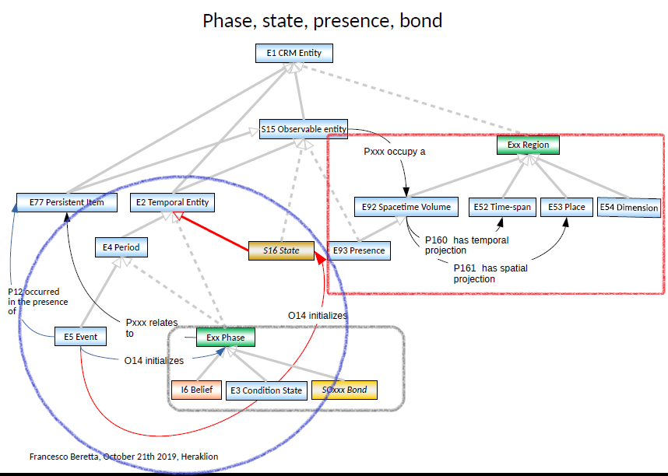
COMMENTS on HW and decisions:
- blue frame:
The sig decided against linking Phases or States to the Events that initialize them through O14 –the property has been deprecated in CRMsci (decision of the 44th CRM-sig meeting) and it is to be introduced in CRMinf (with a different class as range).
- red frame:
  - A model where mathematical constructs (Region) are conflated with real-life phenomena (like spacetime and its specifications) lacks coherence.
DECISION: the isA relation proposed to hold among Exx Region and E92, E52, E53 and E54 was rejected.
  - Pxxx occupy a [D: S15; R: E92]: depends on decisions regarding the Spacetime Volume and cannot be resolved independently of issue 326 (DECISION).
- grey frame: phase and its state-like sub-classes across the crm (base and compatible models) –review of how they relate to the scope note definition of Phase by MD; points of convergence/divergence.
  - The scope note for Phase by MD seems too narrow for it to act as a superclass of I6, E3 and Social Bond. The definition mainly draws on Natural History and Evolution and seems restricted to instances of E18 Physical Thing. In the same spirit, one could go up a level of abstraction to incorporate mental (I6 Belief) and social states (socExx Bond) [[FB]].
  - The scope note for Phase proposed by MD suggests that the class should be called “Physical State” or something more appropriate –an instance of which could be E3 Condition State. Superclass Phase should be more generic than what MD’s definition prescribes and it could also take Social and Mental Phase as its subclasses [[GB]].
  - DECISION: since there is a need to generalize over E3 Condition State and MD’s Phase –for conservation and natural history purposes, the sig decided to postpone the discussion on this issue, until TV gave his presentation on conceptual modelling from an art conservator’s point of view.
Mental Attitudes and Phases from a social relations point of view were deferred to the issues regarding CRMinf and CRMsoc, respectively.
The label “Phase” is to be reserved to refer to a potential superclass that might end up being used (or not) in the CRM in the future.
  - DECISION: Phase is to be broken down to Social, Mental and Physical Phenomena according to the accepted breakdown presented in the issue 369 and suggested by MD's post on 22/11/2018 . HW: MD is assigned with breaking the notion of Phase to these three domains of interest and explain how this relates the principles by means of which to declare a class in the CRM.
  - DECISION: issue 422 is paused.

Issue 437: Scope note and examples of E41 Appellation
Following the deprecation of many subclasses of E41 Appellation, a revision of the scope note for E41 was in order.
DECISION: The sig reviewed the draft scope note definition provided by MD, edited a bit and accepted it as a working definition.
DECISION: The sentence “Postal addresses and E-mail addresses are characteristic examples of identifiers used by services transporting things between clients” which got deleted from the old scope note, is to be incorporated in the scope note for E42 Identifier. Examples of postal and email addresses
- “+41 22 418 5571”
- “weasel@paveprime.com”
- “1-29-3 Otsuka, Bunkyo-ku, Tokyo, 121, Japan”
- “Rue David Dufour 5, CH-1211, Genève”
are to be moved to E42 as well.
HW: SS is to proofread within the current sig.
The new, temporary, scope note reads:
E41 Appellation
Subclass of: E90 Symbolic Object
Superclass of: E35 Title
E42 Identifier
Scope note: This class comprises signs, either meaningful or not, or arrangements of signs following a specific syntax, that are used or can be used to refer to and identify a specific instance of some class or category within a certain context.
Instances of E41 Appellation do not identify things by their meaning, even if they happen to have one, but instead by convention, tradition, or agreement. Instances of E41 Appellation are cultural constructs; as such, they have a context, a history, and a use in time and space by some group of users. A given instance of E41 Appellation can have alternative forms, i.e., other instances of E41 Appellation that are always regarded as equivalent independent from the thing it denotes.
Different language groups may use their own appellations for the same thing, for example the names of major cities. Likewise, some appellations may be formulated using a valid noun phrase of a particular language. In such cases, the respective instances of E41 Appellation can also be instantiated as E33 Linguistic Object. Then the language in which the appellation is formulated may then be declared with the property P72 has language: E56 Language.
Instances of E41 Appellation may be used to identify any instance of E1 CRM Entity and sometimes are characteristic for instances of more specific subclasses of E1 CRM Entity, such as for instances of E52 Time-Span (for instance “dates”), E39 Actor, E53 Place or E28 Conceptual Object.
Identifiers in continua, particularly those expressed numerically, such as dates or spatial coordinates, are regarded as instances of E41 Appellation. This is the case even when they also allow for determining a time or spot they identify by a known procedure starting from a reference point and by virtue of that play a double role as instances of E59 Primitive Value.
E41 Appellation should not be confused with the act of naming something. Cf. E15 Identifier Assignment
Examples:
- "Martin"
- "the Forth Bridge"
- "the Merchant of Venice" (E35) (McCullough, 2005)
- "Spigelia marilandica (L.) L." [not the species, just the name] (Hershberger, Jenkins and Robacker, 2015)
- "information science" [not the science itself, but the name through which we refer to it in an English-speaking context]
- “安” [Chinese “an”, meaning “peace”]
- “6°5’29”N 45°12’13”W”
- “Black queen’s bishop 4” [chess coordinate][MD1]
- “1900”
- “4-4-1959”
- “19-MAR-1922”
- “19640604”
- “Vienna”
- “CH-1211, Genève”
- “Aquae Sulis Minerva”
- “Bath”
- “Cambridge”
- “the Other Place”
- “the City”
- “the entrance lobby to the Ripley Center”
- “the poop deck of H.M.S Victory”
- “the Venus de Milo’s left buttock”
- “left inner side of my box”
In First Order Logic:
E41(x) ⊃ E90(x)
During the last day of the meeting, the sig reviewed the above definition and concluded to the following

E41 Appellation
Subclass of: E90 Symbolic Object
Superclass of: E35 Title
E42 Identifier

Scope note: This class comprises signs, either meaningful or not, or arrangements of signs following a specific syntax, that are used or can be used to refer to and identify a specific instance of some class or category within a certain context.

Instances of E41 Appellation do not identify things by their meaning, even if they happen to have one, but instead by convention, tradition, or agreement. Instances of E41 Appellation are cultural constructs; as such, they have a context, a history, and a use in time and space by some group of users. A given instance of E41 Appellation can have alternative forms, i.e., other instances of E41 Appellation that are always regarded as equivalent independent from the thing it denotes.

Specific subclasses of E41 Appellation should be used when instances of E41 Appellation of a characteristic form are used for particular objects. Instances of E49 Time Appellation, for example, which take the form of instances of E50 Date, can be easily recognised.
Numerically expressed identifiers in continua are instances of E41 Appellation, such as Gregorian dates or spatial coordinates, even though their encoding may be similar to instances of E60 Number.

Thus, the use of subclasses of E41 is not determined by the characteristics of the object the appellation refers to, e.g., a person or a place, but rather the form of the appellation itself shows it as a special type of appellation, such as an identifier.

E41 Appellation should not be confused with the act of naming something. Cf. E15 Identifier Assignment
Examples:
- "Martin"
- "the Forth Bridge"
- "the Merchant of Venice" (E35) (McCullough, 2005)
- "Spigelia marilandica (L.) L." [not the species, just the name] (Hershberger, Jenkins and Robacker, 2015)
- "information science" [not the science itself, but the name through which we refer to it in an English-speaking context]
- “安” [Chinese “an”, meaning “peace”]
- “6°5’29”N 45°12’13”W”
- “Black queen’s bishop 4” [chess coordinate]
- “1900”
- “4-4-1959”
- “19-MAR-1922”
- “19640604”
- “+41 22 418 5571”
- weasel@paveprime.com
- “Vienna”
- “CH-1211, Genève”
- “Aquae Sulis Minerva”
- “Bath”
- “Cambridge”
- “the Other Place”
- “the City”
- “1-29-3 Otsuka, Bunkyo-ku, Tokyo, 121, Japan”
- “Rue David Dufour 5, CH-1211, Genève”
- “the entrance lobby to the Ripley Center”
- “the poop deck of H.M.S Victory”
- “the Venus de Milo’s left buttock”
- “left inner side of my box”
- “the entrance lobby to the Ripley Center”
- “the poop deck of H.M.S Victory”
- “the Venus de Milo’s left buttock”
- “left inner side of my box”

In First Order Logic:
E41(x) ⊃ E90(x)

Properties:
P139 has alternative form: E41 Appellation
(P139.1 has type: E55 Type)
Thus the scope note of E42 has been changed from

E42 Identifier

Old
Subclass of: E41 Appellation

Scope note: This class comprises strings or codes assigned to instances of E1 CRM Entity in order to identify them uniquely and permanently within the context of one or more organisations. Such codes are often known as inventory numbers, registration codes, etc. and are typically composed of alphanumeric sequences. The class E42 Identifier is not normally used for machine-generated identifiers used for automated processing unless these are also used by human agents.
Examples:
- “MM.GE.195”
- “13.45.1976”
- “OXCMS: 1997.4.1”
- ISSN “0041-5278”
- ISRC “FIFIN8900116”
- Shelf mark “Res 8 P 10”
    - “Guillaume de Machaut (1300?-1377)” [a controlled personal name heading that follows the French rules] (Reaney, 1974)

In First Order Logic:
E42(x) ⊃ E41(x)

New

Subclass of: E41 Appellation

Scope note: This class comprises strings or codes assigned to instances of E1 CRM Entity in order to identify them uniquely and permanently within the context of one or more organisations. Such codes are often known as inventory numbers, registration codes, etc. and are typically composed of alphanumeric sequences. Postal addresses, telephone numbers, urls and e-mail addresses are characteristic examples of identifiers used by services transporting things between clients.
The class E42 Identifier is not normally used for machine-generated identifiers used for automated processing unless these are also used by human agents.

Examples:
- “MM.GE.195”
- “13.45.1976”
- “OXCMS: 1997.4.1”
- ISSN “0041-5278”
- ISRC “FIFIN8900116”
- Shelf mark “Res 8 P 10”
    - “Guillaume de Machaut (1300?-1377)” [a controlled personal name heading that follows the French rules] (Reaney, 1974)
- “+41 22 418 5571”
- weasel@paveprime.com
- “1-29-3 Otsuka, Bunkyo-ku, Tokyo, 121, Japan”
- “Rue David Dufour 5, CH-1211, Genève”

In First Order Logic:
E42(x) ⊃ E41(x)

Issue 440: E51 Contact Point instance examples
DECISION: Following the deprecation of E51 Contact Points, the sig decided that the examples of E51 Contact Point that were listed under E41 Appellation should move to E42 Identifier. The examples referred to were the ones mentioned in the context of Issue 437, above. This issue is to be resolved by the decisions reached in issue 437. Closed.

Issue 410: Layout of the CIDOC CRM official version

Examples Section –Laokoon:
- Order of diagrams in the Examples section of the CIDOC CRM definition:
DECISION: Diagrams of reasoning about spatial information & temporal information and a spacetime graph showing how things meet in spacetime (see below), are to precede the diagram of Johan-Joachim Winkelmann seeing the Roman copy of the statue of Laokoon inspired him to write the “History of the Art of the Antiquity”. SS & AK will cooperate to comment the graphics
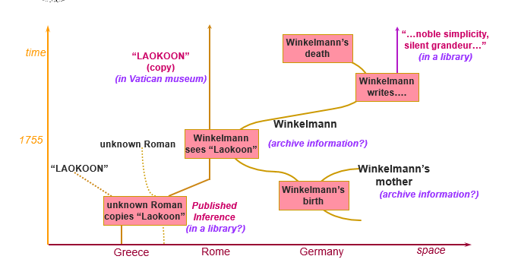
Space-time Laokoon graph
The Examples section should comprise three sub-sections, namely: one for basic constructs (space and time), one showing the spacetime volumes of things coming together, and then the particular example of Winkelmann seeing Laokoon.
- Regarding the diagram of “Winkelmann-sees-Laokoon”:
  - It must be preceded by a small text giving a little context on the particular event, plus and subsequent events attested to have followed it.
HW: MD is to provide the text
  - It should be structured in a more obvious manner, starting from J.J. Winkelmann and following him in the course of its life (was born, saw the statue, it made an impression, then he wrote the “History…”, then he died). Information on the statue and the book are to be given in the context of Winkelmann’s activities, so they have to be placed near the relevant nodes.
HW: TV is to check that the narrative of “Winkelmann saw Laokoon, which resulted in him writing history of ancient art” fits the diagram of events represented
  - Instead of the generic P12 occurred in the presence of (was present at), use relevant subproperties thereof; the same applies for the classes used throughout the diagram. (see below).
Use a predefined contour-style for arrows standing for properties connecting classes to underline the relations among properties (Pxx isA Pxx’).
HW: MD, AK [?]
  - It is proposed that the events found in the diagram and the entities participating in them are to be represented following the color-code of 3M.
HW: GB, SS, AK to get the color-code right.
  - Roman and Hellenistic are to be treated as instances of E4 Period –of the E12 Production of the Roman copy of Laokoon and the E12 Production of the original statue, respectively.
HW: AK, MD [?]
  - Just have a label on the time spans, don’t model them out and put no appellation instances. Just use quotes ???
  - This example could be made into a demo using ResearchSpace/metaphacts. Instances of E53 Place and E21 Person are to be given as TGN and ULAN URLs and then connected to their appellations there. This doesn’t go to the CIDOC CRM official version –it should appear in the Tutorials section or FAQ on the CRM site.
HW: ML & NC are to produce the .rdf for the Laokoon example.
- DECISION: the sig decided to form a NEW ISSUE regarding the color-code used for representing CRM classes. HW: NC to make a demo of that using the color code of 3M.
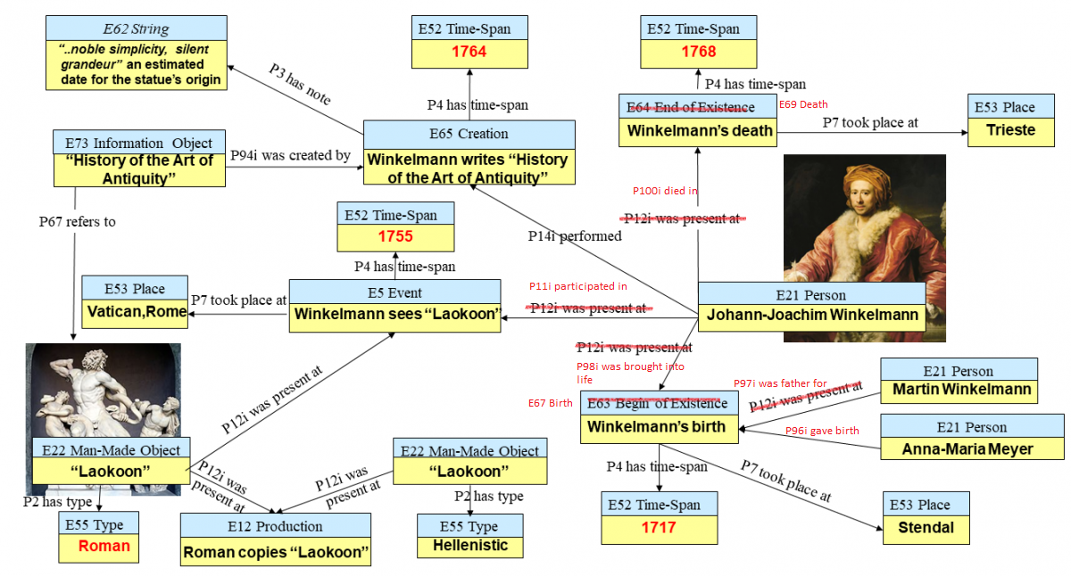

Compatibility statement:
DECISION: Reading out the text once more and voting on the spot was considered counterproductive and time consuming. The members of the sig mentioned they preferred to be sent the document and then comment and initiate an e-vote on its content. E-vote message was sent to the crm-sig members about compatibility. See more in the appendix

FOL Shortcuts:
DECISION: The sig decided that the FOL representation of properties should also state full paths to shortcuts. These full paths should also include classes for intermediate nodes. Where an inverse property is used as an intermediate node in the full path, it should also appear in the FOL formulation. FOL representation of full paths will be listed under the “In First Order Logic” section in the definition of the property. No subsection specially designated for the representation of shortcuts in FOL is required.

NEW ISSUE: Color-code used for representing CRM classes.
DECISION: In accordance with the decision reached on Issue 410 Layout of the official version of the CRM, a new issue has been formed on the color code to represent CRM classes. A proposal has been made about making use the color code used in 3M.

Issue 430: Update list of contributors
DECISION: The sig decided to only list the main editors in each release of the CIDOC CRM. For the next official version of the CIDOC CRM, these are MD, GB, CB, CEO, TV, SS.
Other sig members that participate in maintaining the standard –either through participation over multiple meetings (documented in the minutes) or the activities of the crm-sig list (email votes and email discussions) will be acknowledged as Contributors, but not be listed on the front page of the official version –as was the case until now. They will appear as contributors on the website, under the respective versions.
Issue closed.

Issue 428: the scope notes of E59 Primitive Value and E61 Time Primitive
DECISION: Following CEO’s observation that the scope note of E61 Time Primitive essentially reprises the last two paragraphs of E59 Primitive Value, the sig appointed MD and CEO to redraft the scope note of E61 Time Primitive, so that it refers to the superclass, instead of copying out chunks of text from it. Furthermore, the new text must reflect and highlight that E61 Time Primitive is a specialization of E59 Primitive Value (HW).

Issue 427: Reuse identifiers of obsolete entities never published
DECISION: Given the distress and concerns caused by reusing identifiers in the crm, the sig decided against this practice –even when reuse concerns numbers that were previously assigned to deprecated CRM classes and properties, which, in their turn, have never made it to an official version.
From this point on, identifiers will never get reused. Of course, classes/properties already making use of a “reused” identifier are not going to change numbers now.
Issue closed.

Issue 424: Exploring alternatives to reusing identifiers for newly introduced CRM classes and properties.
DECISION: This issue was duplicated by Issue 427 above. It is resolved by the same decision. Issue closed.

Issue 357: FOL representation for shortcuts
DECISION: The issue is closed by the decision on FOL representation of shortcuts in issue 410

Issue 314: The introductory text of CIDOC CRM site
DECISION: the text “How can I use the CRM” is to be up for an email vote. Should be approved during the current sig.
HW: GB is to send out to the sig list presentations on using the crm intended for training purposes.

Issue 363: Form and persistence of RDF identifiers
DECISION: The sig decided to close this issue, as its title is irrelevant to its content now. Discussions on the content of “Implementing the CIDOC Conceptual Reference Model in RDF” should be carried out in a separate issue.
As part of this NEW ISSUE, the sig approved the changes by GH on the document “Implementing the CIDOC Conceptual Reference Model in RDF” and the addition of the paragraph on Multiple Instantiation (by MD). The document is to be given a version number and every time there is change in its content, it should be assigned a new version status. The current version is 1.0.
GH is to appear in the list of authors (together with RL and MD).

NEW ISSUE: content of “Implementing the CIDOC Conceptual Reference Model in RDF”
DECISION: In accordance with the decision in Issue 363 above, the sig approved the changes by GH on the document “Implementing the CIDOC Conceptual Reference Model in RDF” and the addition of the paragraph on Multiple Instantiation (by MD). The document is to be given a version number and every time there is change in its content, it should be assigned a new version status. The current version is 1.0.
GH is to appear in the list of authors (together with RL and MD).
PROPOSAL: In view of the fact that the Guidelines for using P81/82(a/b) and P90(a/b) have been incorporated in the document “Implementing the CIDOC Conceptual Reference Model in RDF”, maybe it should be removed in the best practices section [MD].

Issue 286: Why #TEI P5 as format-of-record for #cidocCRM Definition document
DECISION: The topic of this issue is about finding a manageable way to edit the CRM. The sig decided to close it, because it’s fairly old and has been lying still for 4 years and to open NEW ISSUE regarding the main editors and primary maintainers of the CRM and compatible models.

NEW ISSUE: Main editors and primary maintainers of the CRM and compatible models; identity and responsibilities
DECISION: Aside establishing who these people will be, the sig should also determine their responsibilities, like:
- determining who is granted access to edit which extension of the model (i.e. issuing accounts)
- assigning tasks among the maintainers of a given extension
- formulating new issues per extension and introducing them to the sig over meetings
- keeping track of issues per extension and incorporating changes in the new versions
- setting the agenda for each model ahead of every meeting.
The new issue is to be reassessed and closed over the next sig meeting.
Main editors for the CRM extensions are:
CRMsoc: Thanasis Velios (TV), George Bruseker(GB), Francesco Beretta (FB), Vincent Alamercery (VA)
CRMtex: Achille Felicetti (AF), Francesca Murano (FM)
CRMba: Paola Ronzino (PaRo)
CRMdig: Maria Theodoridou (MT)
CRMgeo: Gerald Hiebel (GH)
CRMinf: Stephen Stead (SS), Martin Doerr(MD)
CRMsci: Thanasis Velios (TV), Athina Kritsotaki (AK)
CRMarchaeo: Achille Felicetti (AF)
FRBRoo: Pat Riva (PR), Melanie Roche (MR)
PRESSoo: Pat Riva (PR), Melanie Roche (MR)

Issue 241: Wider practical scope note of CRM
DECISION: The sig decided to close this issue and transfer the discussion points from this thread to issue 410 –together with everything else pertaining to the next official version.
HW: SS & GB to edit the new parts of the Introduction relating to the Scope of the CRM within the current meeting.

Issue 236: RDF file for CRM CORE
DECISION: It is obsolete since we have the application profile discussion (issue 364) The issue closed

Wednesday, 23rd October 2019

Presentation by TV: Linked Conservation Data; modelling workshop –London, Sep 2019.
Comments & Discussion:

1st Workshop: Terminology
Linked Conservation Data could become an application profile –i.e. recommending vocabularies for specific purposes.
It would be interesting to see how the CRM is used in specific projects –and how it gets extended by different types.
Align thesauri and vocabularies used across art conservation to the BBT as a first step, it’s very high level, should accommodate all concepts quickly and easily. That the relations among concepts are isA is not a problem: you get better recall and precision this way –AAT is also committed to isA semantics for the most part.

2nd Workshop: Modelling
Negative properties:
absence of a property either to be modelled as a type OR as a negated property linking CRM classes to types.
TV is to contact and consult with CM on modelling absence of a feature
NC will collaborate with TV in locating relevant work
Orientation and Relative position:
both are very central to museum documentation, even with highly under specific relations like *between* or *above* between objects one can rely on geometric concepts to represent the space available and the object that needs to occupy (part of) it.
Physical Phase vs Condition State:
from an Art Conservator’s point of view, Exx Physical Phase and E3 Condition State seem identical, so it seems off to say that Exx Physical Phase is a generalization of E3 Condition State
proposal for Exx Audio Item:
duplicating E36 Visual Item for audio is not something that could be decided on the spot. Probably not going to be implemented.

Issue 351: Modelling Principles (continuation)
MaDu. & MS updated the sig on where the document stands in gitlab. They agreed

Issue 326: Resolving inconsistences between E2, E4, E52 and E92 / Issue 438: proposal to replace E18 isa E92 and E4 isa E92 with properties
CEO walked everyone through the presentation (see below) on alternatives to relations among high-level classes of the CRM to E92 STV. The difficulties of users of CRM to deal with the applicability of E92 STV to the domain of physical things as well as the domain of temporal entities and the resulting mistakes (f.i. positing more than one STVs per object, each corresponding to a separate phase in its evolution/existence), suggested that a revision of the definition of E92 Spacetime Volume is in order.
Specifically, people seemed to have trouble understanding that an instance of E92 Spacetime Volume that is also an instance of E4 Period is never an instance of E18 Physical Thing (and vice versa).
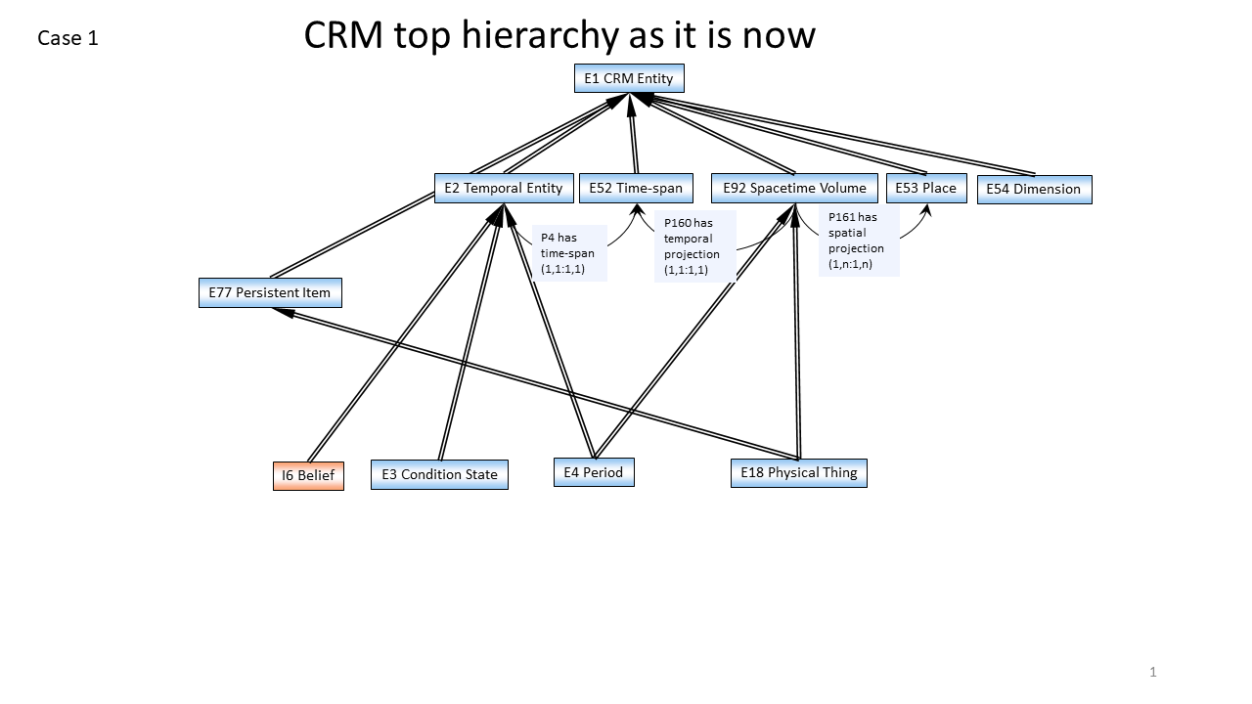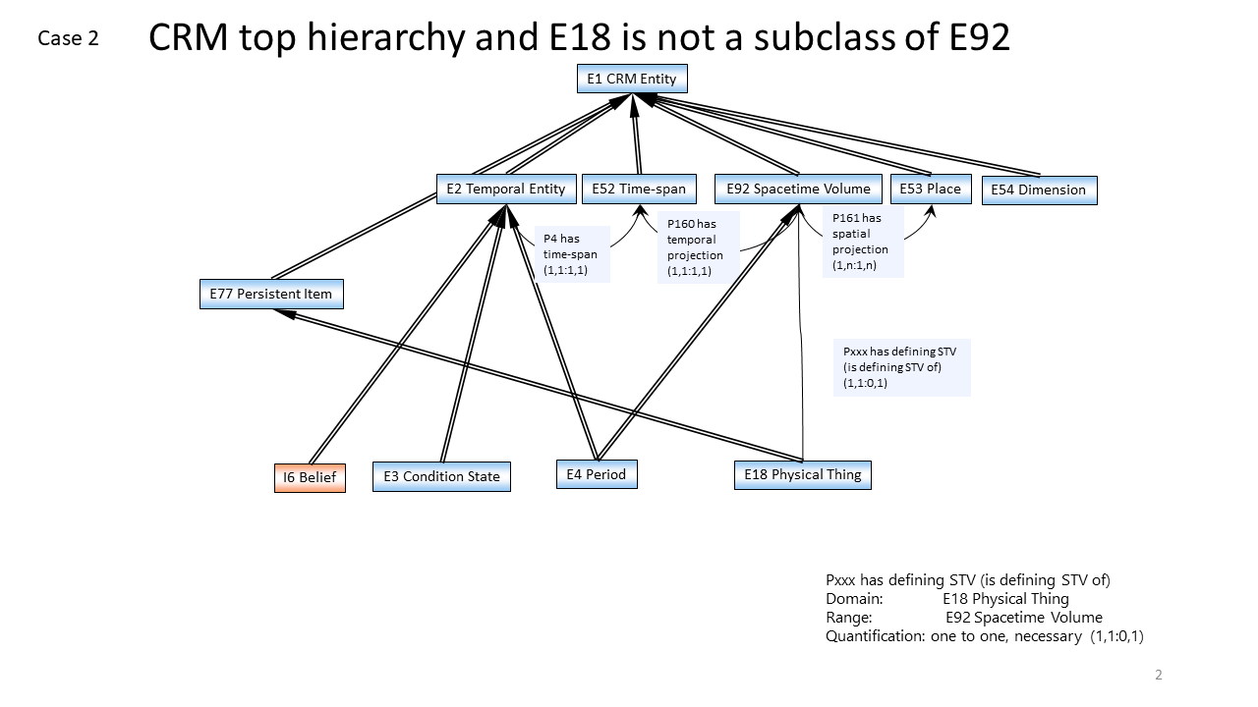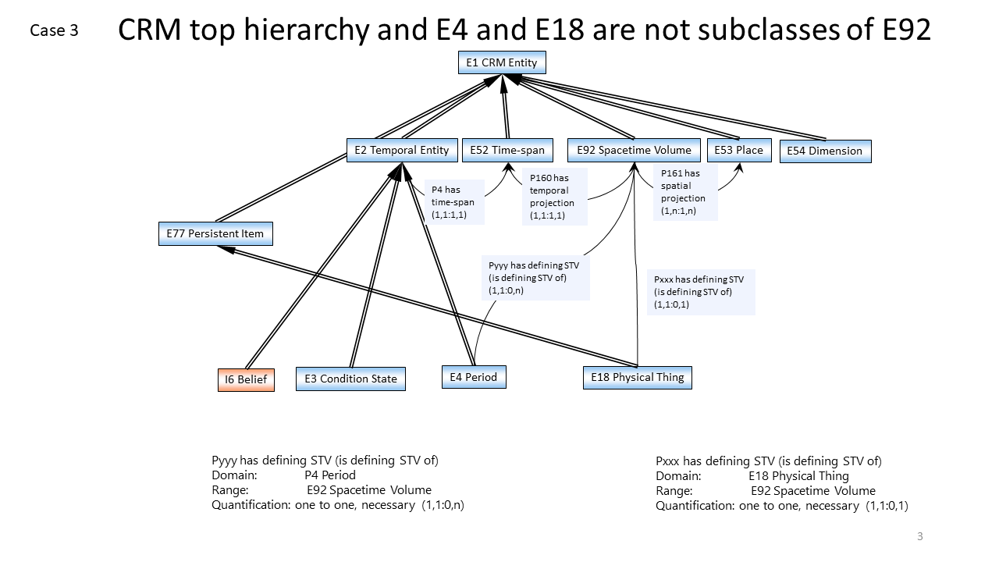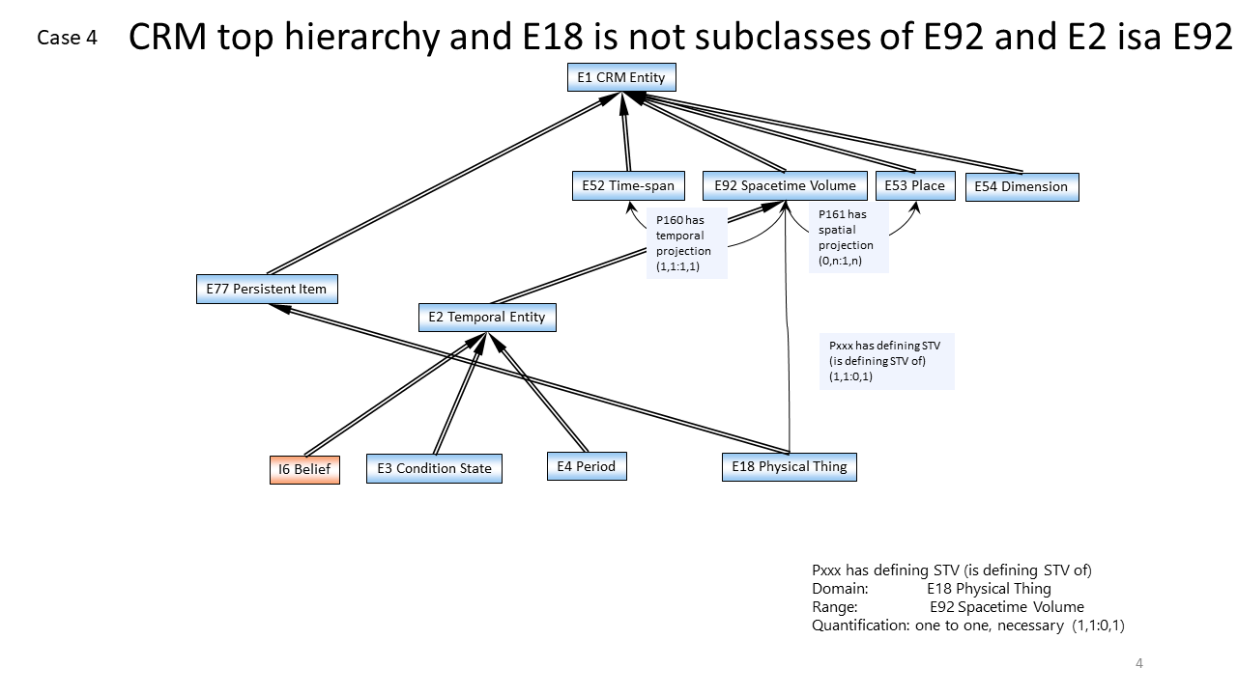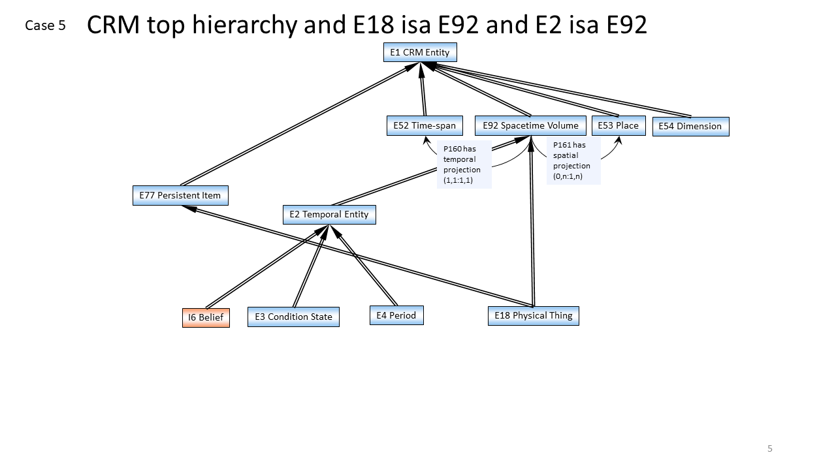

DECISION: Keeping E18 disjoint from E92 is in line with the kind of assertions that can be made for an instance of E18 and an instance of E92 in practice –and also solves the problem of creating unintended models, f.i. when people are tempted to assign temporality to instances of E18.
From this point of view, Cases 2, 3, 4 (but not Case 5) in CEO’s slides can be considered in as preferred alternatives to the current state of affairs regarding the definition of STV in the CRM.
Turning to case 3 (E4 Period isA E2 Temporal Entity; E2 Temporal Entity and E92 STV are disjoint):
Background: Properties linking Periods/Events (isA E92) to their temporal and spatial projections can give the impression that two or more events that happened (approximately) over the same place and at (approximately) the same time actually share a Spacetime Volume. Making E4 Period NOT isA E92 Spacetime Volume serves the purpose of keeping STVs of different events apart.
However, this ‘shared’ (sic) STV is false impression; P161 and P160 link the E92 STV that is an event to the approximations of the space and time over which it unfolded. It is these approximations that can be shared (i.e. can almost completely overlap with one another), not the STV as such.
DECISION: Hence, the sig decided that declaring E4 NOT isA E92 (Case 3 in CEO’s slides) is unwarranted.

Turning to case 4 (E2 isA E92 STV):
Even though periods are construed as extending over space, this does not necessarily hold for all instances of E2 Temporal Entity (Beliefs do not have a spatial extent for instance).
DECISION: Hence declaring that E2 isA E92 (Case 4 in CEO’s slides) is also unwarranted.

Case 2: E4 isA E92; E18 NOT isA E92
DECISION: The crm-sig accepted to keep the E4 isA E92, replace the E18 isA E92 with a property and explore the resulting consequences for the model by this change. The relations declared in the Case 2, will appear in the next CRM official version (v.7.0).
According to CEO’s slides, there is need to:
- check the scope-notes of classes and properties mentioning E92 and E18 for inconsistencies with the new structure.
- change the definition for E18 Physical Thing (take out paragraph about multiple inheritance)
- declare a property linking an instance of E18 to its E92:
  - in CEO’s slides:
Pxx defines STV (is defined by) [D: E18, R: E92]
- change the superclass definition for:
  - P46 is composed of (forms part of) [D:E18, R:E18]; it can no longer be a subproperty of P132
    - this also affects its subproperty P56 bears feature (is found on) [D:E19, R:E26]
  - P156 occupies (is occupied by) [D:E18, R:E53]; it can no longer be a subproperty of P161
- declare a property linking instances of E18 to E93 Presence [Pxxx has presence (was presence of) D: E18, R: E93]
- change the diagrams in the introductory section
Comments on CEO’s slides:
- Comments on CEO’s slides Pxx has defining STV (is defining STV of) [D: E18, R: E92]: probably a misnomer –it is not the physical object that gets its identity from the E92 Spacetime Volume; rather the opposite. So property should be labelled: Pxx defines STV (is STV defined by) [D: E18, R: E92]
- P160 has temporal projection [D: E92, R: E52] is identical with P4, if its domain is set to E4 or a subclass thereof.
The issue 326 closed
HW: CEO is to edit the slides accordingly (labels on properties) and send them to Chrysoula (see more in the appendix).
HW: CEO & MD are to go through the revisions proposed by CEO (affected classes and properties, diagrams in the introduction etc.).

NEW ISSUE
Reviewing the decisions of 43rd cidoc crm meeting in the frame of the issue 410, and given that some primitive values are regarded as instances of E41 Appellation, it is a problem for CRM primitive values are not in the scope of the model and that the FOL representation of CRM does not include them. So, instances of E59 Primitive Value and its subclasses should probably be made a subclass of E1 CRM Entity.
Put this up for discussion but do not include it in the official version (v.7.0)

Issue 412: CRMsoc definition

regarding the text on “Using OntoMe” to collaboratively build the CRMsoc ontology.
DECISION: The introductory section on “Using OntoME” to collaboratively build the CRMsoc ontology is postponed until OntoME is ready for use.
So far the use of OntoME has been restricted to declaring classes and properties of CRMsoc (wrt the development of this particular model) and then exporting releases of the definition of CRMsoc. Discussing the classes/properties of CRMsoc takes place on the CRM site.
Ideally, maintainers (and users) of CRMsoc should be able to post their comments directly on OntoME, but links to the CRM site should also be provided –so that discussions would not go undocumented in either medium (only to be ultimately duplicated on both or end up going unnoticed).
Aside that, the sig decided that all future meetings should involve a progress report on CRMsoc.

Regarding the introductory text of the CRMsoc
The sig reviewed the text (with the additions by TV and VA) and accepted it. it is to appear on the home page of The CRMsoc.

What is CRMsoc?
CRMsoc is a formal ontology for integrating data about social phenomena and constructs that are of interest in the humanities and social science based on analysis of documentary evidence. The scope of CRMsoc is the following areas of analysis:
- Characteristics of human beings, as individuals or groups
- Social relations, including between people, between people and groups, and between groups
- Rights and duties
- Economic activities, including relations between people and things, such as financial transactions leading to ownership
- Plans, including expressing proposed activities and legislation
- Evaluations, including assessing risks and estimating the value of things
CRMsoc uses and extends the CIDOC CRM (ISO21127): a general ontology of human activity, things and events happening in space-time. It uses the same encoding-neutral formalism of knowledge representation (“data model” in the sense of computer science) as the CIDOC CRM, which can be implemented in RDFS, OWL, in an RDBMS and in other forms of encoding.

What is the idea?
The CIDOC CRM is a general ontology whose classes and properties primarily reflect common concepts used in documentation systems of memory institutions. These systems primarily revolve around collections. Social and historical research documentation systems also include concepts about our understanding of complex social constructs and relationships which are not necessarily linked to collections but which are essential for their interpretation. To maintain the generic nature of the CIDOC CRM these concepts have been formalised as classes and properties in CRMsoc. CRMsoc is harmonised with the CIDOC CRM and it defines how the two are connected.
CRMsoc can be used to describe characteristics of individuals or groups, economic transactions, rights held by people and groups, historical phases and the description of plans. As a high-level conceptual framework for data integration, the CIDOC CRM and the CRMsoc extension will provide interoperability of existing models devoted to specific historical subdomains (e.g. political, intellectual, social, economic history).

Regarding the appearance and label of CRMsoc button/box in the CRM site
DECISION: CRMsoc is listed in the CRM site (Compatible models & Collaborations) as the “Model for Social Documentation” –the title is misleading (if not just weird). It is to change to “Model for Social Phenomena”.
The contour of the button/box for CRMsoc is slightly smaller than the buttons/boxes for the other compatible models. They should all be symmetrical.
The issue closed.

Issue 408: Rights Model Enriched
Upon discussing how to model the example of IPR on a creation becoming public domain 70 years following a creator’s decease (example by TV and RS) making use of Trigger Event Templates and Activity Plans, the sig realized that it would be premature to decide on either alternative presented by TV at this point.
DECISION: MD is to find references regarding Intellectual Property Rights (look up already existing models that converge with current practices in the domain of documentation of IPR) and share them with TV, RS, GB, FB, NC and others working on the rights model.

Issue 419: Activity Plans
The sig began reviewing the scope notes for the properties linking socE4 Trigger Event Template with other CRM classes (HW by TV).
The properties at stake were:
- socPxx specifies material substantial (is specified material substantial): S10 Material Substantial
- socPxx specifies actor (is specified actor of): E39 Actor
- socPxx specifies time-span (is specified time-span of): E52 Time-span
- socPxx specifies place (is specified place of): E53 Place
- socPxx specifies type of actor (is actor-type specified): E55 Type
- socPxx specifies event type (is specified event type of): E55 Type
- socPxx specifies type of thing (is specified type of thing): E55 Type
The sig thoroughly discussed the scope note and example for the first property and did some editing (see in the appendix), but then dropped it, as it seemed that most examples conflated Trigger Event Templates with Active Plans instead of Reactive ones and the scope ones were ambiguous btw an active and a reactive reading.
HW: TV is to redo the current HW, bearing in mind that active plans presuppose agency on behalf of the person intended to carry out the plan, from conception up to implementation. On the other hand, reactive plans are triggered by events that the person intended to carry out the plan has no control over.
Specifically for socPxx specifies material substantial (is specified material substantial) [D: socE4 Trigger Event Template, R: S10 Material Substantial] the example is OK and accepted [*], but there could be additional examples from an art conservator’s perspective, like the deterioration of the glue on the back of a book or a varnish layer on some painting.

[*] Example:
The Tate Archives Flooding Disaster Plan Trigger Event Template specifies material substantial The River Thames (S14).

Issue 420: Social transactions and bonds
The sig reviewed the HW by AK regarding the provision of examples for socExx Provision and socExx Obligation from historical sources (Account Book of ship D.S.Skyliytsis; Inventory Number A.E 53/01).
DECISION: These were accepted (with minor editorial work).
HW: AK is to present them in a better formatting (making sure that the contextual information is not lost).
Examples with editorial changes can be found below:

socExx Provision:
- The captain A. Syrmas (provider) paid A. Kourinis (receiver) 53 francs for buying 41 soaps. The purchase was made on behalf of the ship-owner company.
  - Payment of 53 francs by A.Syrmas to A.Kourinis (SOXX Provision)
  - Handing out 41 soaps by A.Kourinis to A.Syrmas (SOXX Provision).
- On 12th December 1909, the ship-owner company (Empeirikos and others (provider)) paid a forfeit of 40.000 francs to the local Port Authorities (receiver) for damages that their ship had caused on another ship.
  - Payment of the forfeit of ₣ 40.000 by the ship-owner company to the local port (socExx Provision without exchange).
- Captain A. Syrmas (provider) paid policemen ₤50 sterling to prohibit the ship’s crew from leaving the ship
  - Payment of ₤50 by A.Syrmas to Policemen
  - Service of policing to A.Syrmas by policemen
- Ship-owner company (provider) gave the Captain A. Syrmas a gift of ₣ 200.000 as a present.
  - Gift of ₣ 200.000 by ship-owner company to Captain A. Syrmas (socExx Provision, but it does not entail a business obligation).
- During the 3rd voyage of the ship “D.S.Skylitsis” from Constantinople to Genova, which lasted from 8th May 1899 until 2 June 1899, there was an instance of a transaction among the captain of the D.S. Skylitsis and A. Apostolaton, the latter acting as a mediator on behalf of Foscolo Mango and Co. The transaction took place on 24th May 1899, and A.Apostolaton received ₣1.000 on behalf of Foscolo Mango and co.
  - Payment of ₣ 1.000 franc by A.Syrmas to Foscolo Mango and Co on 24/5/1899 (SOXX Provision)

socExx Business Obligation
- During the 3rd voyage of the ship “D.S.Skylitsis” from Constantinople to Genova, which lasted from 8th May 1899 until 2 June 1899, there was an instance of a transaction among the captain of the D.S. Skylitsis and A. Apostolaton, the latter acting as a mediator on behalf of Foscolo Mango and Co. The transaction took place on 24th May 1899, and A.Apostolaton received ₣1.000 on behalf of Foscolo Mango and co.
  - Payment of ₣ 1.000 franc (socExx Provision) terminated the obligation to pay ₣1.000 to Foscolo Mango and co. (socExx Business Obligation), which in its turn, was obligation of A. Syrnas (E21 Person)
  - Payment of ₣ 1.000 franc (socExx Provision) was provided to Foskolo Mango and Co (E40 Legal Body) and it P14 carried out by A. Apostolaton (E21 Person), in the role of (.1) “mediator”.

Issue 431: make methodology clear
The sig sided with adding a clause conveying the meaning that the label of a class is not its definition –along the lines of that proposed by MD: “It is per definitionem wrong for all CRM concepts to argue with the meaning of the label. Labels can only be wrong with respect to the scope note. Per definitionem they do not constitute definitions.”
HW: MD is to update the definition of class in the Terminology section of the CRM, by adding the aforementioned clause.

Issue 382: where to stop documenting the provenance
The sig reviewed the HW by MD and CM (best practices document on the epistemology of the knowledge base).
DECISION: Since the text by MD and CM covers (to a great extent) the same conceptual space as the document generated in the context of Issue 297: What is Knowledge base / Knowledge Creation Process (now appearing as the definition of Knowledge Creation Process in the Terminology section of the CRM model), it was decided that the two texts should be compared for overlap, make sure that they’re consistent with one another and possibly get merged into a new text. The new text is to appear under Best practices.
HW: SS is to compare the two texts to check that they’re not in conflict and merge them into one. He is also to go into more depth regarding implementation guidelines (also incorporate the problem of endlessly iterated provenance statements).

Issue 436: Broaden scope of P125
The sig discussed the proposal put forth by TV to either broaden the scope of P125 used object of type to include material-types (aside object types) or to introduce a new property in CRMsci such that it replicates P125, with the difference that its range would be compatible with instances of S10 Material Substantial.
DECISION: The sig decided against both options, as the range of P126 covers instances where what is of interest is not the type of object, but the kind of material used.
DECISION: Furthermore, the sig assigned TV (HW) to start a new issue on broadening the scope of P126 employed (was employed in) [D: E11 Modification, R: E57 Material], by changing the domain of the property to E7 Activity –assuming that there are examples justifying the change; i.e. instances of Activities requiring the use of a specific type of material, where the activity type is not an instance of E11 Modification.
The issue closed

Issue 386: Functional identity of E24 Physical Human- Made Thing
DECISION: The sig reviewed CEO’s HW (to rework the definition of E24 Physical Human Made Thing supplied by MD) and accepted them (see below).
Having agreed with CEO’s assessment that the subclasses of E24 Physical Human Made Thing require editing for the sake of consistency with the model, the sig appointed CEO (HW) to come forth with a proposal on what needs changing.

E24 Physical Human-Made Thing

Old
Subclass of: E18 Physical Thing
E71 Human-Made Thing
Superclass of: E22 Human-Made Object
E25 Human-Made Feature
E78 Collection

Scope Note: This class comprises all persistent physical items that are purposely created by human activity.
This class comprises human-made objects, such as a swords, and human-made features, such as rock art. No assumptions are made as to the extent of modification required to justify regarding an object as human-made. For example, a “cup and ring” carving on bedrock is regarded as instance of E24 Physical Human-Made Thing.
Instances of this class may act as carriers of instances of E73 Information Object.

New
E24 Physical Human Made Thing (scope note –post CEO’s editing):
Subclass of: E18 Physical Thing
E71 Human-Made Thing
Superclass of: E22 Human-Made Object
E25 Human-Made Feature
E78 Collection
Scope Note: This class comprises all persistent physical items of any size that are purposely created by human activity. This class comprises, besides others, Human-Made objects, such as a swords, and Human-Made features, such as rock art. For example, a “cup and ring” carving on bedrock is regarded as instance of E24 Physical Human-Made Thing.
Instances of Human-Made thing may be the result of modifying pre-existing physical things, preserving larger parts or most of the original matter and structure, which poses the question if they are new or even Human-Made, the respective interventions of production made on such original material should be obvious and sufficient to regard that the product has a new, distinct identity and intended function and is human-made. Substantial continuity of the previous matter and structure in the new product can be documented by describing the production process also as instance of E81 Transformation.
Whereas interventions of conservation and repair are not regarded to produce a new Human-Made thing, the results of preparation of natural history specimen that substantially change their natural or original state should be regarded as physical Human-Made things, including the uncovering of petrified biological features from a solid piece of stone. On the other side, scribbling a museum number on a natural object should not regarded to make it Human-Made. This notwithstanding, parts, sections, segments, or features of a physical Human-Made thing may continue to be non-Human-Made and preserved during the production process, for example natural pearls used as a part of an eardrop.

Issue 426: Pxxx holds or supports
The sig discussed RS’s proposal to introduce a property linking separate instances of E18 Physical Thing, where the one serves as a container or reference space for the other, without necessarily instantiating a place for it to be located on/at/in.
DECISION: They agreed with the scope note definition provided by RS and the full path over which this new property is supposed to be a shortcut over (E18 Physical Thing - - P59 has section - - > E53 Place - - P35i is former or current location of - - > E18 Physical Thing. The sig however lined up with MD in suggesting that Pxxx holds or supports should best be declared a superproperty of P56 bears feature, instead of declaring the two properties to be similar. Hence, that particular sentence was deleted. HW assigned to RS & MD about the superproperty.

Pxxx holds or supports
Domain: E18 Physical Thing
Range: E18 Physical Thing
Quantification: many to many

Scope Note: This property relates one E18 Physical Thing which acts as a container or support, such as a shelf, for another E18 Physical Thing. Pxxx holds or supports is a shortcut of the more fully developed path from the domain E18 Physical Thing through P59 has section, E53 Place, P53i is former or current location of, to the range E18 Physical Thing. It is not a sub-property of P46 is composed of, as the held or supported object is not a component of the container or support.
This property can be used to avoid explicitly instantiating the E53 Place which is defined by a Physical Thing, especially when the only intended use of that Physical Thing is to act as a container or surface for the storage of other Physical Things. The place’s existence is defined by the existence of the container or surface, and will go out of existence at the same time as the Destruction of the container or surface. As such, there are very few situations in which the identity of the place needs to be distinguished from the defining physical thing.

Examples:
The archival folder (E22) “6” _holds or supports_ the piece of paper (E22) carrying the text of a letter from Alloway to Sleigh
The artist’s materials box (E22) labeled “VG6” _holds or supports_ Van Gogh’s paintbrush 23 (E22)
The storage box “VG” (E22) _holds or supports_ the artist’s materials box (E22) labeled “VG6”
The bronze coin bank “72.AC.99” (E22) _holds or supports_ silver coin “72.AC.99-1” (E22)
The bookshelf “GRI-708.1” (E22) _holds or supports_ the book (E22) “Catalog of Paintings in the J. Paul Getty Museum”

Thursday, 24th October 2019

Issue 441: Change the scope note of A5
PROPOSAL: MD suggested that someone must take on the task of closely looking at cases where there’s ambiguity regarding what is characteristic of a genesis vs. a modification. CEO proposed that this is done in the context of a separate issue.
Since the sig has agreed to change the scope note of A5 Stratigraphic Modification, issue 441 should close.
IMPORTANT COMMENT: The definition of CRMarchaeo needs excessive proofreading; upon looking at the properties linking from A5 Stratigraphic Modification to other CRM classes, CEO noticed that AP8 disturbed (was disturbed by) - - > A8 Stratigraphic Unit was erroneously declared a superproperty of O18 altered (was altered by) [D:S18 Alteration; R: E18 Physical Thing]. –NO HW.
DECISION: The changes CEO proposed in the scope note of A5 Stratigraphic Modification were accepted by the sig, as they reflect the indeterminacy that characterizes the relation btw a genesis and a modification –found across the CRM (base and sci).
The scope note of A5 Stratigraphic Modification changed:

from (old):
A5 Stratigraphic Modification
Subclass of: S18 Alteration
Scope Note: This class comprises activities or processes resulting in the modification of Stratigraphic Units after their genesis through A4 Stratigraphic Genesis Events.
Examples:
- The Event that eroded the number (1) Stratigraphic Volume Unit in Figure 4 and diminished it to its actual size
- During the excavation at Eagle Cave, Texas, archaeologists found many burrows, about 7 cm in diameter on average, deriving from rodents, lizards, and insects, which have disturbed (A5) the intact layers (A8). [Larsen, M. 2015]
- At the Dutton Paleo-Indian site, Colorado, involutions (flame-structures) due to aquaturbations, caused deformation (A5) of the saturated soil (A8). [Wood & Johnson 1978, pp. 315-380].
In First Order Logic:
A5(x) ⊃ S18(x)
Properties:
- AP8 disturbed (was disturbed by): A8 Stratigraphic Unit
- AP13 has stratigraphic relation (is stratigraphic relation of): A5 Stratigraphic Modification

to (new):
A5 Stratigraphic Modification
Subclass of: S18 Alteration
Scope Note: This class comprises activities or processes that create, alter or change instances of A8 Stratigraphic Unit.

Since the distinction between stratigraphic modification and stratigraphic creation is not always clear, stratigraphic modification is regarded as the more generally applicable concept. This implies that some items may be consumed or destroyed in an instance of A5 Stratigraphic Modification, and that others may be produced as a result of it.
Examples:
- The Event that eroded the number (1) Stratigraphic Volume Unit in Figure 4 and diminished it to its actual size
- During the excavation at Eagle Cave, Texas, archaeologists found many burrows, about 7 cm in diameter on average, deriving from rodents, lizards, and insects, which have disturbed (A5) the intact layers (A8). [Larsen, M. 2015]
- At the Dutton Paleo-Indian site, Colorado, involutions (flame-structures) due to aquaturbations, caused deformation (A5) of the saturated soil (A8). [Wood & Johnson 1978, pp. 315-380].
In First Order Logic:
A5(x) ⊃ S18(x)
Properties:
- AP8 disturbed (was disturbed by): A8 Stratigraphic Unit
- AP13 has stratigraphic relation (is stratigraphic relation of): A5 Stratigraphic Modification

Issue 283: Add superproperties to the properties of CRMarchaeo.
DECISION: The sig reviewed the HW by CEO and decided to accept his suggestions for CRMarcheo properties AP3, AP4, AP6, AP7, AP8, AP9, AP11, AP12, AP13, AP14, AP15, AP16.
Of those some don’t require be declared subproperties of a property different than the one they have already been assigned with, whereas others do.

No change in superproperty required:
- AP3 investigated (was investigated by) [D: A9 Archaeological Excavation, R: E27 Site] subproperty of: O8 observed (was observed by),
- AP6 intended to approximate (was approximated by) [D: A1 Excavation Process Unit, R: A3 Stratigraphic Interface]
subproperty of: O8 observed (was observed by),
- AP7 produced (was produced by) [D: A4 Stratigraphic Genesis, R: A8 Stratigraphic Unit] subproperty of: O17 generated (was generated by),
DECISION: Start new issue, make O17 generated (was generated by) [D: S17 Physical Genesis, R: E18 Physical Thing] a subproperty of O18 altered (was altered by) [D: S18 Alteration, R: E18 Physical Thing]
- AP8 disturbed (was disturbed by) [D: A5 Stratigraphic Modification, R: A8 Stratigraphic Unit] subproperty of: O18 altered (was altered by),
- AP9 took matter from (provided matter to) [D: A4 Stratigraphic Genesis, R: S10 Material Substantial]
subproperty of: O18 altered (was altered by),
- AP11 has physical relation (is physical relation of) [D: A8 Stratigraphic Unit, R: A8 Stratigraphic Unit]
HAS NO SUPERPROPERTY
- AP12 confines (is confined by) [D: A3 Stratigraphic Interface, R: A2 Stratigraphic Volume Unit] subproperty of: O7 confined (was confined by)
- AP13 has stratigraphic relation (is stratigraphic relation of) D: A5 Stratigraphic Modification, R: A5 Stratigraphic Modification]
HAS NO SUPERPROPERTY,
- AP14 justified by (is justification of) [D: AP13.1 has type (type of stratigraphic relation), R: AP11.1 has type (type of physical relation)]
HAS NO SUPERPROPERTY,
- AP15 is or contains remains of (is or has remains contained in) [D: A2 Stratigraphic Volume Unit, R: S10 Material Substantial]
HAS NO SUPERPROPERTY,
- AP16 assigned attribute to (was attributed by) [D: A6 Group Declaration Event, R: E18 Physical Thing]
subproperty of: P140 assigned attribute to (was attributed by).

Change in superproperty is required:
- AP4 produced surface (was surface produced by) [D: A1 Excavation Process Unit, R: A10 Excavation Interface] requires editing
  - as CEO correctly pointed out, to produce a surface, one must remove matter, however the surface itself is produced, not removed.
  - AP4 should be a subproperty of P018 has produced (was produced by) [D: E12 Production, R: E24 Human Made Thing]. [DECISION]
  - This change requires additional actions: A1 Excavation Process Unit has to be made a subclass of E12 Production for this to work.
    - DECISION: A new issue will be raised in the sig, regarding the nature of A1 Excavation Process Unit (isA E12 Production vs. isA S1 Matter Removal). In the context of the new issue, all properties connecting A1 Excavation Process Unit to other CRM classes should be examined to determine that both they and that their superproperties are compatible with the newly postulated semantics for A1 Excavation Process Unit.
      - AP1 produced (was produced by) [D: A1 Excavation Process Unit, R: S11 Amount of Matter]
      - AP2 discarder into (was discarded by) [D: A1 Excavation Process Unit, R: S11 Amount of Matter]
      - AP5 removed part or all of (was partially or totally removed by) [D: A1 Excavation Process Unit, R: A8 Stratigraphic Unit],
      - AP10 destroyed (was destroyed by) [D: A1 Excavation Process Unit, R:S22 Segment of Matter]
- The superproperties of the following CRMarchaeo properties need be reexamined in the context of a new issue regarding the semantics of A7 Embedding (in line with the decision reached in the 43rd sig meeting that A7 Embedding should capture a notion of a feature-like entity instead of a temporal one).
  - AP17 is found by (found) [D: A7 Embedding; R: S19 Encounter Event]
  - AP18 is embedding of (is embedded) [D: A7 Embedding; R: E18 Physical Thing]
  - AP19 is embedding in (contains embedding) [[D: A7 Embedding; R: A2 Stratigraphic Volume Unit]
  - AP20 is embedding at (contains) [D: A7 Embedding; R: E53 Place]
  - AP21 contains (is contained in) [D: A2 Stratigraphic Volume Unit, R: E18 Physical Thing]
The sig decided to close the issue 283

[NEW ISSUE]: The nature of A1 Excavation Process Unit (isA E12 Production or isA S1 Matter Removal).
DECISION: In the context of discussing issue 283 (superproperties to CRMarchaeo properties) the sig resolved to declare AP4 produced surface a subproperty of P108 has produced. To achieve that the domain of AP4 –namely A1 Excavation Process Unit –should be made a subclass of E12 Production.
So the sig decided to raise a new issue regarding the nature of A1 Excavation Process Unit (isA E12 Production vs. isA S1 Matter Removal).
In the context of the new issue, all properties connecting A1 Excavation Process Unit to other CRM classes should be examined to determine that both they and that their superproperties are compatible with the newly postulated semantics for A1 Excavation Process Unit.
- AP1 produced (was produced by) [D: A1 Excavation Process Unit, R: S11 Amount of Matter]
- AP2 discarder into (was discarded by) [D: A1 Excavation Process Unit, R: S11 Amount of Matter]
- AP5 removed part or all of (was partially or totally removed by) [D: A1 Excavation Process Unit, R: A8 Stratigraphic Unit],
- AP10 destroyed (was destroyed by) [D: A1 Excavation Process Unit, R:S22 Segment of Matter]

[NEW ISSUE]: A7 Embedding as a Physical Feature like entity –not a temporal one.
DECISION: According to the decision reached in the 43rd meeting of the CIDOC-CRM sig, A7 Embedding should not be declared a temporal entity (previously adopted semantics for A7: isA E3 Condition State) but some sort of feature-like entity (like for instance S20 Rigid Physical Feature).
This decision has implications regarding the semantics of A7 as well as the properties linking it to other CRM classes (plus their superproperties).
Affected properties are:
- AP17 is found by (found) [D: A7 Embedding; R: S19 Encounter Event]
- AP18 is embedding of (is embedded) [D: A7 Embedding; R: E18 Physical Thing]
- AP19 is embedding in (contains embedding) [[D: A7 Embedding; R: A2 Stratigraphic Volume Unit]
- AP20 is embedding at (contains) [D: A7 Embedding; R: E53 Place]
- AP21 contains (is contained in) [D: A2 Stratigraphic Volume Unit, R: E18 Physical Thing]
[this one is a shortcut from the fully developed path:
A2 Stratigraphic Volume Unit -- AP19i contains embedding --> A7 Embedding -- AP18 is embedding of --> E18 Physical Thing
hence any decision reached for A7 and affected properties AP18/19 will also affect AP21]
HW: CEO to edit A7 Embedding accordingly and also check properties AP17 through AP21 (check for consistency with newly postulated semantics for A7 and also determine their superproperties). This HW was not explicitly assigned over the 45th CRM sig meeting, but it was a pending decision from the 43rd meeting, and the HW had previously been assigned to CEO.

[NEW ISSUE]: O17 isA O18
PROPOSAL: discuss in a separate issue making O17 generated (was generated by) [D: S17 Physical Genesis, R: E18 Physical Thing] a subproperty of O18 altered (was altered by) [D: S18 Alteration, R: E18 Physical Thing]

Issue 294: E55 Type relations
The sig reviewed GB’s HW on the scope notes of relations linking instances of E55 Type to E4 Period. Specifically, properties:

restricted to
Domain: E55 Type
Range: E4 Period
Subproperty: appears in
Quantification: many-to-one
Scope Note:
This property connects a kind of object (documented as an instance of E55) to an instance of E4 Period to indicate that this kind of object is exclusively generated in contexts – archaeological, biological, geological –in this period.
This property makes a strong statement with regards to the distribution of the class of object in the archaeological record. The statement would support reasoning, ceteris paribus, that the discovery of an instance of this type of object in a context would be indicative of the extension of an instance of the related instance of E4 Period over the area of archaeological observation.
Weaker claims can be made using ‘typical for’ and ‘appears in’.

A summary of the discussion points made can be found below:
CEO was unhappy with the phrasing “[…] to indicate that this kind of object is *exclusively* generated in contexts – archaeological, biological, geological –in this period”. He thinks that adding “exclusive” in the definition creates problems when a certain type of object, known to belong to a specific archaeological context, is found in a different context than the one anticipated.
GB pointed out that that’s bound to happen in obstructed archaeological contexts –so ”restricted to” essentially corresponds to a falsifiable claim about a type of object.
GH said that this particular problem could be resolved by changing the phrase to “*exclusively* generated in unobstructed contexts – archaeological, biological, geological –in this period”.
SS pointed out that the purpose of this phrasing is not to blindly assign objects to a period based on the identity of the archaeological/geological context that they were found in –especially if it is extremely unlikely that they have been created over the said period. They should be assigned the type of period in the course of which they were actually produced/created –their embedding in an archaeological context that is incompatible with their production/creation period is irrelevant, and should not be taken into account. That is the purpose of the wording of the scope note for the purpose.
DECISION: The scope note was accepted as a working definition. HW assigned to MD to rephrase it a bit, going through a genesis event and assessing the period it forms part of.

typical for
Domain: E55 Type
Range: E4 Period
Subproperty: appears in
Quantification: many-to-one
Scope Note:
This property connects a kind of object (documented as an instance of E55 Type) to an instance of E4 Period in order to indicate that this kind of object is regularly found in archaeological contexts related to this period.
This property makes a moderate statement with regards to the distribution of the class of object in the archaeological record. The statement would support reasoning, ceteris paribus, that the discovery of instances of this type of object in an archaeological context would be a possible indicator of the extension of an instance of the related instance of E4 Period over the area of archaeological observation.
A stronger claim can be made using ‘restricted to’ while a weaker claim is made using ‘appears in.
DECISION: The scope note was accepted as a working definition. The scope note should include some quantifying expression to measure the notion of *enough objects belonging to a kind of period*. This is something to put work on. The sig decided that these properties should go to CRMarchaeo
HW: MD will be redrafting the scope note.
PROPOSAL: MD suggested to send an invitation to Alison Wiley to participate in this discussion (and the sig activities), because she has shown an interest in building an ontology on archaeological excavation. Everyone present was in favor of this proposal. MD is to contact AW.

Issue 332: Properties of S10 Material Substantial of CRMsci.
The sig reviewed the scope note for Oxx split from [D: S2 Sample Taking, R: S13 Sample] (HW by TV) and accepted it as a working definition –post editing.
DECISION: TV is to edit the scope note, make sure to edit the underlined sentence, in a way that it is comprehensible and that it also conveys the meaning that splitting the sample allows one to reason that the subsample retains all the properties of the original sample. Other than that, the scope note is fine.
The scope note can be found below:

Oxx split (was split by)
Domain: S2 Sample Taking
Range: S13 Sample
Subproperty of: S2 Sample taking: O5 removed (was removed by): S13 Sample
Scope note: This property associates an instance of S2 Sample Taking with an instance of S13 Sample that was removed during this activity. The resulting S13 Sample maintains the characteristic qualities of the instance of S10 Material Substantial that the sample was taken from. This supports reasoning that this sample retains/preserves the characteristic qualities of the original sample. This property should be used to model cases when a homogenous sample is split into multiple ones.
Regarding the example proposed:

Examples:
The activity (S2 Sample Taking) of removing fibers from the sample (S13 Sample) of Japanese Kozo hand-made paper [with dimensions 20cm×3cm], which was originally taken from the inside structure of a Japanese sliding screen and used for non-destructive spectral imaging, produced (Oxx split) the new sample of fibers (S13 Sample) [with sub-milimeter dimensions], used for destructive fiber identification.
The sig acknowledged that while the example proposed does not conform to the rules about giving examples, sometimes there is need to provide more information so that the readers can tell why the example is relevant (and in this particular case, it is considered necessary).
Some comments regarding the example:
MD suggested that instantiating the properties and providing context for them to become relevant, may include providing a plausible scenario:
In this particular case for instance, such a scenario could involve an object that had a sample removed by it in a certain sampling event, which would involve a person doing the sampling, a sample taken, a date and a place where the sampling occurred. It would also include a second sampling event where a sub-sample was removed from the original sample, and all the entities involved in this particular event, which corresponds to the splitting of the original sample. One could make use of actual examples of sampling and splitting samples known and published and they could offer them as context –and quote them.
PROPOSAL: start a new issue on how to write examples. Everyone in agreement.
SS seconded that and suggested that instantiating a property and the classes it links could be made easier by supplying the context in a small text above, which would lay out the relevant events for understanding the example and then the example would just list the ones that are relevant.
DECISION: The example needs rewriting, HW to TV.
HW: TV is to come up with a nice example –evoking a stereotypical one, that has already been published and is readily available –to which he is to add a date and actor (make these up if they are not explicitly mentioned, make sure they sound plausible though).

[NEW ISSUE]: How to write examples
The sig pondered on the standard form that examples should conform to.
The idea everyone seemed most fond of was to instoduce a separate section (or maybe a subsection in the Examples section of definitions for classes and properties) that supplies the reader with enough context, so that the relevance of the examples is readily perceived and the examples are easily comprehensible.
DECISION: The issue is to be further pursued and all alternatives considered –f.i. what happens if the same context serves to best comprehend two or more different examples, used across sections in the CRM (base and compatible models)? Do we repeat them throughout? What is to be done then?
DECISION: The nature of the examples used is also to be discussed in the course of this issue; The examples should have the widest coverage of the domains of interest for the CRM. Any scenario explored should involve art conservation, history, cultural heritage, etc.
HW: SS & GB are assigned with providing a template for examples –such that they do not only instantiate classes and properties, but they also come with enough context for readers to perceive them as relevant. Also they are to propose what alternatives there are when one and the same context serves as the background for multiple examples across the CRM.
Final comment: MD suggested that the example with the Lament Cloth be updated. It’s an old example, so it’s probably in TELOS.

Issue 425: definition of Ixx Situation in CRMinf
DECISION: The sig reviewed the definition of Ixx Situation (HW by SS), edited and accepted it. The scope note can be found below:

I11 Situation
Subclass of: I4 Proposition Set
Superclass of:
Scope note: This class comprises the persistence of particular value ranges of the properties of a particular thing or things over a timespan. The identity of an instance of I11 Situation is given by prescribing kinds of properties and a particular timespan and optionally the spatial area. This prescription of properties enables the possibility of observing the values of those properties prescribed, that hold in the specified time-span and spatial area that allow the conclusion that the situation exists.
In general, there are no natural boundaries to the combination of the kinds of properties, the space and the timespan under consideration in the definition of a situation, other than the interest and ability of the observer. Therefore, this class is purely epistemological in nature, describing arbitrary units of observation of the world.
Examples:
- ,.
In First Order Logic:
I11(x) ⊃ I4(x)
HW was assigned to AK to find the reference to Gangemi's paper and NC to find an example related to a time span

Issue 387: CRMinf examples.
DECISION: The sig reviewed the examples for properties J11 used manifestation (was manifestation used by) and J12 (HW by SS), made changes to them and accepted J11 used manifestation (was manifestation used by).
The full path for which J12 used item (was item used by) is a shortcut needs be reworked. (HW SS)

J11 used manifestation (was manifestation used by)
Domain: I7 Belief Adoption
Range: F3 Manifestation
Subproperty of:
Superproperty of:
Quantification: many to many (0,n:0,n)
Scope note: This property associates an instance of I7 Belief Adoption with the instance of F3 Manifestation that carried the instance of F2 Expression that contained the instances of E89 Propositional Object that make up the I4 Proposition Set being embraced. It assumes that a non-contentious reading of the instance of F2 Expression has allowed the instances of E89 Propositional Object to be elicited and enumerated.
This property is a shortcut over the long path:
I7 Belief adoption:J6 adopted:I2 Belief: J4 that (is subject of):I4 Proposition Set: P148i is component of (has component) F3 Manifestation
Examples:
- My belief adoption that the Dragendorff type 29 bowls are from the 1st Century AD (I7) J11 used manifestation (was manifestation used by) "Terra sigillata. Ein Beitrag zur Geschichte der griechischen und römischen Keramik", Bonner Jahrbücher 96 (1895), 18-155 (F3)
In First Order Logic:
J11(x,y) ⊃ I7(x)
J11(x,y) ⊃ F3(y)

J12 used item (was item used by)
Domain: I7 Belief Adoption
Range: F5 Item
Subproperty of:
Superproperty of:
Quantification: many to many (0,n:0,n)

Scope note: This property associates an instance of I7 Belief Adoption with the particular instance of F5 Item that carried the instance of F2 Expression that contained the instances of E89 Propositional Object that make up the I4 Proposition Set being embraced.
This property is a shortcut over the long path: I7 Belief Adoption:J6 adopted: I2 Belief: J2i was concluded by: I5/S5 Inference Making: J1 used as premise (was premise for): E25 Human-Made Feature: O16 observed value (value was observed by): S4 Observation: O8 observed (was observed by):F5 Item
Examples:
- My adoption of the belief that Dragendorff type 29 bowls are from the 1st Century AD (I8) J12 used (was used by) The Institute of Archaeologies’ copy of "Terra sigillata. Ein Beitrag zur Geschichte der griechischen und römischen Keramik", Bonner Jahrbücher 96 (1895), 18-155 (F5)
- Martin’s citation that Nero was singing in Rome while it was burning J12 used (was used by) Martin’s copy of De Vita Caesarum by Gaius Suetonius Tranquillus
In First Order Logic:
J12(x,y) ⊃ I7(x)
J12(x,y) ⊃ F5(y)

Issue 360: LRMoo

R68 is inspiration for (was inspired by) [[new scope note]] –HW by PR
Superproperty of: R2 is derivative of
Domain: F1 Work
Range: F1 Work
Quantification: many to many (0,n:0,n)
Shortcut of: F1 Work (2) R16i was initiated by F27 Work Creation P15 was influenced by F1 Work (1)
Scope note:
This property associates an instance of F1 Work with another instance of F1 Work whose content was inspired by that instance of Work. The content of the first work served in some way as a source of ideas for the second work. Neither instance of Work may be related to the other as a member (R10) of the other.
Examples:
- The musical “West Side Story” (F1) R68i was inspired by the play “Romeo and Juliet” by William Shakespeare (F1)
- The painting “Plan for a Cty gate in Kiev” (F1) by Viktor Hartmann R68 is inspiration for the musical piece The great gate of Kiev (F1) from “Pictures at an Exhibition” by Modest Mussorgsky
DECISION: The new scope note is accepted as a working definition. Furthermore, making R68 a superproperty of R2 is a possibility worth exploring.
HW: GB is to ponder on possible ramifications for the model if this proposal is accepted.

Examples for R10 vs. R67 (HW by PR)
Since R10 has member (is member of) is a superproperty of R67 has part (is part of), the examples listed under R10 should not instantiate its subproperty, but R10 itself. With that in mind, PR proposed to move some examples from R10 to R67.
DECISION: Having reviewed her HW, the sig accepted PR’s proposal. Definitions for R10 and R67 (examples included) can be found below.

R10 has member (is member of)
Domain: F1 Work
Range: F1 Work
Superproperty of: R67 has part (is part of)
Subproperty of: E89 Propositional Object. P148 has component (is component of): E89 Propositional Object
Quantification: (0,n:0,n)
Scope note:
This property associates an instance of F1 Work with another instance of F1 Work that forms part of it. This property is transitive. An instance of F1 Work may neither directly nor indirectly be member of itself. Instances of F1 Work that are not member of another one may not share a common member
Examples:
- Dante’s textual work entitled ‘Inferno’ (F1) R10 has member the abstract content of the pseudo-old French text of Émile Littré’s translation entitled ‘L’Enfer mis en vieux langage françois et en vers’ [a 19th century translation of Dante’s ‘Inferno’ into old French] published in Paris in 1879 (F1)
- Giovanni Battista Piranesi’s graphic work entitled ‘Carcere XVI: the pier with chains’ (F1) R10 has member the abstract content of Giovanni Battista Piranesi’s graphic work entitled ‘Carcere XVI: the pier with chains: 2nd state’ (F1)

R67 has part (forms part of)
Domain: F1 Work
Range: F1 Work
Subproperty of: R10 has member (is member of)
Subproperty of: E89 Propositional Object. P148 has component (is component of): E89 Propositional Object
Quantification: (0,n:0,n)
Scope note:
This property associates an instance of F1 Work with another instance of F1 Work that forms part of it in a complementary role to other sibling parts, conceived at some point in time to form together a logical whole, such as the parts of a trilogy. This property is transitive. In contrast, the property R10 has member may, for instance, also associate with the overall instance of F1 Work translations, adaptations and other derivative works that do not form a logical whole with sibling parts.

Examples:
- Dante Alighieri’s textual work entitled ‘Divina Commedia’ (F1) R67 has part Dante Alighieri’s textual work entitled ‘Inferno’ (F1)
- Giovanni Battista Piranesi’s graphic work entitled ‘Carceri’ (F1) R67 has part Giovanni Battista Piranesi’s graphic work entitled ‘Carcere XVI: the pier with chains’ (F1)

DECISION: The examples listed under R67 are to be kept for the moment, however, PLB should go over the examples for symphonies that have been revised.
HW: PLB should go over the examples for symphonies that have been revised.

CLPs
The sig went over the scope notes of the former CLPs that are retained in LRMoo (HW by PR), did some editorial work accepted them as properties of LRMoo.

R69 specifies physical for (is specified physical form of) [1]
[1] formerly known as CLP2 should have type (should be type of)
Domain: F3 Manifestation
Range: E55 Type
Quantification: (0,n:0,n)
Scope note:
This property associates an instance of F3 Manifestation with an instance of E55 Type describing the kind of physical form foreseen for the exemplars carrying this F3 Manifestation. In the case that the F3 Manifestation is intended to be used and distributed in digital form, the property describes the form in which a physical copy can be obtained. In the case that the F3 Manifestation is an abstraction of a singleton item, the property describes the actual physical form of the F5 Item the form of the F3 Manifestation is abstracted from.
This logical inference is an induction along the path that can be modelled as: F3 Manifestation R7i is materialized in F5 Item P2 has type: E55 Type.
It can happen that a given exemplar, or subset of exemplars, originally produced, or intended to be produced, with that specific characteristic, accidentally lacks it. This fact should be recorded as a property of F5 Item, and not of F3 Manifestation.

Examples:
The sound recording entitled ‘The Glory (????) of the human voice’, identified by label and label number ‘RCA Victor Gold Seal GD61175’, containing recordings of musical works performed by Florence Foster Jenkins (F3) R69 has physical form Compact Disc (E55)

R70 specifies dimension (is specified dimension of) [2]:
[2] formerly known as CLP43 should have dimension (should be dimension of)
Domain: F3 Manifestation
Range: E54 Dimension
Quantification: (1,n:1,1)
Scope note:
This property associates an instance of F3 Manifestation with an instance of E54 Dimension characterizing aspects of the symbolic content, such as word counts, or of the physical form foreseen for the exemplars carrying this F3 Manifestation, such as number of pages. In the case that the F3 Manifestation is an abstraction of a singleton item, the property may describe the dimensions of the actual physical form of the F5 Item the F3 Manifestation is abstracted from.
This logical inference is an induction along the path that can be modelled as: F3 Manifestation R7i is materialized in F5 Item P43 has dimension E54 Dimension
It can happen that a given exemplar, or subset of exemplars, originally produced, or intended to be produced, with that specific characteristic, accidentally lacks it. This fact should be recorded as a property of F5 Item, and not of F3 Manifestation.
Examples:
- The publication entitled ‘Functional Requirements for Bibliographic Records: final report’, published by K. G. Saur in 1998, identified by ISBN ‘3-598-11382-X’ (F3) R70 specifies dimension height (E54): P90 has value ‘24’ (E60) and P91 has unit ‘cm’ (E58)
- The jigsaw puzzle entitled ‘Map of the New York city subway system’, designed by Stephen J. Voorhies and released around 1954 by the Union Dimes Savings Bank (F3) R70 specifies dimension length and height (E54) P3 has note ‘46 x 29 cm’ (E62)

R71 specifies material part (is specified material part for)
[3] formerly known as CLP46 should be composed of (may form part of)
Domain: F3 Manifestation
Range: F3 Manifestation
Quantification: (0,n:0,n)
Scope note:
This property associates an instance of F3 Manifestation which prescribes that all its physical exemplars will contain as a separable part an exemplar of the associated instance of F3 Manifestation. In the case that the F3 Manifestation is intended to be used and distributed in digital form on a physical carrier, the property describes the form in which a physical copy can be obtained. In the case that the F3 Manifestation is an abstraction of a singleton item, the property describes the actual physical form of the F5 Item the F3 Manifestation is abstracted from.
This logical inference is an induction along the path that can be modelled as: F3 Manifestation (the whole) R7i is materialized in F5 Item P46 is composed of F5 Item R7 is materialization of F3 Manifestation (the part).
Examples:
- The publication product identified by ISBN ‘0618260587’ and consisting of a 3-volume edition of J.R.R. Tolkien’s ‘The Lord of the rings’ (F3) R71 specifies material part the publication product identified by ISBN ‘0618260595’ and consisting of an edition of J.R.R Tolkien’s ‘The two towers’ (F3)
- The publication product issued by Deutsche Grammophon in 1998 and consisting of a recording of Richard Wagner’s ‘Der fliegende Holländer’ as performed in 1991 by Plácido Domingo, Cheryl Studer et al., and conducted by Giuseppe Sinopoli (F3) R71 specifies material part the publication product consisting of printed programme notes and libretto with French and English translations (F3)
DECISION: add an example of a digital object distributed on many physical copies.

R72 specifies number of parts (is the specified number of parts for) [4]
[4] formerly known as CLP57 should have number of parts
Domain: F3 Manifestation
Range: E60 Number
Quantification: (1,1:0,n)
Scope note:
This property associates an instance of F3 Manifestation with an instance of E60 Number, which denotes the number of physical units all exemplars of that publication should consist of. In the case that the F3 Manifestation is intended to be used and distributed in digital form, the property describes the number of parts which a physical copy would have. In the case that the F3 Manifestation is an abstraction of a singleton item, the property describes the actual number of physical parts that form the F5 Item from which the F3 Manifestation is abstracted.
This logical inference is an induction along the path that can be modelled as: F3 Manifestation R7i is materialized in F5 Item P57 has number of parts: E60 Number.
Examples:
- The jigsaw puzzle entitled ‘Map of the New York city subway system’, designed by Stephen J. Voorhies and released around 1954 by the Union Dimes Savings Bank (F3) R72 specifies number of parts 76 (E60)
The publication entitled ‘History of costume: in slides, notes, and commentaries’ by Jeanne Button, Patricia Quinn Stuart, and Stephen Sbarge, released by Slide Presentations (New York) ca. 1975 (F3) R72 specifies number of parts 1,491 (E60) [Number of physical units of the exemplar held by the Gelman Library of the George Washington University, as observed by a cataloguer from the Gelman Library of the George Washington University when he/she catalogued that particular exemplar and recorded the statement: ‘1,491 slides in 14 slide trays + 6 ring binders in cases (30 x 29 cm.)’]

New proposal for Rn to map LRM attribute LRM-E2-A2 Representative expression attribute
The sig went over PR’s HW on a new property Rn takes representative attribute form (bears representative attribute for).
DECISION: the new property was accepted post editing. Both the proposed quantification and the reasoning backing it were accepted. The examples were also accepted.

Rn takes representative attribute form (bears representative attribute for)
Domain: F1 Work
Range: F2 Expression
Quantification: one to many (1,n:0,1)
Shortcut of: F1 Work P140i was attributed by E13 Attribute Assignment [*] P16 uses specific object F2 Expression
[*] or in some cases E15 Identifier Assignment (as a subclass of E13) but not always
Scope note:
This property associates an instance of F1 Work with an instance of F2 Expression that bears an attribute which is used to characterize the work. The instance of F2 Expression in question must be one that realizes that instance of F1 Work. An instance of F2 Expression may or may not serve as source of representative expression attributes for its associated instance of F1 Work. If it does, it may provide one attribute or many. The F1 Work may be imputed attributes from one or more of its associated F2 Expressions.
Examples:
- The work Reading for life, a first book for adults and their tutors, by Virginia French Allen (F1) Rn bears representative attribute from the expression first published in 1987 by Spring Institute for International Studies, ISBN 094072300X (F2) [one attribute is the value for intended audience which is adult literacy learners in the English language, another attribute is the language English]
- The expression of the work Piglet has a bath, by A.A. Milne, with illustrations by Ernest H. Shepard, realised in the edition published on sealed plastic pages by Dutton Children's Books in 1998, ISBN 0525460926 Rni promotes representative attribute to the work Piglet has a bath, by A.A. Milne [one attribute is the language English, another is the value for intended audience which is children]

Issue 400: CRMGeo: super classes of SP5
DECISION: The sig reviewed the HW by GH and agreed
- to deprecate SP5 Geometric Place Expression and E47 Spatial Coordinates in favor of E94 Space Primitive.
- To not declare Q9 expressed in terms of [D: (set to) E94 Space Primitive, R: SP4 Spatial Coordination Reference System] a subproperty of a CRMbase class
- To keep Q10 defines place in CRMgeo, but declare it a subproperty of P168i defines place (place is defined by)
- To start a new issue regarding the possible ramifications of declaring E94 Space Primitive a subclass of E41 Appellation and discuss if its place is in CRMbase or CRMgeo (HW: MD)
- To start a new issue on how to phrase that for every property of every extension of the CRM, there either exists a CRMbase property, which they are subproperties of or there doesn’t.

PROPOSAL: George Bruseker to be appointed deputy chair of the CRM sig.
PROPOSAL: MD proposed to appoint GB Deputy Chair of the CRM sig. Present members of the sig unanimously agreed on this proposal.
DECISION: GB is now Deputy Chair of the CRM sig.

UPCOMING CRM-SIG MEETINGS
The sig discussed possible dates for the next meetings and locations where to host them.
It was agreed that holding three meetings per year helps getting work done and is not cumbersome in the sense that there is still time to finish the HW and discuss issues thoroughly before having to decide on them.
It was suggested that the next meeting take place on the last week of February (25-28 Feb 2020) in Athens. A number of institutions that have collaborated with FORTH on a number of (CRM related) projects were to be contacted (ICOM, the Benaki, the Academy of Athens, to name but a few) and see if they were willing to host the sig meeting.
Muriel van Ruymbeke (Université de Liège) had volunteered to host the meeting after that (summer 2020). The sig decided to confirm with MvR that this option is still available. The dates proposed were (ideally) 23-26 June 2020 and (alternatively) 16-19 June.
As an alternative, if MvR’s invitation was not still valid, FB and VA offered to host the sig meeting in Lyon (LAHRA).
HW: GB is to contact MvR to confirm the dates and location of the meeting in June.
The last meeting for 2020 is to take place in Heraklion (FORTH premises), in late October (20-23 Oct 2020).
Concluding remark: TV mentioned that the same people tend to attend different meetings to discuss very closely related issues. It seems like a waste of time and resources if we can’t coordinate better. MD seconded that, proposed that there be joint meetings –to which could be included meetings for side projects.
DECISION: A chunk of time of the sig activities (in person meetings, or planning thereof, and through the mailing list) should be dedicated to informing the rest of the sig members of ongoing or upcoming projects.
PROPOSAL: the meeting in Liège could turn into a Joint Linked Art meeting
After the meeting in Heraklion (22-25 October 2019) two more meetings need to be called: one early in spring, the other in June. The one in June will take place in Liege, hosted by Muriel van Ruymbeke (Université de Liège). In what concerns the early spring meeting, AF and ML are to be contacted to see whether their institutions would be willing to host the sig meeting.

Friday, 25th October 2019

Issue 410: Layout of the CIDOC CRM official version
The sig reviewed CEO’s HW for Issue 410, which involved editing the classes and properties of CIDOC CRM according to decisions made in the context of other issues, checking for inconsistencies and editing them. In what follows, affected classes and properties will be listed in their old form and their new form (i.e. post-editing in version 6.2.7).

E4 Period
DECISION: The sig accepted the proposed changes on the definition of E4 Period as it appears on the definition of CIDOC CRM v 6.2.7.
The scope note changed from
Old (6.2.6)
Scope note: This class comprises sets of coherent phenomena or cultural manifestations occurring in time and space.

It is the social or physical coherence of these phenomena that identify an E4 Period and not the associated spatiotemporal extent. This extent is only the “ground” or space in an abstract physical sense that the actual process of growth, spread and retreat has covered. Consequently, different periods can overlap and coexist in time and space, such as when a nomadic culture exists in the same area and time as a sedentary culture. This also means that overlapping land use rights, common among first nations, amounts to overlapping periods.

Often, this class is used to describe prehistoric or historic periods such as the “Neolithic Period”, the “Ming Dynasty” or the “McCarthy Era”, but also geopolitical units and activities of settlements are regarded as special cases of E4 Period. However, there are no assumptions about the scale of the associated phenomena. In particular all events are seen as synthetic processes consisting of coherent phenomena. Therefore E4 Period is a superclass of E5 Event. For example, a modern clinical E67 Birth can be seen as both an atomic E5 Event and as an E4 Period that consists of multiple activities performed by multiple instances of E39 Actor.

As the actual extent of an E4 Period in spacetime we regard the trajectories of the participating physical things during their participation in an instance of E4 Period. This includes the open spaces via which these things have interacted and the spaces by which they had the potential to interact during that period or event in the way defined by the type of the respective period or event. Examples include the air in a meeting room transferring the voices of the participants. Since these phenomena are fuzzy, we assume the spatiotemporal extent to be contiguous, except for cases of phenomena spreading out over islands or other separated areas, including geopolitical units distributed over disconnected areas such as islands or colonies.

Whether the trajectories necessary for participants to travel between these areas are regarded as part of the spatiotemporal extent or not has to be decided in each case based on a concrete analysis, taking use of the sea for other purposes than travel, such as fishing, into consideration. One may also argue that the activities to govern disconnected areas imply travelling through spaces connecting them and that these areas hence are spatially connected in a way, but it appears counterintuitive to consider for instance travel routes in international waters as extensions of geopolitical units.

Consequently, an instance of E4 Period may occupy a number of disjoint spacetime volumes, however there must not be a discontinuity in the timespan covered by these spacetime volumes. This means that an instance of E4 Period must be contiguous in time. If it has ended in all areas, it has ended as a whole. However it may end in one area before another, such as in the Polynesian migration, and it continues as long as it is ongoing in at least one area.

We model E4 Period as a subclass of E2 Temporal Entity and of E92 Spacetime volume. The latter is intended as a phenomenal spacetime volume as defined in CRMgeo (Doerr and Hiebel 2013). By virtue of this multiple inheritance we can discuss the physical extent of an E4 Period without representing each instance of it together with an instance of its associated spacetime volume. This model combines two quite different kinds of substance: an instance of E4 Period is a phenomena while a spacetime volume is an aggregation of points in spacetime. However, the real spatiotemporal extent of an instance of E4 Period is regarded to be unique to it due to all its details and fuzziness; its identity and existence depends uniquely on the identity of the instance of E4 Period. Therefore this multiple inheritance is unambiguous and effective and furthermore corresponds to the intuitions of natural language.

There are two different conceptualisations of ‘artistic style’, defined either by physical features or by historical context. For example, “Impressionism” can be viewed as a period lasting from approximately 1870 to 1905 during which paintings with particular characteristics were produced by a group of artists that included (among others) Monet, Renoir, Pissarro, Sisley and Degas. Alternatively, it can be regarded as a style applicable to all paintings sharing the characteristics of the works produced by the Impressionist painters, regardless of historical context. The first interpretation is an instance of E4 Period, and the second defines morphological object types that fall under E55 Type.

A geopolitical unit as a specific case of an E4 Period is the set of activities and phenomena related to the claim of power, the consequences of belonging to a jurisdictional area and an administrative system that establishes a geopolitical unit. Examples from the modern period are countries or administrative areas of countries such as districts whose actions and structures define activities and phenomena in the area that they intend to govern. The borders of geopolitical units are often defined in contracts or treaties although they may deviate from the actual practice. The spatiotemporal properties of Geopolitical units can be modelled through the properties inherited from E92 Spacetime volume.

Another specific case of an E4 Period is the actual extent of the set of activities and phenomena as evidenced by their physical traces that define a settlement, such as the populated period of Nineveh..
Examples:
- Jurassic (Hallam, 1975)
- Populated Period of Nineveh
- Imperial Rome under Marcus Aurelius
- European Bronze Age (Harrison, c2004)
- Italian Renaissance (Macdonald, 1992)
- Thirty Years War (Lee, 1991)
- Sturm und Drang (Berkoff, 2013)
- Cubism (Cox, 2000)

In First Order Logic:
E4(x) ⊃ E2(x)
E4(x) ⊃ E92(x)

Properties:
P7 took place at (witnessed): E53 Place
P8 took place on or within (witnessed): E18 Physical Thing
P9 consists of (forms part of): E4 Period

New: the scope note reads.
Scope note: This class comprises sets of coherent phenomena or cultural manifestations occurring in time and space.
It is the social or physical coherence of these phenomena that identify an E4 Period and not the associated spatiotemporal extent. This extent is only the “ground” or space in an abstract physical sense that the actual process of growth, spread and retreat has covered. Consequently, different periods can overlap and coexist in time and space, such as when a nomadic culture exists in the same area and time as a sedentary culture. This also means that overlapping land use rights, common among first nations, amounts to overlapping periods.
Often, this class is used to describe prehistoric or historic periods such as the “Neolithic Period”, the “Ming Dynasty” or the “McCarthy Era”, but also geopolitical units and activities of settlements are regarded as special cases of E4 Period. However, there are no assumptions about the scale of the associated phenomena. In particular, all events are seen as synthetic processes consisting of coherent phenomena. Therefore, E4 Period is a superclass of E5 Event. For example, a modern clinical birth, an instance of E67 Birth, can be seen as both a single event, i.e., an instance of E5 Event, and as an extended period, i.e., an instance of E4 Period, that consists of multiple physical processes and complementary activities performed by multiple instances of E39 Actor.
As the actual extent of an instance of E4 Period in spacetime we regard the trajectories of the participating physical things during their participation in an instance of E4 Period. This includes the open spaces via which these things have interacted and the spaces by which they had the potential to interact during that period or event in the way defined by the type of the respective period or event. Examples include the air in a meeting room transferring the voices of the participants. Since these phenomena are fuzzy, we assume the spatiotemporal extent to be contiguous, except for cases of phenomena spreading out over islands or other separated areas, including geopolitical units distributed over disconnected areas such as islands or colonies.
Whether the trajectories necessary for participants to travel between these areas are regarded as part of the spatiotemporal extent or not has to be decided in each case based on a concrete analysis, taking use of the sea for other purposes than travel, such as fishing, into consideration. One may also argue that the activities to govern disconnected areas imply travelling through spaces connecting them and that these areas hence are spatially connected in a way, but it appears counterintuitive to consider for instance travel routes in international waters as extensions of geopolitical units.
Consequently, an instance of E4 Period may occupy a number of disjoint spacetime volumes, however there must not be a discontinuity in the timespan covered by these spacetime volumes. This means that an instance of E4 Period must be contiguous in time. If it has ended in all areas, it has ended as a whole. However it may end in one area before another, such as in the Polynesian migration, and it continues as long as it is ongoing in at least one area.
We model E4 Period as a subclass of E2 Temporal Entity and of E92 Spacetime Volume. The latter is intended as a phenomenal spacetime volume as defined in CIDOC CRMgeo (Doerr and Hiebel, 2013). By virtue of this multiple inheritance we can discuss the physical extent of an instance of E4 Period without representing each instance of it together with an instance of its associated spacetime volume. This model combines two quite different kinds of substance: an instance of E4 Period is a phenomena while an instance of E92 Spacetime Volume is an aggregation of points in spacetime. However, the real spatiotemporal extent of an instance of E4 Period is regarded to be unique to it due to all its details and fuzziness; its identity and existence depends uniquely on the identity of the instance of E4 Period. Therefore this multiple inheritance is unambiguous and effective and furthermore corresponds to the intuitions of natural language.
There are two different conceptualisations of ‘artistic style’, defined either by physical features or by historical context. For example, “Impressionism” can be viewed as a period lasting from approximately 1870 to 1905 during which paintings with particular characteristics were produced by a group of artists that included (among others) Monet, Renoir, Pissarro, Sisley and Degas. Alternatively, it can be regarded as a style applicable to all paintings sharing the characteristics of the works produced by the Impressionist painters, regardless of historical context. The first interpretation is an instance of E4 Period, and the second defines morphological object types that fall under E55 Type.
A geopolitical unit as a specific case of an instance of E4 Period is the set of activities and phenomena related to the claim of power, the consequences of belonging to a jurisdictional area and an administrative system that establishes a geopolitical unit. Examples from the modern period are countries or administrative areas of countries such as districts whose actions and structures define activities and phenomena in the area that they intend to govern. The borders of geopolitical units are often defined in contracts or treaties although they may deviate from the actual practice. The spatiotemporal properties of Geopolitical units can be modelled through the properties inherited from E92 Spacetime Volume.
Another specific case of an E4 Period is the actual extent of the set of activities and phenomena as evidenced by their physical traces that define a settlement, such as the populated period of Nineveh.
Examples:
- Jurassic (Hallam, 1975)
- Populated Period of Nineveh
- Imperial Rome under Marcus Aurelius
- European Bronze Age (Harrison, c2004)
- Italian Renaissance (Macdonald, 1992)
- Thirty Years War (Lee, 1991)
- Sturm und Drang (Berkoff, 2013)
- Cubism (Cox, 2000)
In First Order Logic:
E4(x) ⊃ E2(x)
E4(x) ⊃ E92(x)
Poperties:
P7 took place at (witnessed): E53 Place
P8 took place on or within (witnessed): E18 Physical Thing
P9 consists of (forms part of): E4 Period

E15 Identifier Assignment
DECISION: The sig accepted the definition of E15 Identifier Assignment as it appears on the definition of CIDOC CRM v 6.2.7 –i.e. erasing of the identifiers for the classes linked to E15 Identifier Assignment through properties from the examples, as these were considered misleading. Thus the scope note and the examples changed
E15 Identifier Assignment

From (6.2.6)
This class comprises activities that result in the allocation of an identifier to an instance of E1 CRM Entity. An E15 Identifier Assignment may include the creation of the identifier from multiple constituents, which themselves may be instances of E41 Appellation. The syntax and kinds of constituents to be used may be declared in a rule constituting an instance of E29 Design or Procedure.

Examples of such identifiers include Find Numbers, Inventory Numbers, uniform titles in the sense of librarianship and Digital Object Identifiers (DOI). Documenting the act of identifier assignment and deassignment is especially useful when objects change custody or the identification system of an organization is changed. In order to keep track of the identity of things in such cases, it is important to document by whom, when and for what purpose an identifier is assigned to an item.

The fact that an identifier is a preferred one for an organisation can be expressed by using the property E1 CRM Entity. P48 has preferred identifier (is preferred identifier of): E42 Identifier. It can better be expressed in a context independent form by assigning a suitable E55 Type, such as “preferred identifier assignment”, to the respective instance of E15 Identifier Assignment via the P2 has type property.
Examples:
    - Replacement of the inventory number TA959a by GE34604 for a 17th century lament cloth at the Museum Benaki, Athens
    - Assigning the author-uniform title heading “Goethe, Johann Wolfgang von, 1749-1832. Faust. 1. Theil.” for a work (E28)
    - On June 1, 2001 assigning the personal name heading “Guillaume, de Machaut, ca. 1300-1377” (E42,E82) to Guillaume de Machaut (E21)

To :
Subclass of: E13 Attribute Assignment
Scope note: This class comprises activities that result in the allocation of an identifier to an instance of E1 CRM Entity. Instances of E15 Identifier Assignment may include the creation of the identifier from multiple constituents, which themselves may be instances of E41 Appellation. The syntax and kinds of constituents to be used may be declared in a rule constituting an instance of E29 Design or Procedure.
Examples of such identifiers include Find Numbers, Inventory Numbers, uniform titles in the sense of librarianship and Digital Object Identifiers (DOI). Documenting the act of identifier assignment and deassignment is especially useful when objects change custody or the identification system of an organization is changed. In order to keep track of the identity of things in such cases, it is important to document by whom, when and for what purpose an identifier is assigned to an item.
The fact that an identifier is a preferred one for an organisation can be expressed by using the property E1 CRM Entity. P48 has preferred identifier (is preferred identifier of): E42 Identifier. It can better be expressed in a context independent form by assigning a suitable E55 Type, such as “preferred identifier assignment”, to the respective instance of E15 Identifier Assignment via the P2 has type property.
Examples:
    - Replacement of the inventory number TA959a by GE34604 for a 17th century lament cloth at the Museum Benaki, Athens
    - Assigning the author-uniform title heading “Goethe, Johann Wolfgang von, 1749-1832. Faust. 1. Theil.” for the respective work
    - On June 1, 2001 assigning the personal name heading “Guillaume, de Machaut, ca. 1300-1377” to Guillaume de Machaut
In First Order Logic:
E15(x) ⊃ E13(x)
Properties:
P37 assigned (was assigned by): E42 Identifier
P38 deassigned (was deassigned by): E42 Identifier
P142 used constituent (was used in): E90 Symbolic Object

E32 Authority Document
DECISION: the example “64. (Herber, 1994)” was deleted and the bibliographic reference for the Getty Art and Architecture Thesaurus needs be fixed. The examples changed

from (old)
E32 Authority Document
Examples:
- Webster's Dictionary
- 64. (Herbert, 1994)
- Getty Art and Architecture Thesaurus (Getty Trust, 1990) ??? Published on behalf of Paul Getty Trust
- the CIDOC Conceptual Reference Model (Gergatsoulis, M. et al., 2010)

to (new)
Examples:
- Webster's Dictionary
- Getty Art and Architecture Thesaurus (Getty Trust, 1990)
- the CIDOC Conceptual Reference Model (Gergatsoulis, M. et al., 2010)

E34 Inscription
Minor proposed editorial changes approved. Thus the scope note changed

from
Scope note: This class comprises recognisable, short texts attached to instances of E24 Physical Man-Made Thing.

The transcription of the text can be documented in a note by P3 has note: E62 String. The alphabet used can be documented by P2 has type: E55 Type. This class does not intend to describe the idiosyncratic characteristics of an individual physical embodiment of an inscription, but the underlying prototype. The physical embodiment is modelled in the CRM as E24 Physical Man-Made Thing.

The relationship of a physical copy of a book to the text it contains is modelled using E84 Information Carrier. P128 carries (is carried by): E33 Linguistic Object.

To:

Scope note: This class comprises recognisable, short texts attached to instances of E24 Physical Human-Made Thing.

The transcription of the text can be documented in a note by P3 has note: E62 String. The alphabet used can be documented by P2 has type: E55 Type. This class does not intend to describe the idiosyncratic characteristics of an individual physical embodiment of an inscription, but the underlying prototype. The physical embodiment is modelled in the CIDOC CRM as instances of E24 Physical Human-Made Thing.

The relationship of a physical copy of a book to the text it contains is modelled using E18 Physical Thing. P128 carries (is carried by): E33 Linguistic Object.

E39 Actor
DECISION: The sig agreed to delete the **second paragraph** of the scope note. The scope note changed

from (old)
E39 Actor
Subclass of: E77 Persistent Item
Superclass of: E21 Person
E74 Group
Scope note: This class comprises people, either individually or in groups, who have the potential to perform intentional actions of kinds for which someone may be held responsible.
**The CIDOC CRM does not attempt to model the inadvertent action of such actors. Individual people should be documented as instances of E21 Person, whereas groups should be documented as instances of E74 Group.**
Examples:
- London and Continental Railways (E40)
- the Governor of the Bank of England in 1975 (E21)
- Sir Ian McKellan (E21) (Gibson, 1986)
In First Order Logic:
E39(x) ⊃ E77(x)
Properties:
P74 has current or former residence (is current or former residence of): E53 Place
P75 possesses (is possessed by): E30 Right
P76 has contact point (provides access to): E41 Appellation

to (new)
E39 Actor
Subclass of: E77 Persistent Item
Superclass of: E21 Person
E74 Group
Scope note: This class comprises people, either individually or in groups, who have the potential to perform intentional actions of kinds for which someone may be held responsible.
Examples:
- London and Continental Railways (E40)
- the Governor of the Bank of England in 1975 (E21)
- Sir Ian McKellan (E21) (Gibson, 1986)
In First Order Logic:
E39(x) ⊃ E77(x)
Properties:
P74 has current or former residence (is current or former residence of): E53 Place
P75 possesses (is possessed by): E30 Right
P76 has contact point (provides access to): E41 Appellation

E53 Place
DECISION: The sig accepted the changes to the definition of E53 Place. The scope note changed

from (old)
E53 Place
Subclass of: E1 CRM Entity
Scope note: This class comprises extents in space, in particular on the surface of the earth, in the pure sense of physics: independent from temporal phenomena and matter.
The instances of E53 Place are usually determined by reference to the position of “immobile” objects such as buildings, cities, mountains, rivers, or dedicated geodetic marks. A Place can be determined by combining a frame of reference and a location with respect to this frame.
It is sometimes argued that instances of E53 Place are best identified by global coordinates or absolute reference systems. However, relative references are often more relevant in the context of cultural documentation and tend to be more precise. In particular, we are often interested in position in relation to large, mobile objects, such as ships. For example, the Place at which Nelson died is known with reference to a large mobile object – H.M.S Victory. A resolution of this Place in terms of absolute coordinates would require knowledge of the movements of the vessel and the precise time of death, either of which may be revised, and the result would lack historical and cultural relevance.
Any object can serve as a frame of reference for an instance of E53 Place determination. The model foresees the notion of a “section” of an instance of E19 Physical Object as a valid E53 Place determination.
Examples:
- the extent of the UK in the year 2003
- the position of the hallmark on the inside of my wedding ring
- the place referred to in the phrase: “Fish collected at three miles north of the confluence of the Arve and the Rhone”
- here -> <-
In First Order Logic:
E53(x) ⊃ E1(x)
Properties:
P89 falls within (contains): E53 Place
P121 overlaps with: E53 Place
P122 borders with: E53 Place
P157 is at rest relative to (provides reference space for): E18 Physical Thing
P168 place is defined by (defines place) : E94 Space Primitive
P171 at some place within : E94 Space Primitive
P172 contains : E94 Space Primitive

to (new)
E53 Place
Subclass of: E1 CRM Entity
Scope note: This class comprises extents in space, in particular on the surface of the earth, in the pure sense of physics: independent from temporal phenomena and matter.
The instances of E53 Place are usually determined by reference to the position of “immobile” objects such as buildings, cities, mountains, rivers, or dedicated geodetic marks. A Place can be determined by combining a frame of reference and a location with respect to this frame.
It is sometimes argued that instances of E53 Place are best identified by global coordinates or absolute reference systems. However, relative references are often more relevant in the context of cultural documentation and tend to be more precise. In particular, we are often interested in position in relation to large, mobile objects, such as ships. For example, the Place at which Nelson died is known with reference to a large mobile object – H.M.S Victory. A resolution of this Place in terms of absolute coordinates would require knowledge of the movements of the vessel and the precise time of death, either of which may be revised, and the result would lack historical and cultural relevance.
Any instance of E18 Physical Thing can serve as a frame of reference for an instance of E53 Place. This may be documented using the property P157 is at rest relative to (provides reference space for).
Examples:
- the extent of the UK in the year 2003
- the position of the hallmark on the inside of my wedding ring
- the place referred to in the phrase: “Fish collected at three miles north of the confluence of the Arve and the Rhone”
- here -> <-

In First Order Logic:
E53(x) ⊃ E1(x)

Properties:
P89 falls within (contains): E53 Place
P121 overlaps with: E53 Place
P122 borders with: E53 Place
P157 is at rest relative to (provides reference space for): E18 Physical Thing
P168 place is defined by (defines place) : E94 Space Primitive
P171 at some place within : E94 Space Primitive
P172 contains : E94 Space Primitive

E60 Number – Issue 435
DECISION: The sig reviewed MD’s rework of the scope note for E60 Number, which aimed at redefining the class without recourse to deprecated classes of the CRM (E50, E47). The new scope note was accepted. This resolves issue 435 as well
The definition for E60 Number changed

from (old)
E60 Number
Subclass of: E59 Primitive Value
Scope Note: This class comprises any encoding of computable (algebraic) values such as integers, real numbers, complex numbers, vectors, tensors etc., including intervals of these values to express limited precision.
Numbers are fundamentally distinct from identifiers in continua, such as instances of E50 date and E47 Spatial Coordinate, even though their encoding may be similar. Instances of E60 Number can be combined with each other in algebraic operations to yield other instances of E60 Number, e.g., 1+1=2. Identifiers in continua may be combined with numbers expressing distances to yield new identifiers, e.g., 1924-01-31 + 2 days = 1924-02-02. Cf. E54 Dimension
Examples:
- 5
- 3+2i
- 1.5e-04
- (0.5, - 0.7,88)
In First Order Logic:
E60(x) ⊃ E59(x)

to (new)
E60 Number
Subclass of: E59 Primitive Value

Scope Note: This class comprises any encoding of computable (algebraic) values such as integers, real numbers, complex numbers, vectors, tensors etc., including intervals of these values to express limited precision.

Numbers are fundamentally distinct from numerically expressed identifiers in continua, which are instances of E41 Appellation, such as Gregorian dates or spatial coordinates, even though their encoding may be similar. Instances of E60 Number can be combined with each other in algebraic operations to yield other instances of E60 Number, e.g., 1+1=2. Identifiers in continua may be combined with numbers expressing distances to yield new identifiers, e.g., 1924-01-31 + 2 days = 1924-02-02. Cf. E54 Dimension
Examples:
- 5
- 3+2i
- 1.5e-04
- (0.5, - 0.7,88)

In First Order Logic:
E60(x) ⊃ E59(x)

E67 Birth
DECISION: The sig accepted the editorial work by MD and CEO. The scope note changed

from (old)
E67 Birth
Subclass of: E63 Beginning of Existence
Scope note: This class comprises the births of human beings. E67 Birth is a biological event focussing on the context of people coming into life. (E63 Beginning of Existence comprises the coming into life of any living beings).
Twins, triplets etc. are brought into life by the same instance of E67 Birth. The introduction of E67 Birth as a documentation element allows the description of a range of family relationships in a simple model. Suitable extensions may describe more details and the complexity of motherhood with the intervention of modern medicine. In this model, the biological father is not seen as a necessary participant in the E67 Birth event.
Examples:
- the birth of Alexander the Great (Stoneman, 2004)
In First Order Logic:
E67(x) ⊃ E63(x)
Properties:
P96 by mother (gave birth): E21 Person
P97 from father (was father for): E21 Person
P98 brought into life (was born): E21 Person

to (new)
E67 Birth
Subclass of: E63 Beginning of Existence
Scope note: This class comprises the births of human beings. E67 Birth is a biological event focussing on the context of people coming into life. (E63 Beginning of Existence comprises the coming into life of any living being).
Twins, triplets etc. are typically brought into life by the same instance of E67 Birth. The introduction of E67 Birth as a documentation element allows the description of a range of family relationships in a simple model. Suitable extensions may describe more details and the complexity of motherhood with the intervention of modern medicine. In this model, the biological father is not seen as a necessary participant in the birth.
Examples:
- the birth of Alexander the Great (Stoneman, 2004)
In First Order Logic:
E67(x) ⊃ E63(x)
Properties:
P96 by mother (gave birth): E21 Person
P97 from father (was father for): E21 Person
P98 brought into life (was born): E21 Person

E69 Death
Minor editorial changes proposed by CEO accepted. The scope note changed

From
Scope note: This class comprises the deaths of human beings.
If a person is killed, their death should be instantiated as E69 Death and as E7 Activity. The death or perishing of other living beings should be documented using E64 End of Existence.
Examples:

To:

Scope note: This class comprises the deaths of human beings.
If a person is killed, the death should be documented as an instance of both E69 Death and E7 Activity. The death or perishing of other living beings should be documented as instances of E64 End of Existence

E70 Thing
DECISION: The sig accepted the editorial changes on the examples section by MD and his proposal to cite the source of the example in the list of bibliographic references used in the CIDOC-CRM.
The full reference reads: Reinhard Liess: Der Riss A1 der Straßburger Münsterfassade im Kontinuum der Entwürfe Magister Erwins. In: Kunsthistorisches Jahrbuch Graz, 1985, Bd. 21 S. 47–121.
The example changed

from (old)

- the plan of the Straßburger Münster (French: Cathédrale Notre-Dame de Strasbourg) (E29)

to (new)

- the Riss A1 plan of the Straßburger Münster (French: Cathédrale Notre-Dame de Strasbourg) (E29) (Liess, R., 1985)
the following reference has been added to the References section
Liess Reinhard: Der Riss A1 der Straßburger Münsterfassade im Kontinuum der Entwürfe Magister Erwins. In: Kunsthistorisches Jahrbuch Graz 21, 1985, S. 47–121, Austria.

E74 Group
DECISION: The sig reviewed the changes proposed by MD & CEO and accepted them:
- The examples from (deprecated) E40 Legal Body were transferred to E74 Group.
- A citation for the Exxon-Mobil example is to be added in the bibliographical references list. The reference reads: ‘Exxon Mobil Corp’, Mergent's dividend achievers, vol. 3, no. 3, 2006, pp. 97-97.
The scope note for E74 Group changed

from (old)
E74 Group
Subclass of: E39 Actor
Superclass of:
Scope note: This class comprises any gatherings or organizations of E93 Actors that act collectively or in a similar way due to any form of unifying relationship. In the wider sense this class also comprises official positions which used to be regarded in certain contexts as one actor, independent of the current holder of the office, such as the president of a country. In such cases, it may happen that the Group never had more than one member. A joint pseudonym (i.e., a name that seems indicative of an individual but that is actually used as a persona by two or more people) is a particular case of E74 Group.
A gathering of people becomes an instance of E74 Group when it exhibits organizational characteristics usually typified by a set of ideas or beliefs held in common, or actions performed together. These might be communication, creating some common artifact, a common purpose such as study, worship, business, sports, etc. Nationality can be modelled as membership in an instance of E74 Group (cf. HumanML markup). Married couples and other concepts of family are regarded as particular examples of E74 Group.
Examples:
- the impressionists (Wilson, 1983)
- the Navajo (Correll, 1972)
- the Greeks (Williams, 1993)
- the peace protestors in New York City on February 15 2003
- Exxon-Mobil (‘Exxon Mobil Corp’, Mergent's dividend achievers, vol. 3, no. 3, 2006, pp. 97-97)
- King Solomon and his wives (Thieberger, 1947)
- The President of the Swiss Confederation
- Nicolas Bourbaki (Aczel, 2007)
- Betty Crocker (Crocker, 2012)
- Ellery Queen (Queen, 1964)
- Greenpeace
- Paveprime Ltd
- the National Museum of Denmark
In First Order Logic:
E74(x) ⊃ E39(x)
Properties:
P107 has current or former member (is current or former member of): E39 Actor
(P107.1 kind of member: E55 Type)

to (new)
E74 Group
Subclass of: E39 Actor
Superclass of:
Scope note: This class comprises any gatherings or organizations of human individuals or groups that act collectively or in a similar way due to any form of unifying relationship. In the wider sense this class also comprises official positions which used to be regarded in certain contexts as one actor, independent of the current holder of the office, such as the president of a country. In such cases, it may happen that the group never had more than one member. A joint pseudonym (i.e., a name that seems indicative of an individual but that is actually used as a persona by two or more people) is a particular case of E74 Group.
A gathering of people becomes an instance of E74 Group when it exhibits organizational characteristics usually typified by a set of ideas or beliefs held in common, or actions performed together. These might be communication, creating some common artifact, a common purpose such as study, worship, business, sports, etc. Nationality can be modelled as membership in an instance of E74 Group (cf. HumanML markup). Married couples and other concepts of family are regarded as particular examples of E74 Group.
Examples:
- the impressionists (Wilson, 1983)
- the Navajo (Correll, 1972)
- the Greeks (Williams, 1993)
- the peace protestors in New York City on February 15 2003
- Exxon-Mobil (‘Exxon Mobil Corp’, Mergent's dividend achievers, vol. 3, no. 3, 2006, pp. 97-97)
- King Solomon and his wives (Thieberger, 1947)
- The President of the Swiss Confederation
- Nicolas Bourbaki (Aczel, 2007)
- Betty Crocker (Crocker, 2012)
- Ellery Queen (Wheat, 2005)
- Greenpeace
- Paveprime Ltd
- the National Museum of Denmark
In First Order Logic:
E74(x) ⊃ E39(x)
Properties:
P107 has current or former member (is current or former member of): E39 Actor
(P107.1 kind of member: E55 Type)

E77 Persistent Item –issue 433
The sig discussed with the proposal by MD to revise the scope note of E77 Persistent Item and about what is the identity criteria of E77? The issue is pending.
Relevant discussions are to take place in the context of Issue 433 (Scope note of E77 Persistent Item).

E81 Transformation
DECISION: The sig revised the scope note of E81 Transformation taking into account MD’s comments. The scope note changed

from (old)
E81 Transformation
Subclass of: E63 Beginning of Existence
E64 End of Existence

Scope note: This class comprises the events that result in the simultaneous destruction of one or more than one instance of E18 Physical Thing and the creation of one or more than one instance of E18 Physical Thing that preserves recognizable substance and structure from the first one(s) but has fundamentally different nature or identity.
Although the old and the new instances of E18 Physical Thing are treated as discrete entities having separate, unique identities, they are causally connected through an instance of E81 Transformation. The destruction of the old one(s) directly causes the creation of the new one(s) using or preserving some relevant substance structure. Instances of E81 Transformation are therefore distinct from re-classifications (documented as instances of E17 Type Assignment) or modifications (documented as instances of E11 Modification) of objects that do not fundamentally change their nature or identity. Characteristic cases are reconstructions and repurposing of historical buildings or ruins, fires leaving buildings in ruins, taxidermy of specimens in natural history.
Examples:
- the death and mummification of Tut-Ankh-Amun (transformation of Tut-Ankh-Amun from a living person to a mummy) (E69,E81,E7)

In First Order Logic:
E81(x) ⊃ E63(x)
E81(x) ⊃ E64(x)

Properties:
P123 resulted in (resulted from): E18 Physical Thing
P124 transformed (was transformed by): E18 Physical Thing

to (new)
E81 Transformation
Subclass of: E63 Beginning of Existence
E64 End of Existence

Scope note: This class comprises the events that result in the simultaneous destruction of one or more than one instance of E18 Physical Thing and the creation of one or more than one instance of E18 Physical Thing that preserves recognizable substance and structure from the first one(s) but has fundamentally different nature or identity.
Although the old and the new instances of E18 Physical Thing are treated as discrete entities having separate, unique identities, they are causally connected through an instance of E81 Transformation. The creation of the new instances of E18 Physical Thing directly causes the destruction of the old instances of E18 Physical Thing using or preserving some relevant substance and structure. Instances of E81 Transformation are therefore distinct from re-classifications (documented as instances of E17 Type Assignment) or modifications (documented as instances of E11 Modification) of objects that do not fundamentally change their nature or identity. Characteristic cases are reconstructions and repurposing of historical buildings or ruins, fires leaving buildings in ruins, taxidermy of specimens in natural history.
Examples:
- the death and mummification of Tut-Ankh-Amun (transformation of Tut-Ankh-Amun from a living person to a mummy) (E69,E81,E7)

In First Order Logic:
E81(x) ⊃ E63(x)
E81(x) ⊃ E64(x)

Properties:
P123 resulted in (resulted from): E18 Physical Thing
P124 transformed (was transformed by): E18 Physical Thing

E83 Type Creation
minor typos accepted

E92 Spacetime Volume
DECISION: The scope note was edited according to the CEO’s note The scope note changed

from (old)
E92 Spacetime Volume

Subclass of: E1 CRM Entity
Superclass of: E4 Period
E18 Physical Thing
E93 Presence
Scope note: This class comprises 4 dimensional point sets (volumes) in physical spacetime (regardless their true geometric forms. They may derive their identity from being the extent of a material phenomenon or from being the interpretation of an expression defining an extent in spacetime. Intersections of instances of E92 Spacetime Volume, E53 Place and E52 Timespan are also regarded as instances of E92 Spacetime Volume. An instance of E92 Spacetime Volume is either contiguous or composed of a finite number of contiguous subsets. Its boundaries may be fuzzy due to the properties of the phenomena it derives from or due to the limited precision up to which defining expression can be identified with a real extent in spacetime. The duration of existence of an instance of E90 Spacetime Volume is trivially its projection on time.
Examples:
- the extent in space and time of the Event of Caesar’s murder
- where and when the carbon 14 dating of the "Schoeninger Speer II" in 1996 took place
- the spatio-temporal trajectory of the H.M.S. Victory from its building to its actual location
- the extent in space and time defined by a polygon approximating the Danube river flood in Austria between 6th and 9th of August 2002

In First Order Logic:
E92(x) ⊃ E1(x)

Properties:
P10 falls within (contains): E92 Spacetime Volume
P132 spatiotemporally overlaps with: E92 Spacetime Volume
P133 spatiotemporally separated from: E92 Spacetime Volume
P160 has temporal projection(is temporal projection of): E52 Time-Span
P161 has spatial projection (is spatial projection of): E53 Place

to (new)
E92 Spacetime Volume
Subclass of: E1 CRM Entity
Superclass of: E4 Period

E93 Presence

Scope note: This class comprises 4 dimensional point sets (volumes) in physical spacetime (in contrast to mathematical models of it) regardless their true geometric forms. They may derive their identity from being the extent of a material phenomenon or from being the interpretation of an expression defining an extent in spacetime. Intersections of instances of E92 Spacetime Volume, E53 Place and E52 Timespan are also regarded as instances of E92 Spacetime Volume. An instance of E92 Spacetime Volume is either contiguous or composed of a finite number of contiguous subsets. Its boundaries may be fuzzy due to the properties of the phenomena it derives from or due to the limited precision up to which defining expression can be identified with a real extent in spacetime. The duration of existence of an instance of E90 Spacetime Volume is its projection on time.
Examples:
- the extent in space and time of the Event of Caesar’s murder
- where and when the carbon 14 dating of the "Schoeninger Speer II" in 1996 took place
- the spatio-temporal trajectory of the H.M.S. Victory from its building to its actual location
- the extent in space and time defined by a polygon approximating the Danube river flood in Austria between 6th and 9th of August 2002

In First Order Logic:
E92(x) ⊃ E1(x)
Properties:
P10 falls within (contains): E92 Spacetime Volume
P132 spatiotemporally overlaps with: E92 Spacetime Volume
P133 spatiotemporally separated from: E92 Spacetime Volume
P160 has temporal projection(is temporal projection of): E52 Time-Span
P161 has spatial projection (is spatial projection of): E53 Place

E93 Presence
DECISION: The sig accepted the editorial changes proposed by CEO. The scope note changed

from (old)
E93 Presence
Subclass of: E92 Spacetime Volume

Scope note: This class comprises instances of E92 Spacetime Volume, whose arbitrary temporal extent has been chosen in order to determine the spatial extent of a phenomenon over the chosen time-span. Respective phenomena may, for instance, be historical events or periods, but can also be physical things seen in their diachronic existence and extent. In other words, instances of this class fix a slice of E92 Spacetime Volume in time.
The temporal extent is predetermined by the researcher so as to focus the investigation particularly on finding the spatial extent of the phenomenon by testing for its characteristic features. There are at least two basic directions such investigations might take. The investigation may wish to determine where something was during some time or it may wish to reconstruct the total passage of a phenomenon’s Spacetime Volume through an examination of discrete presences. Observation and measurement of features indicating the presence or absence of a phenomenon in some space allows for the progressive approximation of spatial extents through argumentation typically based on inclusion, exclusion and various overlaps.
In First Order Logic:
E93(x) ⊃ E92(x)
Properties:
P164 during (was time-span of): E52 Time Span
P166 was a presence of (had presence): E92 Space Time Volume
P167 at (was place of): E53 Place

to (new)
E93 Presence
Subclass of: E92 Spacetime Volume
Scope note: This class comprises instances of E92 Spacetime Volume, whose temporal extent has been chosen in order to determine the spatial extent of a phenomenon over the chosen time-span. Respective phenomena may, for instance, be historical events or periods, but can also be the diachronic extent and existence of physical things. In other words, instances of this class fix a slice of another instance of E92 Spacetime Volume in time.
The temporal extent of an instance of E93 Presence typically is predetermined by the researcher so as to focus the investigation particularly on finding the spatial extent of the phenomenon by testing for its characteristic features. There are at least two basic directions such investigations might take. The investigation may wish to determine where something was during some time or it may wish to reconstruct the total passage of a phenomenon’s spacetime volume through an examination of discrete presences. Observation and measurement of features indicating the presence or absence of a phenomenon in some space allows for the progressive approximation of spatial extents through argumentation typically based on inclusion, exclusion and various overlaps.
In First Order Logic:
E93(x) ⊃ E92(x)
Properties:
P164 during (was time-span of): E52 Time Span
P166 was a presence of (had presence): E92 Space Time Volume
P167 at (was place of): E53 Place

E94 Space Primitive
DECISION: The sig made changes during the meeting and it is decided to be put up for an email vote the acceptance of these changes.
The scope note changed

from (old)
E94 Space Primitive
Subclass of: E59 Primitive Value
Scope Note: This class comprises instances of E59 Primitive Value for space that should be implemented with appropriate validation, precision and references to spatial coordinate systems to express geometries on or relative to Earth, or on any other stable constellations of matter, relevant to cultural and scientific documentation.
An E94 Space Primitive defines an E53 Place in the sense of a declarative place as elaborated in CRMgeo (Doerr and Hiebel 2013), which means that the identity of the place is derived from its geometric definition. This declarative place may allow for the application of all E53 Place properties to relate phenomenal places to their approximations expressed with geometries.
Instances of E94 Space Primitive provide the ability to link CIDOC CRM encoded data to the kinds of geometries used in maps or Geoinfromation systems. They may be used for visualization od the instances of E53 Place they define, in their geographic context and for computing topological relations between places based on these geometries.
Note that it is possible for a place to be defined by phenomena causal to it, such as a settlement or a riverbed, or other forms of identification rather by an instance of E94 Space Primitive. Any geometric approximation of such a place by an instance of E94 Space Primitive constitutes an instance of E53 Place in its own right. E94 Space Primitive is not further elaborated upon within this model. Compatibility with OGC standards is considered good practice.

Examples:
- Coordinate Information in GML like <gml:Point gml:id="p21" srsName="http://www.opengis.net/def/crs/EPSG/0/4326"> <gml:coordinates>45.67, 88.56</gml:coordinates> </gml:Point>
- Coordinate Information in lat, long 48,2 13,3
- Well Known Text like POLYGON ((30 10, 40 40, 20 40, 10 20, 30 10))

In First Order Logic:

E94(x) ⊃ E59(x)

Properties:

to (new)
E94 Space Primitive
Subclass of: E59 Primitive Value

Scope Note: This class comprises instances of E59 Primitive Value for space that should be implemented with appropriate validation, precision and references to spatial coordinate systems to express geometries on or relative to Earth, or on any other stable constellations of matter, relevant to cultural and scientific documentation.
An instance of E94 Space Primitive defines an instance of E53 Place in the sense of a declarative place as elaborated in CRMgeo (Doerr and Hiebel 2013), which means that the identity of the place is derived from its geometric definition. Such a declarative place may allow for the approximation of instances of E53 Place defined by the actual extent of some phenomenon, such as a settlement or a riverbed, or other forms of identification rather than by an instance of E94 Space Primitive. Note that using an instance of E94 Space Primitive for approximating the actual extent of some place always defines a (declarative) instance of E53 Place in its own right.
Definitions of instances of E53 Place using different spatial reference systems are always definitions of different instances of E53 Place.
Instances of E94 Space Primitive provide the ability to link CIDOC CRM encoded data to the kinds of geometries used in maps or Geoinformation systems. They may be used for visualization of the instances of E53 Place they define, in their geographic context and for computing topological relations between places based on these geometries. E94 Space Primitive is not further elaborated upon within this model. It is considered good practice to maintain compatibility with OGC standards.

Examples:
- Coordinate Information in GML like <gml:Point gml:id="p21" srsName="http://www.opengis.net/def/crs/EPSG/0/4326"> <gml:coordinates>45.67, 88.56</gml:coordinates> </gml:Point>
- Coordinate Information in lat, long 48,2 13,3
- Well Known Text like POLYGON ((30 10, 40 40, 20 40, 10 20, 30 10))

In First Order Logic:

E94(x) ⊃ E59(x)

Properties:

P2 has type (is type of)
DECISION: The scope note was edited according to the proposal by MD & CEO –i.e. to substitute the sentence on refining CIDOC CRM concepts by E55 Type by a reference to the introductory section on Types. The new scope note is to be put up for an email vote.

Old scope note
P2 has type (is type of)
Domain: E1 CRM Entity
Range: E55 Type
Superproperty of:E1 CRM Entity.P137 exemplifies (is exemplified by):E55 Type
Quantification: many to many (0,n:0,n)

Scope note: This property allows sub typing of CIDOC CRM entities - a form of specialisation – through the use of a terminological hierarchy, or thesaurus.

The CIDOC CRM is intended to focus on the high-level entities and relationships needed to describe data structures. Consequently, it does not specialise entities any further than is required for this immediate purpose. However, entities in the isA hierarchy of the CIDOC CRM may by specialised into any number of sub entities, which can be defined in the E55 Type hierarchy. E41 Appellation, for example, may be specialised into “e-mail address”, “telephone number”, “post office box”, “URL” etc. none of which figures explicitly in the CIDOC CRM hierarchy. Subtyping obviously requires consistency between the meaning of the terms assigned and the more general intent of the CIDOC-CRM entity in question.
Examples:
“enquiries@cidoc-crm.org” (E41) has type e-mail address (E55)
In First Order Logic:
P2(x,y) ⊃ E1(x)
P2(x,y) ⊃ E55(y)

New scope note
P2 has type (is type of)
Domain: E1 CRM Entity
Range: E55 Type
Superproperty of:E1 CRM Entity.P137 exemplifies (is exemplified by):E55 Type
Quantification: many to many (0,n:0,n)

Scope note: This property allows sub typing of CIDOC CRM entities - a form of specialisation – through the use of a terminological hierarchy, or thesaurus.

The CIDOC CRM is intended to focus on the high-level entities and relationships needed to describe data structures. Consequently, it does not specialise entities any further than is required for this immediate purpose. However, entities in the isA hierarchy of the CIDOC CRM may by specialised into any number of sub entities, which can be defined in the E55 Type hierarchy. E41 Appellation, for example, may be specialised into “e-mail address”, “telephone number”, “post office box”, “URL” etc. none of which figures explicitly in the CIDOC CRM hierarchy.
A comprehensive explanation about refining CIDOC CRM concepts by E55 Type is given in the section “About Types” in the section on “Specific Modelling Constructs” of this document.
Examples:
“enquiries@cidoc-crm.org” (E41) has type e-mail address (E55)

In First Order Logic:
P2(x,y) ⊃ E1(x)
P2(x,y) ⊃ E55(y)

P4 has time-span (is time-span of)
DECISION: The sig reworked the scope note for P4 has time-span (is time-span of) on the basis that it expressed epistemological notions rather than defining what a time-span is.
In a similar vein, it was decided that a new issue should start to explain that shared time-spans can only be declarative ones –not phenomenal.
The scope note for P4 has time-span (is time-span of) changed

from (old)
P4 has time-span (is time-span of)
Domain: E2 Temporal Entity
Range: E52 Time-Span
Quantification: many to one, necessary, dependent (1,1:1,n)

Scope note: This property describes the temporal confinement of an instance of an E2 Temporal Entity.
The related instance of E52 Time-Span is understood as the real Time-Span during which the phenomena were active, which make up the temporal entity instance. It does not convey any other meaning than a positioning on the “time-line” of chronology. The Time-Span in turn is approximated by a set of dates (instances of E61 Time Primitive). A temporal entity can have in reality only one Time-Span, but there may exist alternative opinions about it, which we would express b assigning multiple Time-Spans. Related temporal entities may share a E52 Time-Span. Instances of E52 Time-Span may have completely unknown dates but other descriptions by which we can infer knowledge.
Examples:
- the Yalta Conference (E7) has time-span Yalta Conference time-span (E52)
In First Order Logic:
P4(x,y) ⊃ E2(x)
P4(x,y) ⊃ E52(y)

to (new, working definition)
P4 has time-span (is time-span of)
Domain: E2 Temporal Entity
Range: E52 Time-Span
Quantification: many to one, necessary, dependent (1,1:1,n)

Scope note: This property describes the temporal confinement of an instance of an E2 Temporal Entity.

The related instance of E52 Time-Span is understood as the real Time-Span during which the phenomena were active, which make up the temporal entity instance. It does not convey any other meaning than a positioning on the “time-line” of chronology. The Time-Span in turn is approximated by a set of dates (instances of E61 Time Primitive). Related temporal entities may share an instance of E52 Time-Span. Instances of E52 Time-Span may have completely unknown dates but other descriptions by which we can infer knowledge.
Examples:
- the Yalta Conference (E7) has time-span Yalta Conference time-span (E52)

In First Order Logic:
P4(x,y) ⊃ E2(x)
P4(x,y) ⊃ E52(y)

P9 consists of (forms part of)
DECISION: The sig accepted MD’s proposal to erase P132 spatiotemporally overlaps with [D:E92 Spacetime Volume, R: E92 Spacetime Volume] from the list of superproperties of P9 consists of (forms part of).
The subproperty and FOL sections of P9 consists of (forms part of) changed

from (old)
P9 consists of (forms part of)
Domain: E4 Period
Range: E4 Period
Subproperty of: E92 Spacetime Volume. P132 spatiotemporally overlaps with: E92 Spacetime Volume
E92 Spacetime Volume. P10i contains (falls within):E92 Spacetime Volume
….
In First Order Logic:
P9(x,y) ⊃ E4(x)
P9(x,y) ⊃ E4(y)
P9(x,y) ⊃ P10(y,x)
P10(x,y) ⊃ P132(x,y)

to (new)
P9 consists of (forms part of)
Domain: E4 Period
Range: E4 Period
Subproperty of: E92 Spacetime Volume. P10i contains (falls within):E92 Spacetime Volume
…
In First Order Logic:
P9(x,y) ⊃ E4(x)
P9(x,y) ⊃ E4(y)
P9(x,y) ⊃ P10(y,x)

P11 had participant (participated in)
DECISION: The sig did some editorial work on the scope note of P11 had participant (participated in). The scope note changed

from (old)
P11 had participant (participated in)
Domain: E5 Event
Range: E39 Actor
Subproperty of: E5 Event. P12 occurred in the presence of (was present at): E77 Persistent Item
Superproperty of:
- E7 Activity. P14 carried out by (performed): E39 Actor
- E67 Birth. P96 by mother (gave birth): E21 Person
- E68 Dissolution. P99 dissolved (was dissolved by): E74 Group
- E85 Joining.P143 joined (was joined by): E39 Actor
- E85 Joining.P144 joined with (gained member by): E74 Group
- E86 Leaving.P145 separated (left by):E39 Actor
- E86 Leaving.P146 separated from (lost member by):E74 Group
- P151 was formed from: E74 Group
Quantification: many to many (0,n:0,n)
Scope note: This property describes the active or passive participation of instances of E39 Actors in an instance of E5 Event.
It documents known events in which an instance of E39 Actor has participated during the course of that actor’s life or history. The E53 Place and E52 Time-Span where and when these events happened provide us with constraints about the presence of the related E39 Actor in the past. Collective actors, i.e., instances of E74 Group, may physically participate in events via their representing E21 Persons only. The participation of multiple actors in an event is most likely an indication of their acquaintance and interaction.
The property implies that the Actor was involved in the event but does not imply any causal relationship. For instance, someone having been portrayed can be said to have participated in the creation of the portrait.
Examples:
- Napoleon (E21) participated in The Battle of Waterloo (E7)
- Maria (E21) participated in Photographing of Maria (E7)
In First Order Logic:
P11(x,y) ⊃ E5(x)
P11(x,y) ⊃ E39(y)
P11(x,y) ⊃ P12(x,y)

to (new)
P11 had participant (participated in)
Domain: E5 Event
Range: E39 Actor
Subproperty of: E5 Event. P12 occurred in the presence of (was present at): E77 Persistent Item
Superproperty of: E7 Activity. P14 carried out by (performed): E39 Actor
E67 Birth. P96 by mother (gave birth): E21 Person
E68 Dissolution. P99 dissolved (was dissolved by): E74 Group
E85 Joining.P143 joined (was joined by): E39 Actor
E85 Joining.P144 joined with (gained member by): E74 Group
E86 Leaving.P145 separated (left by):E39 Actor
E86 Leaving.P146 separated from (lost member by):E74 Group
E66 Formation .P151 was formed from: E74 Group
Quantification: many to many (0,n:0,n)
Scope note: This property describes the active or passive participation of instances of E39 Actors in an instance of E5 Event.
It documents known events in which an instance of E39 Actor has participated during the course of that actor’s life or history. The instances of E53 Place and E52 Time-Span where and when these events happened provide us with constraints about the presence of the related instances of E39 Actor in the past. Collective actors, i.e., instances of E74 Group, may physically participate in events via their representing instances of E21 Persons only. The participation of multiple actors in an event is most likely an indication of their acquaintance and interaction.
The property implies that the actor was involved in the event but does not imply any causal relationship. For instance, someone having been portrayed can be said to have participated in the creation of the portrait.
Examples:
- Napoleon (E21) participated in The Battle of Waterloo (E7)
- Maria (E21) participated in Photographing of Maria (E7)
In First Order Logic:
P11(x,y) ⊃ E5(x)
P11(x,y) ⊃ E39(y)
P11(x,y) ⊃ P12(x,y)

P13 destroyed (was destroyed by)
DECISION: The sig did some editorial work on the scope note of P13 destroyed (was destroyed by). The scope note changed

from (old)
P13 destroyed (was destroyed by)
Domain: E6 Destruction
Range: E18 Physical Thing
Subproperty of: E64 End of Existence. P93 took out of existence (was taken out of existence by): E77 Persistent Item
Quantification: one to many, necessary (1,n:0,1)
Scope note: This property links specific instances of E18 Physical Thing that have been destroyed to be related to an instance of E6 destruction event.
Destruction implies the end of an item’s life as a subject of cultural documentation – the physical matter of which the item was composed may in fact continue to exist. An instance of E6 Destruction may be contiguous with an instance of E12 Production that brings into existence a derived object composed partly of matter from the destroyed object.
Examples:
- the Tay Bridge Disaster (E6) destroyed The Tay Bridge (E22)
In First Order Logic:
P13 (x,y) ⊃ E6 (x)
P13 (x,y) ⊃ E18(y)
P13 (x,y) ⊃ P93(x,y)

to (new)
P13 destroyed (was destroyed by)
Domain: E6 Destruction
Range: E18 Physical Thing
Subproperty of: E64 End of Existence. P93 took out of existence (was taken out of existence by): E77 Persistent Item
Quantification: one to many, necessary (1,n:0,1)
Scope note: This property links an instance of E6 Destruction to an instance of E18 Physical Thing that has been destroyed by it.
Destruction implies the end of an item’s life as a subject of cultural documentation – the physical matter of which the item was composed may in fact continue to exist. An instance of E6 Destruction may be contiguous with an instance of E12 Production that brings into existence a derived object composed partly of matter from the destroyed object.
Examples:
- the Tay Bridge Disaster (E6) destroyed The Tay Bridge (E22)
In First Order Logic:
P13 (x,y) ⊃ E6 (x)
P13 (x,y) ⊃ E18(y)
P13 (x,y) ⊃ P93(x,y)

P31 has modified (was modified by)
DECISION: The sig accepted CEO’s proposal to delete the final clause of the scope note. The scope note changed

from (old)
P31 has modified (was modified by)
Domain: E11 Modification
Range: E18 Physical Thing
Subproperty of: E5 Event. P12 occurred in the presence of (was present at): E77 Persistent Item
Superproperty of: E12 Production. P108 has produced (was produced by): E24 Physical Human-Made Thing
E79 Part Addition. P110 augmented (was augmented by): E24 Physical Human-Made Thing
E80 Part Removal. P112 diminished (was diminished by): E24 Physical Human-Made Thing
Quantification: many to many, necessary (1,n:0,n)
Scope note: This property identifies the instance of E24 Physical Human-Made Thing modified in an instance of E11 Modification.
If a modification is applied to a non-human-made object, it is regarded as an E22 Human Made Object from that time onwards.
Examples:
- rebuilding of the Reichstag (E11) has modified the Reichstag in Berlin (E24)
In First Order Logic:
P31(x,y) ⊃ E11(x)
P31(x,y) ⊃ E18(y)
P31(x,y) ⊃ P12(x,y)

to (new)
P31 has modified (was modified by)
Domain: E11 Modification
Range: E18 Physical Thing
Subproperty of: E5 Event. P12 occurred in the presence of (was present at): E77 Persistent Item
Superproperty of: E12 Production. P108 has produced (was produced by): E24 Physical Human-Made Thing
E79 Part Addition. P110 augmented (was augmented by): E24 Physical Human-Made Thing
E80 Part Removal. P112 diminished (was diminished by): E24 Physical Human-Made Thing
Quantification: many to many, necessary (1,n:0,n)
Scope note: This property identifies the instance of E24 Physical Human-Made Thing modified in an instance of E11 Modification.
Examples:
- rebuilding of the Reichstag (E11) has modified the Reichstag in Berlin (E24)
In First Order Logic:
P31(x,y) ⊃ E11(x)
P31(x,y) ⊃ E18(y)
P31(x,y) ⊃ P12(x,y)

P46 is composed of (forms part of)
DECISION: The sig did some editing on the scope note.
PROPOSAL: MD proposed that the clause “The spatial extent of the part is included in the whole” be included in the scope note.
DECISION: the clause is to be discussed in a separate issue.
The scope note changed

from (old)
P46 is composed of (forms part of)
Domain: E18 Physical Thing
Range: E18 Physical Thing
Subproperty of: E92 Spacetime Volume. P132 spatiotemporally overlaps with: E92 Spacetime Volume
Superproperty of:E19 Physical Object. P56 bears feature (is found on): E26 Physical Feature
Quantification: many to many (0,n:0,n)
Scope note: This property allows instances of E18 Physical Thing to be analyzed into component elements..
Component elements, since they are themselves instances of E18 Physical Thing, may be further analysed into sub-components, thereby creating a hierarchy of part decomposition. An instance of E18 Physical Thing may be shared between multiple wholes, for example two buildings may share a common wall. This property does not specify when and for how long a component element resided in the respective whole. If a component is not part of a whole from the beginning of existence or until the end of existence of the whole, the classes E79 Part Addition and E90 Part Removal can be used to document when a component became part of a particular whole and/or when it stopped being a part of it. For the time-span of being part of the respective whole, the component is completely contained in the place the whole occupies.
This property is intended to describe specific components that are individually documented, rather than general aspects. Overall descriptions of the structure of an instance of E18 Physical Thing are captured by the P3 has note property.
The instances of E57 Material of which an item of E18 Physical Thing is composed should be documented using P45 consists of (is incorporated in).
Examples:
- the Royal carriage (E22) forms part of the Royal train (E22)
- the “Hog’s Back” (E24) forms part of the “Fosseway” (E24)
In First Order Logic:
P46(x,y) ⊃ E18(x)
P46(x,y) ⊃ E18(y)
P46(x,y) ⊃ P132(x,y)
P46(x,y) ⊃ (∃uzw)[E93(u) ∧ P166 (x,u) ∧ E52(z) ∧ P164(u,z) ∧ E93(w) ∧ P166 (y,w) ∧
P164(w,z) ∧ P10(w,u)]

to (new):
P46 is composed of (forms part of)
Domain: E18 Physical Thing
Range: E18 Physical Thing
Subproperty of:
Superproperty of:E19 Physical Object. P56 bears feature (is found on): E26 Physical Feature
Quantification: many to many (0,n:0,n)
Scope note: This property associates an instance of E18 Physical Thing with another instance of Physical Thing that forms part of it.
Component elements, since they are themselves instances of E18 Physical Thing, may be further analysed into sub-components, thereby creating a hierarchy of part decomposition. An instance of E18 Physical Thing may be shared between multiple wholes, for example two buildings may share a common wall. This property does not specify when and for how long a component element resided in the respective whole. If a component is not part of a whole from the beginning of existence or until the end of existence of the whole, the classes E79 Part Addition and E90 Part Removal can be used to document when a component became part of a particular whole and/or when it stopped being a part of it. For the time-span of being part of the respective whole, the component is completely contained in the place the whole occupies.
This property is intended to describe specific components that are individually documented, rather than general aspects. Overall descriptions of the structure of an instance of E18 Physical Thing are captured by the P3 has note property.
The instances of E57 Material of which an item of E18 Physical Thing is composed should be documented using P45 consists of (is incorporated in).
Examples:
- the Royal carriage (E22) forms part of the Royal train (E22)
- the “Hog’s Back” (E24) forms part of the “Fosseway” (E24)
In First Order Logic:
P46(x,y) ⊃ E18(x)
P46(x,y) ⊃ E18(y)
P46(x,y) ⊃ P132(x,y)
P46(x,y) ⊃ (∃uzw)[E93(u) ∧ P166 (x,u) ∧ E52(z) ∧ P164(u,z) ∧ E93(w) ∧ P166 (y,w) ∧
P164(w,z) ∧ P10(w,u)]

P53 has former or current location (is former or current location of)
The sig accepted the re formulation of CEO, in the first paragraph. The first paragraph of scope note changed from
Scope note: This property allows an instance of E53 Place to be associated as the former or current location of an instance of E18 Physical Thing.
To:
Scope note: This property associates an instance of E53 Place as the former or current location of an instance of E18 Physical Thing.

P54 has current permanent location (is current permanent location of)
PROPOSAL: It was proposed that the property be deprecated due to lack of use.
DECISION: A new issue is to be formed to discuss the fate of P54.

P57 has number of parts
The sig accepted the re formulation of CEO, in the first paragraph. The first paragraph of scope note changed from:
Scope note: This property documents the E60 Number of parts of which an instance of E19 Physical Object is composed.
To:
Scope note: This property documents the number of parts, an instance of E60 Number, of which an instance of E19 Physical Object is composed.

P76 has contact point (provides access to)
DECISION: following the deprecation of E51 Contact Point in the CRM in favor of E41 Appellation, affected properties need be edited as well.
The property definition changed

from (old)
P76 has contact point (provides access to)
Domain: E39 Actor
Range: E51 Contact Point
Quantification: many to many (0,n:0,n)
Scope note: This property identifies an E51 Contact Point of any type that provides access to an E39 Actor by any communication method, such as e-mail or fax.
Examples:
RLG (E40) has contact point “bl.ric@rlg.org” (E51)
In First Order Logic:
P76(x,y) ⊃ E39(x)
P76(x,y) ⊃ E51(y)

to (new)
P76 has contact point (provides access to)
Domain: E39 Actor
Range: E41 Appellation
Quantification: many to many (0,n:0,n)
Scope note: This property identifies an E41 Appellation of any type that provides access to an E39 Actor by any communication method, such as e-mail or fax.
Examples:
RLG (E40) has contact point “bl.ric@rlg.org” (E41)
In First Order Logic:
P76(x,y) ⊃ E39(x)
P76(x,y) ⊃ 41(y)

P79 beginning is qualified by
DECISION: The current scope note was accepted as a working definition by the 43rd CRM sig meeting. It still needs to undergo editing. SS was given the task of proofreading.
HW: SS is to proofread and edit the scope note for P79 beginning is qualified by.

P79 beginning is qualified by
Domain: E52 Time-Span
Range: E62 String
Subproperty of: E1 CRM Entity. P3 has note: E62 String
Quantification: many to one (0,1:0,n)
Scope note: This property associates an instance of E52 Time-Span with a note detailing the scholarly or scientific opinions and justifications about the beginning of this time-span concerning certainty, precision, sources etc. This property may also be used to describe arguments constraining possible dates and to distinguish reasons for alternative dates.
Examples:
- the time-span of the Holocene (E52) beginning is qualified by “The formal definition and dating of the GSSP (GlobalStratotype Section and Point) for the base of theHolocene using the Greenland NGRIP ice core,and selected auxiliary records” (E62)
In First Order Logic:
P79 (x,y) ⊃ E52 (x)
P79 (x,y) ⊃ E62(y)
P79(x,y) ⊃ P3(x,y)

P80 end is qualified by
DECISION: The scope note needs editing. SS is to proofread it.
HW: SS is to proofread the scope note for P80 end is qualified by

P80 end is qualified by
Domain: E52 Time-Span
Range: E62 String
Subproperty of: E1 CRM Entity. P3 has note: E62 String
Quantification: many to one (0,1:0,n)
Scope note: This property associates an instance of E52 Time-Span with a note detailing the scholarly or scientific opinions and justifications about the end of this time-span concerning certainty, precision, sources etc. This property may also be used to describe arguments constraining possible dates and to distinguish reasons for alternative dates.
Examples:
- the time-span of the Holocene (E52) end is qualified by “still ongoing” (E62)
In First Order Logic:
P80(x,y) ⊃ E52(x)
P80(x,y) ⊃ E62(y)
P80(x,y) ⊃ P3(x,y)

P81 ongoing throughout
Following MD’s proposal, the sig decided that the scope note for P81 needs revising due to epistemological implications. The quantification the quantification is wrong (I,n= the right one). Needs formulation. . Aside that, the sig did some editorial changes but the scope note is not complete. More editing is needed. The sig assigned to MD & CEO to reformulate it.

The last formulation of P81 is the following
P81 ongoing throughout

Domain: E52 Time-Span
Range: E61 Time Primitive
Quantification: many to one, necessary (1,n:0,n)

Scope note: This property associates an instance of E52 Time-Span with an instance of E61 Time Primitive specifying a minimum period of time covered by it.
Since Time-Spans may not have precisely known temporal extents, there may be multiple minimum periods of …. Union of
Examples:
- the time-span of the development of the CIDOC CRM (E52) ongoing throughout 1996-2002 (E61)

In First Order Logic:
P81 (x,y) ⊃ E52(x)
P81 (x,y) ⊃ E61(y)

P82 at some time within
DECISION: Following MD’s proposal, the sig decided that the scope note for P82 needs be revised. The sig assigned to MD & CEO to reformulate it.

P92 brought into existence (was brought into existence by)
DECISION: The minor editorial changes proposed by MD were accepted by the sig. The scope note of P92 changed

from (old)
P92 brought into existence (was brought into existence by)
Domain: E63 Beginning of Existence
Range: E77 Persistent Item
Subproperty of: E5 Event. P12 occurred in the presence of (was present at): E77 Persistent Item
Superproperty of:E65 Creation. P94 has created (was created by): E28 Conceptual Object
E66 Formation. P95 has formed (was formed by): E74 Group
E67 Birth. P98 brought into life (was born): E21 Person
E12 Production. P108 has produced (was produced by): E24 Physical Human-Made Thing
E81 Transformation. P123 resulted in (resulted from): E77 Persistent Item
Quantification: one to many, necessary, dependent (1,n:1,1)
Scope note: This property links an instance of E63 Beginning of Existence to the E77 Persistent Item brought into existence by it.
It allows a “start” to be attached to any Persistent Item being documented, i.e. E70 Thing, E72 Legal Object, E39 Actor, E41 Appellation and E55 Type.
Examples:
- the birth of Mozart (E67) brought into existence Mozart (E21)
In First Order Logic:
P92(x,y) ⊃ E63(x)
P92(x,y) ⊃ E77(y)
P92(x,y) ⊃ P12(x,y)

to (new)
P92 brought into existence (was brought into existence by)
Domain: E63 Beginning of Existence
Range: E77 Persistent Item
Subproperty of: E5 Event. P12 occurred in the presence of (was present at): E77 Persistent Item
Superproperty of:E65 Creation. P94 has created (was created by): E28 Conceptual Object
E66 Formation. P95 has formed (was formed by): E74 Group
E67 Birth. P98 brought into life (was born): E21 Person
E12 Production. P108 has produced (was produced by): E24 Physical Human-Made Thing
E81 Transformation. P123 resulted in (resulted from): E77 Persistent Item
Quantification: one to many, necessary, dependent (1,n:1,1)
Scope note: This property links an instance of E63 Beginning of Existence to the instance of E77 Persistent Item brought into existence by it.
It allows a “start” to be attached to any instance of E77 Persistent Item being documented, i.e. as instances of E70 Thing, E72 Legal Object, E39 Actor, E41 Appellation and E55 Type.
Examples:
- the birth of Mozart (E67) brought into existence Mozart (E21)
In First Order Logic:
P92(x,y) ⊃ E63(x)
P92(x,y) ⊃ E77(y)
P92(x,y) ⊃ P12(x,y)

P114 is equal in time to
DECISION: The sig agreed to deprecate P114 is equal to in CRMbase and move it to CRMarcheo instead. It will be assigned an appropriate identifier according to the naming conventions of CRMarcheo (APxx).

P115 finishes (is finished by)
DECISION: The sig agreed to deprecate P115 finishes in CRMbase and move it to CRMarcheo instead. It will be assigned an appropriate identifier according to the naming conventions of CRMarcheo (APxx).

P116 starts (is started by)
DECISION: The sig agreed to deprecate P116 starts in CRMbase and move it to CRMarcheo instead. It will be assigned an appropriate identifier according to the naming conventions of CRMarcheo (APxx).

P117 occurs during (includes)
DECISION: The sig agreed to deprecate P117 occurs in CRMbase and move it to CRMarcheo instead. It will be assigned an appropriate identifier according to the naming conventions of CRMarcheo (APxx).

P118 overlaps in time with (is overlapped in time by)
DECISION: The sig agreed to deprecate P118 overlaps in time with in CRMbase and move it to CRMarcheo instead. It will be assigned an appropriate identifier according to the naming conventions of CRMarcheo (APxx).

P119 meets in time with (is met in time with)
DECISION: The sig agreed to deprecate P119 meets in time with in CRMbase and move it to CRMarcheo instead. It will be assigned an appropriate identifier according to the naming conventions of CRMarcheo (APxx).

P120 occurs before (occurs after)
DECISION: The sig agreed to deprecate P120 occurs before in CRMbase and move it to CRMarcheo instead. It will be assigned an appropriate identifier according to the naming conventions of CRMarcheo (APxx).

P121 overlaps with
DECISION: the sig edited the scope notes in line with the proposals made by CEO. The scope note changed

from (old)
P121 overlaps with
Domain: E53 Place
Range: E53 Place
Quantification: many to many (0,n:0,n)
Scope note: This symmetric property allows the instances of E53 place with overlapping geometric extents to be associated with each other.
It does not specify anything about the shared area. This property is purely spatial, in contrast to Allen operators, which are purely temporal.
Examples:
- the territory of the United States (E53) overlaps with the Arctic (E53)
- The maximal extent of the Greek Kingdom (E53) overlaps with the maximal extent of the Ottoman Empire(E53)

In First Order Logic:
P121(x,y) ⊃ E53(x)
P121(x,y) ⊃ E53(y)
P121(x,y) ⊃ P121(y,x)

to (new)
P121 overlaps with
Domain: E53 Place
Range: E53 Place
Quantification: many to many (0,n:0,n)
Scope note: This symmetric property associates an instance of E53 Place with another instance of E53 Place geometrically overlapping it.
It does not specify anything about the shared area. This property is purely spatial, in contrast to Temporal Primitives, which are purely temporal.
Examples:
- the territory of the United States (E53) overlaps with the Arctic (E53)
- The maximal extent of the Greek Kingdom (E53) overlaps with the maximal extent of the Ottoman Empire(E53)

In First Order Logic:
P121(x,y) ⊃ E53(x)
P121(x,y) ⊃ E53(y)
P121(x,y) ⊃ P121(y,x)

P122 borders with
DECISION: the sig edited the scope notes in line with the proposals made by CEO. The scope note changed

from (old)
P122 borders with
Domain: E53 Place
Range: E53 Place
Quantification: many to many (0,n:0,n)
Scope note: This symmetric property allows the instances of E53 Place, which share common borders, to be related as such.
This property is purely spatial, in contrast to Allen operators, which are purely temporal.
Examples:
- Scotland (E53) borders with England (E53)
In First Order Logic:
P122(x,y) ⊃ E53(x)
P122(x,y) ⊃ E53(y)
P122(x,y) ⊃ P122(y,x)

to (new)
P122 borders with
Domain: E53 Place
Range: E53 Place
Quantification: many to many (0,n:0,n)
Scope note: This symmetric property associates an instance of E53 Place with another instance of E53 Place, which shares a part of its borders.
This property is purely spatial, in contrast to Time Primitives, which are purely temporal.
Examples:
- Scotland (E53) borders with England (E53)
In First Order Logic:
P122(x,y) ⊃ E53(x)
P122(x,y) ⊃ E53(y)
P122(x,y) ⊃ P122(y,x)

P127 has broader term (has narrower term)
DECISION: The scope note of the property was editing. A citation to the ISO 2788 must be added.
The scope note changed

from (old)
P127 has broader term (has narrower term)
Domain: E55 Type
Range: E55 Type
Quantification: many to many (0,n:0,n)
Scope note: This property identifies a super-Type to which an E55 Type is related.
It allows Types to be organized into hierarchies. This is the sense of "broader term generic (BTG)" as defined in ISO 2788.
This property is transitive.
Examples:
- dime (E55) has broader term coin (E55)
In First Order Logic:
P127(x,y) ⊃ E55(x)
P127(x,y) ⊃ E55(y)

to (new)
P127 has broader term (has narrower term)
Domain: E55 Type
Range: E55 Type
Quantification: many to many (0,n:0,n)
Scope note: This property associates an instance of E55 Type with another instance of E55 Type that has a broader meaning.
It allows Types to be organized into hierarchies. This is the sense of "broader term generic (BTG)" as defined in ISO 2788.
This property is transitive.
Examples:
- dime (E55) has broader term coin (E55)
In First Order Logic:
P127(x,y) ⊃ E55(x)
P127(x,y) ⊃ E55(y)

P156 occupies (is occupied by)
DECISION: The scope note underwent extensive editing in line with CEO’s observation –namely, that since P156 occupies isA P157i provides reference space for, this relation should also reflect on the scope note. The resulting version is not finalized; it needs more proofreading. The FOL representation is correct. The scope note changed

from (old)
P156 occupies (is occupied by)
Domain: E18 Physical Thing
Range: E53 Place
Subproperty of: E92 Spacetime Volume. P161 has spatial projection: E53 Place
Quantification: one to one (0,1:1,1)
Scope note: This property describes the largest volume in space, an instance of E53 Place, that an instance of E18 Physical Thing has occupied at any time during its existence, with respect to the reference space relative to itself. This allows you to describe the thing itself as a place that may contain other things, such as a box that may contain coins. In other words, it is the volume that contains all the points which the thing has covered at some time during its existence. In the case of an instance of E26 Physical Feature the default reference space is the one in which the object that bears the features or at least the surrounding matter of the feature is at rest. In this case there is a 1:1 relation of E26 Feature and E53 Place. For simplicity of implementation, multiple inheritance (E26 Physical Feature IsA E53 Place) may be a practical approach.
For instances of E19 Physical Objects the default reference space is the one which is at rest relative to the object itself, i.e. which moves together with the object. We include in the occupied space the space filled by the matter of the physical thing and all its inner spaces.
This property is a subproperty of P161 has spatial projection because it refers to its own domain as reference space for its range, whereas P161 has spatial projection may refer to a place in terms of any reference space. For some instances of E18 Physical Object the relative stability of form may not be sufficient to define a useful local reference space, for instance for an amoeba. In such cases, the fully developed path to an external reference space and using a temporal validity component may be adequate to determine the place they have occupied.
In contrast to P156 occupies, the property P53 has former or current location identifies an instance of E53 Place at which a thing is or has been for some unspecified time span. Furthermore, it does not constrain the reference space of the referred instance of P53 Place.
In First Order Logic:
P156 (x,y) = [E18(x) ∧ E53(y) ∧ P161(x,y) ∧ P157(y,x)]

to (new; working definition)
P156 occupies (is occupied by)
Domain: E18 Physical Thing
Range: E53 Place
Subproperty of: E18 Physical Thing. P157i provides reference space for: E53 Place
Quantification: one to one (0,1:1,1)
Scope note: This property describes the largest volume in space, an instance of E53 Place that an instance of E18 Physical Thing has occupied at any time during its existence, with respect to the reference space relative to itself. This allows you to describe the thing itself as a place that may contain other things, such as a box that may contain coins. In other words, it is the volume that contains all the points, which the thing has covered at some time during its existence. The default reference space for the associated place is the one that is at rest (P157 is at rest relative to) relative to the object that bears the feature or at least the matter surrounding it..
For instances of E19 Physical Objects the default reference space is the one which is at rest relative to the object itself, i.e. which moves together with the object. We include in the occupied space the space filled by the matter of the physical thing and all its inner spaces.
In contrast to P156 occupies, the property P53 has former or current location identifies an instance of E53 Place at which a thing is or has been for some unspecified time span. Furthermore, it does not constrain the reference space of the referred instance of P53 Place.
In First Order Logic:
P156 (x,y) = [E18(x) ∧ E53(y) ∧ P161(x,y) ∧ P157(y,x)]

P177 assigned property type
DECISION: The sig decided that the scope note should comprise a reference to the section “About Types” in the introductory chapter of the CRM definition, on a par with the scope note of P2 has type. The scope note changed

from (old)
P177 assigned property type
Domain: E13 Attribute Assignment
Range: E55 Type
Subproperty of: E1 CRM Entity. P2 has type: E55 Type
Quantification: many to many, necessary (1,n:0,n)
Scope note: This property associates an instance of E13 Attribute Assignment with the type of property or relation that this assignment maintains to hold between the item to which it assigns an attribute and the attribute itself. Note that the properties defined by the CIDOC CRM also constitute instances of E55 Type themselves. The direction of the assigned property type is understood to be from the attributed item (the range of property P140 assigned attribute to) to the attribute item (the range of the property P141 assigned). More than one property type may be assigned to hold between two items.
Examples:
- February 1997 Current Ownership Assessment of Martin Doerr’s silver cup (E13) assigned property type P52 has former or current owner (is former or current keeper of) (E55)
- 01 June 1997 Identifier Assignment of the silver cup donated by Martin Doerr (E15) assigned property type P48 has preferred identifier (is preferred identifier of) (E55)
In First Order Logic:
P177(x,y) ⊃ E13(x)
P177(x,y) ⊃ E55(y)

to (new)
P177 assigned property type
Domain: E13 Attribute Assignment
Range: E55 Type
Subproperty of: E1 CRM Entity. P2 has type: E55 Type
Quantification: many to many, necessary (1,n:0,n)
Scope note: This property associates an instance of E13 Attribute Assignment with the type of property or relation that this assignment maintains to hold between the item to which it assigns an attribute and the attribute itself. Note that the properties defined by the CIDOC CRM also constitute instances of E55 Type themselves. The direction of the assigned property type is understood to be from the attributed item (the range of property P140 assigned attribute to) to the attribute item (the range of the property P141 assigned). More than one property type may be assigned to hold between two items.
A comprehensive explanation about refining CIDOC CRM concepts by E55 Type is given in the section “About Types” in the section on “Specific Modelling Constructs” of this document.
Examples:
- February 1997 Current Ownership Assessment of Martin Doerr’s silver cup (E13) assigned property type P52 has former or current owner (is former or current keeper of) (E55)
- 01 June 1997 Identifier Assignment of the silver cup donated by Martin Doerr (E15) assigned property type P48 has preferred identifier (is preferred identifier of) (E55)
In First Order Logic:
P177(x,y) ⊃ E13(x)
P177(x,y) ⊃ E55(y)

P189 approximates (is approximated by)
The sig accepted minor proposed editorial changes. The scope note changed
From:
P189 approximates
Domain E53 Place
Range: E53 Place
Quantification: many to one (0,1:0,n)
Scope note: This property associates an instance of E53 Place with another instance of E53 Place, which is defined in the same reference space, and which is used to approximate the former. The property does not necessarily state the quality or accuracy of this approximation, but rather indicates the use of the first instance of place to approximate the second.
In common documentation practice, find or encounter spots e.g. in archaeology, botany or zoology are often related to the closest village, river or other named place without detailing the relation, e.g. if it is located within the village or in a certain distance of the specified place. In this case the stated “phenomenal” place found in the documentation can be seen as approximation of the actual encounter spot without more specific knowledge.
In more recent documentation often point coordinate information is provided that originates from GPS measurements or georeferencing from a map. This point coordinate information does not state the actual place of the encounter spot but tries to approximate it with a “declarative” place. The accuracy depends on the methodology used when creating the coordinates. It may be dependent on technical limitations like GPS accuracy but also on the method where the GPS location is taken in relation to the measured feature. If the methodology is known a maximum deviation from the measured point can be calculated and the encounter or feature may be related to the resulting circle using the P171 at some place within property.
To:
P189 approximates (is approximated by)
Domain E53 Place
Range: E53 Place
Quantification: many to one (0,1:0,n)
Scope note: This property associates an instance of E53 Place with another instance of E53 Place, which is defined in the same reference space, and which is used to approximate the former. The property does not necessarily state the quality or accuracy of this approximation, but rather indicates the use of the first instance of place to approximate the second.
In common documentation practice, find or encounter spots e.g. in archaeology, botany or zoology are often related to the closest village, river or other named place without detailing the relation, e.g. if it is located within the village or in a certain distance of the specified place. In this case the stated “phenomenal” place found in the documentation can be seen as approximation of the actual encounter spot without more specific knowledge.
In more recent documentation often point coordinate information is provided that originates from GPS measurements or georeferencing from a map. This point coordinate information does not state the actual place of the encounter spot but tries to approximate it with a “declarative” place. The accuracy depends on the methodology used when creating the coordinates. It may be dependent on technical limitations like GPS accuracy but also on the method where the GPS location is taken in relation to the measured feature. If the methodology is known a maximum deviation from the measured point can be calculated and the encounter spot or feature may be related to the resulting circle using an instance of P171 at some place within.

Overall comments:
PROPOSAL: References should be consistent across the document; i.e. observing one citing style. SS proposed that all citations are in Harvard Style (Author. Year. Title. City. Publisher. Pages). Which means that in-text citations should not be relegated to footnotes; rather, these should conform to the in-text references in Harvard Style, i.e. (Author, Year, Pages).

[NEW ISSUE]: Shared timespans are declarative timespans.
HW: MD to put in writing the reasoning supporting that shared timespans can only be declarative timespans.

[NEW ISSUE]: spatial projections of component parts (and relation to whole)
DECISION: MD’s proposal to add the clause “The spatial extent of the part is included in the whole” in the scope note of P46 is composed of (forms part of) is to be discussed in a new, separate issue.
Proposed scope note:
P46 is composed of (forms part of)
Domain: E18 Physical Thing
Range: E18 Physical Thing
Subproperty of: E92 Spacetime Volume. P132 spatiotemporally overlaps with: E92 Spacetime Volume
Superproperty of:E19 Physical Object. P56 bears feature (is found on): E26 Physical Feature
Quantification: many to many (0,n:0,n)
Scope note: This property associates an instance of E18 Physical Thing with another instance of Physical Thing that forms part of it. The spatial extent of the part is included in the whole.
Component elements, since they are themselves instances of E18 Physical Thing, may be further analysed into sub-components, thereby creating a hierarchy of part decomposition. An instance of E18 Physical Thing may be shared between multiple wholes, for example two buildings may share a common wall. This property does not specify when and for how long a component element resided in the respective whole. If a component is not part of a whole from the beginning of existence or until the end of existence of the whole, the classes E79 Part Addition and E90 Part Removal can be used to document when a component became part of a particular whole and/or when it stopped being a part of it. For the time-span of being part of the respective whole, the component is completely contained in the place the whole occupies.
This property is intended to describe specific components that are individually documented, rather than general aspects. Overall descriptions of the structure of an instance of E18 Physical Thing are captured by the P3 has note property.
The instances of E57 Material of which an item of E18 Physical Thing is composed should be documented using P45 consists of (is incorporated in).
Examples:
- the Royal carriage (E22) forms part of the Royal train (E22)
- the “Hog’s Back” (E24) forms part of the “Fosseway” (E24)
In First Order Logic:
P46(x,y) ⊃ E18(x)
P46(x,y) ⊃ E18(y)
P46(x,y) ⊃ P132(x,y)
P46(x,y) ⊃ (∃uzw)[E93(u) ∧ P166 (x,u) ∧ E52(z) ∧ P164(u,z) ∧ E93(w) ∧ P166 (y,w) ∧
P164(w,z) ∧ P10(w,u)]

[NEW ISSUE]: Deprecate P54 has current permanent location (is current permanent location of)
PROPOSAL: It is a property that appears to be redundant. The sig should decide whether it is to be kept in the CRM or not. Discussions should take place in this issue.

About the layout of version 7.0

Issue 437: Scope note and examples of E41 Appellation (part II)
DECISION: The sig reviewed the scope note for E41 Appellation (proofread by SS) and accepted it. The new scope note is presented in the issue 437 in this document. The issue closed.

Issue 410: Layout of the CIDOC CRM official version (continuation)
DECISION: this decision repeats the decision taken for issue 241 above and the decision made in the 43rd CRM sig meeting –i.e. merging the sections “Monotonicity”, “Minimality”, “Extensions”, “Coverage” and “Conservative Extension of the Scope of CIDOC CRM by Model Extensions” (see these in the appendix). The decision was these sections to be included in the new version. HW assigned to Steve to put them in an order, to PR and CEO to merge the text and MD to review the final text.
The sig reviewed the e-vote results about compatibility statement. The e-vote and the answers are in the appendix.
DECISION: The compatibility statement needs more work. HW: MD

Issue 281: Erlagen OWL / CRM
DECISION: The sig decided that there is no issue regarding the license of CRM. The issue closed.

Issue 314: The introductory text of CIDOC CRM
DECISION: The sig ratified the outcome of the e-vote on the introductory text for the “Use and Learn” section of the CRM site. Issue closed.

Issue 432: Adding islands to E27 Site
DECISION: The sig accepted MD’s proposal to add islands as examples of E27 Site. The island of Crete was added to the list of examples. The list of examples of E27 Site changed

from (old)
Examples:
- the Amazon river basin (Hegen, 1966)
- Knossos (Evans, 1921-36)
- the Apollo 11 landing site (Siegler and Smrekar, 2014)
- Heathrow Airport (Wicks, 2014)
- the submerged harbour of the Minoan settlement of Gournia, Crete (Watrous, 2012)

to (new)
Examples:
- the Amazon river basin (Hegen, 1966)
- Knossos (Evans, 1921-36)
- the Apollo 11 landing site (Siegler and Smrekar, 2014)
- Heathrow Airport (Wicks, 2014)
- the submerged harbour of the Minoan settlement of Gournia, Crete (Watrous, 2012)
- the island of Crete

Issue 294: E55 Type relations
The sig decided the E55 Type relations will move to CRM Archaeo.

Appendix: List of abbreviations
AF | Achille Felicetti | PIN IT
AG | Anaïs Guillem | University of California Merced
AK | Athina Kritsotaki | ICS-FORTH
CB | Chryssoula Bekiari | ICS-FORTH
CM | Carlo Meghini | CNR
CEO | Christian Emil Ore | University of Oslo
DA | Dimitris Agelakis | ICS-FORTH
FB | Francesco Beretta | LARHRA
FM | Francesca Murano | Universita di Firenze
GB | George Bruseker | ICS-FORTH
MaDu | Matej Durco | ACDH
MD | Martin Doerr | ICS-FORTH
ML | Matteo Lorenzini | ETH Zurich - GTA
MR | Mélanie Roche | Bibliothèque National de France
MS | Matthias Schlogl | ACDH
MT | Maria Theodoridou | ICS-FORTH
NC | Nicolas Carboni | UZH
OE | Øyvind Eide | Universität zu Köln
PR | Pat Riva | Concordia University
PaRo | Paola Ronzino | Università degli Studi di Firenze (University of Florence)
RS | Rob Sanderson | J.Paul Getty Trust
SS | Stephen Stead | Paverprime Ltd
TA | Trond Aalberg | NTU/OSLOMET
TV | Thanasis Velios | University of the Arts, London

Appendix issue 326/438 CE presentations
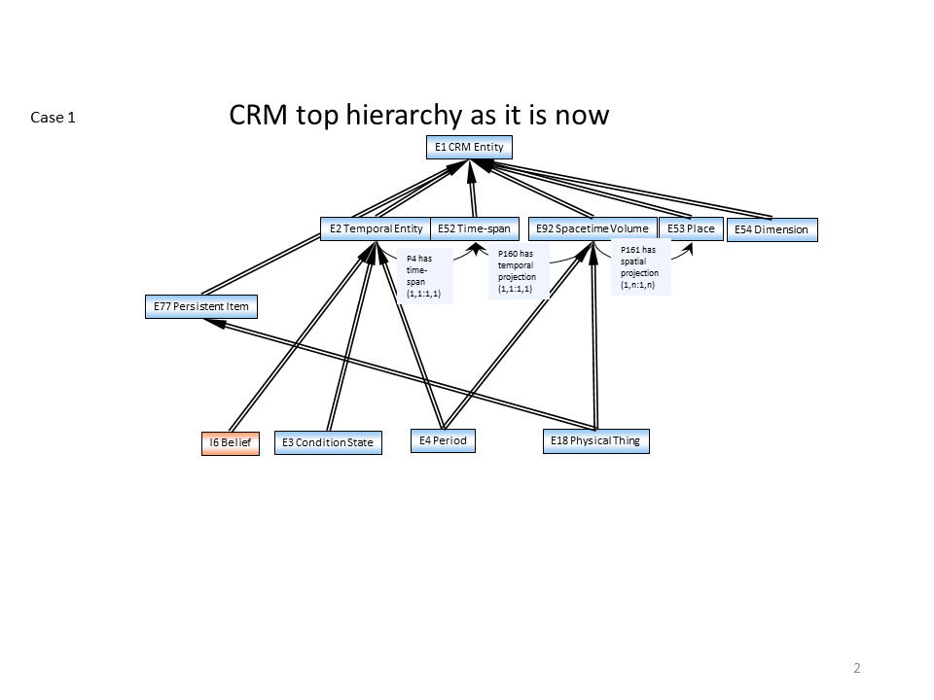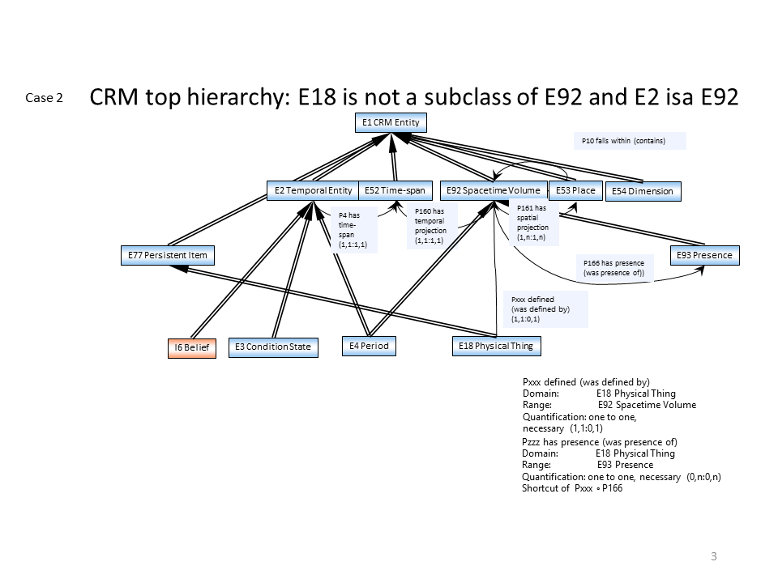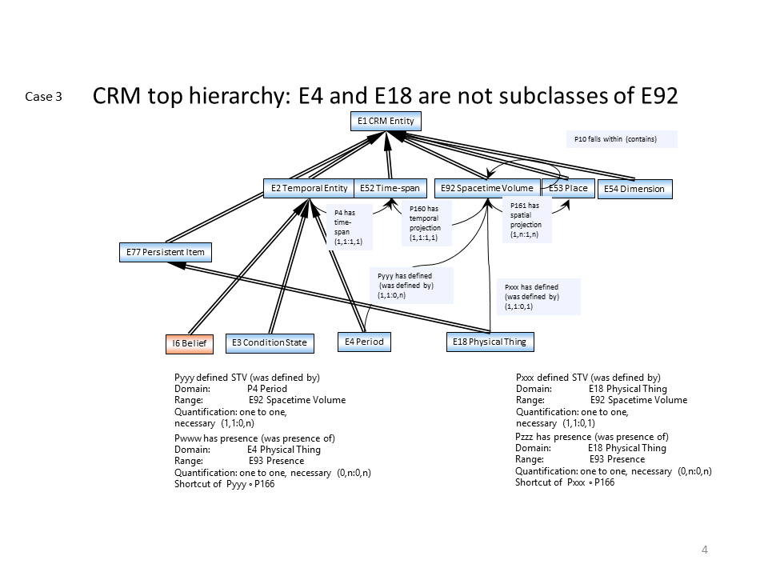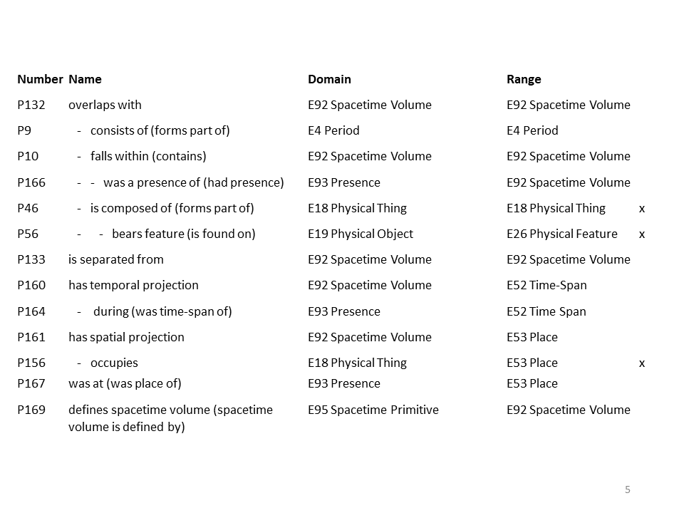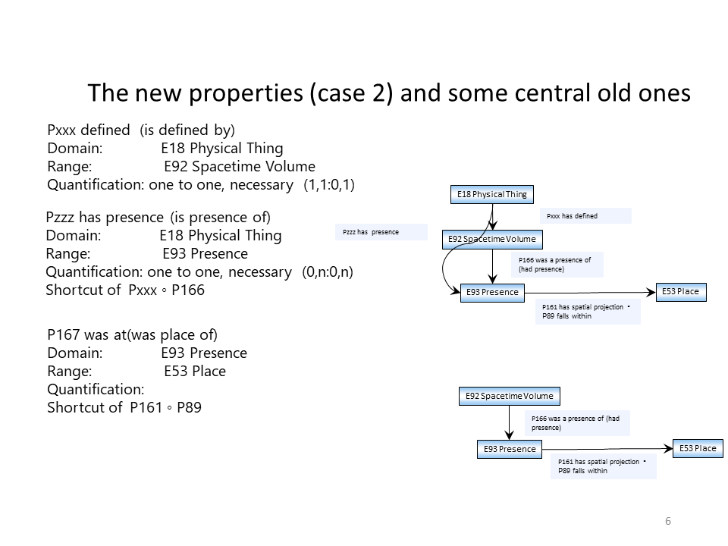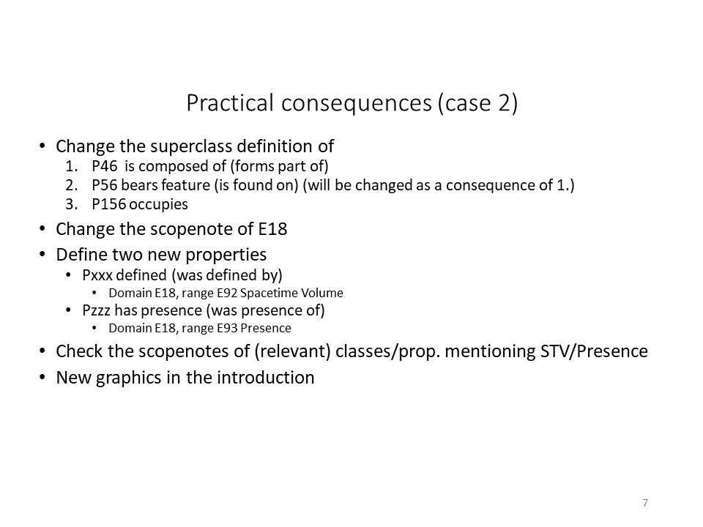

Appendix issue 419

socP24 specifies material substantial (is specified material substantial)

Domain:
socE4 Trigger Event Template
Range:
S10 Material Substantial
Quantification:
0,n:0,n
Scope note:
This property associates an instance of socE4 Trigger Event Template with an instance of S10 Material Substantial which the template specifies be present in the event which is the reason for the execution of the planned activity.
Examples:
The Tate Archives Flooding Disaster Plan Trigger Event Template specifies material substantial The River Thames (S14)
In First Order Logic:
- socP24(x,y) ⊃ socE4(x)
- socP24(x,y) ⊃ S10(y)

socP23 specifies actor (is specified actor of)

Domain:
socE4 Trigger Event Template
Range:
E39 Actor
Quantification:
0,n:0,n
Scope note:
This property associates an instance of socExx Trigger Event Template with the instance of E39 Actor who needs to be present in the triggering event specified.
Examples:

In First Order Logic:
- socP23(x,y) ⊃ socE4(x)
- socP23(x,y) ⊃ E39(y)

socP22 specifies time-span (is specified time-span of)

Domain:
socE4 Trigger Event Template
Range:
E52 Time-Span
Quantification:
0,n:0,n
Scope note:
This property associates an instance of socExx Trigger Event Template with the instance of E52 Time-span which is specified by the template as being the time-span for the planned activity.
Examples:
The template specifying my wedding (socE4 Trigger Event Template), specifies (socPxx specifies time-span) the wedding will take place between 14:00 and 23:00 on the 12th of August 2006 (E52 Time-span).
In First Order Logic:
- socP22(x,y) ⊃ socE4(x)
- socP22(x,y) ⊃ E52(y)

socP21 specifies place (is specified place of)

Domain:
socE4 Trigger Event Template
Range:
E53 Place ??E27 Site??
Quantification:
0,n:0,n
Scope note:
This property associates an instance of socExx Trigger Event Template with the instance of E53 Place which is specified by the template as the place where the planned activity should take place.
Examples:
The template specifying my wedding (socE4 Trigger Event Template), specifies (socP21 specifies place) the location of Cardiff Castle (E53 Place) for the wedding party to take place.
In First Order Logic:
- socP21(x,y) ⊃ socE4(x)
- socP21(x,y) ⊃ E53(y)

socP19 specifies type of actor (is actor type specified)
specifies the role type of a required actor (is the role type of a required actor)
Domain:
socE4 Trigger Event Template
Range:
E55 Type
Quantification:
0,n:0,n
Scope note:
This property associates an instance of socExx Trigger Event Template with the E55 Type of the role of a required E39 Actor specified by the template. This property does not require the instance of E39 Actor to be specified by socP23 specifies actor (is specified actor of).
Examples:
The template specifying my wedding (socE4 Trigger Event Template) specifies (socP19 specifies actor role) that someone acts as a disc jockey (E55 Type) to play music for the wedding guests.
In First Order Logic:
- socP19(x,y) ⊃ socE4(x)
- socP19(x,y) ⊃ E55(y)

socP18 specifies event type (is specified event type of)

Domain:
socE4 Trigger Event Template
Range:
E55 Type
Quantification:
0,n:0,n
Scope note:
This property associates an instance of socExx Trigger Event Template with the type (E55 Type) of the E5 Event which would trigger the planned activity. Typically, the instance of E5 Event is not known when the planned activity and trigger template are produced, so it cannot be specified.
Examples:
The disaster plan of the Tate Archives (socE2 Activity Plan) concerns the event of the river Thames flooding (socE4 Trigger Event Template) which specifies an event of type (socPxx specifies event type) "flood" (E55 Type).
In First Order Logic:
- socP18(x,y) ⊃ socE4(x)
- socP18(x,y) ⊃ E55(y)

scoP20 specifies type of thing (is specified type of thing of)

Domain:
socE4 Trigger Event Template
Range:
E55 Type
Quantification:
0,n:0,n
Scope note:
This property associates an instance of socExx Trigger Event Template with the type (E55 Type) of a thing which the template specifies be used or be present for the planned activity. The instance of the thing can be specified using the property socP24 specifies material substantial (is specified material substantial).
Examples:
No example yet.
In First Order Logic:
- scoP20(x,y) ⊃ socE4(x)
- scoP20(x,y) ⊃ E55(y)

Appendix – compatibility statement e-vote and results

Posted by CB on 22/10/2019
Dear All
Following the decisions of the current working group meeting, we invite you to vote if you accept the text about the compatiblity with CRM in the version 6.2.6. This text is the same with the one found in the iso version(rev 2014).
The text is the following:
==================================================
Compatibility with the CRM
Users intending to take advantage of the semantic interoberability offered by this International Standard should ensure conformance with the relevant data structures. Conformance pertains either to data to be made accessible in an integrated environment or intended for transport to other environments. Any enconding of data in a formal language that preserves the relations of the classes, properties, and inheritance rules defined by this definition of the CIDOC CRM(definition document), is regarded as conformant.
Conformance with this definition document does not require complete matching of all local documentation structures, nor that all concepts and structures present in this definition document be implemented. This definition document is intented to allow room both for extensions, needed to capture the full richness of cultural documentation, and for simplification, in the interests of economy. A system will be deemed partially conformant if it supports a subset of subclasses and subproperties defined by this definition document. Designers of the system should publish details of the constructs that are supported.
The focus of this definition document is the exchange and mediation of structured information. It does not require the interpretation of unstructured (free text) information into a structured, logical form. Unstructured information is supported, but falls outside the scope of conformance considerations.
Any documentation system will be deemed conformant with this definition document, regardless of the internal data structures it uses; if a deterministic logical algorithm can be constructed, that transforms data contained in the system into a directly compatible form without loss of meaning.
No assumptions are made as to the nature of this algorithm. "Without loss of meaning" signifies that designers and users of the system are satisfied that the data representation corresponds to the semantic definitions provided by this definition .
======================================================================
PLEASE VOTE :
YES for accepting,
NO for not accepting,
by Oct. 25 2019.

Posted by Robert Sanderson on 22/10/2019
Mu.

Some issues that could be fixed, but don’t lead me to conclude that it should be a straight No … however if it is about conformance (which I believe it is) then it is a potentially legal issue as to claims of systems and we should be careful with what we say.

Suggested edits:
- Typo: “enconding” for “encoding” in the first paragraph.
- The title is about “compatibility” but the text is about “conformance”. These are very different things. I think the title should be Conformance with the CRM.
- The sentence starting “Conformance pertains” doesn’t make sense as currently structured. Skipping the first part of the or clause, it reads: “Conformance pertains either to […] or intended for transport to other environments.” I think it should be: Conformance pertains to data which is either made accessible … or intended to be transported to other environments.
- The conformance rule is ambiguous. I can claim conformance by supporting one class, as “conformance does not require complete …”. Given the introduction later of “partially conformant”, the first paragraph should define “fully conformant” as supporting all of the classes and properties defined in the document. The next paragraph talks about conformance again, with a very different rubric. I can be fully conformant in a system that manages only Identifiers, but the previous paragraph would require this to be partially conformant.
- The documentation system paragraph talks about compatibility and conformance. It should only talk about conformance, or we would need the definition of “compatible”
- The “without loss of meaning” is based on the subjective opinion of an indeterminate audience, yet is a core part of the determination of conformance. My Identifier system is thus fully conformant, yet implements only one class and no properties because I, as the audience, judge it to be so.

Posted by Дарья Юрьевна Гук on 23/10/2019
YES

Posted by Christos Papatheodorou
YES

Posted by Richard Light on 23/10/2019
I think no.
In addition to Rob's comments below, and the need to change 'intented' to 'intended', I have reservations about the definition of partial conformance (and by extension of full conformance). For a start, are we trying to characterize systems, or data? The text starts off talking about data, then later on talks about systems. They are different things.
My view is that it is useful to define conformance for data, because that helps people decide what they can do with that data. Conformance of systems I think is a less useful concept. In particular, I don't think that having a system support every single CRM class and property is something to push for.
As regards data instances, I see 'full conformance' as meaning that the data is already in a form, or can be programmatically converted into a form, where all the classes and properties expressed by the data are taken from the CRM and meet the CRM's cardinality constraints. (I don't think we need to mention inheritance: this is 'baked into' the CRM model.)
'partial conformance' is where, after a similar optional conversion, some of the classes and properties in the data are taken from the CRM. However, that raises another question: what is the conformance level of data where some of the classes and properties are non-CRM, but an 'extension ontology' is provided which defines all of these classes and properties, and maps them all to 'parent' classes and properties in the CRM? Surely this is to be encouraged, and should be seen as 'more' conformant than data in which some classes and properties are CRM, and the rest is 'any old stuff'?
I agree with Rob's reservations about letting users decide what counts as 'no loss of meaning'. One suggestion is that we could ask them to implement round-tripping between the native form of the data and its CRM-compatible expression.

Appendix - Monotonicity”, “Minimality”, “Extensions”, “Coverage” and “Conservative Extension of the Scope of CIDOC CRM by Model Extensions”

Monotonicity
Because the CIDOC CRM’s primary role is the meaningful integration of information in an Open World, it aims to be monotonic in the sense of Domain Theory. That is, the existing CIDOC CRM constructs and the deductions made from them must always remain valid and well-formed, even as new constructs are added by extensions to the CIDOC CRM.

For example:
One may add a subclass of E7 Activity to describe the practice of an instance of group to use a certain name for a place over a certain time-span. By this extension, no existing IsA Relationships or property inheritances are compromised.

In addition, the CIDOC CRM aims to enable the formal preservation of monotonicity when augmenting a particular CIDOC CRM compatible system. That is, existing CIDOC CRM instances, their properties and deductions made from them, should always remain valid and well-formed, even as new instances, regarded as consistent by the domain expert, are added to the system.

For example:
If someone describes correctly that an item is an instance of E19 Physical Object, and later it is correctly characterized as an instance of E20 Biological Object, the system should not stop treating it as an instance of E19 Physical Object.

In order to formally preserve monotonicity for the frequent cases of alternative opinions, all formally defined properties should be implemented as unconstrained (many: many) so that conflicting instances of properties are merely accumulated. Thus knowledge integrated following the CIDOC CRM serves as a research base, accumulating relevant alternative opinions around well-defined entities, whereas conclusions about the truth are the task of open-ended scientific or scholarly hypothesis building.

For example:
El Greco and even King Arthur should always remain an instance of E21 Person and be dealt with as existing within the sense of our discourse, once they are entered into our knowledge base. Alternative opinions about properties, such as their birthplaces and their living places, should be accumulated without validity decisions being made during data compilation.
Properties, such as having a part, an owner or a location, may change many times for a single item during its existence. Stating instances of such properties for an item in terms of the CIDOC CRM only means that these properties existed during some particular time-span. Therefore, one item may have multiple instances of the same property reflecting an aggregation of these instances over the time-span of its existence. If more temporal details are required, the CIDOC CRM recommends explicitly describing the events of acquiring or losing such property instances, such as by E9 Move etc. By virtue of this principle, the CIDOC CRM achieves monotonicity with respect to an increase of knowledge about the states of an item at different times, regardless of their temporal order.
However, for some of these properties many collection databases describe the “current” state, such as “current location” or “current owner”. Using such a “current” state means, that the database manager is able to verify the respective reality at the latest date of validity of the database. Obviously, this information is non-monotonic, i.e., it requires deletion when the state changes. In order to preserve a reduced monotonicity, these properties have time-neutral superproperties by which respective instances can be reclassified if the validity becomes unknown or no longer holds. Therefore the use of such properties in the CIDOC CRM is only recommended if they can be maintained consistently. Otherwise, they should be reclassified by their time-neutral superproperties. This holds in particular if data is exported to another repository.

Extensions
Since the intended scope of the CIDOC CRM is a subset of the “real” world and is therefore potentially infinite, the model has been designed to be extensible through the linkage of compatible external type hierarchies.

Compatibility of extensions with the CIDOC CRM means that data structured according to an extension must also remain valid as a CIDOC CRM instance. In practical terms, this implies query containment: any queries based on CIDOC CRM concepts should retrieve a result set that is correct according to the CIDOC CRM’s semantics, regardless of whether the knowledge base is structured according to the CIDOC CRM’s semantics alone, or according to the CIDOC CRM plus compatible extensions. For example, a query such as “list all events” should recall 100% of the instances deemed to be events by the CIDOC CRM, regardless of how they are classified by the extension.

A sufficient condition for the compatibility of an extension with the CIDOC CRM is that CIDOC CRM classes subsume all classes of the extension, and all properties of the extension are either subsumed by CIDOC CRM properties, or are part of a path for which a CIDOC CRM property is a shortcut. Obviously, such a condition can only be tested intellectually.

Coverage
Of necessity, some concepts covered by the CIDOC CRM are less thoroughly elaborated than others: E39 Actor and E30 Right, for example. This is a natural consequence of staying within the CIDOC CRM’s clearly articulated practical scope in an intrinsically unlimited domain of discourse. These ‘underdeveloped’ concepts can be considered as hooks for compatible extensions.

The CIDOC CRM provides a number of mechanisms to ensure that coverage of the intended scope is complete:
- Existing high level classes can be extended, either structurally as subclasses or dynamically using the type hierarchy.
- Existing high level properties can be extended, either structurally as subproperties, or in some cases, dynamically, using properties of properties which allow subtyping.
- Additional information that falls outside the semantics formally defined by the CIDOC CRM can be recorded as unstructured data using E1 CRM Entity. P3 has note: E62 String.
In mechanisms 1 and 2 the CIDOC CRM concepts subsume and thereby cover the extensions.
In mechanism 3, the information is accessible at the appropriate point in the respective knowledge base. This approach is preferable when detailed, targeted queries are not expected; in general, only those concepts used for formal querying need to be explicitly modelled.

Conservative Extension of the Scope of the CIDOC CRM by Model Extensions
CIDOC CRMbase (or an extention of it) may be extended by declaring subclasses of existing classes as well as superclasses. In the former case, all properties of the CIDOC CRM class will hold for the subclasses. In the latter case, the scope of the CIDOC CRMbase will be extended and a property of the CIDOC CRM base class may hold for the new superclass but not necessarily. In the case a property p of a class A also holds for a new superclass B it should be a conservative extension. That is, when restricted to the original class the extended property, p’, is identical to the original property p. In general a superproperty is said to be a conservative extension of a subproperty when it is identical to the sub property when restricted to its domain and range.
Taken on its own, CIDOC CRMbase is not affected by such a conservative extension of scope, since it is not concerned with A. This is similar to what in logic is called a conservative extension of a theory. This construct is necessary for an effective modular management of ontologies, but is not possible with the current way RDF/OWL treats it.
In first order logic the conservative extension of a property can be expressed as follows. Assume that A and C are subclasses of B and D respectively and that p, p’ are properties between A,C and B, D respectively:
A(x) ⊃ B(x)
C(x) ⊃ D(x)
P(x,y) ⊃ A(x)
P(x,y) ⊃ C(y)
P’(x,y) ⊃ B(x)
P’(x,y) ⊃ D(y)
If p’ is a conservative extension of p then
A(x) ∧ C(y) ∧ P’(x,y) ≡ P(x,y)

Minimality
Although the scope of the CIDOC CRM is very broad, the model itself is constructed as economically as possible.
- CIDOC CRM classes and properties are either primitive, or they are key concepts in the practical scope.
- Complements of CIDOC CRM classes are not declared, because, considering the Open World Assumption, there are no properties for complements of a class (see Terminology).
A CIDOC CRM class is declared when:
- It is required as the domain or range of a property not appropriate to its superclass.
- It serves as a merging point of two CIDOC CRM class branches via multiple IsA (e.g. E25 Human-Made Feature). When the branch superclasses are used for multiple instantiation of an item, this item is in the intersection of the scopes. The class resulting from multiple IsA should be narrower in scope than the interrsection of the scopes od the branch superclasses.
- It is useful as a leaf class (i.e. at the end of a CIDOC CRM branch) to domain communities building CIDOC CRM extensions or matching key domain classes from other models to the CIDOC CRM (e.g. E34 Inscription).

Appendix issue 314

Posted by Chryssoula on 22/10/2019

Dear All
Following the decisions of the current working group meeting, we invite you to vote if you accept the introductory text for the “Use and Learn” section of the CRM site

The text is the following:
==================================================
How can I use the CIDOC CRM?
The CIDOC CRM is, first of all, an intellectual system for organizing and integrating cultural heritage data. This system is officially expressed in specification documents. These documents are available in the resource section of this website. These are the official reference documents for the CIDOC CRM and are actively maintained by the CIDOC CRM SIG and updated according to user needs and the organic growth of the standard.
Using CIDOC CRM in practical data integration scenarios can be achieved in a number of ways. In a common scenario it can be implemented in RDF or OWL based knowledge bases; alternatively, it can be used to enable the implementation of cross database query interpreters. It can also be used as an intellectual guide in order to build more effective traditional relational databases.
In order to begin the adoption of CIDOC CRM in different use scenarios, potential adopters are encouraged to consult the tutorials and information available in the teaching section of this website. There are also a series of FAQ documents designed to help answer common questions of CRM adopters. Potential users/members of the CRM community are also welcomed to contact the CIDOC CRM SIG for advice and information. If you are already using CIDOC CRM and have questions or issues that are not resolved by the documentation and tutorials, you may always join the CIDOC CRM SIG mailing list and post questions on specific topics there. The results of past questions and issues are collected on the website and form a useful archive to consult in order to answer previously asked questions.
As mentioned above, the CIDOC CRM now encompasses both the basic standard, CRMbase, as well as a family of modular extensions. Each of these extensions has its own specific website to support its use in the same manner as above. To see the present list of extensions, please click here.

======================================================================

PLEASE VOTE :

YES for accepting,
NO for not accepting,
OR
Send us any major comment you might have

by Oct. 25 2019.

Posted by Robert Sanderson on 23/10/2019 about the introductory text for the “Use and Learn” section of the CRM site

YES

Posted by Siegfried Krause on 23/10/2019 about the introductory text for the “Use and Learn” section of the CRM site

I would propose instead of „an intellectual system for organizing and integrating cultural heritage data“ another more simple wording we used in former times like ‘well elaborated method’ or ‘well specified method’ or just simply method (based on a conceptual hierarchy) organising and integrating cultural heritage data.

Posted by Daria Hookk on 23/10/2019 about the introductory text for the “Use and Learn” section of the CRM site

Simply "method", even well elaborated looses the aim, applicability.

Posted by Christian Emil on 23/10/2019 about the introductory text for the “Use and Learn” section of the CRM site

I agree with Siegfried. but otherwise yes. In general we should be careful not to fall into the EU-application-speech-trap.

Chr-E

Posted by Pat Riva on 23/10/2019 about the introductory text for the “Use and Learn” section of the CRM site

YES

Posted by George Bruseker on 23/10/2019 about the introductory text for the “Use and Learn” section of the CRM site

Yes, edits welcome

Posted by Richard Light on 23/10/2019

YES

Posted by Olivier Marlet on 23/10/2019

YES

Posted by Christos Papatheodorou on 23/10/2019

YES

Posted by Pierre Choffé

YES

Updates from the version 0

The issues 422 (decision d), 390, 347, 410, 363,286,241, 236 have been updated.
The List of abbreviations has been updated.

Updates from the version 1
The issues 351,326,440, 412,408, 419,436,386,426,283,410,294,425,281,314,432 have been updated.
The List of abbreviations has been updated
The following appendices have been added
- Appendix issue 326/438 CE presentations
- Appendix issue 419
- Appendix – compatibility statement e-vote and results
- Appendix - Monotonicity”, “Minimality”, “Extensions”, “Coverage” and “Conservative Extension of the Scope of CIDOC CRM by Model Extensions”
- Appendix issue 314

«[…] As the actual extent of an instance of E4 Period in spacetime we regard the trajectories of the participating physical things during their participation in an instance of E4 Period. […]”
Walker, Mike; Johnsen, Sigfus; Rasmussen, Sune Olander; Popp, Trevor; Steffensen, Jorgen-Peder; Gibrard, Phil; Hoek, Wim; Lowe, John; Andrews, John; Bjo Rck, Svante; Cwynar, Les C.; Hughen, Konrad; Kersahw, Peter; Kromer, Bernd; Litt, Thomas; Lowe, David J.; Nakagawa, Takeshi; Newnham, Rewi; Schwander, Jakob (2009). "Formal definition and dating of the GSSP (Global Stratotype Section and Point) for the base of the Holocene using the Greenland NGRIP ice core, and selected auxiliary records" (PDF). Journal of Quaternary Science. 24 (1): 3–17. Bibcode:2009JQS....24....3W. doi:10.1002/jqs.1227.

