Issue 446: The nature of A1 Excavation Process Unit
http://www.cidoc-crm.org/Issue/ID-446-the-nature-of-a1-excavation-process-unit

Latest decisions: October 2019
In the 45th joint meeting of the CIDOC CRM SIG and SO/TC46/SC4/WG9; 38th FRBR – CIDOC CRM Harmonization meeting and in the context of discussing issue 283 (superproperties to CRMarchaeo properties) the sig resolved to declare AP4 produced surface a subproperty of P108 has produced. To achieve that the domain of AP4 –namely A1 Excavation Process Unit –should be made a subclass of E12 Production.

So the sig decided to raise a new issue regarding the nature of A1 Excavation Process Unit (isA E12 Production vs. isA S1 Matter Removal).

In the context of this new issue, all properties connecting A1 Excavation Process Unit to other CRM classes should be examined to determine that both they and that their superproperties are compatible with the newly postulated semantics for A1 Excavation Process Unit.

AP1 produced (was produced by) [D: A1 Excavation Process Unit, R: S11 Amount of Matter]
AP2 discarder into (was discarded by) [D: A1 Excavation Process Unit, R: S11 Amount of Matter]
AP5 removed part or all of (was partially or totally removed by) [D: A1 Excavation Process Unit, R: A8 Stratigraphic Unit],
AP10 destroyed (was destroyed by) [D: A1 Excavation Process Unit, R:S22 Segment of Matter]

Investigating the consequences of the issue
Currently the class E1 Excavation Process is a subclass of S1 Matter Removal and S4 Observation. The properties AP1 produced (was produced by) and AP2 discarder into (was discarded by) mentioned above are subproperties of S1 Matter Removal. O2 removed (was removed by): S11 Amount of Matter as indicated in Figure 1. Without giving a full analysis here, it is quite evident that neither AP1 nor AP2 can be subproperties (that is, specializations) of any of the properties of E11 Modification or its subclasses. The only candidate I see is E80 Part Removal. P113 removed (was removed by): E18 Physical Thing. Since one can remove stuff without a fixed form like mud, sand, ashes etc. the range of P113, E18 Physical Thing, is too restrictive: “This class comprises all persistent physical items with a relatively stable form, human-made or natural.” In my opinion, the conclusion is that A1 Excavation Process Unit has to continue to be a subclass of S1 Matter Removal.
A purpose of the issue is to investigate whether AP4 Produced surface (was surface produced by) can be a subproperty of E12 Production. P108 has produced (was produced by). E24 Physical Human-Made Thing. To achieve this E12 Production has to be a third superclass of A1 Excavation Process Unit.
The range of P108 has produced (was produced by) is E24 Physical Human-Made Thing. The class A10 Excavation Interface is a subclass of S20 Rigid Physical Feature which in turn is a subclass of E26 Physical Feature, see Figure 2. An instance of A10 is always human-made while an instance of A8 Stratigraphic Unit need not to be made by humans. There are at least three alternatives:
- Introduce a new class S?? Rigid Human-Made Physical Feature analog to S20 Rigid Physical Feature and make A10 a subclass of this new class, see figure 2.
- Make A10 Excavation Interface a direct subclass of E53 Place and E25 Human-Made Feature, see figure 3.
- Make A10 Excavation Interface a direct subclass of E25 Human-Made Feature in addition, see figure 4.
There are pros and cons for all three. Alternative 1 requires a new class defined in analogue with S20. However, S20, as it is defined today, comprises both non human-made and human-made features. So this class should be a subclass of S20 or S20 has to be changed to comprise only non human-made features. The latter implies a kind of disjointness and should be ruled out. Alternative 2 is also problematic for similar reasons.
Alternative 3 seems to be the best solution. Also, as GH argues, in excavation documentation it is not always clear whether a referred structure is a pre-excavation surface or the approximating surface made by the excavators. So it will be preferable to model it as an S20 having later the opportunity to specify it more (to either A8 or A10), or leave it as S20. So the proposal is to i to leave A10 as a subclass of AS20 and and in addition make it a sub class of E25 Human-Made Feature.

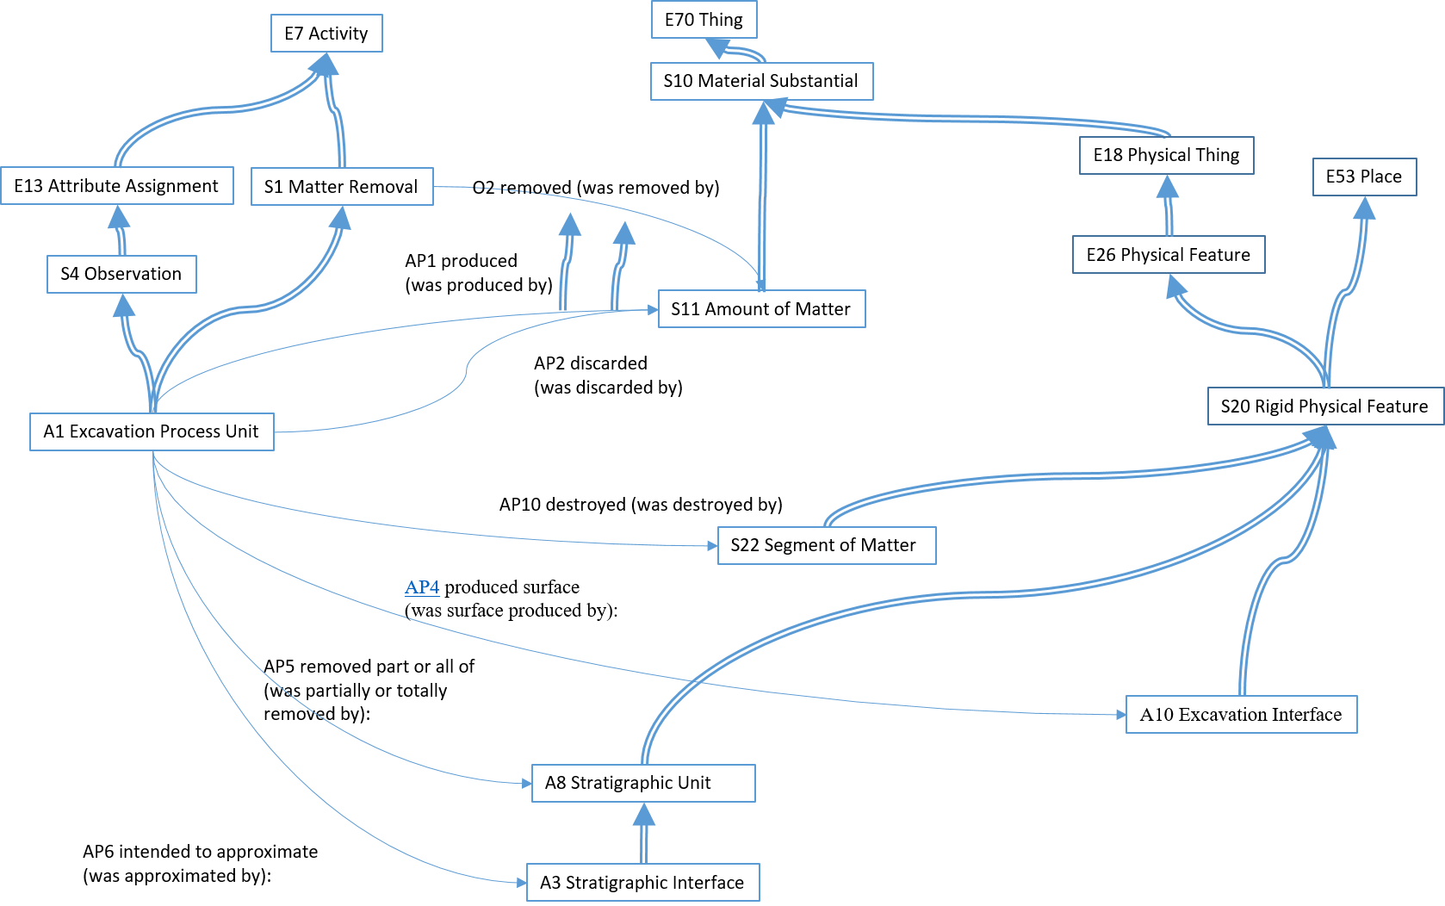
Figure 1 A1 Excavation Process Unit as it is today

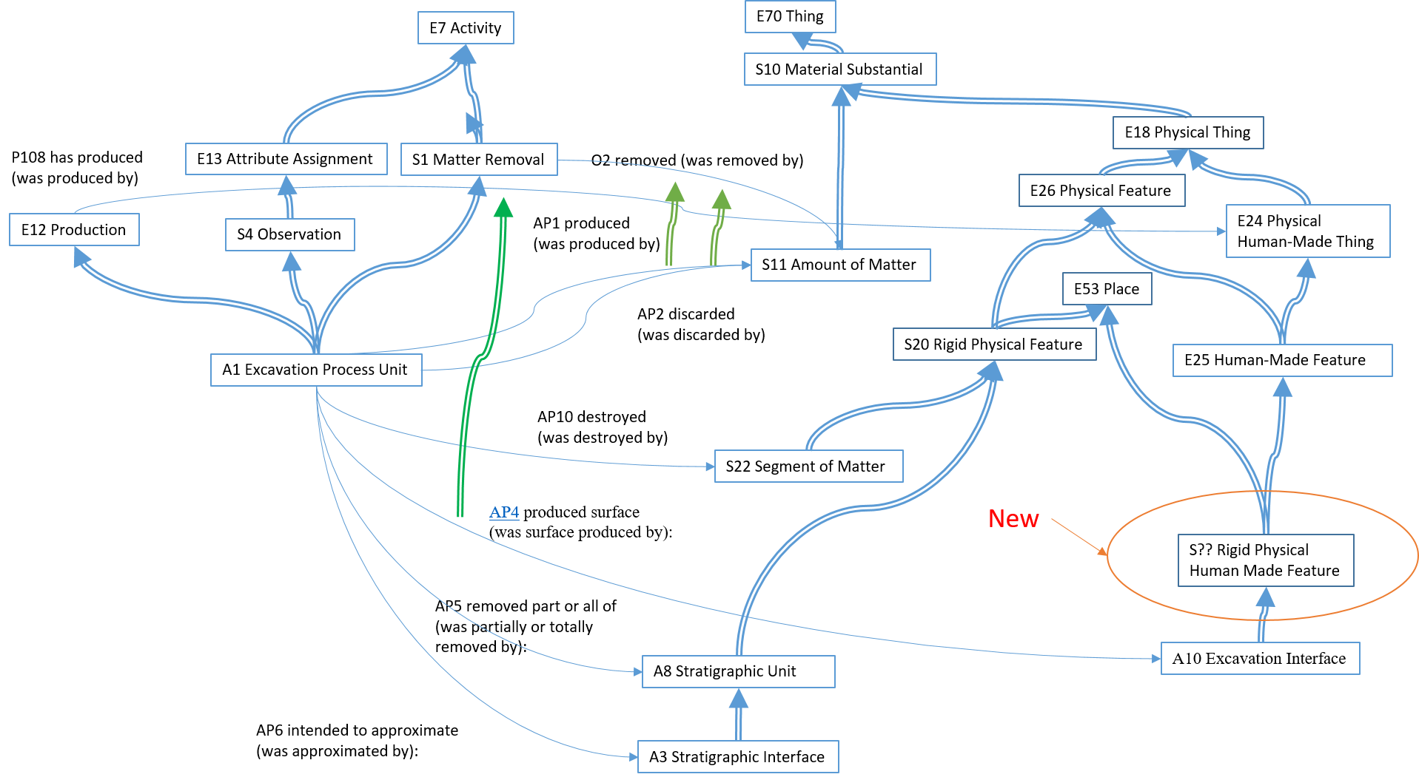
Figure 2 A new class S?? Rigid Physical Human Made Feature isA E25 Human-Made Feature and isA E53 Place

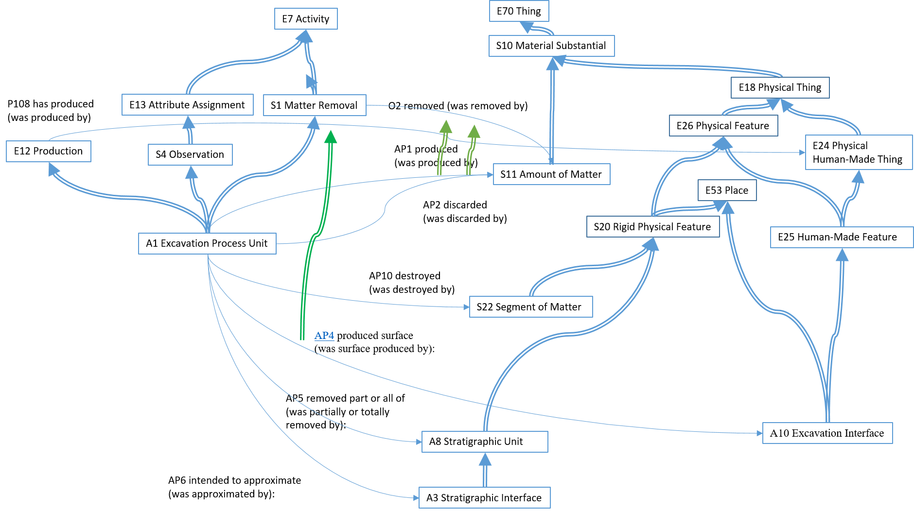
Figure 3 A10 Excavation Interface isA E25 Human-Made Feature and isA E53 Place

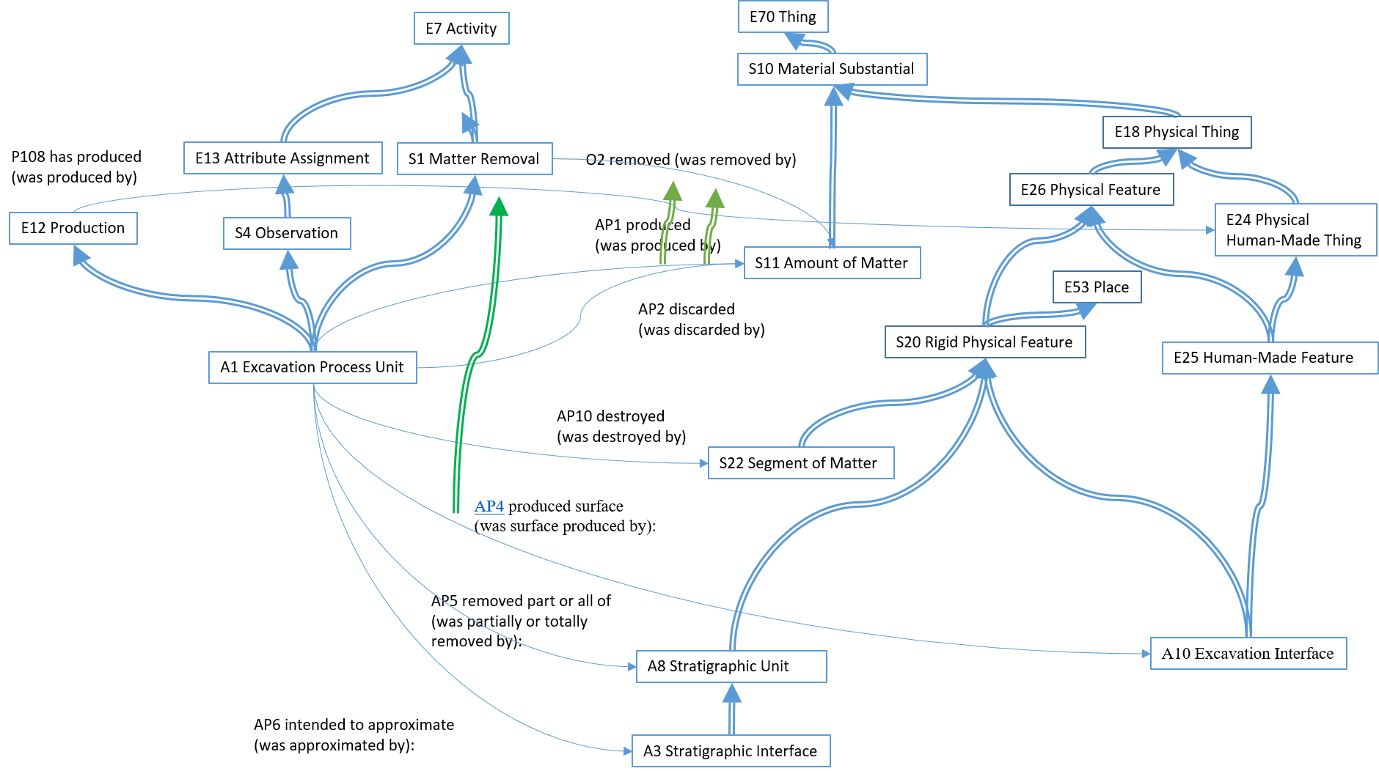
Figur 4 A10 Excavation Interface isA E25 Human-Made Feature and isA S20 Rigid Physical Feature

