Definition of CRMsoc

Editorial Status: v. 0.2 Ongoing
Editors:
Francesco Beretta, George Bruseker
with the contribution of ...

2020/10/02 14:09:41

1.1 Introduction

1.1.1 Scope

What is CRMsoc CRMsoc is an extension to the CIDOC CRM aimed at expanding the expressivity of the standard relative to the representation of conventionally grounded, socially constructed facts and their foundation in intentionality. In historical and social sciences, and increasingly in cultural heritage studies as they encounter the challenges of the decolonialist turn, it is typical to record and analyze the context which grounds and supports the commitment to socially constituted facts (names, memberships, ownership, rights, classifications, etc.). For facts which are established by convention as opposed to pure spatio-temporal facts, it is typically important for historical research to record the constituent actors, events, social conventions and the temporal boundaries which ground and characterize their original constitution and which support their continued existence. The purpose of this extension is thus to enable the representation and exchange of information regarding the social context and identity of conventional facts and the intentionality of actors for the exchange of said information in an objective and uniform manner. CRMsoc provides an extension and overlay of CRMbase that delivers an intention-centric extension of temporal classes for the representation of the commitment of individuals and social groups to conventional facts as well as enabling the modelling of the conventional actions which establish or de-establish such facts. What is the idea? Historians, social scientists and cultural heritage specialists record and are concerned to understand, track and explain the evolution of socially constituted facts and other intentional phenomena like reading, discussing or voting. Conventionally attributed facts have a different ontological nature to physically established facts, being grounded in the communal epistemic commitment of a group to ‘something being the case’ called ‘social or collective representations’ in contemporary social sciences. The notion of intentionality, of taking something to be the case in the context of specific social representations, is called upon to allow the modelling of a rich set of relations required by researchers to understand when a fact or intentional phenomenon was the case, for whom and under what conditions. This extension thus allows the argumentation over empirically retrievable facts regarding the conventional agreement of groups about characteristics of entities over time and how these facts were established, maintained or de-established. This extension thus enriches the overall expressivity of CIDOC CRM for researchers and professionals for whom the parameters of the establishment of social fact are an object of direct study or have direct impact on their understanding of wider networks of knowledge. It is based on standard concepts in social philosophy and social psychology, notably the notions of intentionality and social representations, in order to propose a comprehensive perspective and without adopting the viewpoint of a specific author or school of thought. Reference literature (selection): Gallotti Mattia and Michael John (éds.), Perspectives on Social Ontology and Social Cognition, Dordrecht, Springer Netherlands, 2014. Sammut Gordon et al. (éds.), The Cambridge Handbook of Social Representations, Cambridge, University Press, 2015. Searle John, Making the Social World: The Structure of Human Civilization, Oxford University Press, 2010. The Stanford Encyclopedia of Philosophy (Fall 2021 Edition), Edward N. Zalta (ed.) (online) (especially entries: Collective Intentionality, Mental Representation, Consciousness and Intentionality, Social Norms, etc.) Thomas T. (ed.), Encyclopedia of critical psychology (New York: Springer Reference, 2014) (especially entries: Interobjectivity; Social Constructionism; Social Representations; Socialisation).

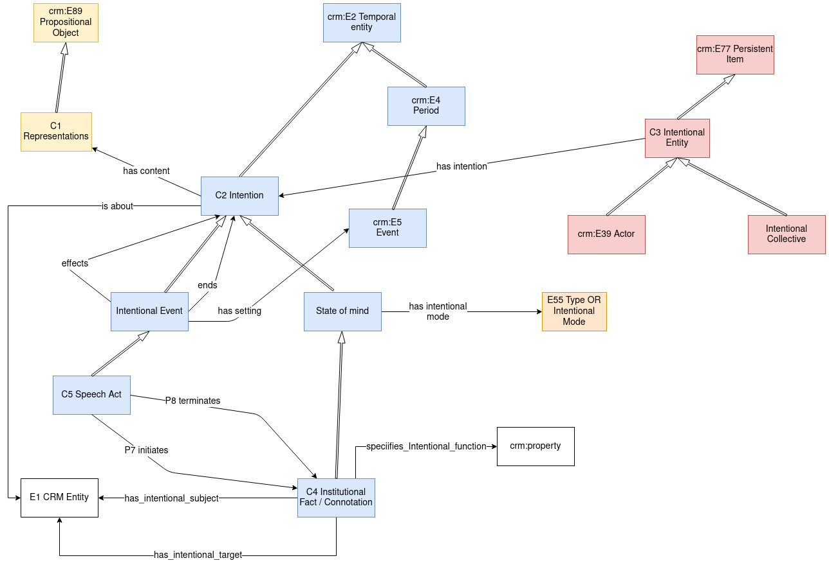

1.1.2 Status

Ongoing version

1.4 Class Declarations

The classes are comprehensively declared in this section using the following format:

- Class names are presented as headings in bold face, preceded by the class’ unique identifier;
- The line “Subclass of:” declares the superclass of the class from which it inherits properties;
- The line “Superclass of:” is a cross-reference to the subclasses of this class;
- The line “Scope note:” contains the textual definition of the concept the class represents;
- The line “Examples:” contains a bulleted list of examples of instances of this class.
- The line “Properties:” declares the list of the class’s properties;
- Each property is represented by its unique identifier, its forward name and the range class that it links to, separated by colons;
- Inherited properties are not represented;

C1 - Representations

Subclass of: Propositional Object

Scope note: Representations are modelled as the content of individual or collective intentionality. They are sets of propositional objects and other related abstract objects that are present in human minds as a conceptualization proper to and shared by individuals in a social context. These persons do not necessarily act together, and are therefore not a group in the sense of crm:E74 Group but they share the same representations stemming from education, social context, professional and social engagement, media, etc. In this perspective, representations (beliefs, hopes, desires, knowledge, and also practical know-how, etc.) are constitutive of human individuals in their mental identity, as well as communities and social collectives.

In First Order Logic: C1 ⊃ E89

C2 - Intention

Subclass of: Temporal Entity

Superclass of:
State of Mind
Intentional Event

Scope note: This class comprises qualities of the mind of a single person, or the minds of intentional collectives of humans. It consists in the presence in the mind of sdh:C26 Representations about things, be these tangible or intangible. This class is modelled as comprehensive of all intentional phenomea, be they static, in the sense of states of mind, or dynamic, i.e. changes of mind or opinions evolving in time. Intentionality is defined in philosophy as the power of minds to be directed at objects, i.e. entities, states of affairs, goals, or values (Stanford Encyclopedia of Philosophy). It is important to note that "intentionality" is not to be confused with "intention" as the purpose people have in mind when they act. The notion of intentionality applies primarily to the theory of knowledge, not to the theory of human action. Since sdh:C26 Representations are modelled as sets of one or more propositional objects and therefore as a subclass of crm:E89 Propositional Object, the objects of the personal or collective intention can be associated to the representations using the crm:P129 is about (is subject of) property. Intention class, as a descendant of the crm:E2 Temporal Entity class, models the fact that instances of sdh:C26 Representations are present to human minds or intentional entities, be these taken individually or as collectives, during a given time span. The intention therefore appears to be a time-related quality of a mind or minds be this realized in a more stable way, as in intentional states of mind, or engaged in an evolutionary, dynamic process, e.g. discussing a topic or changing one's mind.

In First Order Logic: C2 ⊃ E2

Properties:
C2 has content (is content of) (P1 has content (is content of)): C1
C2 is about (is concerned by) (P11 is about (is concerned by)): E1
C2 is intention of (has intention) (P2 is intention of (has intention)): C3

C3 - Intentional Entity

Subclass of: Persistent Item

Superclass of:
Actor

Scope note: Entity capable of having representations about objects. The present class is modelled as expressing at the same time the individual and the collective intentionality in order to avoid taking a stand in the ongoing debate about the nature of collective intentionality: is it simply the sum of individual intentions or does it express something more substantial in the sense of an intentional collective ? The model is open to both interpretations and one can choose to use or not the sdh:C25 Intentional Collective class for expressing collective intentionality, or provide specific types to the sdh:C26 Representations Class, e.g. 'social representations' for modelling views and conceptualizations shared by groups and societies. In the perspective of psychology and social sciences, personal intentionality cannot exist —in real human lives— outside a socialisation that shapes the language and categories of thought of individuals. Individuality is realised in the context of this substrate, i.e. the sharing and adopting, or contributing to the development of social representations. Beyond its irreducible individuality, a person embodies, and specialises, an intentional collective which he or she helps to achieve and contributes to evolve. This constant interaction between persons and intentional collectives appears to be one of the foundations of social life.

In First Order Logic: C3 ⊃ E77

C4 - Institutional Fact

Subclass of: State of Mind

Scope note: An instance of institutional fact is an ascription of a status function to an object by a community. The institutional fact is a concretization of a collective intentionality of the community in question towards a certain object over a certain period. An instance of institutional fact is recognizable to a competent speaker/member of a symbolic community (native or learner with sufficient progress, e.g. anthropologist). An instance of institutional fact may not be perceived through a single sense impression but through multiple experiences and implicit reasonings (e.g.: the behaviour of a child to an elder, and linguistic evidence and interview), yet typically such intermediate observations and inferences are not necessarily recorded or accessible. The historical statement is typically the assertion of the institutional fact, that such and such a fact was the case, and in force, at some time. The epistemic veridicality of the stated /reference instance of institutional fact is always open to contestation. The means of contestation involve analyzing the sources which support it. Instances of institutional fact come into existence based on conventions establishing the conditions under which they come into effect. Typically, an instance of institutional fact will come into existence either because of the performance of its stipulated, initiating speech act (e.g.: state of being married via marriage) or as a result of events fulfilling existing norm prescriptions in the community (e.g.: state of being father as result of birth of child of sister). An institutional fact comes to be through the agreed fiat of a community. It typically ceases to exist either because of a stipulated, nullifying speech act (e.g. divorce proceeding), because a community ceases to support the effective rule supporting its declaration (e.g.: ownership of people) or force majeure (e.g.: object ascribed function/status or community perceiving status is eliminated).

In First Order Logic: C4 ⊃ C6

Properties:
C4 holds for (is held by) (P3 holds for (is held by)): C3
C4 has intentional target (is intentional target of) (P6 has intentional target (is intentional target of)): E68
C4 has intentional subject (is intentional subject of) (P4 has intentional subject (is intentional subject of)): E1
C4 ascribes intentional relation (is intentional relation ascribed by) (P5 ascribes intentional relation (is intentional relation ascribed by)): E55

C5 - Speech act

Subclass of: Intentional Event

Scope note: An instance of speech act comprises an intentional activity engaged in by a set of actors to create a new institutional fact within a community. Speech acts are carried out through invoking a social rule and performing a prescribed set of actions often including the locution of set formulae. Correct execution of the speech act as specified by the rule results in the existence of new institutional facts. The substance of speech act is ritual action by a group. An instance of speech act begins when the intended ritual proceeding as specified by the rule invoked is initiated. The instance of speech act ends when the required set of actions specified for the action in question are executed or it is abandoned.

In First Order Logic: C5 ⊃ C8

Properties:
C5 terminates (is terminated by) (P8 terminates (is terminated by)): C4
C5 invoked (was invoked by) (P13 invoked (was invoked by)): E68
C5 initiated (was initiated by) (P7 initiated (was initiated by)): C4
C5 performed (was performed by) (P12 performed (was performed by)): C1

C6 - State of Mind

Subclass of: Intention

Superclass of:
Institutional Fact

Scope note: This class comprises opinions, beliefs, certainties, doubts etc. of a person or collective of persons about representations concerning an object. The representations are considered as being stable during a given time-span and expressed in form of propositional or intentional content. A state of mind is modelled as a time-indexed quality inherent to a person, or persons belonging to an intentional collective, having as content a propositional object defining the content of the state of mind about an object. The concerned object of the intentional state can be associated to the propositional content using the crm:P129 is about (is subject of) property, while the type or mode of intentional state, e.g. belief, hope, fear, etc. can be expressed with the sdh:P44 has intentional type (is intentional type of) property. Individual or collective states of mind are an expression of intentionality, defined in philosophy as "the power of minds and mental states to be about, to represent, or to stand for things, properties and states of affairs. To say of an individual’s mental states that they have intentionality is to say that they are mental representations or that they have contents" (Jacob, Pierre, "Intentionality", The Stanford Encyclopedia of Philosophy (Winter 2019 Edition), ed. Edward N. Zalta).

In First Order Logic: C6 ⊃ C2

Properties:
C6 has intentional mode (is intentional mode of) (P10 has intentional mode (is intentional mode of)): C7

C7 - Intentional Mode

Subclass of: Type

Scope note: This class comprises concepts expressing different intentional states or psychological modes about the same propositional content, i.e. representations. For instance hope, belief, fear, scientific certainty, etc. about the same intentional content, e.g. "the election of this person to the position of president". In the given context, the concerned person can be seen as the object of the intention, the election to a position as the content and the hope as the mode or type of the intentional state.

In First Order Logic: C7 ⊃ E55

C8 - Intentional Event

Subclass of: Intention

Superclass of:
Speech act

Scope note: This classes comprises changes of mind of persons or human collectives, or other dynamic phenomena taking place in the mind, such as reading or having a conversation, which are likely to bring about a change in intention. Intentional events, insofar as they happen in the minds of one or more persons, do not directly have a projection in geographical space. But as they are always related to sets of human actions (one or more) that provide the setting for the given intentional events (sdh:P43 is setting for) they share with these physical events the geographical location. E.g. the reading of a book as a mental operation, or a conversation with one or more persons has the correspondent physical events (having the book in the hand, sitting in a coffee house) as its setting.

In First Order Logic: C8 ⊃ C2

Properties:
C8 has setting (is setting of) (P9 has setting (is setting of)): E5 Event

1.4 Property Declarations

The properties are comprehensively declared in this section using the following format:

- Property names are presented as headings in bold face, preceded by unique property identifiers;
- The line “Domain:” declares the class for which the property is defined;
- The line “Range:” declares the class to which the property points, or that provides the values for the property;
- The line “Superproperty of:” is a cross-reference to any subproperties the property may have;
- The line “Scope note:” contains the textual definition of the concept the property represents;
- The line “Examples:” contains a bulleted list of examples of instances of this property.

P1 - has content (is content of)

Domain: C2 Intention
Range: C1 Representations

Quantification: many to one, necessary, dependant
UML: 1,n:1,1
Merise: 1,1:1,n

Scope note: This property associates a time-indexed collective state of mind with the social representation representing its content.

In First Order Logic:
P1(x,y) ⊃ C2(x)
P1(x,y) ⊃ C1(y)

P2 - is intention of (has intention)

Domain: C2 Intention
Range: C3 Intentional Entity

Quantification: many to one, necessary, dependant
UML: 1,n:1,1
Merise: 1,1:1,n

Scope note: This property associates a person or intentional collective with the intentional situations that characterise them. These are time-indexed qualities of the intentional entities.

In First Order Logic:
P2(x,y) ⊃ C2(x)
P2(x,y) ⊃ C3(y)

P3 - holds for (is held by)

Domain: C4 Institutional Fact
Range: C3 Intentional Entity

Quantification: many to many, necessary
UML: 0,n:1,n
Merise: 1,n:0,n

Scope note: This property is used to indicate the community or group for whom an instance of institutional fact holds. Institutional facts have identity only relative to some group for whom they have a significance as formulated through a chosen symbolic system.

In First Order Logic:
P3(x,y) ⊃ C4(x)
P3(x,y) ⊃ C3(y)

P4 - has intentional subject (is intentional subject of)

Domain: C4 Institutional Fact
Range: E1 CRM Entity

Quantification: many to one, necessary
UML: 0,n:1,1
Merise: 1,1:0,n

Scope note: This property is used to connect an instance of institutional fact to an entity with which it is concerned. The intentional subject indicated by this property is the object about which the institutional fact holds for the group committed to this institutional reality.

In First Order Logic:
P4(x,y) ⊃ C4(x)
P4(x,y) ⊃ E1(y)

P5 - ascribes intentional relation (is intentional relation ascribed by)

Domain: C4 Institutional Fact
Range: E55 Type

Quantification: many to one
UML: 0,n:0,1
Merise: 0,1:0,n

Scope note: This property is used to indicate the relationship which an instance of institutional fact takes to hold between its subject and its object. The intentional relation indicated by this property is the kind of relationship which the institutional fact establishes as holding between them for the group committed to this institutional reality.

In First Order Logic:
P5(x,y) ⊃ C4(x)
P5(x,y) ⊃ E55(y)

P6 - has intentional target (is intentional target of)

Domain: C4 Institutional Fact
Range: E68 Dissolution

Scope note: This property is used to indicate the entity which an instance of institutional fact ascribes to its subject. The intentional target indicated by this property is the object which the institutional fact establishes as holding of its subject for the group committed to this institutional reality. The manner of its holding is indicated by the intentional relation.

In First Order Logic:
P6(x,y) ⊃ C4(x)
P6(x,y) ⊃ E68(y)

P7 - initiated (was initiated by)

Domain: C5 Speech act
Range: C4 Institutional Fact

Quantification: many to many, dependant
UML: 1,n:0,n
Merise: 0,n:1,n

Scope note: This property is used to connect the instance of speech act to the instance of institutional fact which it brought into existence through the correct performance of the specified performance to bring about the norm type it aimed to bring about.

In First Order Logic:
P7(x,y) ⊃ C5(x)
P7(x,y) ⊃ C4(y)

P8 - terminates (is terminated by)

Domain: C5 Speech act
Range: C4 Institutional Fact

Quantification: many to many
UML: 0,n:0,n
Merise: 0,n:0,n

Scope note: This property is used to connect the instance of speech act to the instance of institutional fact of which it terminated the existence through the correct performance of the specified performance to bring about the norm type it aimed to bring about

In First Order Logic:
P8(x,y) ⊃ C5(x)
P8(x,y) ⊃ C4(y)

P9 - has setting (is setting of)

Domain: C8 Intentional Event
Range: E5 Event

Quantification: many to many, necessary
UML: 0,n:1,n
Merise: 1,n:0,n

Scope note: This property associates an intentional event with the spatio-temporal phenomena in the context of which it takes place or occurs.

In First Order Logic:
P9(x,y) ⊃ C8(x)
P9(x,y) ⊃ E5(y)

P10 - has intentional mode (is intentional mode of)

Domain: C6 State of Mind
Range: C7 Intentional Mode

Quantification: many to one
UML: 0,n:0,1
Merise: 0,1:0,n

Scope note: This property associates a state of mind with its intentional mode or psychological attitude (belief, desire, etc.)

In First Order Logic:
P10(x,y) ⊃ C6(x)
P10(x,y) ⊃ C7(y)

P11 - is about (is concerned by)

Domain: C2 Intention
Range: E1 CRM Entity

Quantification: many to one
UML: 0,n:0,1
Merise: 0,1:0,n

Scope note: This property associates the intention to the entity it is directed to.

In First Order Logic:
P11(x,y) ⊃ C2(x)
P11(x,y) ⊃ E1(y)

P12 - performed (was performed by)

Domain: C5 Speech act
Range: C1 Representations

Quantification: many to many
UML: 0,n:0,n
Merise: 0,n:0,n

Scope note: This property is used to indicate the performance plan sanctioned by normative rule appealed to by the speech act to bring about a new institutional fact. This performance plan indicates the series of necessary procedures that must be followed in order for the speech act to have been successfully carried out and to have created a genuine instance of the institutional fact that it was designed to make possible.

In First Order Logic:
P12(x,y) ⊃ C5(x)
P12(x,y) ⊃ C1(y)

P13 - invoked (was invoked by)

Domain: C5 Speech act
Range: C1 Representations

Quantification: many to many
UML: 0,n:0,n
Merise: 0,n:0,n

Scope note: This property is used to indicate the normative rule which a speech act relies on as typological and as sanctioning code in order to bring out a token/instance of the institutional fact it prescribes.

In First Order Logic:
P13(x,y) ⊃ C5(x)
P13(x,y) ⊃ E68(y)

