Definition of the CRMdig
An Extension of CIDOC-CRM to support provenance metadata

Proposal for approval by CIDOC CRM-SIG

Version 3.2.1

April 2016

Currently Maintained by FORTH.

Contributors: Martin Doerr, Stephen Stead, Maria Theodoridou, and others.

Index
Index 2
Introduction 4
CRMdig Class Declaration 6
D1 Digital Object 6
D2 Digitization Process 6
D3 Formal Derivation 6
D7 Digital Machine Event 7
D8 Digital Device 7
D9 Data Object 7
D10 Software Execution 7
D11 Digital Measurement Event 8
D12 Data Transfer Event 8
D13 Digital Information Carrier 8
D14 Software 8
D21 Person Name 9
D23 Room 9
D29 Annotation Object 9
D30 Annotation Event 9
D35 Area 9
CRMdig Property Declaration 11
L1 digitized (was digitized by) 11
L2 used as source (was source for) 11
L4 has preferred label 11
L10 had input (was input of) 11
L11 had output (was output of) 11
L12 happened on device (was device for) 12
L13 used parameters (parameters for) 12
L14 transferred (was transferred by) 12
L15 has sender (was sender for) 12
L16 has receiver (was receiver for) 12
L17 measured thing of type (was type of thing measured by) 13
L18 has modified (was modified by) 13
L19 stores (is stored on) 13
L20 has created (was created by) 13
L21 used as derivation source (was derivation source for) 13
L22 created derivative (was derivative created by) 14
L23 used software or firmware (was software or firmware used by) 14
L24 created logfile (was logfile created by) 14
L29 has responsible organization (is responsible organization for) 14
L30 has operator (is operator of) 14
L31 has starting date-time (was starting date-time of) 14
L32 has ending date-time (was ending date-time of) 15
L33 has maker (is maker of) 15
L34 has contractor (is contractor for) 15
L35 has commissioner (is commissioner for) 15
L43 annotates (is annotated by) 15
L47 has comment 16
L48 created annotation (was annotation created by) 16
L49 is primary area of (has primary area) 16
L50 is propagated area of (has propagated area) 16
L51 has first name 16
L52 has last name 16
L53 is not uniquely identified by 17
L54 is same-as (is same-as) 17
L55 has inventory no 17
L56 has pixel width 17
L57 has pixel height 17
L59 has serial number 17
L60 documents (is documented by) 18
L61 was ongoing at 18
L63 is primary MPO of 18

Introduction

CRMdig is an ontology and RDF Schema to encode metadata about the steps and methods of production ("provenance") of digitization products and synthetic digital representations such as 2D, 3D or even animated Models created by various technologies (see Figure 1, Figure 2). Compared to competitive models, its distinct features are the complete inclusion of the initial physical measurement processes and their parameters. It has been developed as compatible extension of CIDOC CRM (ISO21127), which allows for querying the most relevant facts and returning complete descriptions encoded in this model by generic CIDOC CRM terms without the need to refer to its specific properties. In contrast, competitive models cannot be queried by a more general standard and are restricted to the computational provenance only. Data encoded in the major competitive models can be transformed without loss of meaning into a CRMdig form.
The use of CIDOC CRM for provenance modelling has been conceived in the framework of the European IP CASPAR for different disciplines (digitization, born digital objects, performing arts, satellite data) by interpreting OAIS guidelines and was fully developed and tested on relevant data sets in the framework of the European IP 3D-COFORM. During the latter, also the mandatory practical user guidelines for the identification description of provenance-related entities, such as physical objects, equipment, software, people, time where developed and a repository infrastructure capable to effectively store, query and access such metadata and the related data items has been created. As such, 3D-COFORM has a real impact in drawing together the workflow from initial data capture to communication of results.
The model is so far being employed in the Greek national project "3D-SYSTEK" on managing 3D model production, in a US-national NSF-funded project for RTI tools lead by Cultural Heritage Imaging, San Francisco, in the ongoing European Projects ARIADNE for scientific data in archaeology and in InGeoClouds for geological observational data. FORTH-ICS further promotes its use for biodiversity observations and measurements in the framework of the European LifeWatch project and its Greek National implementation.
The applications so far perfectly confirm the wide applicability and potential of this model for all kinds of scientific data and other digital objects and its superior maturity in terms of coverage, genericity, expressive power and level of detail. It should be stressed that the aforementioned take up of 3D-COFORM metadata handling is currently occurring in infrastructure projects with direct bearing on the professional practice and standards of disciplinary communities. We expect a great impact of this model and the related technology in the near future, particularly when more data in this format will become publicly visible as Linked Open Data on the Internet through the above projects and others.

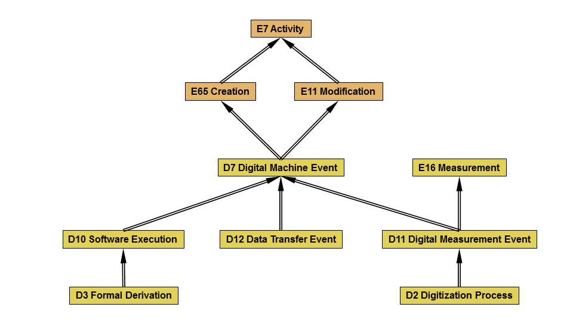
Figure 1: Digital Events

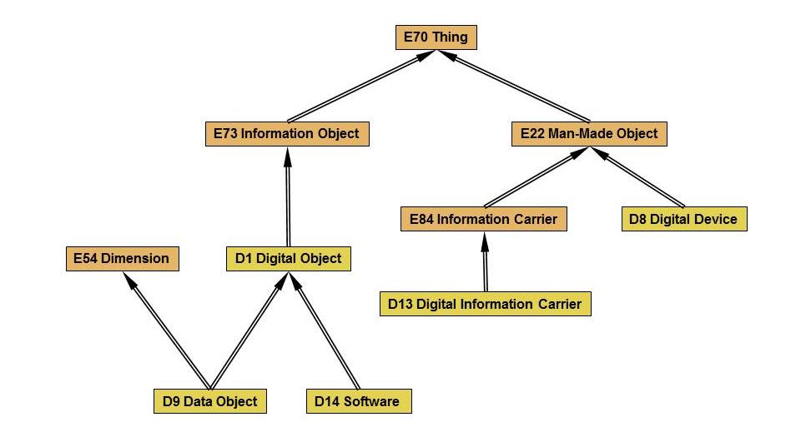
Figure 2: Digital Things

CRMdig Class Declaration

D1 Digital Object

Subclass of: E73 Information Object
Superclass of: D9 Data Object
D14 Software
D35 Area

Scope note: This class comprises identifiable immaterial items that can be represented as sets of bit sequences, such as data sets, e-texts, images, audio or video items, software, etc., and are documented as single units.
Any aggregation of instances of D1 Digital Object into a whole treated as single unit is also regarded as an instance of D1 Digital Object.
This means that for instance, the content of a DVD, an XML file on it, and an element of this file, are regarded as distinct instances of D1 Digital Object, mutually related by the P106 is composed of (forms part of) property.
A D1 Digital Object does not depend on a specific physical carrier, and it can exist on one or more carriers simultaneously.
Properties:

D2 Digitization Process

Subclass of: D11 Digital Measurement Event

Scope note: This class comprises events that result in the creation of instances of D9 Data Object that represent the appearance and/or form of an instance of E18 Physical Thing such as paper documents, statues, buildings, paintings, etc.
A particular case is the analogue-to-digital conversion of audiovisual material.
This class represents the transition from a material thing to an immaterial representation of it.
The characteristic subsequent processing steps on digital objects are regarded as instances of D3 Formal Derivation.
Properties:
L1 digitized (was_digitized_by): E18 Physical Thing
L60 documents (is documented by): E1 CRM Entity

D3 Formal Derivation

Subclass of: D10 Software Execution
Scope note: This class comprises events that result in the creation of a D1 Digital Object from another one following a deterministic algorithm, such that the resulting instance of digital object shares representative properties with the original object.
In other words, this class describes the transition from an immaterial object referred to by property L21 used as derivation source (was derivation source for) to another immaterial object referred to by property L22 created derivative (was derivative created by) preserving the representation of some things but in a different form. Characteristic examples are colour corrections, contrast changes and resizing of images.
Properties:
L21 used as derivation source (was derivation source for): D1 Digital Object
L22 created derivative (was derivative created by): D1 Digital Object

D7 Digital Machine Event

Subclass of: E11 Modification
E65 Creation
Superclass of: D10 Software Execution
D11 Digital Measurement Event
D12 Data Transfer Event
Scope note: This class comprises events that happen on physical digital devices following a human activity that intentionally caused its immediate or delayed initiation and results in the creation of a new instance of D1 Digital Object on behalf of the human actor.
The input of a D7 Digital Machine Event may be parameter settings and/or data to be processed. Some D7 Digital Machine Events may form part of a wider E65 Creation event. In this case, all machine output of the partial events is regarded as creation of the overall activity.

Properties:
L10 had input (was input of): D1 Digital Object
L11 had output (was output of) : D1 Digital Object
L12 happened on device (was device for): D8 Digital Device
L18 has modified (was modified by): D13 Digital Information Carrier
L23 used software or firmware (was software or firmware used by):
D14 Software
L31 has starting date-time (was starting date-time of): Literal
L32 has ending date-time (was ending date-time of): Literal
L61 was ongoing at: Literal

D8 Digital Device

Subclass of: E22 Man-Made Object
Scope note: This class comprises identifiable material items such as computers, scanners, cameras, etc. that have the capability to process or produce instances of D1 Digital Object.

D9 Data Object

Subclass of: E54 Dimension
D1 Digital Object

Scope note: This class comprises instances of D1 Digital Object that are the direct result of a digital measurement or a formal derivative of it, containing quantitative properties of some physical things or other constellations of matter.
Properties:
L56 has pixel width: Literal
L57 has pixel height: Literal

D10 Software Execution

Subclass of: D7 Digital Machine Event
Superclass of: D3 Formal Derivation

Scope note: This class comprises events by which a digital device runs a software program or a series of computing operations on a digital object as a single task, which is completely determined by its digital input, the software and the generic properties of the device.

Properties:
L2 used as source (was_source_for): D1 Digital Object
L13 used parameters (parameters for): D1 Digital Object
L24 created logfile (was logfile created by): D1 Digital Object

D11 Digital Measurement Event

Subclass of: D7 Digital Machine Event
E16 Measurement
Superclass: D2 Digitization Process

Scope note: This class comprises actions measuring physical properties using a digital device,
that are determined by a systematic procedure and creates an instance of D9 Data Object, which is stored on an instance of D13 Digital Information Carrier.
In contrast to instances of D10 Software Execution, environmental factors have an intended influence on the outcome of an instance of D11 Digital Measurement Event.
Measurement devices may include running distinct software, such as the RAW to JPEG conversion in digital cameras.
In this case, the event is regarded as instance of both classes, D10 Software Execution and D11 Digital Measurement Event.

Properties:
L17 measured thing of type (was type of thing measured by):E55 Type
L20 has created (was created by): D9 Data Object

D12 Data Transfer Event

Subclass of: D7 Digital Machine Event

Scope note: This class comprises events that transfer a digital object from one digital carrier to another. Normally, the digital object remains the same. If in general or by observation the transfer implies or has implied some data corruption, the change of the digital objects may be documented distinguishing input and output rather than instantiating the property L14 transferred (was transferred by).

Properties:
L14 transferred (was transferred by): D1 Digital Object
L15 has sender (was sender for): D8 Digital Device
L16 has receiver (was sender for): D8 Digital Device

D13 Digital Information Carrier

Subclass of: E84 Information Carrier

Scope note: This class comprises all instances of E84 Information Carrier that are explicitly designed to be used as persistent digital physical carriers of instances of D1 Digital Object. A D13 Digital Information Carrier may or may not contain information, e.g., an empty diskette.

Properties:
L19 stores (is stored on): D1 Digital Object

D14 Software

Subclass of: D1 Digital Object

Scope note: This class comprises software codes, computer programs, procedures and functions that are used to operate a system of digital objects.

D21 Person Name

Subclass of: E82 Actor Appellation

Scope note: This class comprises the proper noun name that identifies a person that acts as an entity.

Properties:
L51 has first name: Literal
L52 has last name: Literal

D23 Room

Subclass of: E53 Place

Scope note: This class comprises a small scale space that contains manipulable objects and retains the bodily experiences of how people assimilate image schemata.

D29 Annotation Object

Subclass of: E89 Propositional Object
Superclass of:

Scope note: This class comprises objects that make propositions about other artefacts.
Instances of this class are not the attributes themselves, by which things are annotated, but represent the connection between the concepts related in a proposition, and the activities of creation, modification and deletion.
This class is specialized by appropriate subclasses to express more specific relationships between annotated things, such as knowledge object, same as etc.

Properties:
L43 annotates (is annotated by): E1 CRM Entity

D30 Annotation Event

Subclass of: E65 Creation

Scope note: This class comprises events that describe the creation of associations (“Annotation Objects”) between objects or areas of objects of the Repository, with other objects or regions or persons, places, events. It is the event that creates the Annotation Object.

Properties:
L48 created annotation (was annotation created by): D29 Annotation Object

D35 Area

Subclass of: D1 Digital Object
E26 Physical Feature

Scope note: This class describes a part (of any shape or size) of interest in basically any media object stored in the Object Repository, i.e., a text, an image, a video or a 3D model. It points to content consisting of just a portion or area of a file. In some contexts, however, the area can also point to content represented by an integral (i.e., proper) file. It is equal to the METS AREA element.

Properties:
L49 is primary area of (has primary area): D1 Digital Object
L50 is propagated area of (has propagated area): D1 Digital Object

CRMdig Property Declaration

L1 digitized (was digitized by)

Domain: D2 Digitization Process
Range: E18 Physical Thing
Subproperty of: E16 Measurement: P39 measured (was measured by): E1 CRM Entity

Scope note: This property associates an instance of D2 Digitization Process with an instance of E18 Physical Thing which is a material thing.

L2 used as source (was source for)

Domain: D10 Software Execution
Range: D1 Digital Object
Subproperty of: D7 Digital Machine Event: L10 had input (was input of): D1 Digital Object
Superproperty of: D3 Formal Derivation: L21 used as derivation source (was derivation source for) : D1 Digital Object

Scope note: This property associates an instance of D10 Software Execution with an instance of D1 Digital Object which is used as a source, software essential for the performance.

L4 has preferred label

Domain: E1 CRM Entity
Range: Literal
Subproperty of: label

Scope note: This property associates an instance of E1 Entity with an instance of resource used as a preferred lexical label. This property is a specialisation of rdf schema label.

L10 had input (was input of)

Domain: D7 Digital Machine Event
Range: D1 Digital Object
Subproperty of: E7 Activity : P16 used specific object (was used for): E70 Thing
Superproperty of: D10 Software Execution: L2 used as source (was source for): D1 Digital Object
D10 Software Execution: L13 used parameters (parameters for): D1 Digital Object
D12 Data Transfer Event: L14 transferred (was transferred by): D1 Digital Object
D2 Digitization Process: L73 used template (template for): D1 Digital Object
D2 Digitization Process: L75 used complete raw data (complete raw data for): D1 Digital Object

Scope note: This property associates an instance of D7 Digital Machine Event with an instance of D1 Digital Object which is the input used to specify the machine action.

L11 had output (was output of)

Domain: D7 Digital Machine Event
Range: D1 Digital Object
Subproperty of: E65 Creation:P94 has created (was created by): E28 Conceptual Object
Superproperty of: D11 Digital Measurement Event: L20 has created (was created by): D9 Data Object
D3 Formal Derivation: L22 created derivative (was derivative created by): D1 Digital Object
D10 Software Execution: L24 created logfile (was logfile created by): D1 Digital Object

Scope note: This property associates an instance of D7 Digital Machine Event with an instance of D1 Digital Object which is the output of the activity.

L12 happened on device (was device for)

Domain: D7 Digital Machine Event
Range: D8 Digital Device
Subproperty of: E5 Event: P12 occurred in the presence of (was present at): E77 Persistent Item
Superproperty of: D12 Data Transfer Event: L15 has sender (was sender for): D8 Digital Device
D12 Data Transfer Event: L16 has receiver (was sender for): D8 Digital Device

Scope note: This property associates an instance of D7 Digital Machine Event with an object, the D8 Digital Device, which happened with, e.g a capturing event that happened on/with a digital camera, etc.

L13 used parameters (parameters for)

Domain: D10 Software Execution
Range: D1 Digital Object
Subproperty of: D7 Digital Machine Event: L10 had input (was input of): D1 Digital Object

Scope note: This property associates an instance of D10 Software Execution with a digital object used as a parameter during the process.

L14 transferred (was transferred by)

Domain: D12 Data Transfer Event
Range: D1 Digital Object
Subproperty of: D7 Digital Machine Event: L10 had input (was input of): D1 Digital Object
L11F had output

Scope note: This property identifies a digital object transferred by a D12 Data Transfer Event.

L15 has sender (was sender for)

Domain: D12 Data Transfer Event
Range: D8 Digital Device
Subproperty of: D7 Digital Machine Event: L12 happened on device (was device for): D8 Digital Device

Scope note: This property identifies a digital device used as a medium on which data are transferred through a D12 Data Transfer Event.

L16 has receiver (was receiver for)

Domain: D12 Data Transfer Event
Range: D8 Digital Device
Subproperty of: D7 Digital Machine Event: L12 happened on device (was device for): D8 Digital Device

Scope note: This property identifies a digital device used as a medium to receive data through a D12 Data Transfer Event.

L17 measured thing of type (was type of thing measured by)

Domain: D11 Digital Measurement Event
Range: E55 Type
Subproperty of: E7 Activity: P125 used object of type (was type of object used in): E55 Type

Scope note: This property associates an instance of D11 Digital Measurement Event with the instance of E55Type of object to which it applied.

L18 has modified (was modified by)

Domain: D7 Digital Machine Event
Range: D13 Digital Information Carrier
Subproperty of: E11 Modification: P31 has modified (was modified by): E24 Physical Man-Made Thing

Scope note: This property identifies a Digital Information Carrier modified in a Digital Machine Event.

L19 stores (is stored on)

Domain: D13 Digital Information Carrier
Range: D1 Digital Object
Subproperty of: E24 Physical Man-Made Thing: P128 carries (is carried by): E90 Symbolic Object

Scope note: This property associates an instance of a D13 Digital Information Carrier with the instance of Digital Object that is stored on it.

L20 has created (was created by)

Domain: D11 Digital Measurement Event
Range: D9 Data Object
Subproperty of: E16 Measurement: P40 observed dimension (was observed in): E54 Dimension
D7 Digital Machine Event: L11 had output (was output of): D1 Digital Object

Scope note: This property identifies a Data Object that came into existence as a result of a D11 Digital Measurement Event.

L21 used as derivation source (was derivation source for)

Domain: D3 Formal Derivation
Range: D1 Digital Object
Subproperty of: D10 Software Execution: L2 used as source (was source for): D1 Digital Object

Scope note: This property associates an instance of a D3 Formal Derivation with the instance of D1 Digital Object that is used as a derivation source.

L22 created derivative (was derivative created by)

Domain: D3 Formal Derivation
Range: D1 Digital Object
Subproperty of: D7 Digital Machine Event: L11 had output (was output of): D1 Digital Object

Scope note: This property associates an instance of D3 Formal Derivation with the Digital Object it used to create a version of.

L23 used software or firmware (was software or firmware used by)

Domain: D7 Digital Machine Event
Range: D14 Software
Subproperty of: E7 Activity: P16 used specific object (was used for): E70 Thing

Scope note: This property associates an instance of D7 Digital Machine Event with the instance of D14 Software that had used.

L24 created logfile (was logfile created by)

Domain: D10 Software Execution
Range: D1 Digital Object
Subproperty of: D7 Digital Machine Event: L11 had output (was output of): D1 Digital Object

Scope note: This property identifies the logfile that was created by a D10 Software Execution in order to record all the activities in the system.

L29 has responsible organization (is responsible organization for)

Domain: E7 Activity
Range: E40 Legal Body
Subproperty of: E7 Activity: P14 carried out by (performed): E39 Actor

Scope note: This property describes the participation of a Legal Body in being responsible for the outcome of a specific activity.

L30 has operator (is operator of)

Domain: E7 Activity
Range: E21 Person
Subproperty of: E7 Activity: P14 carried out by (performed): E39 Actor

Scope note: This property describes the activity that is being operated by a person.

L31 has starting date-time (was starting date-time of)

Domain: D7 Digital Machine Event
Range: Literal

Scope note: This property allows the starting point for a D7 Digital Machine Event to be situated. This property expresses the approximation of the starting date of a time span.

L32 has ending date-time (was ending date-time of)

Domain: D7 Digital Machine Event
Range: Literal

Scope note: This property allows the ending point for a D7 Digital Machine Event to be situated. This property expresses the approximation of the ending date of a time span.

L33 has maker (is maker of)

Domain: E24 Physical Man-Made Thing
Range: E39 Actor

Scope note: This property identifies the maker, the actor who is responsible for the production of a device, a computer, a digital camera, any kind of a machine that has been produced. This property is a shortcut of a more fully developed path from CRM E12 Production: P108 has produced: E24 Physical Man-Made Thing. In this case, there is no need to describe the more detailed property through a production event, so L33F has maker is recommended to be used instead.

L34 has contractor (is contractor for)

Domain: E7 Activity
Range: E40 Legal Body
Subproperty of: E7 Activity: L29 has responsible organization (is responsible organization for): E40 Legal Body

Scope note: This property describes the participation of a Legal Body in being contractor for the outcome of a specific activity.
This property is a specialisation of L29_has_responsible_organization.

L35 has commissioner (is commissioner for)

Domain: E7 Activity
Range: E40 Legal Body
Subproperty of: E7 Activity: L29 has responsible organization (is responsible organization for): E40 Legal Body

Scope note: This property describes the participation of a Legal Body in being commissioner for the outcome of a specific activity.
This property is a specialisation of L29_has_responsible_organization.

L43 annotates (is annotated by)

Domain: D29 Annotation Object
Range: E1 CRM Entity

Scope note: This property describes the associations between objects or areas of objects of the RI, with other objects or regions or persons, places, events.

L47 has comment

Domain: E1 CRM Entity
Range: Literal
Subproperty of: E1 CRM Entity: P3 has note: E62 String

Scope note: This property associates an instance of a textual note with an instance of an object of RI it makes a comment about.

L48 created annotation (was annotation created by)

Domain: D30 Annotation Event
Range: D29 Annotation Object
Subproperty of: E65 Creation: P94 has created (was created by): E28 Conceptual Object

Scope note: This property identifies the D29 Annotation Object (associations) that came into existence as a result of a D30 Annotation Event.

L49 is primary area of (has primary area)

Domain: D35 Area
Range: D1 Digital Object
Subproperty of: E90 Symbolic Object: P106 is composed of (forms part of): E90 Symbolic Object

Scope note: This property describes the association between a particular area declared in an original digital object.

L50 is propagated area of (has propagated area)

Domain: D35 Area
Range: D1 Digital Object
Subproperty of: E90 Symbolic Object: P106 is composed of (forms part of): E90 Symbolic Object

Scope note: This property describes the association between an area and the digital object to which it is propagated.

L51 has first name

Domain: D21 Person Name
Range: Literal
Subproperty of: label

Scope note: This property defines a personal name used to identify a person.

L52 has last name

Domain: D21 Person Name
Range: Literal
Subproperty of: E1 CRM Entity: L4 has preferred label: Literal

Scope note: This property defines the last name used to identify a person.

L53 is not uniquely identified by

Domain: E1 CRM Entity
Range: Literal
Subproperty of: label
Superproperty of: E1 CRM Entity: L55 has inventory no: Literal
E22 Man-Made Object: L59 has serial number: Literal

Scope note: This property describes a non unique identification applied to E1 CRM Entity.

L54 is same-as (is same-as)

Domain: E1 CRM Entity
Range: E1 CRM Entity

Scope note: This property describes the association kind of "same as" between objects. It is used to declare that two or more objects are exactly the same.

L55 has inventory no

Domain: E1 CRM Entity
Range: Literal
Subproperty of: E1 CRM Entity: L53 is not uniquely identified by: Literal

Scope note: This property records the inventory number that was used to identify an instance of E1 CRM Entity at the time this property was record.

L56 has pixel width

Domain: D9 Data Object
Range: Literal
Subproperty of: E54 Dimension: P90 has value: E60 Number

Scope note: This property records the pixel width of the data object; it approximates a dimension that is part of the image data analysis.

L57 has pixel height

Domain: D9 Data Object
Range: Literal
Subproperty of: E54 Dimension: P90 has value: E60 Number

Scope note: This property records the pixel height of the data object; it approximates a dimension that is part of the image data analysis.

L59 has serial number

Domain: E22 Man-Made Object
Range: Literal
Subproperty of: E1 CRM Entity: L53 is not uniquely identified by: Literal

Scope note: This property records the serial number that was assigned to identify an instance of E22 Man Made Object.

L60 documents (is documented by)

Domain: D2 Digitization Process
Range: E1 CRM Entity
Subproperty of: E13 Attribute Assignment: P140 assigned attribute to (was attributed by): E1 CRM Entity

Scope note: This property describes the CRM Entities documented by instances of Digitization Processes.

L61 was ongoing at

Domain: D7 Digital Machine Event
Range: Literal
Subproperty of: E52 Time-Span: P 81 ongoing throughout: E61 Time Primitive

Scope note: This property describes the minimum period of time covered by a digital machine event. It identifies the minimum extent of the event.

