Immagine che contiene clipart

|  |
| --- |
| **Definition of the CRMarchaeo**  An Extension of CIDOC CRM to support the archaeological excavation process |

*Proposal for approval by CIDOC CRM - SIG*

Document Type: Current

Editorial Status: In progress since [21/3/2017]

Version 1.5.0 (draft)

February 2020

Currently Maintained by PIN, University of Florence, Italy

Contributors: Martin Doerr, Achille Felicetti, Sorin Hermon, Gerald Hiebel, Athina Kritsotaki, Anja Masur, Keith May, Paola Ronzino, Wolfgang Schmidle, Maria Theodoridou, Despoina Tsiafaki, Eleni Christaki, Christian-Emil Ore and others.

**Index**

Contents

*Proposal for approval by CIDOC CRM - SIG* 1

Document Type: Current 1

Editorial Status: In progress since [21/3/2017] 1

Version 1.5.0 (draft) 1

1February 2020

Currently Maintained by PIN, University of Florence, Italy 1

Index 1

1.1 Introduction 1

1.1.1 Scope 1

1.1.2 Status 1

1.1.3 Naming Convention 1

1.2 Class and Property hierarchies 1

1.2.1 Excavation model class hierarchy, aligned with portions from the CRMsci and the CIDOC CRM class hierarchies 1

1.2.2 Excavation Model property hierarchy, aligned with portions from the CRMsci and the CIDOC CRM property hierarchies 1

1.3 Graphical overview 1

1.4 Class and property usage examples 1

1.5 Excavation Model Class Declarations 1

A1 Excavation Process Unit 1

A2 Stratigraphic Volume Unit 1

A3 Stratigraphic Interface 1

A4 Stratigraphic Genesis 1

A5 Stratigraphic Modification 1

A6 Group Declaration Event 1

A7 Embedding 1

A8 Stratigraphic Unit 1

A9 Archaeological Excavation 1

A10 Excavation Interface 1

1.6 Excavation Property Declarations 1

AP1 produced (was produced by) 1

AP2 discarded into (was discarded by) 1

AP3 investigated (was investigated by) 1

AP4 produced surface (was surface produced by) 1

AP5 removed part or all of (was partially or totally removed by) 1

AP6 intended to approximate (was approximated by) 1

AP7 produced (was produced by) 1

AP8 disturbed (was disturbed by) 1

AP9 took matter from (provided matter to) 1

AP10 destroyed (was destroyed by) 1

AP11 has physical relation (is physical relation of) 1

AP12 confines (is confined by) 1

AP13 has stratigraphic relation (is stratigraphic relation of) 1

AP14 justified by (is justification of) 1

AP15 is or contains remains of (is or has remains contained in) 1

AP16 assigned attribute to (was attributed by) 1

AP17 is found by (found) 1

AP18 is embedding of (is embedded) 1

AP19 is embedding in (contains embedding) 1

AP20 is embedding at (contains) 1

AP21 contains (is contained in) 1

AP22 is equal in time to 1

AP23 finishes (is finished by) 1

AP24 starts (is started by) 1

AP25 occurs during (includes) 1

AP26 overlaps in time with (is overlapped in time by) 1

AP27 meets in time with (is met in time by) 1

AP28 occurs before (occurs after) 1

1.7 Referred to CIDOC CRM Classes and properties 1

1.7.1 CIDOC CRM Classes 1

E1 CRM Entity 1

E3 Condition State 1

E6 Destruction 1

E7 Activity 1

E13 Attribute Assignment 1

E18 Physical Thing 1

E27 Site 1

E53 Place 1

E55 Type 1

E81 Transformation 1

1.7.2 CIDOC CRM Properties 1

P9 consists of (forms part of) 1

P13 destroyed (was destroyed by) 1

P44 has condition (is condition of) 1

P93 took out of existence (was taken out of existence by) 1

P123 resulted in (resulted from) 1

P124 transformed (was transformed by) 1

P140 assigned attribute to (was attributed by) 1

1.8 Referred to Scientific Observation Model Classes and properties 1

1.8.1 CRMsci Classes 1

S1 Matter Removal 1

S4 Observation 1

S5 Inference Making 1

S10 Material Substantial 1

S11 Amount of Matter 1

S15 Observable Entity 1

S16 State 1

S17 Physical Genesis 1

S18 Alteration 1

S19 Encounter Event 1

S20 Rigid Physical Feature 1

S22 Segment of Matter 1

1.8.2 CRMsci Properties 1

O2 removed (was removed by) 1

O7 confined (was confined by) 1

O8 observed (was observed by) 1

O17 generated (was generated by) 1

O18 altered (was altered by) 1

Bibliography 1

Amendments 1.4.7 1

The 36nd joined meeting of the CIDOC CRM SIG and ISO/TC46/SC4/WG9 and the 29th FRBR - CIDOC CRM Harmonization meeting 1

A1 Excavation Process Unit 1

A2 Stratigraphic Volume Unit 1

A8 Stratigraphic Unit 1

A9 Archaeological Excavation 1

AP3 excavated (was excavated by) 1

AP15 is or contains remains of (is or has remains contained in) 1

AP21 contains (is contained in) 1

37th joined meeting of the CIDOC CRM SIG and ISO/TC46/SC4/WG9 and the 30th FRBR - CIDOC CRM Harmonization meeting 1

A2 Stratigraphic Volume Unit 1

A6 Group Declaration Event 1

A7 Embedding 1

AP15 is or contains remains of (is or has remains contained in) 1

AP16 assigned attribute to (was attributed by) 1

AP19 is embedding in (contains embedding) 1

AP20 is embedding at (contains) 1

AP21 contains (is contained in) 1

Proofreading: 1

# 1.1 Introduction

### 1.1.1 Scope

This document presents CRM*archaeo*, an extension of CIDOC CRM created to support the archaeological excavation process and all the various entities and activities related to it. The model has been created starting from standards and models already in use by national and international cultural heritage institutions and has evolved through deep analysis of existing metadata from real archaeological documentation. It has been enriched by continuous collaboration with various communities of archaeologists from different countries and schools. Furthermore, it takes advantage of the concepts provided by CRM*sci*, from which it inherits and extends most of the geological and stratigraphic principles that govern archaeological stratigraphy.

CRM*archaeo* intends to provide all necessary tools to manage and integrate existing documentation in order to formalise knowledge extracted from observations made by archaeologists, recorded in various ways and adopting different standards. In this sense, its purpose is to facilitate the semantic encoding, exchange, interoperability and access of existing archaeological documentation.

CRM*archaeo* takes inspiration from the basic idea on which archaeology is based according to Harris [Harris 1989], that the features of an archaeological site are to be found in the stratified context, which is investigated by an archaeological excavation. It takes into account the physical arrangement of archaeological stratification and the events that led to the formation of a particular stratigraphic situation. The model comprises entities and properties for describing stratigraphic genesis and modifications and the natural phenomena or human intervention that led to their creation, the nature and shape of existing stratifications and surfaces, and the analysis of the human remains, or artefacts found within the strata. This will enable archaeologists to determine the relative chronological order in which stratification was formed. The interpretation of the chronological sequences, also based on the space-time analysis of a specific site, provides all the elements needed for the reconstruction of the identity, life, beliefs, behaviour and activities of a given group of people in the past in that specific place.

Furthermore, the model documents the various aspects of archaeological excavation process, including the technical details concerning different methods of excavation, the reasons for their application and the observations made by archaeologists during their activities in the field in a transparent way. This approach allows the creation of objective documentation that guarantees the scientific validity of the results, making them revisable following further investigations and reusable in different research contexts, in order to answer further (and potentially different) research questions.

One of the most important goals of the model is to overcome the differences resulting from the application of different excavation techniques and procedures, e.g. from different traditions and schools of archaeology, revealing the common ways of thinking that characterise the stratigraphic excavation. This will serve to provide a unified view that can express the common concepts without imposing any specific recording or investigation technique on stratigraphic activity and will also provide a sound basis for the integration of various methods.

From a technical point of view, the model provides conceptual descriptions of classes and properties in an encoding-agnostic formalism, inherited from CIDOC CRM, allowing implementation of its concepts and relationships by the use of various languages and formal encodings (such as RDF and OWL), thereby providing maximum flexibility for operations of mapping and conversion and giving IT experts the freedom to implement it in the way they prefer.

### 1.1.2 Status

CRM*archaeo* is the result of collaboration between many cultural heritage institutions and the unifying efforts of numerous European projects, including ARIADNE [ARIADNE 2013]. The first need that the model attempts to meet is to create a common ground for the integration of archaeological records on every level, from raw excavation data to official documentation produced according to national and institutional standards. This document describes a community model, which has been approved by CRM SIG to be formally and methodologically compatible with CIDOC CRM. However, in a broader sense, it is always open to any possible integration and addition that may become necessary as a result of its practical use on real archaeological problems on a large scale. The model is intended to be maintained and promoted as an international standard.

### 1.1.3 Naming Convention

All the declared classes were given both a name and an identifier constructed according to the conventions used in the CIDOC CRM model. For classes that identifier consists of the letter A followed by a number. Resulting properties were also given a name and an identifier, constructed according to the same conventions. That identifier consists of the letters AP followed by a number, which in turn is followed by the letter “i” every time the property is mentioned “backwards”, i.e., from target to domain (inverse link). “A” and “AP” do not have any other meaning. They correspond respectively to letters “E” and “P” in the CIDOC CRM naming conventions, where “E” originally meant “entity” (although the CIDOC CRM “entities” are now consistently called “classes”), and “P” means “property”. Whenever CIDOC CRM classes are used in our model, they are named by the name they have in the original CIDOC CRM. CRMsci classes and properties are referred with their respective names, classes denoted by S and properties by O.

Letters in red colour in CRM Classes and properties are additions/extensions coming by the scientific observation model.

# 1.2 Class and Property hierarchies

The CIDOC CRM model declares no “attributes” at all (except implicitly in its “scope notes” for classes), but regards any information element as a “property” (or “relationship”) between two classes. The semantics are therefore rendered as properties, according to the same principles as the CIDOC CRM model.

Although they do not provide comprehensive definitions, compact mono hierarchical presentations of the class and property IsA hierarchies have been found to significantly aid in the comprehension and navigation of the model, and are therefore provided below.

The class hierarchy presented below has the following format:

• Each line begins with a unique class identifier, consisting of a number preceded by the appropriate letter “E”, “A”, “S”

• A series of hyphens (“-”) follows the unique class identifier, indicating the hierarchical position of the class in the IsA hierarchy.

• The English name of the class appears to the right of the hyphens.

• The index is ordered by hierarchical level, in a “depth first” manner, from the smaller to the larger sub hierarchies.

• Classes that appear in more than one position in the class hierarchy as a result of multiple inheritance are shown in an italic typeface.

### 1.2.1 Excavation model class hierarchy, aligned with portions from the CRMsci and the CIDOC CRM class hierarchies

This class hierarchy lists:

• all classes declared in Excavation Model,

• all classes declared in CRM*sci*and CIDOC CRM that are declared as superclasses of classes declared in the Excavation Model,

• all classes declared in CRM*sci* or CIDOC CRM that are either domain or range for a property declared in the Excavation Model,

• all classes declared in CRM*sci* and CIDOC CRM that are either domain or range for a property declared in Excavation Model or CIDOC CRM that is declared as superproperties of a property declared in the Excavation Model,

• all classes declared in CRM*sci* and CIDOC CRM that are either domain or range for a property that is part of a complete path of which a property declared in Excavation Model is declared to be a shortcut.

E1 CRM Entity

S15 - Observable Entity

E2 - - Temporal Entity

S16 - - - State

A7 - - - - Embedding

E5 - - - Event

E7 - - - - Activity

S1 - - - - - Matter Removal

A1 - - - - - - - Excavation Process Unit

E13 - - - - - Attribute Assignment

A6 - - - - - - Group Declaration Event

S4 - - - - - - Observation

A1 - - - - - - - *Excavation Process Unit*

S19 - - - - - - - Encounter Event

S18 - - - - Alteration

S17 - - - - - Physical Genesis

A5 - - - - - Stratigraphic Modification

A4 - - - - - - Stratigraphic Genesis

E63 - - - - Beginning Of Existence

E81 - - - - - Transformation

A5 - - - - - *Stratigraphic Modification*

S17 - - - - - *Physical Genesis*

E77 - - Persistent Item

E70 - - - Thing

S10 - - - - Material Substantial

S11 - - - - - Amount of Matter

E18 - - - - - Physical Thing

E26 - - - - - - Physical Feature

S20 - - - - - - - Rigid Physical Feature

A10 - - - - - - - - Excavation Interface

A8 - - - - - - - - Stratigraphic Unit

A2 - - - - - - - - - Stratigraphic Volume Unit

A3 - - - - - - - - - Stratigraphic Interface

S22 - - - - - - - - Segment of Matter

E53 - Place

S20 - - *Rigid* *Physical Feature*

A8 - - - *Stratigraphic Unit*

A2 - - - - *Stratigraphic Volume Unit*

A3 - - - - *Stratigraphic Interface*

### 1.2.2 Excavation Model property hierarchy, aligned with portions from the CRMsci and the CIDOC CRM property hierarchies

This property hierarchy lists:

• all properties declared in Excavation Model,

• all properties declared in CRM*sci* and CIDOC CRM that are declared as superproperties of properties declared in Excavation Model,

• all properties declared in CRM*sci* and CIDOC CRM that are part of a complete path of which a property declared in Excavation Model, is declared to be a shortcut.

**Property id Property Name Entity – Domain Entity-Range**

[AP1](#_AP1_produced_(was) produced (was produced by) A1 Excavation Process Unit S11 Amount of Matter

AP2 discarded (was discarded by) A1 Excavation Process Unit S11 Amount of Matter

[AP3](#_AP3_excavated_(was) investigated (was investigated by) A9 Archaeological Excavation E27 Site

AP4 produced surface (was surface produced by) A1 Excavation Process Unit A10 Excavation Interface

AP5 removed part or all of (was partially or totally removed by) A1 Excavation Process Unit A8 Stratigraphic Unit

AP6 intended to approximate (was approximate) A1 Excavation Process Unit A3 Stratigraphic Interface

[AP7](#_AP7_produced_(was) produced (was produced by) A4 Stratigraphic Genesis A8 Stratigraphic Unit

[AP8](#_AP8_disturbed_(was) disturbed (was disturbed by) A5 Stratigraphic Modification A8 Stratigraphic Unit

AP9 took matter from (provided matter to) A4 Stratigraphic Genesis S10 Material Substantial

[AP10](#_AP10_destroyed_(was) destroyed (was destroyed by) A1 Excavation Process Unit S22 Segment of Matter

AP11 has physical relation (is physical relation of) A8 Stratigraphic Unit A8 Stratigraphic Unit

[AP12](#_AP12_confines_(is_1) confines (is confined by) A3 Stratigraphic Interface A2 Stratigraphic Volume Unit

AP13 has stratigraphic relation (is stratigraphic relation of) A5 Stratigraphic Modification A5 Stratigraphic Modif.

AP14 justified by (is justification of) AP13.1 has stratigraphic relation AP11.1 has physical relation

AP15 is or contains remains of (is or has remains contained in) A8 Stratigraphic Unit S10 Material Substantial

AP16 assigned attribute to (was attributed by) A6 Group Declaration Event E18 Physical Thing

AP17 is found by (found) A7 Embedding S19 Encounter Event

AP18 is embedding of (is embedded) A7 Embedding E18 Physical Thing

AP19 is embedding in (contains embedding) A7 Embedding A2 Stratigraphic Vol. Unit

AP20 is embedding at (contains) A7 Embedding E53 Place

[AP21](#_AP21_contains_(is) contains (is contained in) A2 Stratigraphic Volume Unit E18 Physical Thing

AP22 is equal in time to E2 Temporal Entity E2 Temporal Entity

AP23 finishes (is finished by) E2 Temporal Entity E2 Temporal Entity

AP24 starts (is started by) E2 Temporal Entity E2 Temporal Entity

AP25 occurs during (includes) E2 Temporal Entity E2 Temporal Entity

AP26 overlaps in time with (is overlapped in time by) E2 Temporal Entity E2 Temporal Entity

AP27 meets in time with (is met in time by) E2 Temporal Entity E2 Temporal Entity

AP28 occurs before (occurs after) E2 Temporal Entity E2 Temporal Entity

# 1.3 Graphical overview

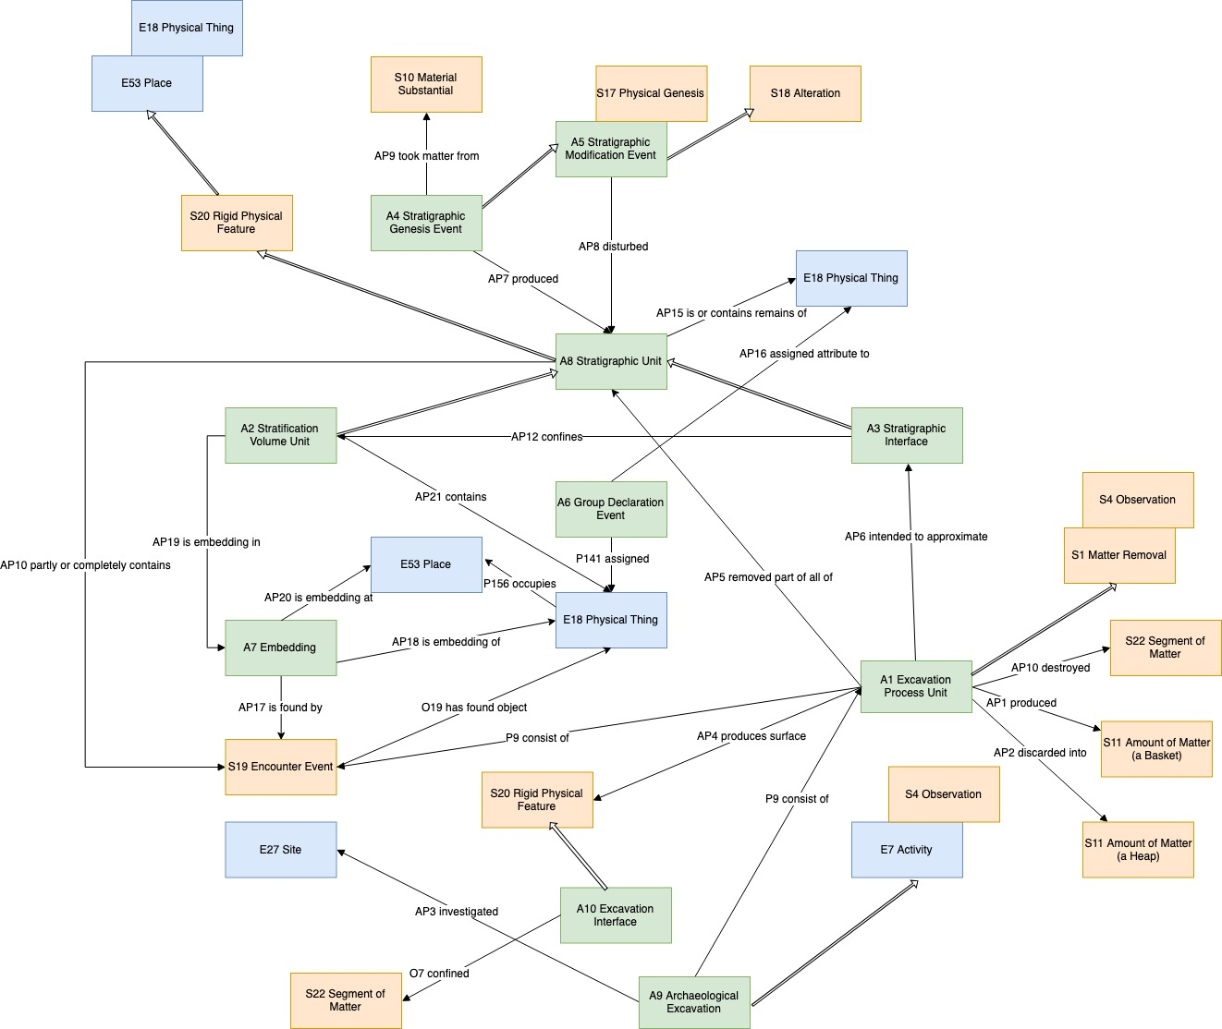

Fig. 1: CRMarchaeo classes and properties with relations to CRM and CRMsci classes

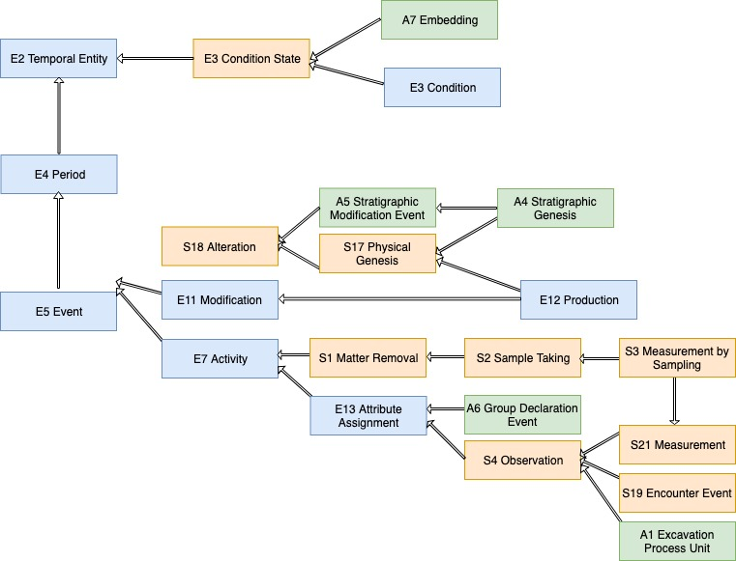

Fig. 2: CRMarchaeo, temporal entities

**../Downloads/CRMarchaeo3.pdf**

Fig. 3: Things in CRMarchaeo

# 1.4 Class and property usage examples

The following examples are taken from the English Heritage Recording Manual [*Harris 1989*] and try to illustrate the use of classes and properties of CRMarchaeo to represent the entities and relations of documentation praxis in relation to the Harris Matrix.

The stratigraphic sequence explains how the site was formed. For this example, we’ll work backwards and explain how the site was formed to make determining the stratigraphic sequence easier. Focussing near the top of Figure 4, the post-hole [3] was dug and the post inserted, the hole was packed (18). Eventually the post rotted away, leaving a post-pipe [19], into which later material accumulated (2) (see Fig. 4).

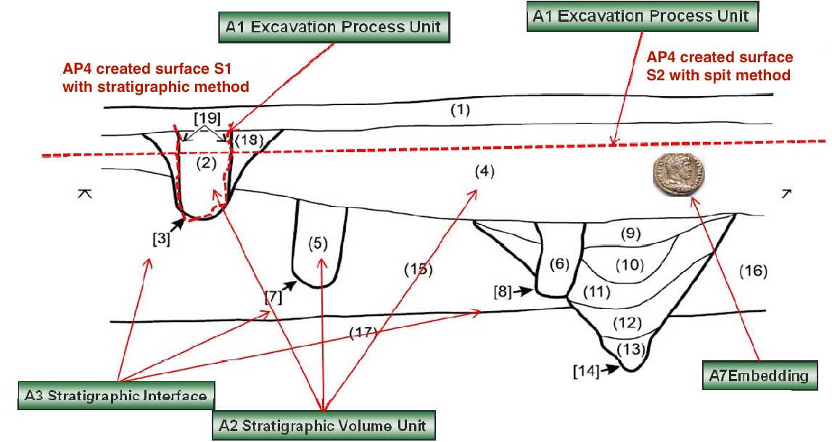

**Fig. 4: Section drawing with A3 Stratigraphic Interfaces in square brackets [], A2 Stratigraphic Volume Unit in round brackets (), the surfaces S1 and S2 created through A1 Excavation Process Units using different methodologies and an A7 Embedding of a coin.**

**../Downloads/CRMarchaeo4.pdf**

**Fig. 5: CRMarchaeo conceptualisation to represent stratigraphic relationships contained in Harris Matrix, being justified by physical relationships.**

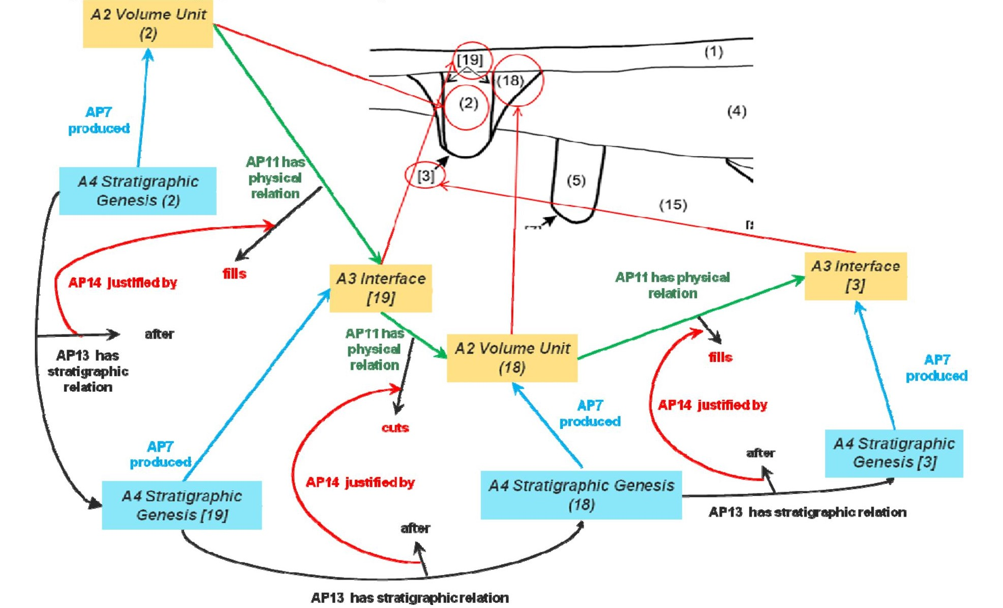

Fig. 6: CRMarchaeo representation of Harris Matrix for post-hole [3] (Figure 4)

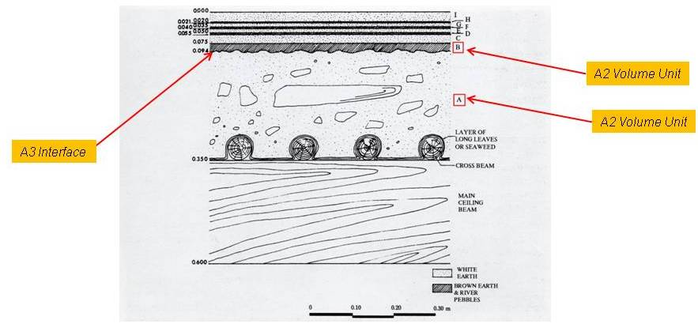

Fig. 7: CRMarchaeo example of A2 and A3 classes (Shaw 1977, ill.1-Michailidou 2001, fig.24)

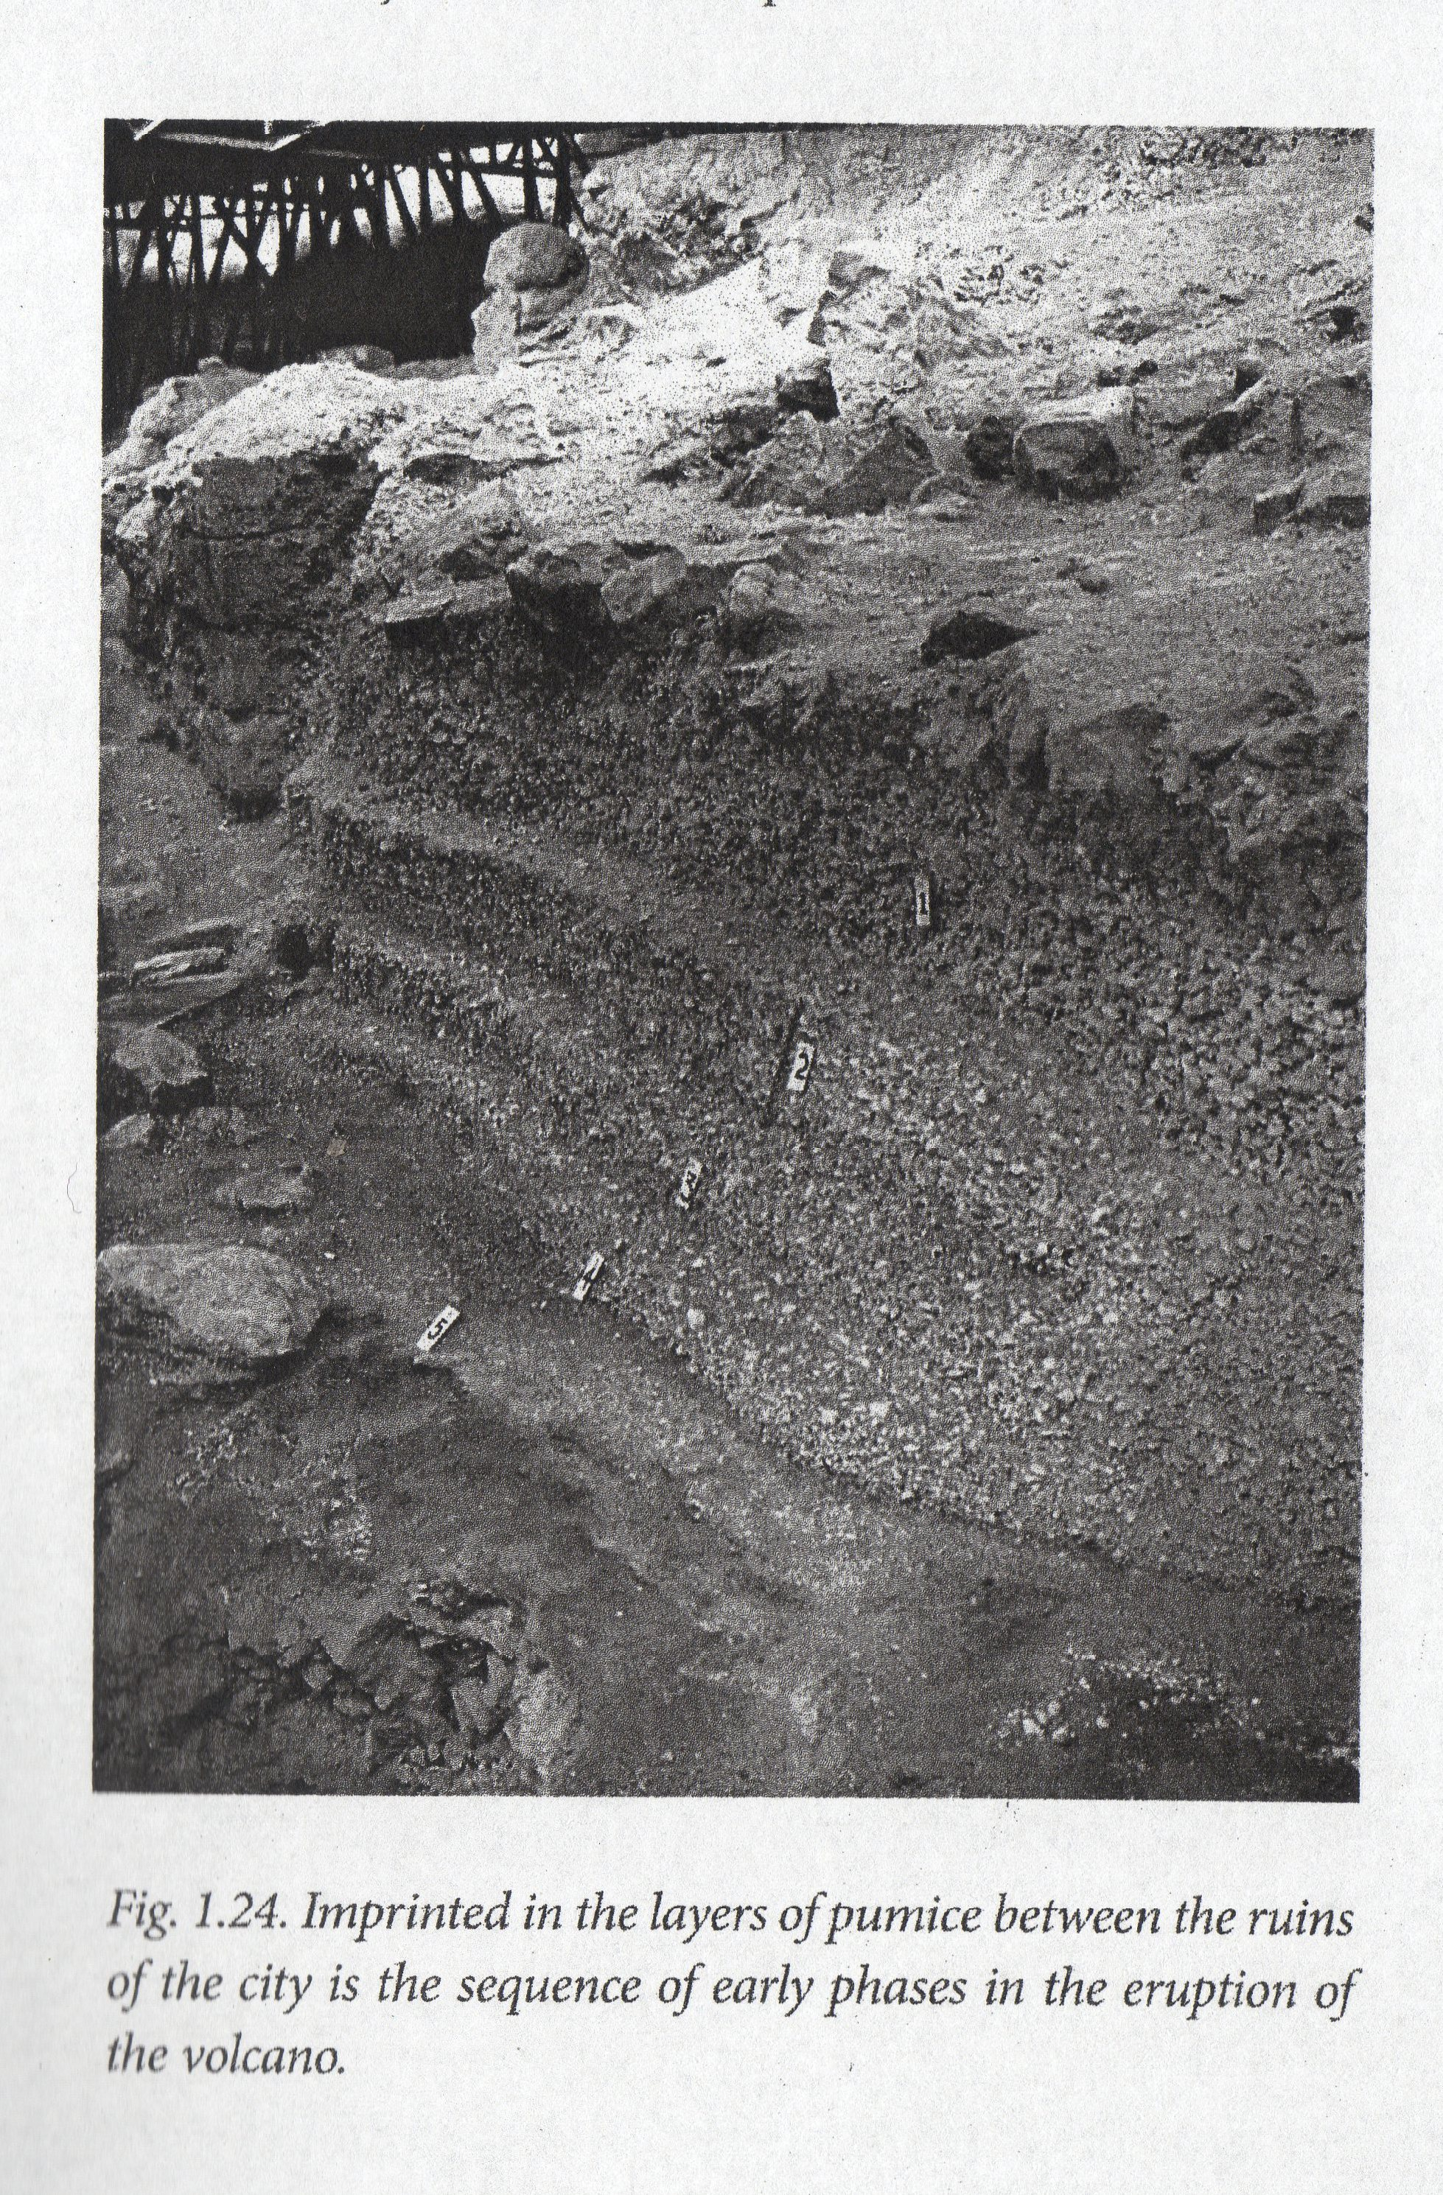

Fig. 8: CRMarchaeo example of A4 and A8 classes (Doumas 2015, fig. 1.24)

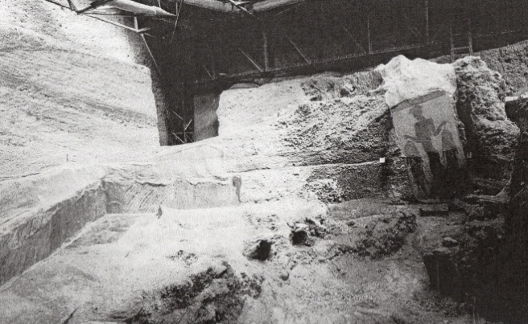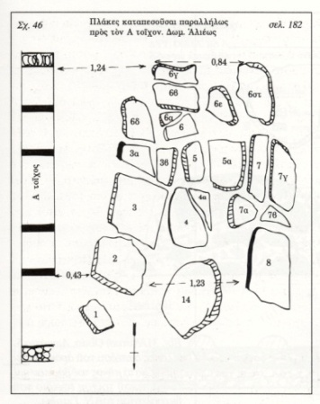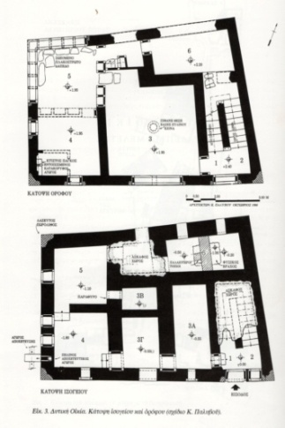

Fig. 9: CRMarchaeo example of A6 class (Marinatos 1974, pl. 38b-Michailidou 2001, Fig.3, 29)

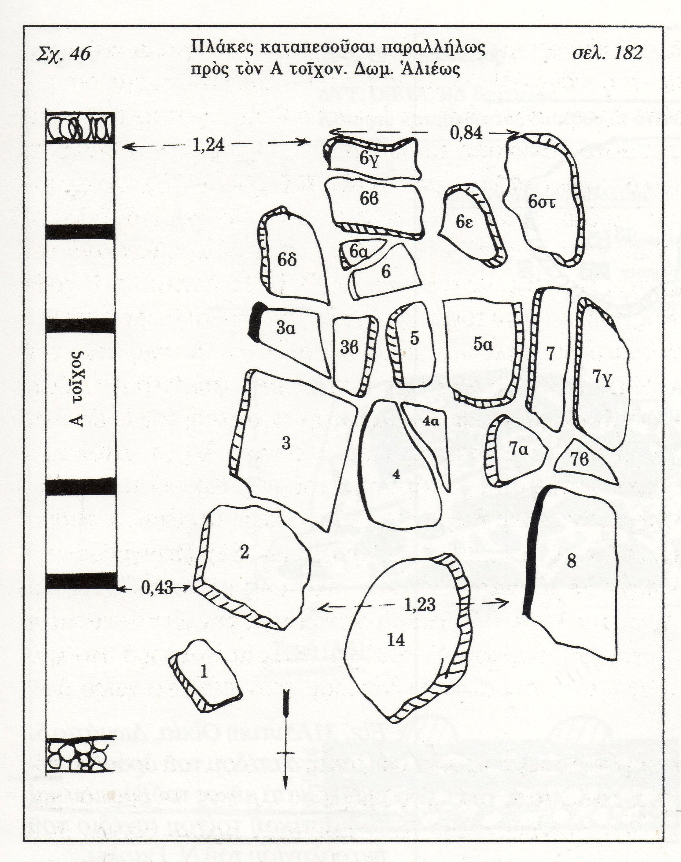

Fig. 10: CRMarchaeo example of A7 class (Michailidou 2001, Fig.29)

# 1.5 Excavation Model Class Declarations

The classes are comprehensively declared in this section using the following format:

* Class names are presented as headings in bold face, preceded by the class’ unique identifier;
* The line “Subclass of:” declares the superclass of the class from which it inherits properties;
* The line “Superclass of:” is a cross-reference to the subclasses of this class;
* The line “Scope note:” contains the textual definition of the concept the class represents;
* The line “Examples:” contains a bulleted list of examples of instances of this class.
* The line “Properties:” declares the list of the class’s properties;
* Each property is represented by its unique identifier, its forward name and the range class that it links to, separated by colons;
* Inherited properties are not represented;
* Properties of properties, if they exist, are provided indented and in parentheses beneath their respective domain property.

### A1 Excavation Processing Unit

Subclass of: S1 Matter Removal

S4 Observation

Scope Note: This class comprises activities of excavating in the sense of archaeology, which are documented as a coherent set of actions of progressively recording and removing matter from a pre-specified location under specific rules. Typically, an excavation process unit would be terminated if significant discontinuities of substance or finds come to light, or if the activity is interrupted due to external factors, such as end of a working day. In other cases, the termination would be based on predefined physical specifications, such as the boundaries of a maximal volume of matter to be excavated in one unit of excavation.

Depending on the methodology, an instance of A1 Excavation Process Unit may intend to remove matter only within the boundaries of a particular stratigraphic unit, or it may follow a pre-declared spatial extent such as a trench. It may only uncover, clean or expose a structure or parts of it.

The process of excavation results in the production of a set of recorded (documentation) data that should be sufficient to provide researchers enough information regarding the consistence and spatial distribution of the excavated Segment of Matter and things and features embedded in it. Some parts or all of the removed physical material (S11 Amount of Matter) may be dispersed, whereas others may be kept in custody in the form of finds or samples, while others (such as parts of walls) may be left at the place of their discovery. The data produced by an instance of excavation process unit should pertain to the material state of matter at excavation time only and should be clearly distinguished from subsequent interpretation about the causes for this state of matter.

Examples:

* + - The activity taking place on 21.9.2007 between 12:00 and 13:00 that excavated the Stratigraphic Volume Unit (2) of Figure 4 and created the surface S1 (A10)
    - The activity that excavated the first 20 cm of a spit excavation on 21.7.2007 created the surface S2 in Figure 4.

In First Order Logic:

A1(x) ⊃ S1(x)

A1(x) ⊃ S4(x)

Properties:

[AP1](#_AP1_produced_(was) produced (was produced by): S11 Amount of Matter

AP2 discarded (was discarded by): S11 Amount of Matter

AP4 produced surface (was surface produced by): A10 Excavation Interface

AP5 removed part or all of (was partially or totally removed by): A8 Stratigraphic Unit

AP6 intended to approximate (was approximated by): A3 Stratigraphic Interface

[AP10](#_AP10_destroyed_(was) destroyed (was destroyed by): S22 Segment of Matter

### A2 Stratigraphic Volume Unit

Subclass of: A8 Stratigraphic Unit

Scope Note: This class comprises instances of A8 Stratigraphic Unit which are connected portions of terrain or other solid structures on, in, or under the surface of earth or seafloor exhibiting some homogeneity of structure or substance and which are completely bounded by surfaces or discontinuities in substance or structure with respect to other portions of the terrain or surfaces of objects or finds.

Normally at least one of the surfaces, i.e. instances of A3 Stratigraphic Interface (such as the lower one), from the genesis event of the A2 Stratigraphic Volume Unit will remain during its existence.

An instance of A2 Stratigraphic Volume Unit may contain physical objects

Examples:

The stratigraphic deposit unit number (2) of Figure 5 representing the filling of a post hole.

A collapsed part of the roof of the West House was found in a horizontal position on the first floor during the excavation of Room 3. It is made up of a number of successive layers, the principal ones being the thick layer “A” (A2), consisting of grey soil and small tuff stones, and the thinner layer “B” (A2) consisting of brownish red soil and marine pebbles (Fig. 7). [Μιχαηλίδου 2001, pp.64-65].

In First Order Logic:

A8(x) ⊃ A2(x)

Properties: [AP21](#_AP21_contains_(is) contains (is contained in): E18 Physical Thing

### A3 Stratigraphic Interface

Subclass of: A8 Stratigraphic Unit

Scope Note: This class comprises instances of A8 Stratigraphic Unit, which are coherent parts of a boundary surface that appear as the result of a stratigraphic genesis event or process. The interface marks the limit of the geometric extent of the effect of a genesis or modification event, and indicates in particular where the effect of this event ended. Each event of creation or destruction of a deposition layer implies the creation of new interfaces. Thus there are two main types of interface: those that are surfaces of strata (that can be directly related to the corresponding stratum via the AP12 confines property), and those that are only surfaces, formed by the removal or destruction of existing stratifications.

Examples:

* The Stratigraphic Interface number [19] confines the number (2) Stratigraphic Volume Unit, in Figure 5.
* The two layers A and B (A2) are separated by a stratigraphic interface (A3) (Fig.7) [Μιχαηλίδου 2001, pp. 64-645]

**In First Order Logic:**

**A3(x) ⊃ A8(x)**

Properties:

[AP12](#_AP12_confines_(is_1) confines (is confined by): A2 Stratigraphic Volume Unit

### A4 Stratigraphic Genesis

Subclass of: S17 Physical Genesis

A5 Stratigraphic Modification

Scope Note: This class comprises activities or processes that have produced homogeneous, distinguishable units of stratification that are in a relatively stable form from the time of their genesis until they are observed. Such processes may be the aggregation of cycles of erosion/destruction, deposit/accumulation, or transformation/modification occurring on a particular site throughout a particular period of time. These processes are usually not only due to natural forces (i.e., climate, the impact of flora and fauna, other natural events), but also to human activities, in particular excavation and construction. An event of stratification genesis typically produces two main forms of stratification units, both a deposit and an interface.

Examples:

The cut in the pre-existing strata of the posthole in Figure 8 produced the stratigraphic interface number [3]; the filling of the posthole with detritus or some other matter produced stratigraphic unit number (18).

In the excavation of Akrotiri, Thera, five distinct layers (A2) of pumice create a level (A8), about one metre thick, which covers the ruins caused by the earthquake (A4). Above the pumice, the deposition of successive layers (A2) of volcanic ash created an 8-10 m thick level (A8) (Fig. 5, 8). [Doumas 2015].

At the time of the destruction (A4) of Room 5 of the West House, the upper storey's paved floor collapsed and some of its slabs fell on the ground floor. This event produced two deposit levels (A8) (Fig. 5). [Μιχαηλίδου, Α. 2001, pp. 68-70].

In First Order Logic:

A4(x) ⊃ S17(x)

A4(x) ⊃ A5(x)

Properties:

[AP7](#_AP7_produced_(was) produced (was produced by): A8 Stratigraphic Unit or A3 Stratigraphic Interface

AP9 took matter from (provided matter to): S10 Material Substantial

### A5 Stratigraphic Modification

Subclass of: S18 Alteration

Scope Note: This class comprises activities or processes resulting in the modification of Stratigraphic Units after their genesis through A4 Stratigraphic Genesis Events.

Examples:

The Event that eroded the number (1) Stratigraphic Volume Unit in Figure 4 and diminished it to its actual size

During the excavation at Eagle Cave, Texas, archaeologists found many burrows, about 7 cm in diameter on average, deriving from rodents, lizards, and insects, which have disturbed (A5) the intact layers (A8). [Larsen, M. 2015]

At the Dutton Paleo-Indian site, Colorado, involutions (flame-structures) due to aquaturbations, caused deformation (A5) of the saturated soil (A8). [Wood & Johnson 1978, pp. 315-380].

In First Order Logic:

A5(x) ⊃ S18(x)

Properties:

[AP8](#_AP8_disturbed_(was) disturbed (was disturbed by): A8 Stratigraphic Unit

AP13 has stratigraphic relation (is stratigraphic relation of): A5 Stratigraphic Modification

### A6 Group Declaration Event

Subclass of: E13 Attribute Assignment

Scope Note: This class comprises interpretive activities that lead to the recognition two or more instances of Stratigraphic Units (A8) or other Physical Thing (E18) that simultaneously exist at the time of this activity or at the time of an archaeological observation this activity refers to as source and that are attributed to be the remains of one complete instance of Physical Thing (E18) that had existed at a time of reference in the past. Instances of this class could be, for example: two stratigraphic units (with no evident contact) cut through by a ditch having been segments of the same original stratigraphic unit, two or more surviving parts of a structure having been segments of the same wall (B5), a number of postholes being the indication of a past wooden house or a number of potsherds being segments of the same original artefact.

Examples:

* The excavator declared the post holes [7] and [8] in Figure 4 to be part of one building.
* During the excavation process of Room 5 (A1) of the West House (E24) a slab surface (E18) was found on deposit (A8) located on the upper storey (E53), as well as several individual slabs (E19) on deposit (A8) located on the ground floor (E53); these were declared, by the excavators, to be parts of the same object, i.e. the original paved floor (E19) of the upper storey (Fig. 9). [Μαρινάτος 1974] [Μιχαηλίδου 2001, pp. 40, 68-70]

In First Order Logic:

A6(x) ⊃ E13(x)

Properties:

AP16 assigned attribute to (was attributed by): E18 Physical Thing

### A7 Embedding

Subclass of: E3 Condition State

Superclass of:

Scope Note: This class comprises the states of instances of E18 Physical Things of being partially or completely embedded at a particular position with relative stability in one or more A2 Stratigraphic Volume Units. Normally, an embedding is expected to have been stable from the time of generation of the first A2 Stratigraphic Volume Unit that surrounds it. However, it may also be due to later intrusion. As an empirical fact, the expert may only be able to decide that a particular embedding is not recent, i.e. has been persisting for longer than the activity that encountered it. This class can be used to document the fact of embedding generally with respect to the surrounding matter or, more specifically, with respect to a more precise position within this matter. It further allows for specifying temporal bounds for which a particular embedding has existed, as specified by the evidence.

Examples:

Τhe individual fallen slabs (E19) that were discovered (S19) during the excavation process of Room 5 (A1) of the West House in Akrotiri, Thera, were embedded (A7) in an almost vertical position (E55) within deposit (A8) on the ground floor (E53) (Fig. 10). [Μιχαηλίδου 2001, pp. 68-70].

In First Order Logic:

A7(x) ⊃ E3(x)

Properties:AP17 is found by (found): S19 Encounter Event

AP18 is embedding of (is embedded): E18 Physical Thing

AP19 is embedding in (contains embedding): A2 Stratigraphic Volume Unit

AP20 is embedding at (contains): E53 Place

### A8 Stratigraphic Unit

Subclass of: S20 Rigid Physical Feature

Superclass of: A2 Stratigraphic Volume Unit

A3 Stratigraphic Interface

Scope Note: This class comprises instances of S20 Rigid Physical Features which appear as the result of a stratigraphic genesis event or process. The form of an instance of A8 Stratigraphic Unit should be of a kind that can be attributed to a single genesis event or process and has the potential to be observed. One genesis event may have created more than one SU. An instance of A8 Stratigraphic Unit is regarded to exist as long as a part of its matter is still in place with respect to a surrounding reference space, such that its spatial features can be associated with effects of the genesis process of interest.

This also implies that a certain degree of coherent (“conformal”) deformation is tolerable within its time-span of existence. Therefore the place an instance of A8 Stratigraphic Unit occupies can be uniquely identified with respect to the surrounding reference space of archaeological interest

Examples:

The excavator declared the post holes [7] and [8] in Figure 4 to be part of one building.

In the excavation of Akrotiri, Thera, five distinct layers (A2) of pumice create a level (A8) about one metre thick which covers the ruins caused by the earthquake (A4) (Fig. 8) [Doumas 2015].

In First Order Logic:

A8(x) ⊃ S20(x)

Properties:AP11 has physical relation (is physical relation of): A8 Stratigraphic Unit

AP15 is or contains remains of (is or has remains contained in): S10 Material Substantial

### A9 Archaeological Excavation

Subclass of: S4 Observation

Scope Note: This class describes the general concept of archaeological excavation intended as a coordinated set of activities performed on an area considered as part of a broader topographical, rural, urban, or monumental context. An archaeological excavation is usually under the responsibility of a coordinator, officially designated, which is legally and scientifically responsible for all the activities carried out within each of the excavation process units and is also responsible for the documentation of the whole process.

Examples:

The archaeological excavation (A9) of the West House (E24) that took place at the archaeological site of Akrotiri, Thera (E53) during the years (1967-1973) (E52) by the archaeologist Sp. Marinatos (E39). [Μιχαηλίδου 2001, p. 41] [Palyvou 200].

In First Order Logic:

A9(x) ⊃ S4(x)

Properties: [AP3](#_AP3_investigated_(was) investigated (was investigated by): E27 Site

### A10 Excavation Interface

Subclass of: S20 Rigid Physical Feature

Scope Note: This class comprises instances of S20 Rigid Physical Feature that constitutes a surface produced through one or several A1 Excavation Process Units. Instances are often documented through drawing and/or measured by technical means such as photography, tachymetry or laser scanning. Using a planar excavation methodology this is typically the surface of a planum or the surface of a profile. Using a stratigraphic excavation methodology, the A10 Excavation Interface would have the intention to approximate an A3 Stratigraphic Interface. The drawing and measurement of profiles is also common practice when a stratigraphic excavation methodology is used.

Examples:

* The Excavation Interface Planum 6 of square I22 in Area F-I is documented in the fielddrawing “Planum 6 F-I i22” created in Fall 1982.
* The Excavation Interface Eastern profile of square I22 in Area F-I is documented in fielddrawing “Ostprofil F-I i22” and confines the excavation square I22 to the east.

In First Order Logic:

A10(x) ⊃ S20(x)

Properties:

# 1.6 Excavation Property Declarations

The properties are comprehensively declared in this section using the following format:

• Property names are presented as headings in bold face, preceded by unique property identifiers;

• The line “Domain:” declares the class for which the property is defined;

• The line “Range:” declares the class to which the property points, or that provides the values for  the property;

• The line “Superproperty of:” is a cross-reference to any subproperties the property may have;

• The line “Scope note:” contains the textual definition of the concept the property represents;

• The line “Examples:” contains a bulleted list of examples of instances of this property.

### AP1 produced (was produced by)

Domain: A1 Excavation Process Unit

Range: S11 Amount of Matter

Subproperty of: [O2](#_O2_removed_(was) removed (was removed by)

Quantification: one to many (0,n:0,1)

Scope note: This property identifies the S11 Amount of Matter, e.g. a basket, that is preserved (part or total of) from an A1 Excavation Process Unit for further examination or evidence keeping.

Examples:

* The excavation of the posthole (A1) *produced* an amount of black turf with wood inclusions (S11).

In First Order Logic:

AP1(x,y) ⊃ A1(x)

AP1(x,y) ⊃ S11 (y)

AP1(x,y) ⊃ O2(x,y)

Properties:

### AP2 discarded (was discarded by)

Domain: A1 Excavation Process Unit

Range: S11 Amount of Matter

Subproperty of: [O2](#_O2_removed_(was) removed (was removed by)

Quantification: one to many (0,1:1,1)

Scope note: This property identifies the S11 Amount of Matter discarded (e.g. onto the spoil heap) by A1 Excavation Processing Unit.

Examples:

The stratum of ash, pumice and other volcanic material removed (S11) *was* *discarded by* the excavation of Villa of the Mysteries in Pompeii, Italy (A1).

In First Order Logic:

AP2(x,y) ⊃ A1(x)

AP2(x,y) ⊃ S11(y)

AP2(x,y) ⊃ O2(x,y)

Properties:

### AP3 investigated (was investigated by)

Domain: A9 Archaeological Excavation

Range: E27 Site

Subproperty of: [O8](#_O8_observed_(was) observed (was observed by)

Quantification: one to many (0,n:0,1)

Scope note: This property identifies the 3D excavated volume instance of E27 Site, i.e., a three- dimensional volume, that was actually investigated during an A9 Archaeological Excavation.

Examples:

The 1938 archaeological excavation, carried out by Pietro Romanelli (A9) *investigated* the archaeological site of the ancient Etruscan city of Tarquinia(E27).

In First Order Logic:

AP3(x,y) ⊃ A9(x)

AP3(x,y) ⊃ E27(y)

AP3(x,y) ⊃ O8(x,y)

Properties:

### AP4 produced surface (was surface produced by)

Domain: A1 Excavation Process Unit

Range: A10 Excavation Interface

Subproperty of:

Quantification: one to many (0,n:0,1)

Scope note: This property identifies the instance of A10 Excavation Interface that constitutes the new surface produced during an A1 Excavation Process Unit in the excavated area. Frequently this surface or parts of it are documented through drawing and/or measured by technical means such as photography, tachymetry or laser scanning.

Examples:

The excavation of the south trench in 1949 (A1) *produced surface* the confinement of the south part of the archaeological site of Sybaris, Italy (A10) .

In First Order Logic:

AP4(x,y) ⊃ A1(x)

AP4(x,y) ⊃ A10 (y)

AP(4x,y) ⊃ O2(x,y)

Properties:

### AP5 removed part or all of (was partially or totally removed by)

Domain: A1 Excavation Process Unit

Range: A8 Stratigraphic Unit

Subproperty of:

Quantification: one to many (0,n:0,1)

Scope note: This property identifies the instance of A8 Stratigraphic Unit that was cut during an A1 Excavation Process Unit.

Examples:

The spit excavation producing the surface S2 (A1) *removed part or all of* the structures and infill marked 2, 3, 4, 18, 19 in fig. 4 (A8).

In First Order Logic:

AP5(x,y) ⊃ A1(x)

AP5(x,y) ⊃ A8(y)

AP5(x,y) ⊃ O2(x,y)

Properties:

### AP6 intended to approximate (was approximated by)

Domain: A1 Excavation Process Unit

Range: A3 Stratigraphic Interface

Subproperty of: [O8](#_O8_observed_(was) observed (was observed by)

Quantification: one to many (0,n:0,1)

Scope note: This property identifies the A3 Stratigraphic Interface that was intended to approximate during an A1 Excavation Process Unit. This property should be assigned when a stratigraphic excavation methodology is used. It enables the linkage of the surface produced by an A1 Excavation Process Unit and an A3 Stratigraphic Interface.

Examples:

The excavation in ancient Akrotiri (A1) *intended to approximate* the various interfaces witnessing the sequences of eruption of ancient Santorini’s volcano (A3) (see Fig. 8).

In First Order Logic:

AP6(x,y) ⊃ A1(x)

AP6(x,y) ⊃ A3 (y)

AP6(x,y) ⊃ O8(x,y)

Properties:

### AP7 produced (was produced by)

Domain: A4 Stratigraphic Genesis

Range: A8 Stratigraphic Unit

Subproperty of: [O17](#_O17_generated_(was) generated

Quantification: one to many (0,n:0,1)

Scope note: This property identifies the A8 Stratigraphic Unit that was produced during an A4 Stratigraphic Genesis Event.

Examples:

The layers of pumice and volcanic ash, about one metre thick, covering the ancient city of Akrotiri (A8) *was produced by* the explosion of the ancient Santorini’s volcano (A4) (see Fig. 5, 8).

In First Order Logic:

AP7(x,y) ⊃ A4(x)

AP7(x,y) ⊃ A8(y)

AP7(x,y) ⊃ O17(y)

Properties:

### AP8 disturbed (was disturbed by)

Domain: A5 Stratigraphic Modification

Range: A8 Stratigraphic Unit

Superproperty of: [O18](#_O18_altered_(was) altered (was altered by)

Quantification: one to many (0,n:0,1)

Scope note: This property identifies an A8 Stratigraphic Unit that was disturbed through an A5 Stratigraphic Modification. One A5 Stratigraphic Modification may disturb several A8 Stratigraphic Units.

Example:

The burrows found by archaeologists during the excavation at Eagle Cave, Texas, deriving from rodents, lizards, and insects (A5) *disturbed* the intact stratigraphic layers of the archaeological site (A8) [Larsen, M. 2015].

In First Order Logic:

AP8(x,y) ⊃ A5(x)

AP8(x,y) ⊃ A8(y)

AP8(x,y) ⊃ O18(y)

### AP9 took matter from (provided matter to)

Domain: A4 Stratigraphic Genesis

Range: S10 Material Substantial

Superproperty of: [O18](#_O18_altered_(was) altered (was altered by)

Quantification: one to many (0,n:0,1)

Scope note:

Example: The slabs from the collapse of the upper storey’s paved floor of Room 5 of West House in ancient Akrotiri (S10) *provided matter to* the formation of two slab deposit layers on the ground floor (A4).

In First Order Logic:

AP9(x,y) ⊃ A4(x)

AP9(x,y) ⊃ S10(y)

AP9(x,y) ⊃ O18(x,y)

### AP10 destroyed (was destroyed by)

Domain: A1 Excavation Process Unit

Range: S22 Segment of Matter

Subproperty of:

Quantification: one to many (0,n:0,1)

Scope note: This property identifies the S22 Segment of Matter that was destroyed through an A1 Excavation Process Unit. The spatial extent of the S22 Segment of Matter is defined by the extent of the spatial 3 dimensional projection of the A1 Excavation Process Unit. Depending on the granularity of the A1 representation, different S22 may be identified by the A10 property.

Example:

The complete excavation of Villa of the Mysteries in Pompeii, Italy (A1) *destroyed* the stratum of ash, pumice and other volcanic material (S22).

In First Order Logic:

AP10(x,y) ⊃ A1(x)

AP10(x,y) ⊃ S22(y)

AP10 (x,y) ⊃ P13(x,y)

### AP11 has physical relation (is physical relation of)

Domain: A8 Stratigraphic Unit

Range: A8 Stratigraphic Unit

Quantification: one to many (0,n:0,1)

Scope note: This property identifies the physical relationship between two A8 Stratigraphic Units. The type of physical relationships found between stratigraphic units in archaeological documentation is documented through the property AP 11.1 has type

Example The layer of burned remains of the log building (in Søndre gate, Trondheim, Norway) (A8) *has physical relation (is physical relation of) under* the foundation of the church of St. Clements (A8).

In First Order Logic:

AP11(x,y) ⊃ A8(x)

AP11(x,y) ⊃ A8 (y)

AP11.1 (x,y,z) ⊃ [AP11 (x,y) ∧ E55(z)]

Properties: AP11.1 has type: E55 Type

### AP12 confines (is confined by)

Domain: A3 Stratigraphic Interface

Range: A2 Stratigraphic Volume Unit

Superproperty of: [O7](#_O7_confined_(was) confined (was confined by)

Scope note: This property identifies partly or completely the surface (A3 Stratigraphic Interface) of an A2 Stratigraphic Volume Unit. One A3 Stratigraphic Interface may confine two or more A2 Stratigraphic Volume Units.

### AP13 has stratigraphic relation (is stratigraphic relation of)

Domain: A5 Stratigraphic Modification

Range: A5 Stratigraphic Modification

Quantification: one to many (0,n:0,1)

Scope note: This property identifies the stratigraphic relation between two A5 Stratigraphic Modification events. This relation may be inferred from the kind of physical relation that exists between the two AP 8 Stratigraphic Units that have been created or modified during the corresponding A5 Stratigraphic Modification events. The type of stratigraphic relationships in archaeological documentation assigned to two A5 Stratigraphic Modification events is documented through the property AP 13.1 has type.

Example The burning of the log building (in Søndre gate, Trondheim, Norway) (A5) *has stratigraphic relation (is stratigraphic relation of) earlier* the laying of the foundation for the church of St. Clements (A5).

In First Order Logic:

AP13(x,y) ⊃ A5(x)

AP13(x,y) ⊃ A5(y)

AP13.1(x,y,z) ⊃ [AP13 (x,y) ∧ E55(z)]

Properties: AP13.1 has type: E55 Type

AP14 justified by: AP11.1 has type (type of physical relation)

### AP14 justified by (is justification of)

Domain: AP13.1 has type (type of stratigraphic relation)

Range: AP11.1 has type (type of physical relation)

Quantification: one to many (0,n:0,1)

Scope note: This property identifies the type of physical relation that was used to justify the type of stratigraphic relation assigned to the relation between two A5 Stratigraphic Modification events. Physical relations of “above” or “fills” may justify the stratigraphic relation type “after”. Figure 7 gives a graphical representation and Figure 6 shows an example.

Examples: The layer of burned remains of the log building (in Søndre gate, Trondheim, Norway) (A8) *has physical relation (is physical relation of) under* the foundation of the church of St. Clements (A8) *justify* the burning of the log building (A5) *has stratigraphic relation (is stratigraphic relation of) earlier* the laying of the foundation for the church of St. Clements (A5).

In First Order Logic:

AP14(u,v,w,x,y,z) ⊃ AP13.1 (u,v,w)

AP14(u,v,w,x,y,z) ⊃ AP11.1 (x,y,z)

### AP15 is or contains remains of (is or has remains contained in)

Domain: [A](#_A8_Stratigraphic_Unit)2 Stratigraphic Volume Unit

Range: S10 Material Substantial

Quantification: one to many (0,n:0,1)

Scope note: This property indicates that an instance of A2 Stratigraphic Volume Unit can be the remains of or contain the remains of an instance of S10 Material Substantial.

Examples: The posthole, Dilling 2AS34019, (A2) *is or contains remains of (is or has remains contained in)* the rotten bottom part of a pole (S10).

In First Order Logic:

AP15(x,y) ⊃ A2(x)

AP15(x,y) ⊃ S10(y)

### AP16 assigned attribute to (was attributed by)

Domain: A6 Group Declaration Event

Range: E18 Physical Thing

Subproperties: P140 assigned attribute to (was attributed by)

Quantification: one to many (0,n:0,1)

Scope note: This property indicates an instance of E18 Physical Thing that was assigned by an instance of A6 Group Declaration Event as remains of the target of this instance of A6 Group Declaration Event.

Examples: The excavator declaration that the post holes [7] and [8] to be part of one building (A6) *assigned attribute to* the post holes [7] and [8] (E18) (see fig. 4)

In First Order Logic:

AP16(x,y) ⊃ A6(x)

AP16(x,y) ⊃ E18(y)

AP16(x,y) ⊃ P140(x,y)

### AP17 is found by (found)

Domain: A7 Embedding

Range: S19 Encounter Event

Subproperty of: [O8](#_O8_observed_(was) observed (was observed by)

Quantification: one to many (0,n:0,1)

Scope note: This property associates an instance of S19 Encounter Event with an instance of A7 Embedding that has been found during this even.

Examples: Τhe embedding of a small whetstone with an erratic runic inscription in a Medieval rubbish dump (A7) *is found by* the discovery of the whetstone in the early morning in November 2017 in Oslo, Norway (S19)

In First Order Logic:

AP17(x,y) ⊃ A7(x)

AP17(x,y) ⊃ S19(y)

AP17(x,y) ⊃ O8(x,y)

### AP18 is embedding of (is embedded)

Domain: A7 Embedding

Range: E18 Physical Thing

Subproperty of: P44 has condition (is condition of)

Quantification: one to many (0,n:0,1)

Scope note: This property identifies the E18 Physical Thing that is contained in an A7 Embedding.

Example: The embedding of the small whetstone with an erratic runic inscription in a Medieval rubbish dump (A7) *is embedding of* this whetstone, discovered in the early morning in November 2017 in Oslo, Norway (E18)

In First Order Logic:

AP18(x,y) ⊃ A7(x)

AP18(x,y) ⊃ E18(y)

AP18(x,y) ⊃ P44(x,y)

### AP19 is embedding in (contains embedding)

Domain: A7 Embedding

Range: A2 Stratigraphic Volume Unit

Quantification: one to many (1,1:0,n)

Scope note: This property identifies the instance of A2 Stratigraphic Volume Unit that contains the A7 Embedding. An Embedding may not extend over more than one instance of A2 Stratigraphic Volume Unit.

Example: The embedding of the small whetstone with an erratic runic inscription, discovered in the early morning in November 2017 in Oslo, Norway, in a medieval rubbish dump (A7) *is embedding in* the medieval rubbish dump Follo234532 (A2).

In First Order Logic:

AP19(x,y) ⊃ A7(x)

AP19(x,y) ⊃ A2(y)

### AP20 is embedding at (contains)

Domain: A7 Embedding

Range: E53 Place

Quantification: one to many (1,n:0,n)

Scope note: This property identifies the E53 Place that is documented as the E53 Place of the A7 Embedding. This place must be at rest relative to the instance of A2 Stratigraphic Volume Unit that contains the A7 Embedding.

Example: Τhe embedding of the small whetstone with an erratic runic inscription, discovered in the early morning in November 2017 in Oslo, Norway,  in a Medieval rubbish dump (A7) is embedding at the bottom of the Medieval rubbish dump, Follo234532, (E53 Place).

In First Order Logic:

AP20(x,y) ⊃ A7(x)

AP20(x,y) ⊃ E53(y)

AP20(x,y) ⊃ (∃z)[ A2(z) ∧ AP19(x,z) ∧ P157(y,z)]

### AP21 contains (is contained in)

Domain: A2 Stratigraphic Volume Unit

Range: E18 Physical Thing

Quantification: one to many (0,n:0,1)

Scope note: This property associates an E18 Physical Thing that is found within an A2 Stratigraphic Volume Unit with the stratigraphic volume unit. [*AP21*](#_AP21_contains_(is) *contains (is contained in)* is a shortcut for the more detailed path from E18 Physical Thing through *AP18i* *is embedded,* A7 Embedding, *AP19* *is embedding in,* A2 Stratigraphic Volume Unit.

Example: A Medieval rubbish dump in Oslo, Norway (A2) *contains* a whetstone, discovered in the early morning in November 2017 in Oslo, Norway (E18)

In First Order Logic:

AP21(x,y) ⊃ A2(x)

AP21(x,y) ⊃ E18(y)

### AP22 is equal in time to

Domain: E2 Temporal Entity

Range: E2 Temporal Entity

Subproperty of: E2 Temporal Entity.P175 starts before or with the start of (starts after or with the start of):E2 Temporal Entity

E2 Temporal Entity. P184 ends before or with the end of (ends with or after the end of):E2 Temporal Entity

Quantification: many to many (0,n:0,n)

Scope note: This property symmetrically identifies a situation in which the starting point and the ending point for an instance of E2 Temporal Entity is equal to the starting point and the ending point respectively of another instance of E2 Temporal Entity

This property is only necessary if the time span is unknown (otherwise the equivalence can be calculated).

This property is the same as the "equal" relationship of Allen’s temporal logic (Allen, 1983, pp. 832-843).

This property is transitive.

Example: The destruction of the Villa Justinian Tempus (E6) *is equal in time to* the death of Maximus Venderus (E69)

In First Order Logic:

AP22(x,y) ⊃ E2(x)

AP22(x,y) ⊃ E2(y)

AP22(x,y) ⊃ P175(y,x)

AP22(x,y) ⊃ P184(y,x)

### AP23 finishes (is finished by)

Domain: E2 Temporal Entity

Range: E2 Temporal Entity

Subproperty of: E2 Temporal Entity.P184 ends before or with the end of (ends with or after the end of):E2 Temporal Entity

Quantification: many to many (0,n:0,n)

Scope note: This property identifies a situation in which the ending point of an instance of E2 Temporal Entity is equal to the ending point of another temporal entity of longer duration. There is no causal relationship implied by this property.

This property is only necessary if the time span is unknown (otherwise the relationship can be calculated). This property is the same as the "finishes / finished-by" relationships of Allen’s temporal logic (Allen, 1983, pp. 832-843).

This property is transitive.

Example: Late Bronze Age (E4) *finishes* Bronze Age (E4)

In First Order Logic:

AP23(x,y) ⊃ E2(x)

AP23(x,y) ⊃ E2(y)

AP23(x,y) ⊃ P184(x,y)

### AP24 starts (is started by)

Domain: E2 Temporal Entity

Range: E2 Temporal Entity

Subproperty of: E2 Temporal Entity.P185 ends before the end of (ends after the end of):E2 Temporal Entity

E2 Temporal Entity.P175 starts before or with the start of (starts after or with the start of):E2 Temporal Entity

Quantification: many to many (0,n:0,n)

Scope note: This property identifies a situation in which the starting point for an instance of E2 Temporal Entity is equal to the starting point of another instance of E2 Temporal Entity of longer duration.

This property is only necessary if the time span is unknown (otherwise the relationship can be calculated). This property is the same as the "starts / started-by" relationships of Allen’s temporal logic (Allen, 1983, pp. 832-843).

This property is transitive.

Example: Early Bronze Age (E4) *starts* Bronze Age (E4)

In First Order Logic:

AP24(x,y) ⊃ E2(x)

AP24(x,y) ⊃ E2(y)

AP24(x,y) ⊃ P175(x,y)

AP24(x,y) ⊃ P185(x,y)

### AP25 occurs during (includes)

Domain: E2 Temporal Entity

Range: E2 Temporal Entity

Subproperty of: E2 Temporal Entity.P185 ends before the end of (ends after the end of):E2 Temporal Entity

Quantification: many to many (0,n:0,n)

Scope note: This property identifies a situation in which the entire instance of E52 Time-Span of an instance of E2 Temporal Entity falls within the instance of E52 Time-Span of another instance of E2 Temporal Entity that starts before and ends after the included temporal entity.

This property is only necessary if the time span is unknown (otherwise the relationship can be calculated). This property is the same as the "during / includes" relationships of Allen’s temporal logic (Allen, 1983, pp. 832-843).

This property is transitive.

Example: Middle Saxon period (E4) *occurs during* Saxon period (E4)

In First Order Logic:

AP25(x,y) ⊃ E2(x)

AP25(x,y) ⊃ E2(y)

AP25(x,y) ⊃ P185(x,y)

### AP26 overlaps in time with (is overlapped in time by)

Domain: E2 Temporal Entity

Range: E2 Temporal Entity

Subproperty of: E2 Temporal Entity.P176 starts before the start of (starts after the start of): E2Temporal Entity

E2 Temporal Entity.P185 ends before the end of (ends after the end of):E2 Temporal Entity

Quantification: many to many (0,n:0,n)

Scope note: This property identifies a situation in which there is an overlap between the instances of E52 Time-Span of two instances of E2 Temporal Entity.

It implies a temporal order between the two entities: if A overlaps in time B, then A must start before B, and B must end after A. This property is only necessary if the relevant time spans are unknown (otherwise the relationship can be calculated).

This property is the same as the "overlaps / overlapped-by" relationships of Allen’s temporal logic (Allen, 1983, pp. 832-843).

Example: the Iron Age (E4) *overlaps in time with* the Roman period (E4)

In First Order Logic:

AP26(x,y) ⊃ E2(x)

AP26(x,y) ⊃ E2(y)

AP26(x,y) ⊃ P176(x,y)

AP26(x,y) ⊃ P185(x,y)

### AP27 meets in time with (is met in time by)

Domain: E2 Temporal Entity

Range: E2 Temporal Entity

Subproperty of: E2 Temporal Entity.P182 ends before or with the start of (starts after or with the end of):E2 Temporal Entity

Quantification: many to many (0,n:0,n)

Scope note: This property identifies a situation in which one instance of E2 Temporal Entity immediately follows another instance of E2 Temporal Entity.

It implies a particular order between the two entities: if A meets in time with B, then A must precede B. This property is only necessary if the relevant time spans are unknown (otherwise the relationship can be calculated).

This property is the same as the "meets / met-by" relationships of Allen’s temporal logic (Allen, 1983, pp. 832-843).

Example: Early Saxon Period (E4) *meets in time with* Middle Saxon Period (E4)

In First Order Logic:

AP27(x,y) ⊃ E2(x)

AP27(x,y) ⊃ E2(y)

AP27(x,y) ⊃ P182(x,y)

### AP28 occurs before (occurs after)

Domain: E2 Temporal Entity

Range: E2 Temporal Entity

Subproperty of: E2 Temporal Entity. P183 ends before the start of (starts after the end of): E2 Temporal Entity

Quantification: many to many (0,n:0,n)

Scope note: This property identifies the relative chronological sequence of two temporal entities.

It implies that a temporal gap exists between the end of A and the start of B. This property is only necessary if the relevant time spans are unknown (otherwise the relationship can be calculated).

This property is the same as the "before / after" relationships of Allen’s temporal logic (Allen, 1983, pp. 832-843).

This property is transitive.

Example: Early Bronze Age (E4) *occurs before* Late Bronze age (E4)

In First Order Logic:

AP28(x,y) ⊃ E2(x)

AP28(x,y) ⊃ E2(y)

AP28(x,y) ⊃ P183(x,y)

# 1.7 Referred to CIDOC CRM Classes and properties

Since Excavation Modelrefers to and reuses, wherever appropriate, large parts of the CIDOC Conceptual Reference Model, this section provides a comprehensive list of all constructs used from CIDOC CRM, together with their definitions following the CIDOC CRM ver6.2, May 2015*maintained by CIDOC CRM - SIG*. 1.5.1 CIDOC CRM Classes

## 1.7.1 CIDOC CRM Classes

### E1 CRM Entity

Superclass of: E2 Temporal Entity

E52 Time-Span

E53 Place

E54 Dimension

E77 Persistent Item

E92 Spacetime Volume

Scope note: This class comprises all things in the universe of discourse of the CIDOC Conceptual Reference Model.

It is an abstract concept providing for three general properties:

1. Identification by name or appellation, and in particular by a preferred identifier
2. Classification by type, allowing further refinement of the specific subclass an instance belongs to
3. Attachment of free text for the expression of anything not captured by formal properties

With the exception of E59 Primitive Value, all other classes within the CRM are directly or indirectly specialisations of E1 CRM Entity.

Examples:

* the earthquake in Lisbon 1755 (E5)

In First Order Logic:

E1(x)

Properties:

P1 is identified by (identifies): E41 Appellation

P2 has type (is type of): E55 Type

P3 has note: E62 String

(P3.1 has type: E55 Type)

P48 has preferred identifier (is preferred identifier of): E42 Identifier

P137 exemplifies (is exemplified by): E55 Type

(P137.1 in the taxonomic role: E55 Type)

### E3 Condition State

Subclass of: E2 Temporal Entity

Scope note: This class comprises the states of objects characterised by a certain condition over a time-span.

An instance of this class describes the prevailing physical condition of any material object or feature during a specific E52 Time Span. In general, the time-span for which a certain condition can be asserted may be shorter than the real time-span, for which this condition held.

The nature of that condition can be described using *P2 has type*. For example, the E3 Condition State “condition of the SS Great Britain between 22 September 1846 and 27 August 1847” can be characterized as E55 Type “wrecked”.

Examples:

* the "reconstructed" state of the “Amber Room” in Tsarskoje Selo from summer 2003 until now (Owen, 2009)
* the "ruined" state of Peterhof Palace near Saint Petersburg from 1944 to 1946(Maddox, 2015)
* the state of my turkey in the oven at 14:30 on 25 December, 2002 (*P2* *has type: E55* *Type* “still not cooked”)
* the topography of the leaves of Sinai Printed Book 3234.2361 on the 10th of July 2007 (described as: of type "cockled")

In First Order Logic:

E3(x) ⊃ E2(x)

Properties**:**

P5 consists of (forms part of): E3 Condition State

### E6 Destruction

Subclass of: E64 End of Existence

Scope note: This class comprises events that destroy one or more instances of E18 Physical Thing such that they lose their identity as the subjects of documentation.

Some destruction events are intentional, while others are independent of human activity. Intentional destruction may be documented by classifying the event as both an E6 Destruction and E7 Activity.

The decision to document an object as destroyed, transformed or modified is context sensitive:

1. If the matter remaining from the destruction is not documented, the event is modelled solely as E6 Destruction.

2. An event should also be documented using E81 Transformation if it results in the destruction of one or more objects and the simultaneous production of others using parts or material from the original. In this case, the new items have separate identities. Matter is preserved, but identity is not.

3. When the initial identity of the changed instance of E18 Physical Thing is preserved, the event should be documented as E11 Modification.

Examples:

* the destruction of Herculaneum by volcanic eruption in 79 AD
* the destruction of Nineveh (E6, E7)
* the breaking of a champagne glass yesterday by my dog

In First Order Logic:

E6(x) ⊃ E64(x)

Properties:

[P13](#_P13_destroyed_(was) destroyed (was destroyed by): E18 Physical Thing

### E7 Activity

Subclass of: E5 Event

Superclass of: E8 Acquisition

E9 Move

E10 Transfer of Custody

E11 Modification

E13 Attribute Assignment

E65 Creation

E66 Formation

E85 Joining

E86 Leaving

E87 Curation Activity

Scope note: This class comprises actions intentionally carried out by instances of E39 Actor that result in changes of state in the cultural, social, or physical systems documented.

This notion includes complex, composite and long-lasting actions such as the building of a settlement or a war, as well as simple, short-lived actions such as the opening of a door.

Examples:

* + - the Battle of Stalingrad
    - the Yalta Conference
    - my birthday celebration 28-6-1995
    - the writing of “Faust” by Goethe (E65)
    - the formation of the Bauhaus 1919 (E66)
    - calling the place identified by TGN ‘7017998’ ‘Quyunjig’ by the people of Iraq
    - Kira Weber working in glass art from 1984 to 1993
    - Kira Weber working in oil and pastel painting from 1993

In First Order Logic:

E7(x) ⊃ E5(x)

Properties:

P14 carried out by (performed): E39 Actor

(P14.1 in the role of: E55 Type)

P15 was influenced by (influenced): E1 CRM Entity

P16 used specific object (was used for): E70 Thing

(P16.1 mode of use: E55 Type)

P17 was motivated by (motivated): E1 CRM Entity

P19 was intended use of (was made for): E71 Man-Made Thing

(P19.1 mode of use: E55 Type)

P20 had specific purpose (was purpose of): E5 Event

P21 had general purpose (was purpose of): E55 Type

P32 used general technique (was technique of): E55 Type

P33 used specific technique (was used by): E29 Design or Procedure

P125 used object of type (was type of object used in): E55 Type

P134 continued (was continued by): E7 Activity

### E13 Attribute Assignment

Subclass of: E7 Activity

Superclass of: E14 Condition Assessment

E15 Identifier Assignment

E16 Measurement

E17 Type Assignment

Scope note: This class comprises the actions of making assertions about properties of an object or any relation between two items or concepts.

This class allows the documentation of how the respective assignment came about, and whose opinion it was. All the attributes or properties assigned in such an action can also be seen as directly attached to the respective item or concept, possibly as a collection of contradictory values. All cases of properties in this model that are also described indirectly through an action are characterised as "short cuts" of this action. This redundant modelling of two alternative views is preferred because many implementations may have good reasons to model either the action or the short cut, and the relation between both alternatives can be captured by simple rules.

In particular, the class describes the actions of people making propositions and statements during certain museum procedures, e.g. the person and date when a condition statement was made, an identifier was assigned, the museum object was measured, etc. Which kinds of such assignments and statements need to be documented explicitly in structures of a schema rather than free text, depends on if this information should be accessible by structured queries.

Examples:

* the assessment of the current ownership of Martin Doerr’s silver cup in February 1997

In First Order Logic:

E13(x) ⊃ E7(x)

Properties:

P140 assigned attribute to (was attributed by): E1 CRM Entity

P141 assigned (was assigned by): E1 CRM Entity

### E18 Physical Thing

Subclass of: E72 Legal Object

E92 Spacetime Volume

Superclass of: E19 Physical Object

E24 Physical Man-Made Thing

E26 Physical Feature

Scope Note: This class comprises all persistent physical items with a relatively stable form, man-made or natural.

Depending on the existence of natural boundaries of such things, the CRM distinguishes the instances of E19 Physical Object from instances of E26 Physical Feature, such as holes, rivers, pieces of land etc. Most instances of E19 Physical Object can be moved (if not too heavy), whereas features are integral to the surrounding matter.

An instance of E18 Physical Thing occupies not only a particular geometric space, but in the course of its existence it also forms a trajectory through spacetime, which occupies a real, that is phenomenal, volume in spacetime. We include in the occupied space the space filled by the matter of the physical thing and all its inner spaces, such as the interior of a box. Physical things consisting of aggregations of physically unconnected objects, such as a set of chessmen, occupy a number of individually contiguous spacetime volumes equal to the number of unconnected objects that constitute the set.

We model E18 Physical Thing to be a subclass of E72 Legal Object and of E92 Spacetime volume. The latter is intended as a phenomenal spacetime volume as defined in CRMgeo (Doerr and Hiebel 2013). By virtue of this multiple inheritance we can discuss the physical extent of an E18 Physical Thing without representing each instance of it together with an instance of its associated spacetime volume. This model combines two quite different kinds of substance: an instance of E18 Physical Thing is matter while a spacetime volume is an aggregation of points in spacetime. However, the real spatiotemporal extent of an instance of E18 Physical Thing is regarded to be unique to it, due to all its details and fuzziness; its identity and existence depends uniquely on the identity of the instance of E18 Physical Thing. Therefore this multiple inheritance is unambiguous and effective and furthermore corresponds to the intuitions of natural language.

The CIDOC CRM is generally not concerned with amounts of matter in fluid or gaseous states.

Examples:

* + - the Cullinan Diamond (E19)
    - the cave “Ideon Andron” in Crete (E26)
    - the Mona Lisa (E22)

In First Order Logic:

E18(x) ⊃ E72(x)

E18(x) ⊃ E92(x)

Properties:

P44 has condition (is condition of): E3 Condition State

P45 consists of (is incorporated in): E57 Material

P46 is composed of (forms part of): E18 Physical Thing

P49 has former or current keeper (is former or current keeper of): E39 Actor

P50 has current keeper (is current keeper of): E39 Actor

P51 has former or current owner (is former or current owner of): E39 Actor

P52 has current owner (is current owner of): E39 Actor

P53 has former or current location (is former or current location of): E53 Place

P58 has section definition (defines section): E46 Section Definition

P59 has section (is located on or within): E53 Place

P128 carries (is carried by): E90 Symbolic Object

P156 occupies (is occupied by): E53 Place

### E27 Site

Subclass of: E26 Physical Feature

Scope Note: This class comprises pieces of land or sea floor.

In contrast to the purely geometric notion of E53 Place, this class describes constellations of matter on the surface of the Earth or other celestial body, which can be represented by photographs, paintings and maps.

Instances of E27 Site are composed of relatively immobile material items and features in a particular configuration at a particular location.

Examples:

* the Amazon river basin (Hegen, 1966)
* Knossos (Evans, 1921-36)
* the Apollo 11 landing site (Siegler and Smrekar, 2014)
* Heathrow Airport (Wicks, 2014)
* the submerged harbour of the Minoan settlement of Gournia, Crete (Watrous, 2012)

In First Order Logic:

E27(x)⊃ E26(x)

### E53 Place

Subclass of: E1 CRM Entity

Scope note: This class comprises extents in space, in particular on the surface of the earth, in the pure sense of physics: independent from temporal phenomena and matter.

The instances of E53 Place are usually determined by reference to the position of “immobile” objects such as buildings, cities, mountains, rivers, or dedicated geodetic marks. A Place can be determined by combining a frame of reference and a location with respect to this frame. It may be identified by one or more instances of E44 Place Appellation.

It is sometimes argued that instances of E53 Place are best identified by global coordinates or absolute reference systems. However, relative references are often more relevant in the context of cultural documentation and tend to be more precise. In particular, we are often interested in position in relation to large, mobile objects, such as ships. For example, the Place at which Nelson died is known with reference to a large mobile object – H.M.S Victory. A resolution of this Place in terms of absolute coordinates would require knowledge of the movements of the vessel and the precise time of death, either of which may be revised, and the result would lack historical and cultural relevance.

Any object can serve as a frame of reference for E53 Place determination. The model foresees the notion of a "section" of an E19 Physical Object as a valid E53 Place determination.

Examples:

* the extent of the UK in the year 2003
* the position of the hallmark on the inside of my wedding ring
* the place referred to in the phrase: “Fish collected at three miles north of the confluence of the Arve and the Rhone”
* here -> <-

In First Order Logic:

E53(x) ⊃ E1(x)

Properties:

P87 is identified by (identifies): E44 Place Appellation

P89 falls within (contains): E53 Place

P121 overlaps with: E53 Place

P122 borders with: E53 Place

P157 is at rest relative to (provides reference space for): E18 Physical Thing

P168 place is defined by (defines place) : E94 Space Primitive

P171 at some place within: E53 Place

P172 contains: E53 Place

### E55 Type

Subclass of: E28 Conceptual Object

Superclass of: E56 Language

E57 Material

E58 Measurement Unit

Scope note: This class comprises concepts denoted by terms from thesauri and controlled vocabularies used to characterize and classify instances of CRM classes. Instances of E55 Type represent concepts in contrast to instances of E41 Appellation which are used to name instances of CRM classes.

E55 Type is the CRM’s interface to domain specific ontologies and thesauri. These can be represented in the CRM as subclasses of E55 Type, forming hierarchies of terms, i.e. instances of E55 Type linked via P127 has broader term (has narrower term). Such hierarchies may be extended with additional properties.

Examples:

* weight, length, depth [types of E54]
* portrait, sketch, animation [types of E38]
* French, English, German [E56]
* excellent, good, poor [types of E3]
* Ford Model T, chop stick [types of E22]
* cave, doline, scratch [types of E26]
* poem, short story [types of E33]
* wedding, earthquake, skirmish [types of E5]

In First Order Logic:

E55(x) ⊃ E28(x)

Properties:

P127 has broader term (has narrower term): E55 Type

P150 defines typical parts of (define typical wholes for): E55 Type

### E81 Transformation

Subclass of: E63 Beginning of Existence

E64 End of Existence

Scope note: This class comprises the events that result in the simultaneous destruction of one or more than one E77 Persistent Item and the creation of one or more than one E77 Persistent Item that preserves recognizable substance from the first one(s) but has fundamentally different nature or identity.

Although the old and the new instances of E77 Persistent Item are treated as discrete entities having separate, unique identities, they are causally connected through the E81 Transformation; the destruction of the old E77 Persistent Item(s) directly causes the creation of the new one(s) using or preserving some relevant substance. Instances of E81 Transformation are therefore distinct from re-classifications (documented using E17 Type Assignment) or modifications (documented using E11 Modification) of objects that do not fundamentally change their nature or identity. Characteristic cases are reconstructions and repurposing of historical buildings or ruins, fires leaving buildings in ruins, taxidermy of specimen in natural history and the reorganization of a corporate body into a new one.

Examples:

the death and mummification of Tut-Ankh-Amun (transformation of Tut-Ankh-Amun from a living person to a mummy) (E69, E81, E7)

In First Order Logic:

E81(x) ⊃ E63(x)

E81(x) ⊃ E64(x)

Properties:

P123 resulted in (resulted from): E77 Persistent Item

P124 transformed (was transformed by): E77 Persistent Item

## 1.7.2 CIDOC CRM Properties

This section contains the complete definitions of the properties of the CIDOC CRM Conceptual Reference Model vers. 6.2 May, 2015referred to by CRMarchaeo model

### P9 consists of (forms part of)

Domain: E4 Period

Range: E4 Period

Subproperty of: E92 Spacetime Volume. P10i contains: E92 Spacetime Volume

Quantification: one to many, (0,n:0,1)

Scope note: This property associates an instance of E4 Period with another instance of E4 Period that is defined by a subset of the phenomena that define the former. Therefore the spacetime volume of the latter must fall within the spacetime volume of the former.

This property is transitive.

Examples:

* Cretan Bronze Age (E4) *consists of* Middle Minoan (E4)

In First Order Logic:

P9(x,y) ⊃ E4(x)

P9(x,y) ⊃ E4(y)

P9(x,y) ⊃ P10(y,x)

### P13 destroyed (was destroyed by)

Domain: E6 Destruction

Range: E18 Physical Thing

Subproperty of: E64 End of Existence. P93 took out of existence (was taken out of existence by): E77 Persistent Item

Quantification: one to many, necessary (1,n:0,1)

Scope note: This property allows specific instances of E18 Physical Thing that have been destroyed to be related to a destruction event.

Destruction implies the end of an item’s life as a subject of cultural documentation – the physical matter of which the item was composed may in fact continue to exist. A destruction event may be contiguous with a Production that brings into existence a derived object composed partly of matter from the destroyed object.

Examples:

* the Tay Bridge Disaster (E6) *destroyed* The Tay Bridge (E22)

In First Order Logic:

P13 (x,y) ⊃ E6 (x)

P13 (x,y) ⊃ E18(y)

P13 (x,y) ⊃ P93(x,y)

### P44 has condition (is condition of)

Domain: E18 Physical Thing

Range: E3 Condition State

Quantification: one to many, dependent (0,n:1,1)

Scope note: This property records an E3 Condition State for some E18 Physical Thing.

It is a shortcut of the more fully developed path from ‘*E18 Physical Thing’* through *‘P34 concerned’, ‘E14 Condition Assessment’, ‘P35 has identified’,* to *‘E3 Condition State’*. It offers no information about how and when the E3 Condition State was established, nor by whom.

An instance of Condition State is specific to an instance of Physical Thing.

Examples:

* silver cup 232 (E22) *has* *condition* oxidation traces were present in 1997 (E3) *has type* oxidation traces (E55)

In First Order Logic:

P44(x,y) ⊃ E18(x)

P44(x,y) ⊃ E3(y)

### P93 took out of existence (was taken out of existence by)

Domain: E64 End of Existence

Range: E77 Persistent Item

Subproperty of: E5 Event. [P12](#_P12_occurred_in_the presence of (wa) occurred in the presence of (was present at): E77 Persistent Item

Superproperty of: E6 Destruction. [P13](#_P13_destroyed_(was_destroyed by)) destroyed (was destroyed by): E18 Physical Thing

E68 Dissolution. [P99](#_P99_dissolved_(was_dissolved by)) dissolved (was dissolved by): E74 Group

E69 Death. [P100](#_P100_was_death_of (died in)) was death of (died in): E21 Person

E81 Transformation. [P124](#_P124_transformed_(was_transformed b) transformed (was transformed by): E77 Persistent Item

Quantification: one to many, necessary (1,n:0,1)

Scope note: This property allows an E64 End of Existence event to be linked to the E77 Persistent Item taken out of existence by it.

In the case of immaterial things, the E64 End of Existence is considered to take place with the destruction of the last physical carrier.

This allows an “end” to be attached to any Persistent Item being documented i.e. E70 Thing, E72 Legal Object, E39 Actor, E41 Appellation, E51 Contact Point and E55 Type. For many Persistent Items we know the maximum life-span and can infer, that they must have ended to exist. We assume in that case an End of Existence, which may be as unnoticeable as forgetting the secret knowledge by the last representative of some indigenous nation.

Examples:

* the death of Mozart (E69) *took out of existence* Mozart (E21)

In First Order Logic:

P93 (x,y) ⊃ E64(x)

P93 (x,y) ⊃ E77(y)

P93(x,y) ⊃ P12(x,y)

### P123 resulted in (resulted from)

Domain: E81 Transformation

Range: E77 Persistent Item

Subproperty of: E63 Beginning of Existence. P92 brought into existence (was brought into existence by): E77 Persistent Item

Quantification: many to many, necessary (1,n:0,n)

Scope note: This property identifies the E77 Persistent Item or items that are the result of an E81 Transformation.

New items replace the transformed item or items, which cease to exist as units of documentation. The physical continuity between the old and the new is expressed by the link to the common Transformation.

Examples:

the transformation of the Venetian Loggia in Heraklion into a city hall (E81)  *resulted in* the City Hall of Heraklion (E22)

the death and mummification of Tut-Ankh-Amun (E81) resulted in the Mummy of Tut Tut-Ankh-Amun (E22 and E20)

In First Order Logic:

P123(x,y) ⊃ E81(x)

P123(x,y) ⊃ E77(y)

P123(x,y) ⊃ P92(x,y)

### P124 transformed (was transformed by)

Domain: E81 Transformation

Range: E77 Persistent Item

Subproperty of: E64 End of Existence. P93 took out of existence (was taken out of existence by): E77 Persistent Item

Quantification: one to many, necessary (1,n:0,1)

Scope note: This property identifies the E77 Persistent Item or items that cease to exist due to a E81 Transformation.

It is replaced by the result of the Transformation, which becomes a new unit of documentation. The continuity between both items, the new and the old, is expressed by the link to the common Transformation.

Examples:

* the transformation of the Venetian Loggia in Heraklion into a city hall (E81) *transformed* the Venetian Loggia in Heraklion (E22)
* the death and mummification of Tut-Ankh-Amun (E81) *transformed* the ruling Pharao Tut-Ankh-Amun (E21)

In First Order Logic:

P124(x,y) ⊃ E81(x)

P124(x,y) ⊃ E77(y)

P124(x,y) ⊃ P93(x,y)

### P140 assigned attribute to (was attributed by)

Domain: E13 Attribute Assignment

Range: E1 CRM Entity

Superproperty of: E14 Condition Assessment. P34 concerned (was assessed by): E18 Physical Thing

E16 Measurement. P39 measured (was measured by): E70 Thing

E17 Type Assignment. P41 classified (was classified by): E1 CRM Entity

Quantification: many to many (0,n:0,n)

Scope note: This property indicates the item to which an attribute or relation is assigned.

Examples:

* February 1997 Current Ownership Assessment of Martin Doerr’s silver cup (E13) *assigned attribute to* Martin Doerr’s silver cup (E19)
* 01 June 1997 Identifier Assignment of the silver cup donated by Martin Doerr (E15) *assigned attribute to* silver cup 232 (E19)

In First Order Logic:

P140(x,y) ⊃ E13(x)

P140(x,y) ⊃ E1(y)

# 1.8 Referred to Scientific Observation Model Classes and properties

Since CRMarchaeo refers to and reuses, wherever appropriate, large parts of Scientific Observation Model this section provides a comprehensive list of all constructs used from that model, together with their definitions following the CRM*sci*, together with their definitions following version 1.2 maintained by FORTH.

## 1.8.1 CRMsci Classes

This section contains the complete definitions of the classes of the Scientific Observation Model referred to by Excavation Model

### S1 Matter Removal

Subclass of: E7 Activity

Superclass of: E80 Part Removal

S2 Sample Taking

Scope note: This class comprises the activities that result in an instance of S10 Material Substantial being decreased by the removal of an amount of matter.

Typical scenarios include the removal of a component or piece of a physical object, removal of an archaeological or geological layer, taking a tissue sample from a body or a sample of fluid from a body of water. The removed matter may acquire a persistent identity of different nature beyond the act of its removal, such as becoming a physical object in the narrower sense. Such cases should be modeled by using multiple instantiation with adequate concepts of creating the respective items.

Examples:

* The removal of the layer of black overpainting that covered the background of "La Gioconda of the Prado" between 2011 and 2012 by the Prado Museum in Madrid (Museo del Prado, 2012).

In First Order Logic:

S1(x) ⊃ E7(x)

Properties:

O1 diminished (was diminished by): S10 Material Substantial

O2 removed (was removed by): S11 Amount of Matter

### S4 Observation

Subclass of: E13 Attribute Assignment

Superclass of: S21 Measurement

S19 Encounter Event

A1 Excavation Process Unit

Scope note:

This class comprises the activity of gaining scientific knowledge about particular states of physical reality gained by empirical evidence, experiments and by measurements. We define observation in the sense of natural sciences, as a kind of human activity: at some Place and within some Time-Span, certain Physical Things and their behavior and interactions are observed, either directly by human sensory impression, or enhanced with tools and measurement devices. The output of the internal processes of measurement devices that do not require additional human interaction are in general regarded as part of the observation and not as additional inference. Manual recordings may serve as additional evidence. Measurements and witnessing of events are special cases of observations. Observations result in a belief about certain propositions. In this model, the degree of confidence in the observed properties is regarded to be “true” per default, but could be described differently by adding a property *P3 has note* to an instance of S4 Observation, or by reification of the property *O16 observed value*. Primary data from measurement devices are regarded in this model to be results of observation and can be interpreted as propositions believed to be true within the (known) tolerances and degree of reliability of the device. Observations represent the transition between reality and propositions in the form of instances of a formal ontology, and can be subject to data evaluation from this point on.

Properties:

[O8](#_O8_observed_(was) observed (was observed by): S15 Observable Entity

O9 observed property type (property type was observed by): S9 Property Type

O16 observed value (value was observed by): E1 CRM Entity

### S5 Inference Making

Subclass of: E13 Attribute Assignment

Superclass of: S6 Data Evaluation

S7 Simulation or Prediction

S8 Categorical Hypothesis Building

Scope note: This class comprises the action of making propositions and statements about particular states of affairs in reality or in possible realities or categorical descriptions of reality by using inferences from other statements based on hypotheses and any form of formal or informal logic. It includes evaluations, calculations, and interpretations based on mathematical formulations and propositions.

In First Order Logic:

S5(x) ⊃ E13(x)

Properties:

### S10 Material Substantial

Subclass of: E70 Thing

Superclass of: S14 Fluid Body

S11 Amount of Matter

E18 Physical Thing

Scope note:

This class comprises constellations of matter with a relative stability of any form sufficient to associate them with a persistent identity, such as being confined to certain extent, having a relative stability of form or structure, or containing a fixed amount of matter. In particular, it comprises physical things in the narrower sense and fluid bodies. It is an abstraction of physical substance for solid and non-solid things of matter.

Properties:

P44 has condition (is condition of): E3 Condition State

P45 consists of (is incorporated in): E57 Material

P46 is composed of (forms part of): S10 Material Substantial

O15 occupied (was occupied by): E53 Place

### S11 Amount of Matter

Subclass of: S10 Material Substantial

Superclass of: S12 Amount of Fluid

S13 Sample

Scope note:

This class comprises fixed amounts of matter specified as some air, some water, some

soil, etc., defined by the total and integrity of their material content.

### S15 Observable Entity

Subclass of: E1 CRM Entity

Superclass of: E2 Temporal Entity

E77 Persistent Item

Scope note:

This class comprises instances of E2 Temporal Entity or E77 Persistent Item, i.e. items or phenomena that can be observed, either directly by human sensory impression, or enhanced with tools and measurement devices, such as physical things, their behavior, states and interactions or events.

Conceptual objects can be present in events by their carriers such as books, digital media, or even human memory. By virtue of this presence, properties of conceptual objects, such as number of words can be observed on their carriers. If the respective properties between carriers differ, either they carry different instances of conceptual objects or the difference can be attributed to accidental deficiencies in one of the carriers. In that sense even immaterial objects are observable. By this model we give credit to the fact that frequently, the actually observed carriers of conceptual objects are not explicitly identified in documentation, i.e., the actual carrier is assumed having existed but is unknown as an individual.

In First Order Logic:

S15(x) ⊃ E1(x)

Properties:

O12 has dimension (is dimension of): E54 Dimension

### S16 State

### S17 Physical Genesis

Subclass of: E63 Beginning of Existence

S18 Alteration

Superclass of: E12 Production

Scope note: This class comprises events or processes that result in (generate) physical things, man-made or natural, coming into being in the form by which they are later identified. The creation of a new physical item, at the same time, can be a result of an alteration (modification) – it can become a new thing due to an alteration activity.

Examples:

* The desertification process that resulted in the spatial distribution of ‘tiger bush’ pattern on the gradually sloped terrain in Western Africa, as it was studied in 1994.(Thiery et al., 1995)
* The corrosion process affecting my copper samples (S13) in the artificial aging salt-spray apparatus after 10 cycles which produced layers (E25) of cuprite and malachite. (E12)

In First Order Logic:

S17(x) ⊃ E63(x)

S17(x) ⊃ S18(x)

Properties:

[O17](#_O17_generated_(was) generated (was generated by): E18 Physical Thing

### S18 Alteration

Subclass of: E5 Event

Superclass of: S17 Physical Genesis

E11 Modification

Scope note: This class comprises natural events or man-made processes that create, alter or change physical things, by affecting permanently their form or consistency without changing their identity. Examples include alterations on depositional features-layers by natural factors or disturbance by roots or insects, organic alterations, petrification, etc.

In First Order Logic:

S18(x) ⊃ E5(x)

Properties:

O18 altered (was altered by): E18 Physical Thing

### S19 Encounter Event

Subclass of: S4 Observation

Scope note:

This class comprises activities of S4 Observation (substance) where an E39 Actor encounters an instance of E18 Physical Thing of a kind relevant for the mission of the observation or regarded as potentially relevant for some community (identity). This observation produces knowledge about the existence of the respective thing at a particular place in or on surrounding matter. This knowledge may be new to the group of people the actor belongs to. In that case we would talk about a discovery. The observer may recognize or assign an individual identity of the thing encountered or regard only the type as noteworthy in the associated documentation or report.

In archaeology there is a particular interest if an object is found “in situ”, i.e. if its embedding in the surrounding matter supports the assumption that the object was not moved since the archaeologically relevant deposition event. The surrounding matter with the relative position of the object in it as well as the absolute position and time of the observation may be recorded in order to enable inferences about the history of the E18 Physical Thing.

In Biology, additional parameters may be recorded like the kind of ecosystem, if the biological individual survives the observation, what detection or catching devices have been used or if the encounter event supported the detection of a new biological kind (“taxon”).

Properties:

O19 has found object (was object found by): E18 Physical Thing

O21 has found at (witnessed): E53 Place

### S20 Rigid Physical Feature

Subclass of: E26 Physical Feature

E53 Place

Superclass of: E27 Site

S22 Segment of Matter

Scope Note: This class comprises physical features with the following characteristics. Any instance of this class is physically attached in an integral way to particular physical object, and has a stability of form in itself and with respect to the physical object bearing it, in such a way that it is sufficient to associate a permanent reference space within which its form is invariant and at rest.

Due to this stability of form, the maximal real volume in space that an instance of S20 Rigid Physical Feature occupies at some time within its existence with respect to the default reference space relative to which the feature is at rest defines uniquely a place for the feature with respect to its surrounding matter.

Therefore we model S20 Rigid Physical Feature as a subclass of E26 Physical Feature and of E53 Place. The latter is intended as a phenomenal place as defined in CRMgeo (Doerr and Hiebel 2013). By virtue of this multiple inheritance we can discuss positions relative to the extent of an instance of S20 Rigid Physical Feature without representing each instance of it together with an instance of its associated place. This model combines two quite different kinds of substance: an instance of E26 Physical Feature and of E53 Place. It is an aggregation of points in a geometric space. However, since the identity and existence of this place depends uniquely on the identity of the instance of S20 Rigid Physical Feature as matter, this multiple inheritance is unambiguous and effective and furthermore corresponds to the intuitions of natural language. It shortcuts an implicit self-referential path from E26 Physical Feature through *P156 occupies,* E53 Place, *P157 is at rest relative to* E26 Physical Feature.

In cases of instances of S20 Rigid Physical Feature on or in the surface of earth, the default reference is typically fixed to the closer environment of the tectonic plate or sea floor. In cases of features on mobile objects, the reference space is typically fixed to the geometry of the bearing object. Note that the reference space associated with the instance of S20 Rigid Physical Feature may quite well be deformed over time, as long the continuity of its topology does not become unclear, such as the compression of dinosaur bones in geological layers, or the distortions of the hull of a ship by the waves of the sea. Defined in this way, the reference space can be used as a means to infer from current topological relationships past topological relationships of interest.

Examples:

▪  the temple in Abu Simbel before its removal, which was carved out of solid rock

▪  Albrecht Duerer's signature on his painting of Charles the Great

▪  the damaged nose of the Great Sphinx in Giza

▪  The bones of the Ichtyosaur in Holzmaden, Germany.

▪  The “Schliemann cut” in Troy

In First Order Logic:

S20(x) ⊃ E26(x)

S20(x) ⊃ E53(x)

### S22 Segment of Matter

Subclass of: S20 Rigid Physical Feature

Scope Note:

This class comprises physical material in a relative stability of form (substance) within a specific spacetime volume (unity, extend). The spatial extend of a S22 Segment of Matter is defined by humans usually because the constellation is subject to a specific interest for and investigations of the geometric arrangement of physical features or parts of them on or within the specified S22 Segment of Matter. It comes into existence as being an object of discourse through S4 Observation or declaration and is restricted to the time span starting after the last change through an S18 Alteration before the S4 Observation or declaration and ending with the next S18 Alteration Event (identity). A S22 Segment of Matter exists as long as there is no modification of the geometric arrangement of its particles. Therefore the temporal boundaries of the defining Spacetime Volume are given by two S18 Alteration events.

The history of a S22 Segment of Matter started with the first S17 Physical Genesis event that deposited still existing matter within the defined spatial extend. The collection of all S18 Alteration events represent its history. Some of the events will not leave any physical material within the S22 Segment of Matter.

(to be elaborated further)

Properties:

O22 partly or completely contains (is part of): S20 Rigid Physical Feature

O23 is defined by (defines): E92 Spacetime Volume

## 1.8.2 CRMsci Properties

This section contains the complete definitions of the properties of the Scientific Observation Model referred to by Excavation Model

### O2 removed (was removed by)

Domain: S1 Matter Removal

Range: S11 Amount of Matter

Subproperty of: S1 Matter Removal: O1 diminished (was diminished by): S10Material Substantial

Superproperty of: S2 Sample Taking: [O5](#_O5_removed_(was) removed (was removed by): S13 Sample

Quantification: many to many (0,n:0,n)

Scope note: This property associates an instance of S1 Matter Removal with the instance of S11 Amount of Matter that it has removed.

Examples:

* The "La Gioconda of the Prado” layer removal by the conservators of Prado Museum in Madrid (S1) removed the layer of black overpainting (S11) that covered the background of it (Museo del Prado, 2012).

In First Order Logic:

O2(x,y) ⊃ S1(x)

O2(x,y) ⊃ S11(y)

O2(x,y) ⊃ O1(x,y)

### O7 confined (was confined by)

Domain: S20 Rigid Physical Feature

Range: S10 Material Substantial

Quantification: many to many (0,n:0,n)

Scope note: This property associates an instance of S20 Rigid Physical Feature with an instance of S10 Material Substantial that it partially or completely confines. It describes cases in which rigid features such as stratigraphic layers, walls, dams, riverbeds, etc. form the boundaries of some item such as another stratigraphic layer or the waters of a river.

In First Order Logic:

O7(x,y) ⊃ S20(x)

O7(x,y) ⊃ S10(y)

Examples:

The Stavros – Farsala artesian acquifer (S20) *confined* the overexploited groundwater of the area (S10) (Rozos et al., 2017).

The posthole (S20) *confined the organic material (S10)* identified in the 1997 analysis *of* the post holes of the structure 2 in the Tutu archaeological village site (Righter, 2002) = Borehole No1234 confines intake No5 (InGeoCloudS - INspiredGEOdata CLOUD Services D2.2 2012;D2.3 2013)

### O8 observed (was observed by)

Domain: S4 Observation

Range: S15 Observable Entity

Subproperty of: E13 Attribute Assignment. P140 assigned attribute to (was attributed by): E1 CRM Entity

Superproperty of: [S21](#_S21_Measurement_(equivalent) Measurement. O24 measured (was measured by):S15 Observable Entity

Scope note: This property associates an instance of S4 Observation with an instance of S15 Observable Entity that was observed. Specifically it describes that a thing, a feature, a phenomenon or its reaction is observed by an activity of Observation.

In First Order Logic:

O8(x,y) ⊃ S4(x)

O8(x,y) ⊃ S15(y)

O8(x,y) ⊃ P140(x,y)

### O17 generated (was generated by)

Domain: S17 Physical Genesis

Range: E18 Physical Thing

Superproperty of: E12 Production. P108 has produced (was produced by): E24 Physical Man-Made Thing

Scope note: This property associates an instance of S17 Physical Genesis event with an instance of E18 Physical Thing that the event generated.

### O18 altered (was altered by)

Domain: S18 Alteration  
Range: E18 Physical Thing  
Superproperty of: E11 Modification. P31 has modified (was modified by): E24 Physical Man-Made Thing

Quantification: one to many, necessary (1,n:0,1)

Scope note: This property associates an instance of S17 Physical Genesis event with an instance of E18 Physical Thing that the event generated.

Examples:

▪ ThelandslideofParnithain1999generatedtheheadofthelandslidefeature49.  
▪ The mud flow in the western region of Thessaly million years ago *generated* the deposits  

In First Order Logic:

O18(x,y) ⊃ S18(x)

O18(x,y) ⊃ E18(y)

# Bibliography

**[Μαρινάτος 1974]** Μαρινάτος, Σ. 1974 (1972). *Ανασκαφαί Θήρας VI.* ΒΑΕ 64, πιν.38β. Αθήνα: H Εν Αθήναις Αρχαιολογική Εταιρεία

**[Wood & Johnson 1978]** Wood, W. R and Johnson, D. L. 1978. ‘A Survey of Disturbance Processes in Archaeological Site Formation’, in Advances in Archaeological Method and Theory. Edited by Michael, B. Schiffer, Vol. 1, pp. 315-380, pl. 9.26. London: Academic Press]

**[Harris 1989]:** Harris, E.C.: Principles of Archaeological Stratigraphy. Academic

Press, London (1989)

**[Μιχαηλίδου 2001]** Μιχαηλίδου, Α. 2001. *Ακρωτήρι Θήρας. Η μελέτη των ορόφων στα κτήρια του οικισμού*. ΒΑΕ 212, Αθήνα: H Εν Αθήναις Αρχαιολογική Εταιρεία

**[Palyvou 2005]** Palyvou,Cl., 2005. Akrotiri Thera. *An Architecture of Affluence 3,500 Years Old.* Prehistory Monographs 15, pp. 47. Philadelphia, Pennsylvania: INSTAP

**[ARIADNE 2013]**: <http://www.ariadne-infrastructure.eu/>

**[Doumas, C. 2015]** Doumas, C. 2015. ‘ The Bronze Age on Thera’, in Akrotiri, Thera, 17th century BC, A cosmopolitan harbour town 3,500 years ago, Paris, 30 October 2013. Edited by Society for the promotion of studies on prehistoric Thera, pp. 6-26, pl. 1.24. Athens: Kathimerini S.A

**[Larsen 2015]** Larsen, M. 2015. ‘Adventures in the Ancient Lost City of the Rodents’. [online] Available at: https://aswtproject.wordpress.com/2015/03/19/adventures-in-the-ancient-lost-city-of-the-rodents/ [Accessed 17 Oct.2017

# Amendments 1.4.7

## The 36nd joined meeting of the CIDOC CRM SIG and ISO/TC46/SC4/WG9 and the 29th FRBR - CIDOC CRM Harmonization meeting

### A1 Excavation Process Unit

The crm-sig resolving the issue 283 changed the supeclasses of A1

FROM:

Subclass of: S1 Matter Removal

S4 Observation

**TO**:

Subclass of: E6 Destruction

S4 Observation

### A2 Stratigraphic Volume Unit

The crm-sig resolving the issue 301 changed the scope note of A2

FROM:

Subclass of: A8 Stratigraphic Unit

Scope Note: This class comprises connected portions of terrain or other solid structure on, in, or under the surface of earth or seafloor exhibiting some homogeneity of structure or substance and completely bounded by surfaces or discontinuities in substance or structure with respect to other portions of the terrain or surfaces of objects/finds.

An instance of A8 Stratigraphic Unit may contain physical objects. The internal continuity and the boundaries of an instance of A8 Stratigraphic Unit should be of a kind that can be attributed to a single genesis event or process and have the potential to be observed.

One genesis event may have created more than one SU. An instance of A8 Stratigraphic Unit is regarded to exist as long as a part of its matter is still in place with respect to a surrounding reference space such that its spatial features can be associated with effects of the genesis process of interest. Normally at least one of the surfaces (such as the lower one) from its genesis event will remain during its existence.

This also implies that a certain degree of coherent (“conformal”) deformation is tolerable within its time-span of existence. Therefore the place an instance of A8 Stratigraphic Unit occupies can be uniquely identified with respect to the surrounding reference space of archaeological interest.

Examples:

The stratigraphic deposit unit number (2) of Figure 5 representing the filling of a post hole

Properties: [AP21](#_AP21_contains_(is) contains (is contained in): E18 Physical Thing

TO:

Scope Note: This class comprises instances of A8 Stratigraphic Unit which are connected portions of terrain or other solid structure on, in, or under the surface of earth or seafloor exhibiting some homogeneity of structure or substance and which are completely bounded by surfaces or discontinuities in substance or structure with respect to other portions of the terrain or surfaces of objects or finds.

Normally at least one of the surfaces, i.e. instances of A3 Stratigraphic Interface (such as the lower one), from the genesis event of the A2 Stratigraphic Volume Unit will remain during its existence.

An instance of A2 Stratigraphic Volume Unit may contain physical objects

### A8 Stratigraphic Unit

The crm-sig resolving the issue 300 changed the scope note of A8

FROM:

Scope Note: This class comprises S20 Rigid Physical Features that are either A2 Stratigraphic Volume Units or A3 Stratigraphic Interfaces

TO:

Scope Note: This class comprises instances of S20 Rigid Physical Features which appear as the result of a stratigraphic genesis event or process. The form of an instance of A8 Stratigraphic Unit should be of a kind that can be attributed to a single genesis event or process and have the potential to be observed. One genesis event may have created more than one SU. An instance of A8 Stratigraphic Unit is regarded to exist as long as a part of its matter is still in place with respect to a surrounding reference space such that its spatial features can be associated with effects of the genesis process of interest.

This also implies that a certain degree of coherent (“conformal”) deformation is tolerable within its time-span of existence. Therefore the place an instance of A8 Stratigraphic Unit occupies can be uniquely identified with respect to the surrounding reference space of archaeological interest

### A9 Archaeological Excavation

The crm-sig resolved the issue 315 and added a new class about archaeological excavation with the following definition

Subclass of: E7 Activity

S4 Observation

Scope Note: This class describes the general concept of archaeological excavation intended as a coordinated set of activities performed on an area considered as part of a broader topographical, rural, urban, or monumental context. An archaeological excavation is usually under the responsibility of a coordinator, officially designated, which is legally and scientifically responsible for all the activities carried out within each of the excavation process units and is also responsible for the documentation of the whole process.

Properties: [AP3](#_AP3_excavated_(was) investigated (was investigated by): E53 Place

P9 consists of: A1 Excavation Process Unit

### AP3 excavated (was excavated by)

The crm-sig resolved the issue 315 and changed the label and the domain of the property AP3

**FROM**:

AP3 excavated (was excavated by)

Domain: A1 Excavation Process Unit

Range: E53 Place

**TO**:

AP3 investigated (was investigated by)

Domain: A9 Archaeological Excavation

Range: E53 Place

Quantification: one to many (0,n:0,1)

### AP15 is or contains remains of (is or has remains contained in)

The crm-sig resolving the issue 299 changed the range of AP15

FROM:

Domain: A8 Stratigraphic Unit

Range: E18 Physical Thing

TO:

Domain: [A](#_A8_Stratigraphic_Unit)2 Stratigraphic Volume Unit

Range: S10 Material Substantial

### AP21 contains (is contained in)

The crm-sig resolving the issue 299 added new property AP21 contains with the following definition

Domain: A2 Stratigraphic Volume Unit

Range: E18 Physical Thing

Quantification: one to many (0,n:0,1)

Scope note: This property associates an E18 Physical Thing that is found within an A2 Stratigraphic Volume Unit with the stratigraphic unit. This property is a shortcut for the fully articulated path from E18 Physical Thing through A7 Embedding to A2 Stratigraphic Volume Unit.

## **37th joined meeting of the CIDOC CRM SIG and ISO/TC46/SC4/WG9 and** the 30th FRBR - CIDOC CRM Harmonization meeting

### A2 Stratigraphic Volume Unit

The crm-sig resolving the issue 303 added the appropriate FOL expression

In First Order Logic:

A8(x) ⊃ A2(x)

### A6 Group Declaration Event

The crm-sig resolving the issue 302 changed the scope note and the properties of A6

FROM:

Scope Note: This class comprises activities resulting in recognising two ore more physical things or stratigraphic units as part of a single physical thing or stratigraphic unit. This may be due to an archaeologists interpretation of many units in the stratigraphic context as being part of the same thing, like postholes being part of one building.

Properties:

AP16 assigned attribute to (was attributed by): E18 Physical Thing

P141 assigned: E18 Physical Thing

TO:

Scope Note: This class comprises interpretive activities that lead to the recognition two or more instances of Stratigraphic Units (A8) or other Physical Thing (E18) that simultaneously exist at the time of this activity or at the time of an archaeological observation this activity refers to as source and that are attributed to be the remains of one complete instance of Physical Thing (E18) that had existed at a time of reference in the past, such as two stratigraphic units (with no evident contact) cut through by a ditch having been segments of the same original stratigraphic unit, two or more surviving parts of a structure having been segments of the same wall (B5), a number of postholes being the indication of a past wooden house or a number of potsherds being segments of the same original artefact

Properties:

AP16 assigned attribute to (was attributed by): E18 Physical Thing

### A7 Embedding

The crm-sig resolving the issue 303 added the appropriate FOL expression

In First Order Logic:

A7(x) ⊃ S16(x)

### AP15 is or contains remains of (is or has remains contained in)

The crm-sig resolving the issue 299, changed the domain and the scope note of the property AP15

FROM:

Domain: A8 Stratigraphic Unit

Range: S10 Material Substantial

Quantification: one to many (0,n:0,1)

Scope note: This property associates an S10 Material Substantial that is or is contained within an A8 Stratigraphic Unit with the stratigraphic unit.

TO:

Domain: [A](#_A8_Stratigraphic_Unit)2 Stratigraphic Volume Unit

Range: S10 Material Substantial

Quantification: one to many (0,n:0,1)

Scope note: This property indicates that an instance of A2 Stratigraphic Volume Unit can be the remains of or contain the remains of an instance of S10 Material Substantial.

### AP16 assigned attribute to (was attributed by)

The crm-sig resolving the issue 302 changed the scope note and the range of AP16

FROM:

Domain: A6 Group Declaration Event

Range: A8 Stratigraphic Unit

Scope note: This property indicates the Stratigraphic Unit that was assigned by an A6 Group Declaration Event.

TO:

Domain: A6 Group Declaration Event

Range: E18 Physical Thing

Scope note: This property indicates an instance of E18 Physical Thing that was assigned by an instance of A6 Group Declaration Event as remains of the target of this instance of A6 Group Declaration Event.

### AP19 is embedding in (contains embedding)

The crm-sig resolving the issue 303 changed the scope note of AP19, corrected the quantifications and added the appropriate FOL expression

FROM:

Domain: A7 Embedding

Range: A2 Stratigraphic Volume Unit

Quantification: one to many (0,n:0,1)

Scope note: This property identifies the A2 Stratigraphic Volume Unit that contains the A7 Embedding.

TO:

Domain: A7 Embedding

Range: A2 Stratigraphic Volume Unit

Quantification: one to many (1,1:0,n)

Scope note: This property identifies the instance of A2 Stratigraphic Volume Unit that contains the A7 Embedding. An Embedding may not extend over more than one instance of A2 Stratigraphic Volume Unit.

In First Order Logic:

AP19(x,y) ⊃ A7(x)

AP19(x,y) ⊃ A2(y)

### AP20 is embedding at (contains)

The crm-sig resolving the issue 303 changed the scope note of AP20, corrected the quantifications and added the appropriate FOL expression

FROM:

Domain: A7 Embedding

Range: E53 Place

Quantification: one to many (0,n:0,1)

Scope note: This property identifies the E53 Place that is documented as the E53 Place of the A7 Embedding.

**TO**:

Domain: A7 Embedding

Range: E53 Place

Quantification: one to many (1,n:0,n)

Scope note: This property identifies the E53 Place that is documented as the E53 Place of the A7 Embedding. This place must be at rest relative to the instance of A2 Stratigraphic Volume Unit that contains the A7 Embedding.

In First Order Logic:

AP20(x,y) ⊃ A7(x)

AP20(x,y) ⊃ E53(y)

AP20(x,y) ⊃ (∃z)[ A2(z) ∧ AP19(x,z) ∧ P157(y,z)]

### AP21 contains (is contained in)

The crm-sig resolving the issue 299, changed the scope note of the property AP21

FROM:

Scope note: This property associates an E18 Physical Thing that is found within an A2 Stratigraphic Volume Unit with the stratigraphic unit. This property is a shortcut for the fully articulated path from E18 Physical Thing through A7 Embedding to A2 Stratigraphic Volume Unit.

TO:

Scope note: This property associates an E18 Physical Thing that is found within an A2 Stratigraphic Volume Unit with the stratigraphic volume unit. *AP21 contains (is contained in)* is a shortcut for the more detailed path from E18 Physical Thing through *P18i is embedded,* A7 Embedding,*AP19 is embedding in,* A2 Stratigraphic Volume Unit.

### Proofreading:

The referred classes and properties to CIDOC CRM, CRMsci and CRMinf are updated. Thus :

* E7 Activity is added, E26 Physical Feature is deleted, E29 Design or Procedure is deleted, P19 was intended use of (was made for) is deleted, P20 had specific purpose is deleted, P141 assigned (was assigne by) is deleted.
* The class S20 Physical Feature from CRMsci has been updated to S20 Rigid Physical Feature
* The classes and properties referred to CRMinf (section 1.7) are deleted.