FOL presentation by Carlo Meghini
Carlo presented the proposed formalization of CIDOC in First Order Logic.
Martin commented on
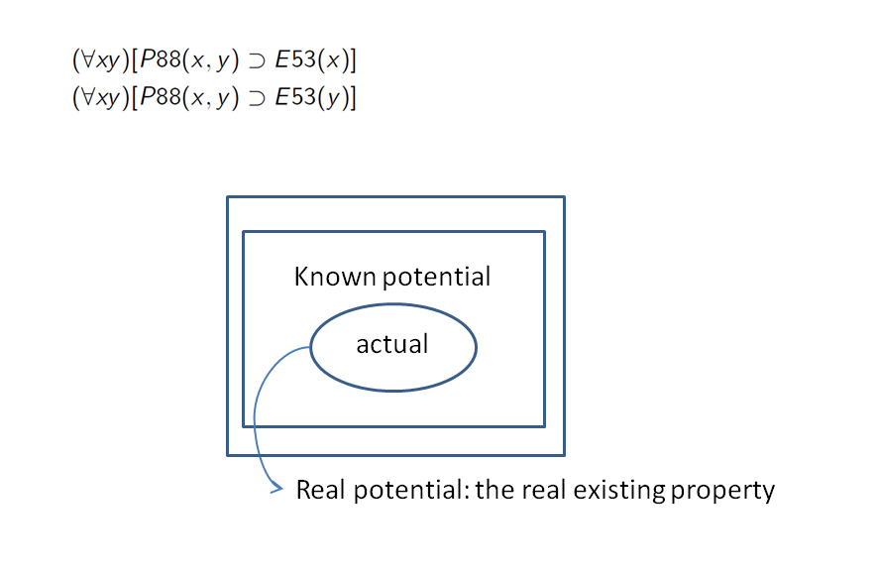
It should be defined in the scope note of the property if it is compatible with the bottom up evolution of the model. ( My intentional properties should be independent).
All the birds are flying but Tweety doesn’t fly! This property doesn’t hold for all instances. This is more complicated and it cannot be represented by FOL.
The problem arises with potential properties. (then we discussed about strong and necessary we referred to P41

About bottom up evolution:
(Martin Doerr, 4/1/2016)

If P is a property with domain Ed and range Er, the logical condition (∀xy)[P(x,y) ⊃ Ed(x)], (∀xy)[P(x,y) ⊃ Er(y)] means, that the actual domain value set D(P) := {x: ∃y[P(xy)]} is a subset of the declared domain Ed of P, and the same for the range of P.
This implies that any superset of Ed, Er also qualifies as domain and range respectively. So, all properties have a trivial domain and range, which is the set of all instances of our domain of discourse.

Apparently, this is not the purpose of the conceptual model. Rather, by specifying a domain and range for a property, we aim at guiding users to understand the precise meaning of the property and preventing them from misinterpretation and abuse for another meaning, which may be quite well be a reasonable interpretation of the property label, but not, what was intended by the model.

For instance, a label “consists of” may be taken to describe the materials a physical object consists of, or for the component parts of an object. As another case, a label “forms part of” may be applied to the pages of a book and the text on those pages. Obviously, such uncontrolled use, even though it may not cause problems to the human reader, will prevent us from automated information processing and hinder correct query answering and information integration.

Consequently, the aim of ontology engineering is to minimize the domain and range of a property. In general, this cannot be done down to the actual occurrence of a property. If it would, semantically the domain and range would become synonymous with the property. For instance, any person in Europe can possess a book. “Book Possessors” and “Possessed Books” convey not more information than the property itself, and do not inform us what class of things can become a “Book Possessor” or a “Possessed Book”. Obviously, the class “Book Possessor” does not have any other reasonable property which applies only to “Book Possessors”, at least in my world.

Therefore, the task of ontology engineering is to minimize the domain and range of a property to the smallest classes of items that comprises all instance having this property or having the potential to acquire this property during their existence or later by discourse. This means, that the minimal domain and range must be defined in terms of intentional properties independent from this property “P”. In practice, we will almost always encounter border cases, in which we may not be sure, if the property can apply to all instances of a particular class or not. For instance, all persons may have other persons as friends, but a particular mental disorder may prevent some individual from it.

So, we are logically on the safe side, if we increase the domain and range to a wider class for which we are sure it will encapsulate all occurrences of the property. For instance, we may add dogs to potential book possessors: who knows if a dog can be declared heir of someone in some society? However, from the point of view of ontological commitment, we are on the bad side, because we declare to the system that dogs can be book possessors, and that may open up uncontrolled interpretations and use of the sense of “book possessing” by the users.
In other words, since we, as humans, do not have globally complete knowledge, allowing a property to be used beyond the domains and ranges in which we have actually understood the property and its behavior and logical consequences may lead to a system which will produce inferences that will contradict our world knowledge (in N. Guraino’s terms: allows for “unintended models). Further if, in the evolution of the ontology on a running system, we are forced to cut back a domain and range to a subclass in order to avoid misinterpretation, we create a backwards incompatible update.

Therefore, we come to this paradoxical methodological guide line: Declare domain and range to narrow, that it comprises all items for which we have understood the meaning and potentiality of occurrence of the property, but do, as if it would comprise all possible items. If some user will encounter another, relevant application of the said property, the ontology can be extended to a wider domain or range. We call this “bottom up development” of the ontology. In logical terms, we can perceive this as a global constraint of the ontology to a part of the world sufficiently understood by the developers of the ontology, its “domain of discourse”. Obviously this constraint should be made explicit in the description of the ontology, but any encounter of a two narrowly cut domain or range can be regarded as an implicit constraint to the domain of discourse.

