601: publish research questions on the website; WDBackground
Link to issue description.

Archaeological Research Questions and other methodological material indicating what motivates a particular modelling decision.

Current State:
Material that needs to be made publically available on the site:
- the Analysis of Scientific Questions in Archaeology somewhere on the CIDOC CRM website
- the research questions that the modelling in SeaLit provides an answer to
- The CRM Requirements Analysis (described in the deliverable for the Chios Project) –and the document where the questions are listed.
- the PhD Dissertation by Stephen Hennicke (the research questions he used).

Proposal:
[1-4] above to appear as links under The Model\ Use & Learn \ Methodology.
To be listed under Resources on a case-by-case basis.
specifically:
(1), (2) under Resources \ References [articles, papers referring to the CIDOC CRM ontology]
(3) under Resources \ Technical Papers
(4) under Resources \ Publications

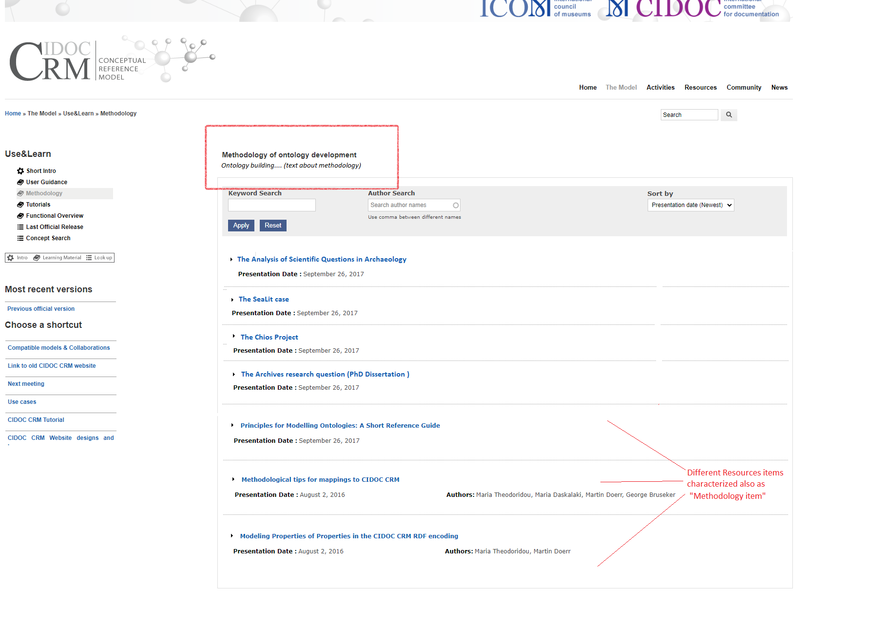
Figure: Mockup for methodology page. Collapsed items as links. For more details, available documents etc, click on them.

