ISSUE 420: Social transactions and bonds.
The sig reviewed the HW by MD on (i) the model for Bilateral Business Relations and (ii) on the scope note definitions for SOxx Provision and SocExx Business Obligation.

A summary of the discussion concerning the model on Bilateral Business Relations can be found below:
PROPOSAL: It was suggested that a distinction among instances of SO2 Provision that initialize and those that terminate an obligation in the context of a transaction is not very clear on the diagram.
Given that an instance of SO5 Service Contract (x,y) creates a set of obligations for the buyer and the provider which are terminated by paying a certain amount of money in exchange for an object/service and providing an object/service in exchange for money, respectively, it might be useful to introduce a new set of properties (both sub-properties to P14 carried out by) to be deployed when modelling transactions:
- from the point of view of the buyer: paid from/ paid to
- from the point of view of the provider: provisioned to/ provisioned from
It might also be useful to introduce a new superclass for E8 Acquisition and DO4 Payment.
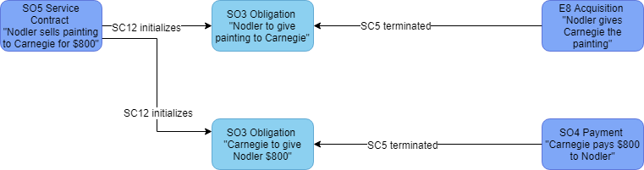
DECISION: it is not the case that E8 Acquisition isA SO7 Service Action
DECISION: SO1 Social Bond isA E2 Temporal Entity.
DECISION: the sig should reconsider how gift giving fits the current model and act accordingly.

The edited scope notes for SOxx Provision and SO3 Obligation can be found below:
HW: RS, FB, AG and AK were assigned with providing examples for SOxx Provision and SOxx Business Obligation from actual project data and their data dictionaries such that they either match and corroborate the proposed model on provisions and exchanges or they disprove it. AG is to provide historical data, AK data from sealit.

SOxx Provision
Subclass of E7 Activity
Scope Note: This class comprises activities of one Actor, the “provider”, providing to another Actor, the “receiver”, some particular entity of identifiable social value that is generally regarded to imply a formal obligation for compensation. The provided entity may be a material service, such as repairing a car, a payment or loan of a monetary amount, the tithe of a quantity of potatoes, or the granting of rights of ownership or use, etc., and should constitute a well-defined unit. Except for the case of being a gift in the proper sense or an act of bribery. A Provision may initialize an obligation of the receiver to the provider, increase an existing obligation or being itself a compensation already and decrease or terminate an existing obligation of the provider to the receiver. A Provision may or may not be associated with a precise monetary counter-value, agreed or demanded beforehand or afterwards. Be it with or without a defined monetary value, the units of mutual provisions should be such that the involved parties should be able to decide when provisions have terminated mutual obligations, although the partners may have different opinions about this. In societies maintaining a currency, in a typical market purchase partners would exchange some goods against immediate payment. Such cases should be modelled by specializing this class to the typical, simplified forms of accountable exchange business in a society. But even in such societies, economic difficulties of partners regularly lead to agreements overriding the specified formal monetary equivalents of provisions, which a historically correct model must be able to represent adequately.

SOxxx Business Obligation
Subclass of SO1 Social Bond
Scope Note: This class comprises a temporary relationship of a socially accepted form between two business partners consisting of an obligation to make compensating provisions to each other, normally with the goal to terminate the obligation immediately or within some agreed time-span. An instance of SOxxx Business Obligation may implicitly come into being by an agreed-on initial provision of one partner, or by a formal contract. It ends with an agreement of the partners about completed compensation or the arbitration by a responsible social institution. The obligation may be accountable, i.e., quantifiable in terms of a currency, and compensation may be agreed to be defined arithmetically based on monetary values and counter-values, such as when paying for a purchase in a supermarket, but also when paying back a loan with interest rates for years. In other cases, partners may agree to define the compensation of obligations by a set of particular material provisions, or by a combination of monetary exchange and provisions without a defined monetary counter-value, as characteristically in small communities, earlier societies but also in exchanges between cultural heritage institutions. Even in a modern industrialized society, business obligations may be supported by, but are not defined by mathematical accounting. Economic difficulties of partners regularly lead to agreements overriding the defined monetary counter-values. Even if the units of provisions made are well-defined, partners may not agree on the termination of the obligation and appeal to an arbiter.
Informal obligations, such as those initiated by gifts or attempts of bribery, and obligations by other social interactions that cannot be formally compensated or terminated, in whatever form of community or society, do not fall under this class and may be modelled as other forms of obligation sharing more general traits with this class.

