ISSUE 414: CRMsci O14 initializes
AK’s request that O14 initializes (is initialized by) [D:E5 Event, R:S16 State] be updated to O14 initializes (is initialized by) [D:E5 Event, R:E3 Condition State], gave rise to a long discussion regarding the incorporation of states-like classes in the CRM –base and family models –and where these should be placed.
The proposed hierarchical ordering of states-related classes, the relevant CRM module they should find their place in and their varying interpretations according to the domain in question, were captured in the following diagram:
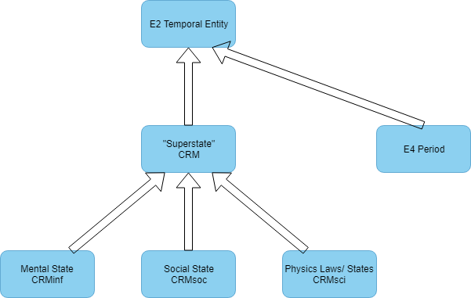
DECISION: The sig decided that O14 should be deprecated in CRMsci. It is to be reinstated in CRMinf, taking as range Ixx Situation or some other relevant class. Issue 414 is closed, discussions regarding the range of O14 are to be subsumed in Issue 329.
HW: SS is to come up with the definition of Ixx Situation in CRMinf.

